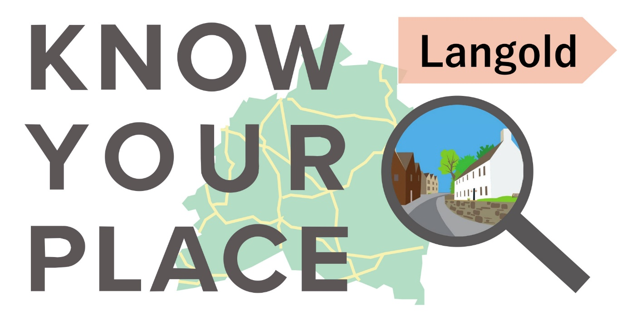
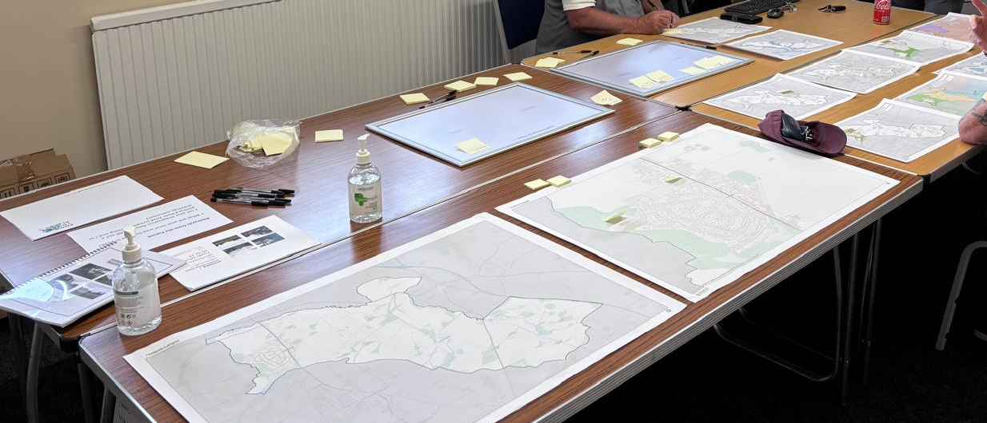

Response data provided at the community events

10am – 12pm, 20 May, and 4 - 7pm, 21 May 2026


Overview
This document summarises the full range of comments gathered during the Know Your Place community events held in Langold in May 2026. The events took place at Now Church on Wednesday 20 May 2026 (10:00 AM –12:00 PM) and at the Village Hall on Thursday 21 May 2026 (16:00 – 19:00 PM).
The purpose of this document is to inform any future review of the existing Langold Neighbourhood Plan and to provide a useful reference for potential project work.
Comments from residents on the SWOT (Strengths, Weaknesses, Opportunities, and Threats) analysis undertaken for Langold are presented first. This is followed by feedback relating to the location-specific maps, and finally, comments on the ‘Postcards from the Future’ submissions. Postcards from the Future is a creative engagement activity where participants draw their vision of how their neighbourhood or local area could look in the future. Through illustrations, people share their ideas, aspirations, and hopes for shaping a place for future generations.
All comments are presented as originally recorded, with explanatory notes added in italics where appropriate. Additional italicised annotations indicate the level of support for comments (e.g. (x3) denotes that two additional participants supported the original comment). Where relevant, similar comments have been grouped together to provide a clearer understanding of key themes.

What is Know your Place?
Know your Place is a social learning tool developed by Bassetlaw District Council following involvement in a government funded-pilot to explore new ways of supporting community-led planning. It aims to encourage curiosity and discussion around local issues, and to assist communities to identify and document local priorities. It is based on the premise that developing a better understanding of a place in the first instance will provide a firm foundation on which to consider if and how the themes raised could be responded to. This could, for example, include community projects, land use planning strategies, or further discussions or investigative work. Equally, better understanding of local issues may be a justifiable outcome. Where relevant, similar comments have been grouped together to provide a clearer understanding of key themes.

What happens next?
There are various ways that the response data included in this report might prove useful. What happens next is down to you – and we are keen to help to consider and facilitate this.

Neighbourhood Planning, Bassetlaw District Council
Date: July 2026

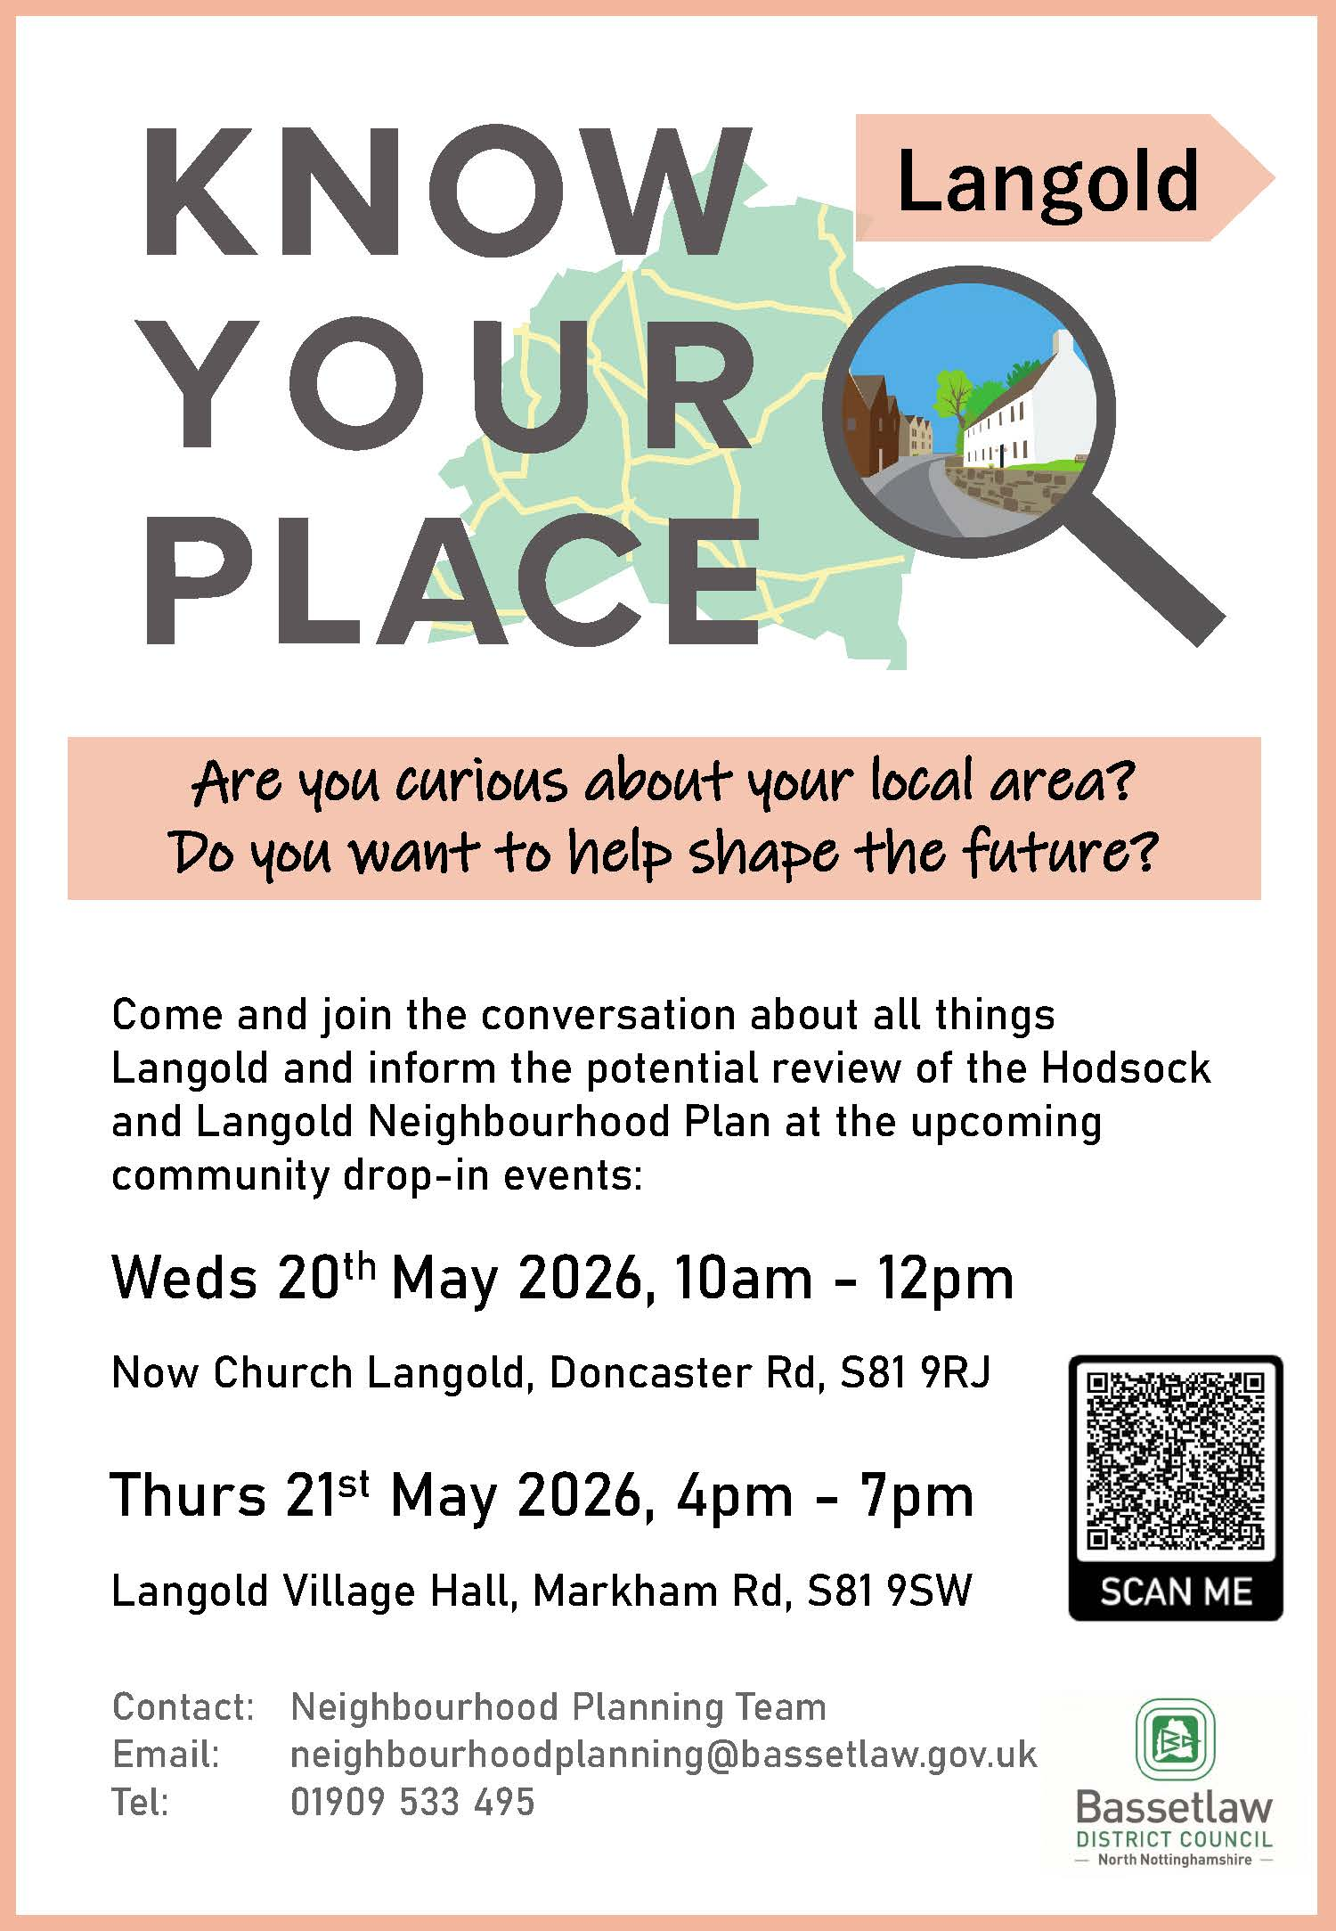
Langold Promotional Flyer
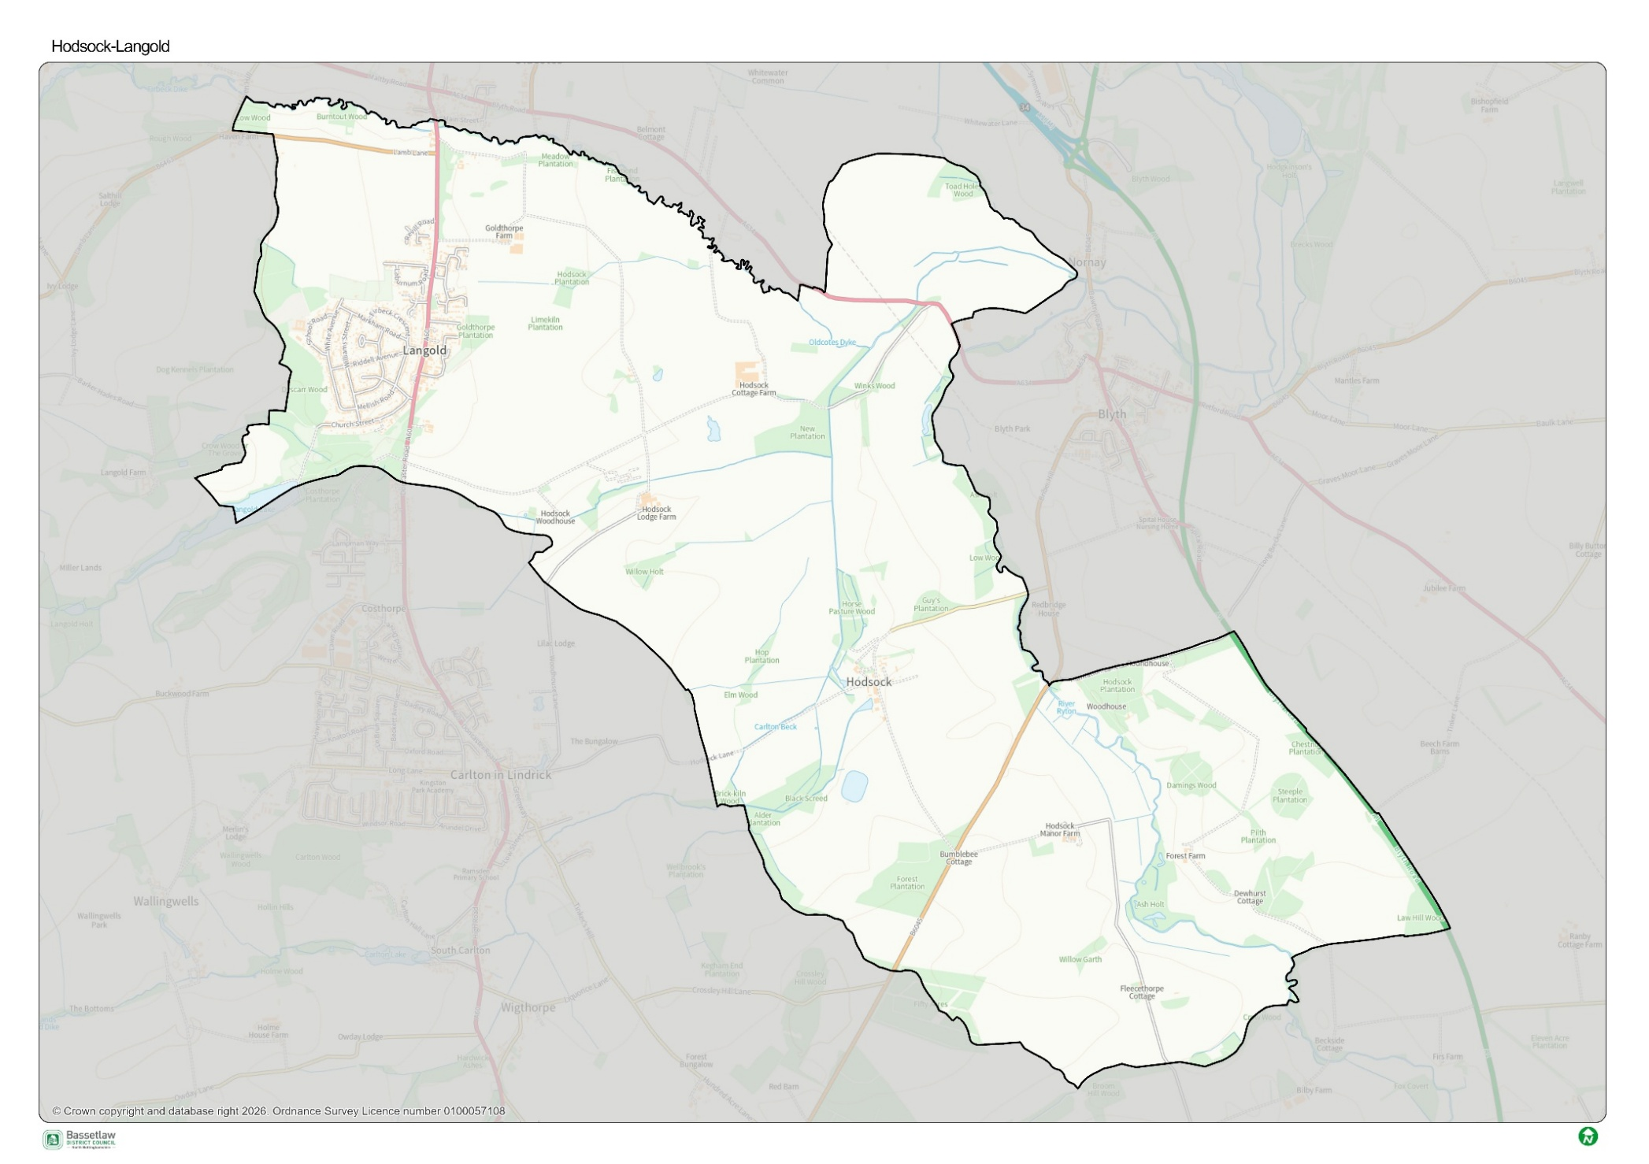
Langold Boundary Map
SWOT analysis

Strengths
- Good community spirit (x6).
- Good and strong community.
- Raised money from local people – positive experience.
- Friendly, some people are very helpful.
- Church does a lot for the village.
- Bingo and other community events.
- Village Hall.
- Like everything, I love Langold friendly people, feel safe walking dog.
- Love Langold!
- Easy access to countryside.
- Close to Clumber Park, Creswell Crags.
- Lake walks outdoor space – Biodiversity.
- Lake (x2).
- I love it - going into woods and lakes.
- Really good walks of variety lengths.
- Well connected.
- Good bus route.
- Housing reasonably priced.
- People moved here in the past because it was affordable.
- Diversity of shops.
- Hill top (but might be closing).
- Nearby villages offering gala.
- Not a bad village.
- It’s better than Harworth.

Weaknesses
- Lack of enough amenities, dentists, doctors, things for kids to do especially with an all-extra housing in area.
- Too many houses for the current infrastructure.
- Don’t like all the new buildings – there aren’t enough facilities to support all the new residents.
- Schools + Drs – problems with capacity – is this related to new housing?
- Dentists – capacity issues – patients having to go private because of lack of spaces on NHS.
- A separate Nursery has been missed by the villagers.
- We have nothing for the youth in the village.
- State of roads all over Langold.
- Roads are terrible.
- Paths and roads haven’t been properly maintained / refurbished for a long time.
- Potholes!
- Parking on footpath/pavements is a nuisance.
- School Road is chaotic – traffic related to school.
- Can’t get a direct bus to Retford.
- Antisocial behaviour down lake with kids drinking setting fires in woods, Vandalising!
- Anti-social behaviours.
- Anti-social doing on motorbikes with no helmets.
- Dog fouling.
- Lack of law enforcement.
- Too many drug dealers.
- Counterfeit goods being sold ‘under the counter’.
- Residents taking matter into their own hands.
- Used to be quiet! Now its loud – not as safe as before.
- Limitations on how open spaces can be used – antisocial behaviour means we don’t feel safe.
- I have lived in this village for 42 years and unfortunately over the last 5 years I don’t feel safe, I don’t go out at all after dark.
- Limited to use woods and open spaces due to the people who hang around them.
- Don’t feel safe due to people that BDC keep giving social housing too.
- Worst thing was losing the diving board at the lake.
- More needs to be done with Langold Lake.
- Lake – shouldn’t have done away with paddling pool.
- Café and toilets at Country Park closed.
- Loss of variety of shops to support everyday needs.
- Loss of Morrisons and factory shop means loss of competition.
- Morrisons is closed – observed that prices were more than a large Morrisons.
- Loss of wardens for older people.
- Parish Council needs to be move active in the village with information.
- Feel left behind and not getting value for money with council tax.
- Forgotten doing the most northern area in the country.
- We need an honest discussion on the future of our village.
- Everything is going backwards.
- My children and grandchildren were born and bred in this village and cannot get a council house because of all the outsiders. My granddaughters and great-granddaughters are living with us and we are pensioners.

Opportunities
- Look after the homeless – there are homeless people in Langold.
- More community spirit – people helping each other (like Now Church).
- More law enforcement.
- Need continuous Warden / Security presence at Lake/Country Park.
- Community Warden (on a local subscription basis?)
- More engagement and visibility from community police.
- Development at lake (not been great since council took over).
- Potential of lake to host events and be a better visitor attraction.
- More activities at the Lake – it’s big but not made enough of.
- Keep edges of lake clearer and remove the fallen trees to allow nice views from all around lake.
- Make the Lake/Country Park more of a tourist attraction.
- Potential of the lake similar to Rother Valley.
- Splash Park – needs better maintenance to keep it open – it’s a real asset.
- Space near Skate Park – potential for MUGA (multi use games area) or near lake.
- Make more adventure park. Now had skate park all painted would be good incorporate other things – Park, crazy gold etc.
- Nothing for the kids – maybe a Youth club. (x2)
- More activities for young people + children.
- Family friendly venue – including play space.
- Kids currently have to walk to Carlton.
- Empty shops – more British produce available would be great.
- Would welcome a large supermarket like Aldi, Lidl, Asda.
- Variety of shops.
- More jobs in the local areas – so people don’t need to travel.
- Better surface on footpath please.
- Highlighting and promoting existing active travel routes.
- Expand the school canteen (not big enough in current capacity – kids rushing dinner).
- Working with neighbouring parishes. e.g. Carlton.

Threats
- Vape shops as a front for illegal activity?
- Police not acting on crime and ASB (minorly impacting lives of majority).
- Enforcement of dog fouling and limited options.
- Keeping Hilltop open – going on a month-to-month basis due to price of beer etc.
- Online and digital threat to high streets and lack of face-to-face service.
- Shops closing and vape + barber shops opening.
- No more barbers, takeaways or vape shops.
- Play areas needed – including family-friendly venues.
- Not a lot to do for younger generations.
- Fix potholes.
- We need to protect our green spaces.
- Stop building on farmland.
- Age of the population.

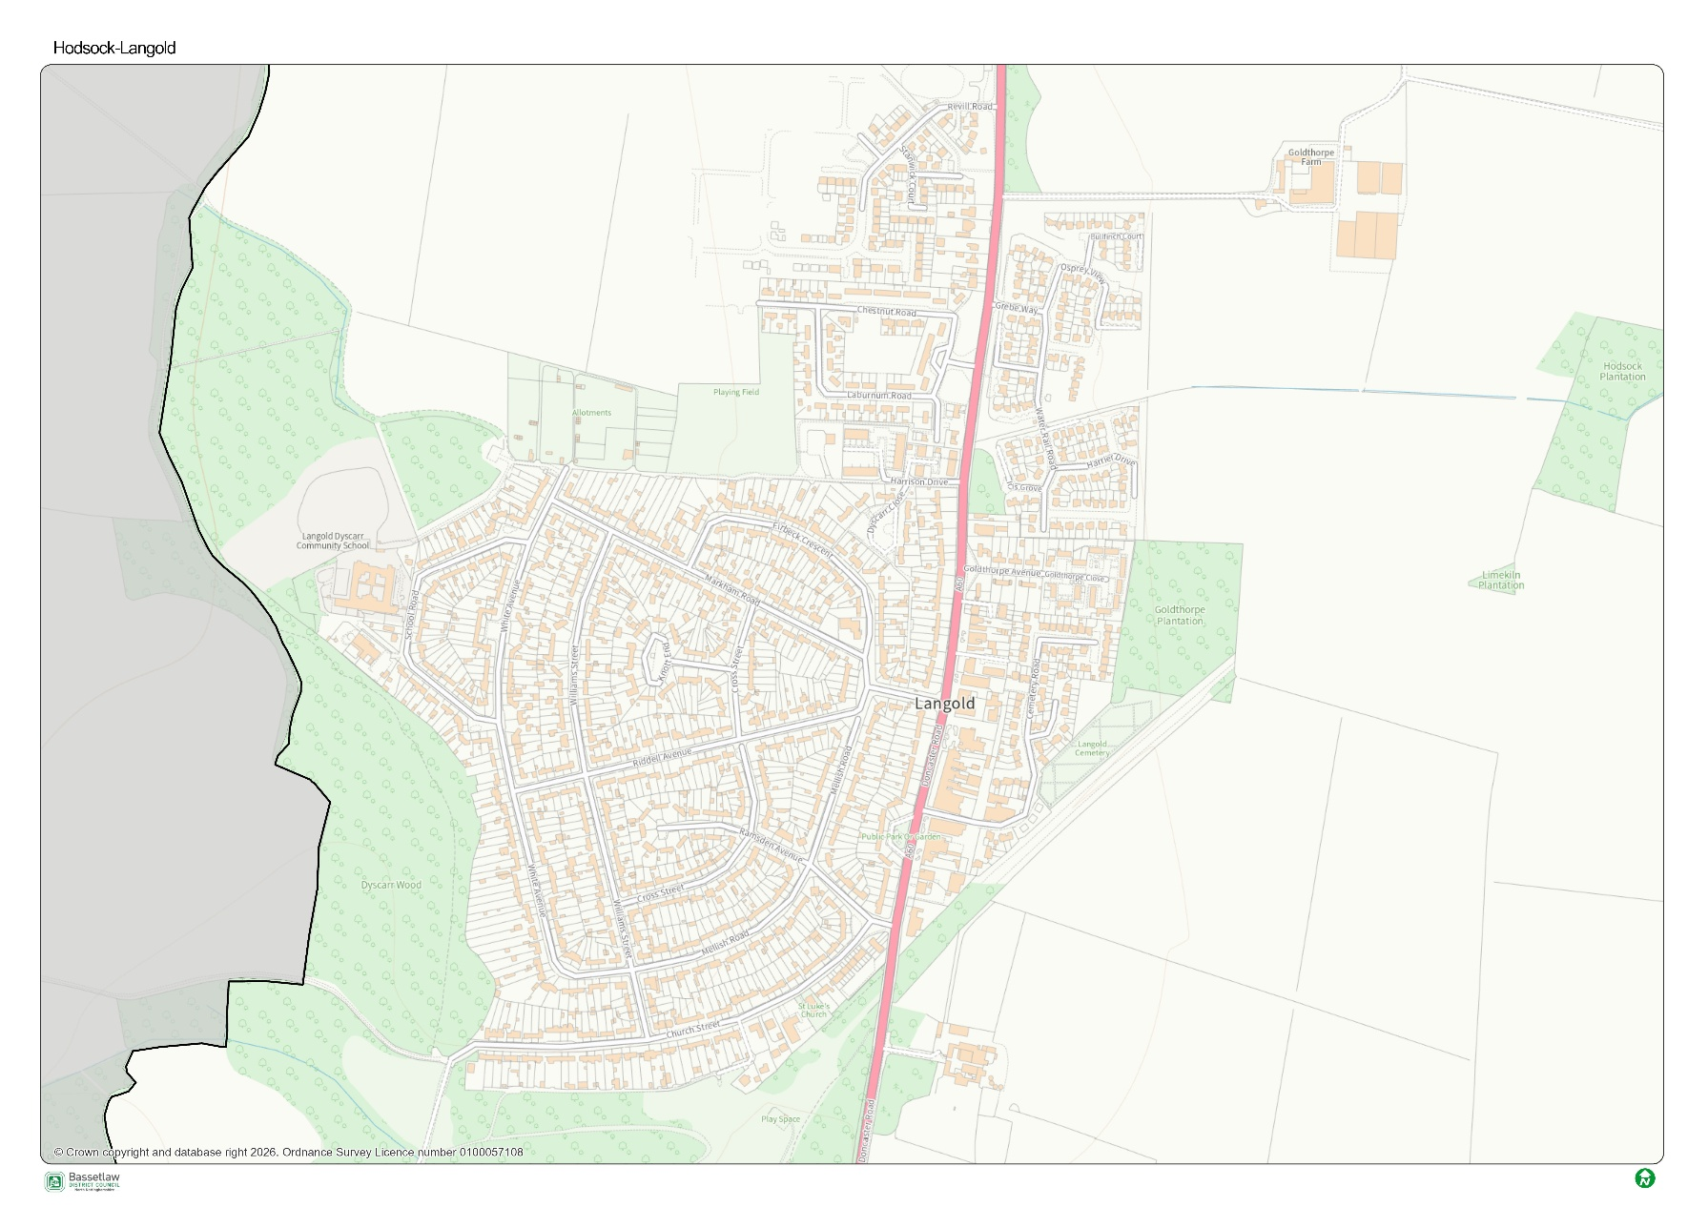
Langold Mapping: Part 1
Community meeting on crime?
Drug use and dealing in White Avenue.
Bottom of School Road near White Avenue 15 – 3 big tree’s roots going into drains and getting blocked and path is uneven.
A big cherry tree outside house in School Road – spoiling gardens with litter.
Drug using in woods behind gardens on School Road.
Kids setting fire in woods.
Langold Mapping: Part 2
Paths poor quality – Markham Road in particular and White Avenue.
Mellish Road, William Street and White Avenue – at junction no cars stopping.
Drug dealing on Doncaster Road reported to police, but NO ACTION.
‘Nothing is happening’
Goldthorpe Plantation designate as a green space.
Anti-social bike use on White Avenue.
Speeding on Markham Road would support 20 mph.
Langold Mapping: Part 3
Concerns for additional housing impact on services and infrastructure.
Bumpy / potholes on roads Langold especially on bus.
Potential for MUGA behind cricket pitch or bike track natural easy access from woodlands.
Speed reduction push:
- Doesn’t work at over 40mph.
- Extra speed reduction – speed cameras on Doncaster Road
- Anti-social behaviour – bikes, no helmets.

No factory shop. It has been closed down. New retail centre.
Scrubland but now has planning permission for six houses – could have been used for community use e.g. local children’s health
No more vape shops – greater and better choice of shops.
Flood Map
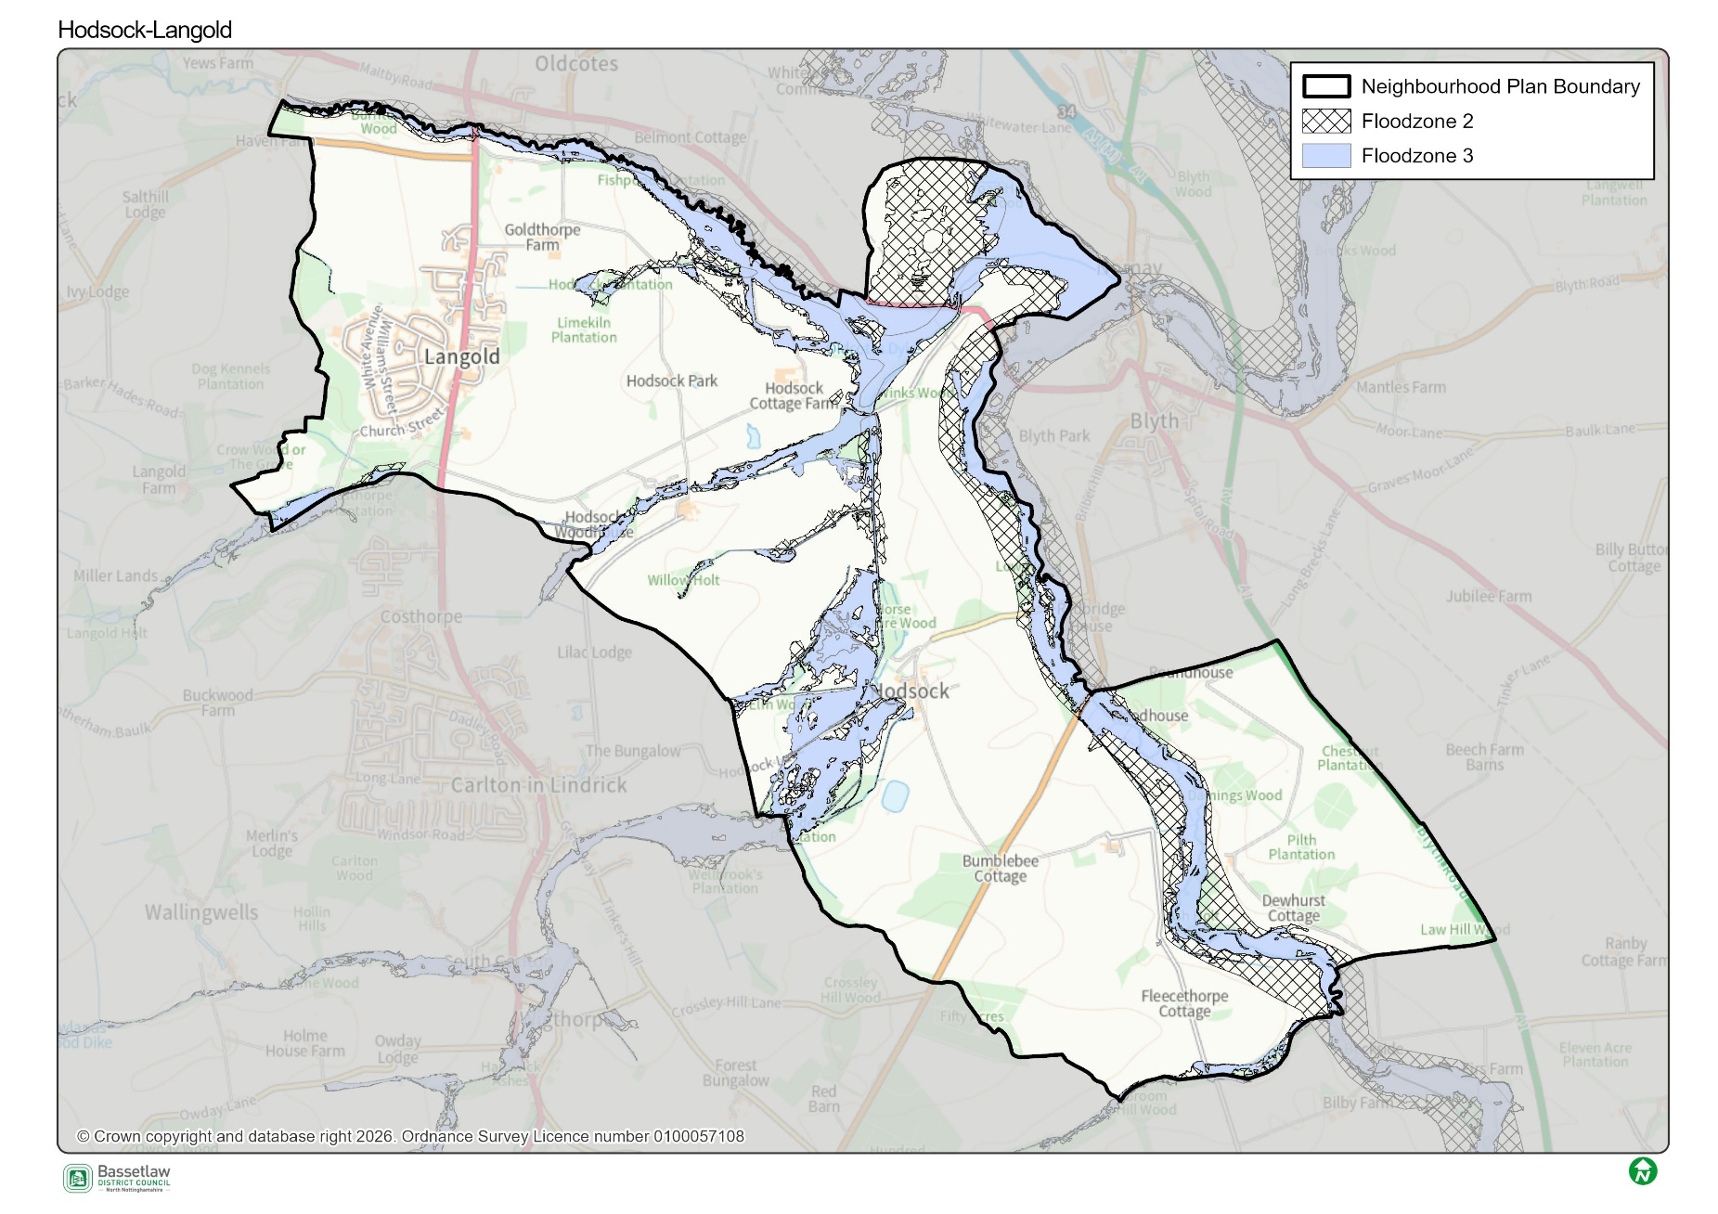
Little Brook
- Flooded.
- Can we protect as green space?
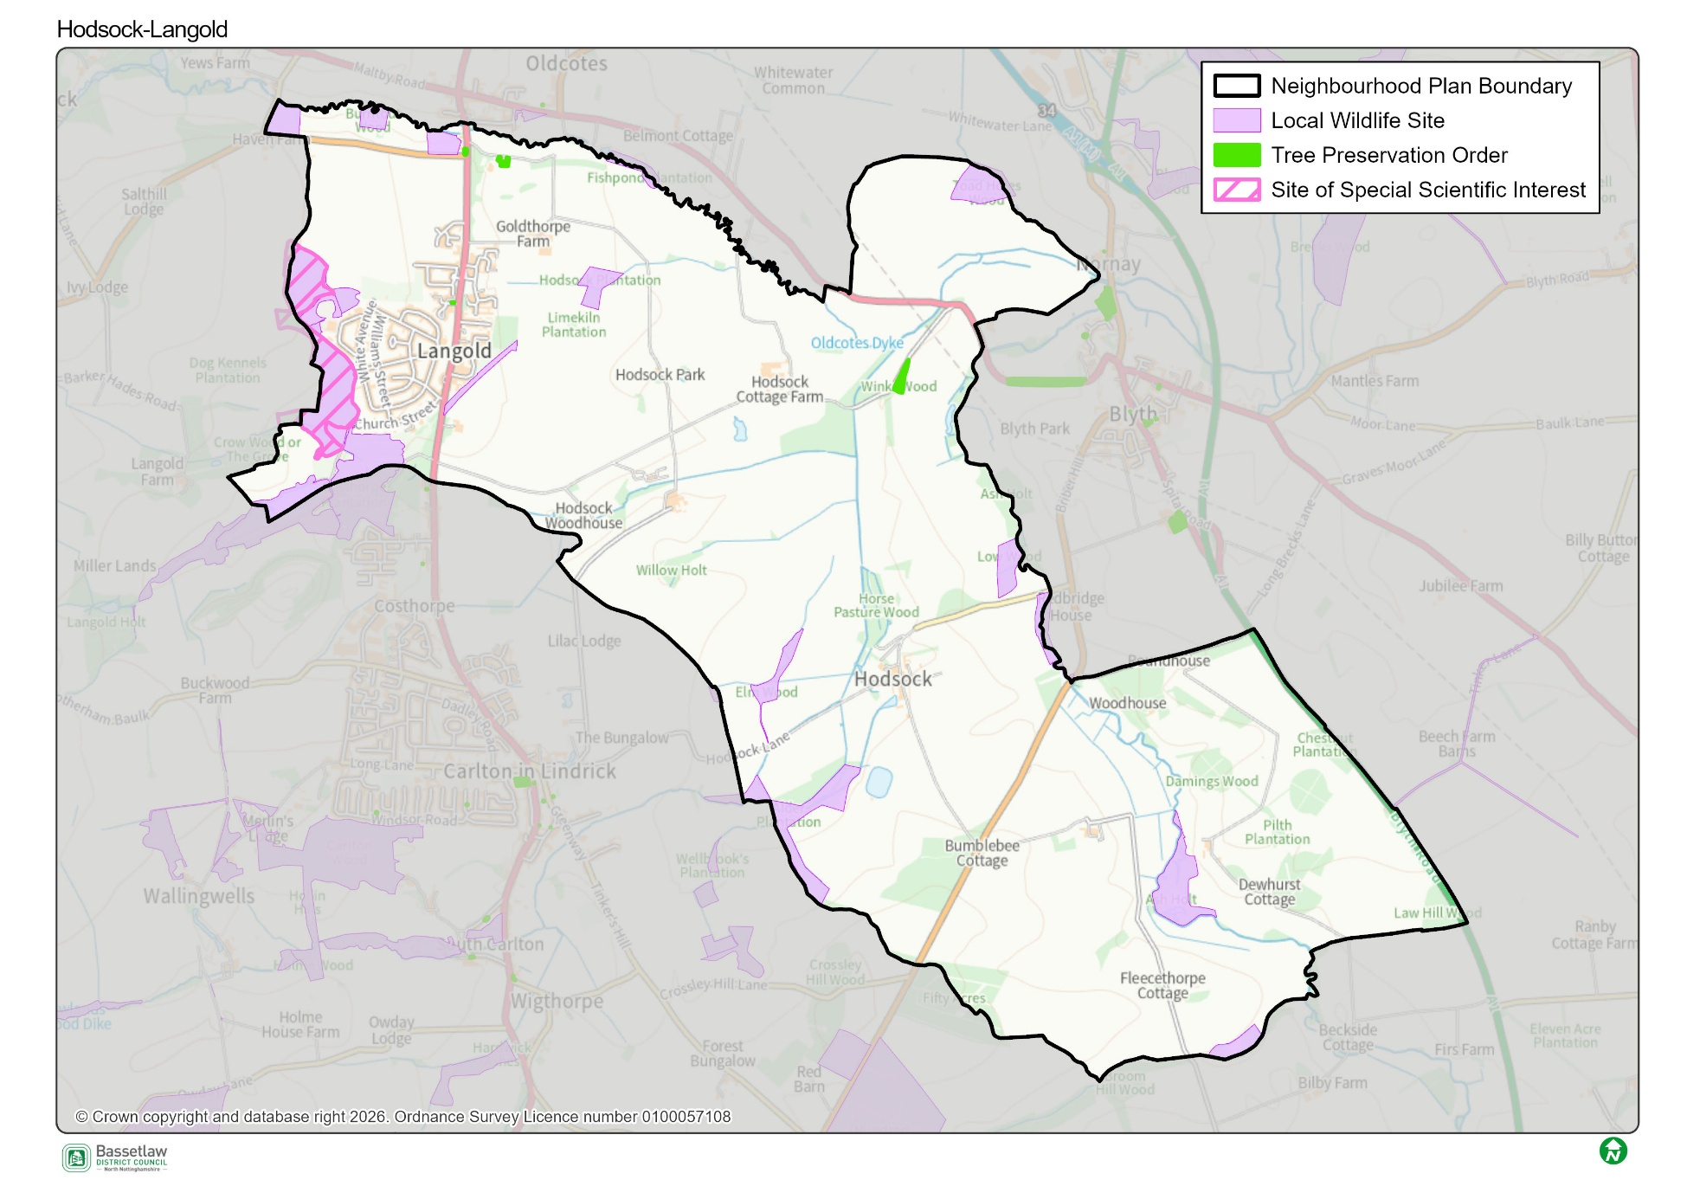
SSSI, TPO Map

Anti-social behaviour in SSSI. Litter and fly tipping and motor bikes.
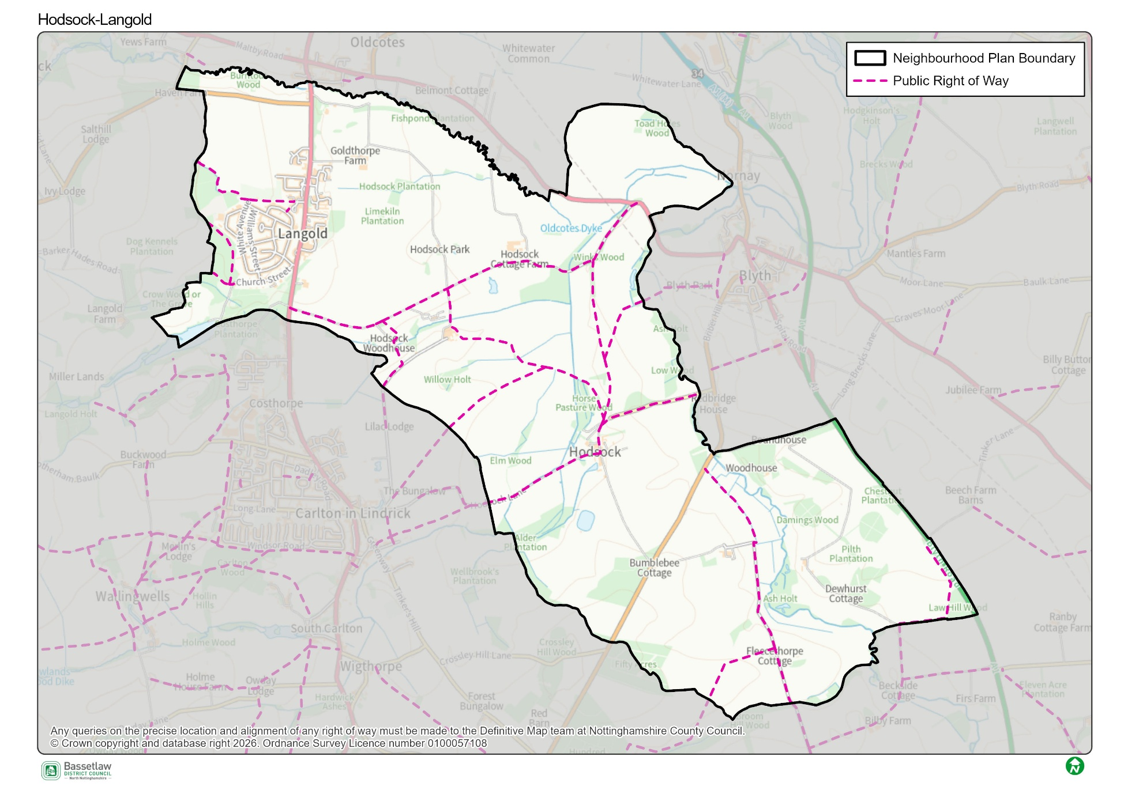
Public Footpath Map

Lots of walks in around Langold, need to make more of them.
Active Travel Corridor.
Some of these routes will make good cycle ways.
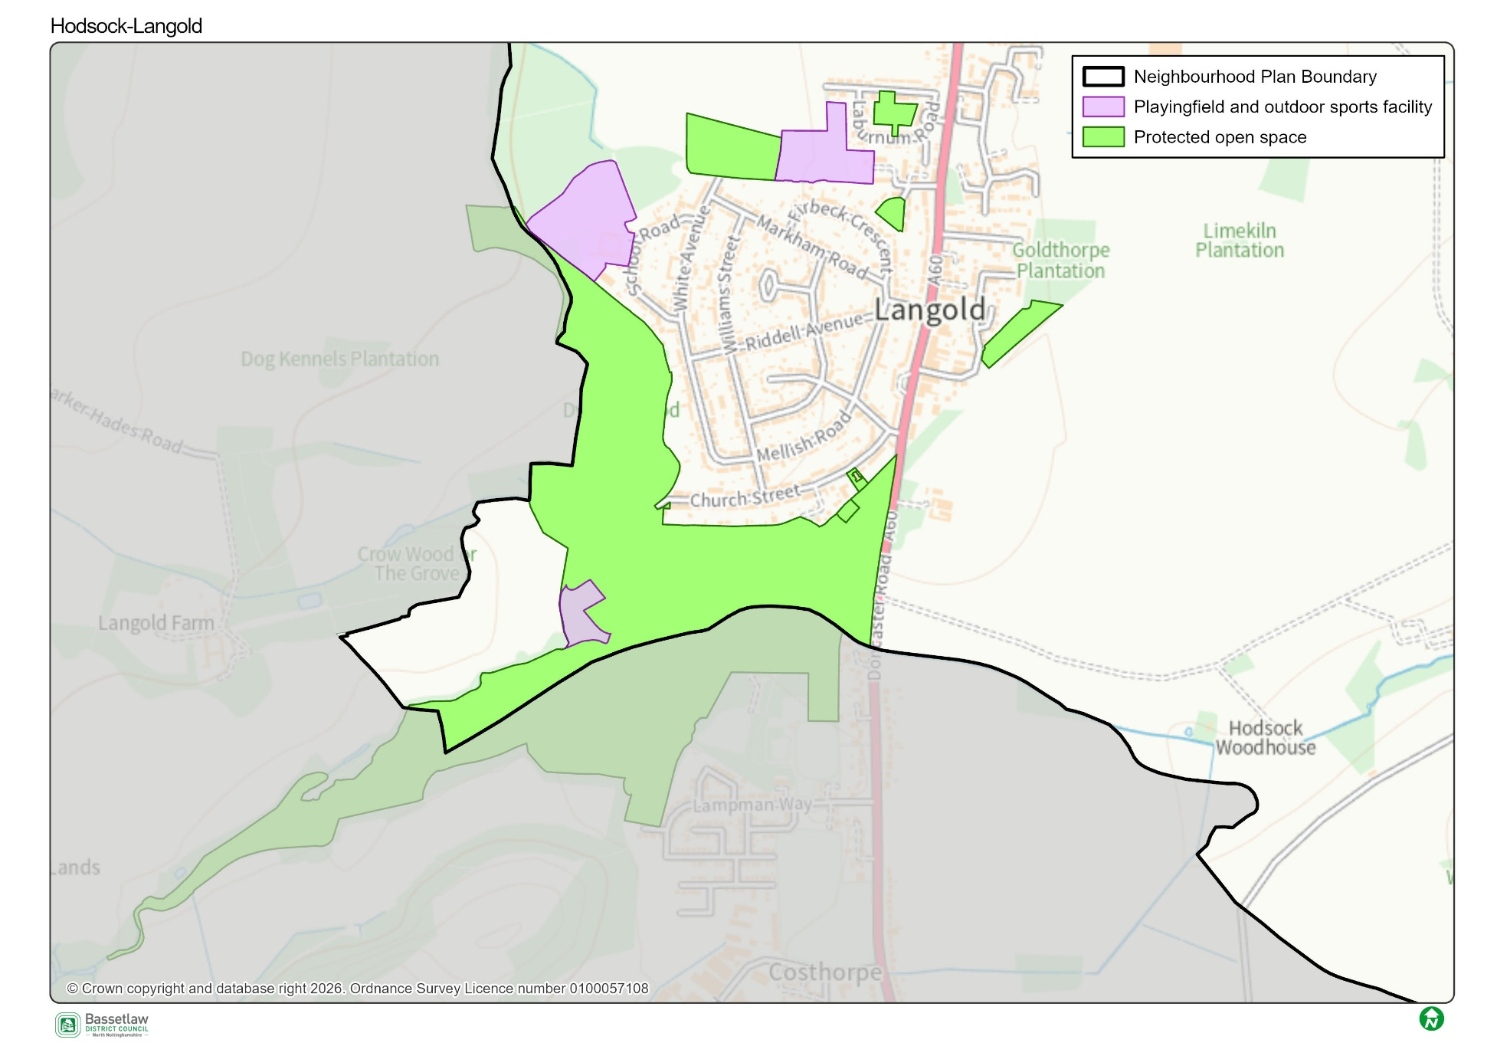
Open Space Map

Grass verge is covering the path – making it difficult to get by.
All the outdoor play equipment is at the lake. New Play Area required to the North.
New Play Area required.

Postcards from the Future: Greetings from 2038
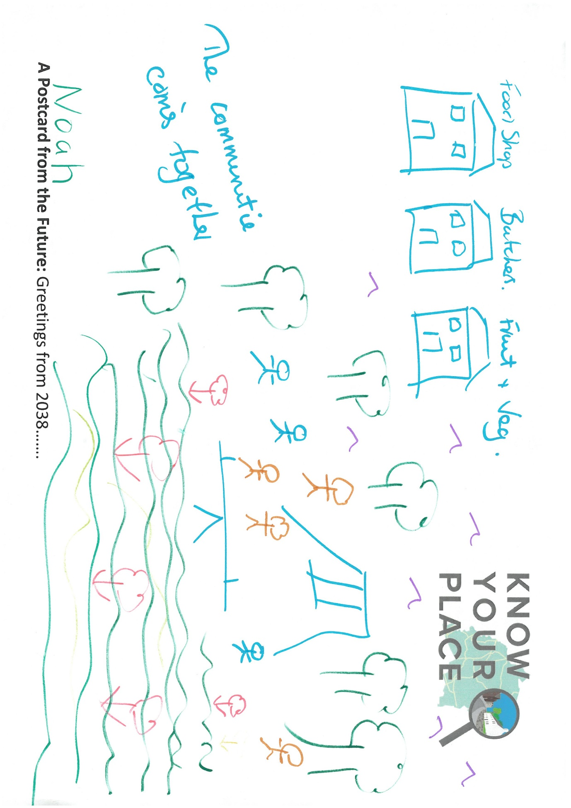
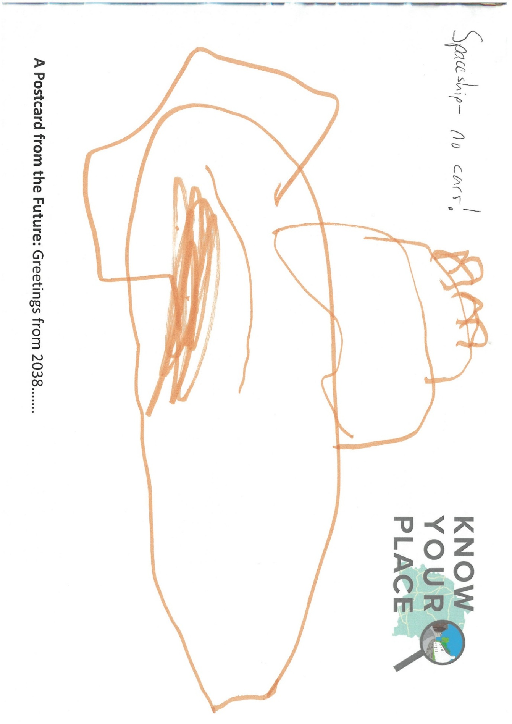






Know your Place: what’s in a name?
The name ‘Know Your Place’ has an intentional dual meaning. On one hand it reflects the opportunity the initiative provides for all involved to learn more about the local area. This could be through viewing the information on display, through reading the contributions made by attendees, or through discussion both at and following community events. The name is also a conscious acknowledgement of the invaluable role communities have in shaping spatial knowledge and informing local priorities. Collectively, the initiative works on the basis that all parties have valuable knowledge and experience to share, but also the capacity to learn from the valuable knowledge and experience of other people.

Neighbourhood Planning
Bassetlaw District Council
Queen’s Buildings,
Potter Street,
Worksop,
S80 2AH
Tel: 01909 533 495
Email: neighbourhoodplanning@bassetlaw.gov.uk
Website: https://www.bassetlaw.gov.uk/planning-and-building-control/planning-policy/neighbourhood-plans/know-your-place/


Know your Place website

