Examiner’s Clarifying Questions and Information Requests put to Babworth Parish Council and Bassetlaw District Council

Questions and Information Requests to Parish Council

**Responses (in red)**

Question PC1:

What is to be the formal name of the neighbourhood plan – Babworth Parish Neighbourhood Plan or the Babworth Neighbourhood Plan? – currently the plan uses both titles.

We would like it to be called ‘Babworth Neighbourhood Plan’

Question PC2

Most neighbourhood plans have a clear thread that runs from identified key issues to vision and objectives and then to policies and proposals in response. The BNP doesn’t identify early on what the key issues are although as the reader progresses through the plan it does become clearer. I will be suggesting that the Parish Council provides a short section of text for section 3 ahead of the vision that sets out what the key issues for the parish are that have emerged out of the preparation and consultation process and which can then lead into the vision and objectives. It would be helpful if this additional text could be provided before the examination completes. A bullet point summary of the key issues will be sufficient.

Please find our preferred text below

* For the Parish to grow in a proportionate manner with housing that meets a local need
* For the most important environmental areas to be protected from inappropriate development
* To safeguard the character of the Neighbourhood Area and to ensure high quality design
* To preserve and enhance the range of community facilities and employment opportunities available to residents

Question PC3

Re the development boundary – what is the rationale for the long extended strip along Blyth Road north of the main part of Ranby? Currently there is no justification set out.

After the consultation event the residents in that area asked for the boundary to be moved so they could feel part of Ranby village. Development has already been approved in that area and it was seen as an opportunity to regularize the area and hopefully improve the road and footpath area. This is a positive response to sustainability filling in gaps between existing developments.

Question PC4

Re the alternative sites set out in the AECOM Site Options Assessment Report – what happened to LAA056 Blyth Road which AECOM considered to be the best site? The now allocated site south of the Conifers was one of 4 identified as possible all below LAA056 in terms of preference. Possibly LAA056 has been developed but even so there should be clarity as to why the now allocated site was chosen – is it just a case of the others either being too small to meet the identified need or too large?

Please see the response below and LAA056 already has planning permission on it so has already a number of houses allocated to it.

Maybe the response should be attached as an Appendix?

Site Allocation for Babworth Neighbourhood Plan.

The site allocation for the Babworth Neighbourhood Plan (BNP) evolved over time after going through several stages and processes both internally by the Babworth Neighbourhood Plan Steering Group (BNPSG) and externally from AECOM Limited (AECOM). The minimum housing requirement for Ranby for the next planning period was dictated by the Bassetlaw Local Plan which has set the target at 13 dwellings.

AECOM were employed to provide a Site Options and Assessment Final Report, using information from the Neighbourhood Plan “call for sites” and the Bassetlaw Land Availability Assessment (LAA) as a starting point. Following the work carried out by AECOM the number of sites that were actually potentially suitable and available were assessed and rated. Some sites already had planning permission granted so no further assessment was required. From the AECOM report 3 potential sites were then put forward for discussion by the BNPSG, these were BAB01, BAB02 and BAB03. BAB02 was the first area to be discounted as the site would only yield 1-2 dwellings and the challenging topography of the site was highlighted in the AECOM report. BAB01 also had significant issues, with the site’s close proximity to the A1 to the west generating large amounts of traffic noise, also a communication mast in the corner which would require ongoing access. The site borders the Chesterfield Canal which is a major feature of Ranby village and the building of a significant number of dwellings next to the canal could have a detrimental impact on the local biodiversity. BAB03 provided the best fit for a potential available site for allocation. The site does not have any physical or topography issues, the site is self-contained with hedging and trees offering some shielding on all sides and it has good potential access from The Conifers Road. The site size matches the number of dwellings allocated for the next planning period when taken in consideration with dwellings that have already been granted with planning permission. Barring infill BAB03 sits next to the last previous development within Ranby Village (The Conifers built in around 2007), which was a development of 5 large houses. This development was next to Beechwood Crescent which was a self-contained mixed development when it was built, meaning Ranby is continuing to grow in a similar way to how the village has developed in the past. BAB03 is also located very close to a bus route which passes through part of the village allowing access to Retford, Worksop and beyond.

After discussion the BNPSG decided that the only site that could be recommended for the Babworth Neighbourhood Plan was BAB03.

Question PC5

What is meant by the last paragraph on P19 – ‘population growth can be expected to be driven by the oldest households’? Does this mean demand for housing is driven by this age group and therefore it is the fastest growing age group?

Yes

Question PC6

Re BDC’s policy comments on policy ENV2 at Regulation 16 stage are there any important OS sites in the policy in need of improvement or enhancement?

Babworth Neighbourhood Plan are unaware of any OS sites in need of improvement.

Question PC7

Re BDC’s policy comments on policy ENV6 at Regulation 16 stage are there any particular footpaths to identify for improvement.

Also Re Policy ENV6 ‘appropriate mitigation’ is not clear as to what is intended. Presumably if loss of a footpath was involved it was intended that mitigation would include alternative provision?

Babworth Neighbourhood Plan are unaware of any footpaths that need improvement but if a footpath was lost mitigation would include appropriate re routing of the footpath and to retain its country side feel.

Question PC8

What is the evidence base/justification of the height threshold for wind turbines in policy ENV8 as 50 metres to tip is now very small in industry terms?

Currently there are a number of smaller wind turbines within the parish and Babworth Neighbourhood Plan would support similar turbines. We also have to be mindful of the proximity of the Sherwood Forest Prospective Potential Special Protection Area which need to be taken into account, and the location of the Parish within the Sherwood Forest Landscape Character Area.

Question PC9

Re community facilities and amenities - whilst the historic background to the churches is interesting - perhaps the more relevant point is the extent to which the buildings offer wider community services beyond worship. Please can you clarify?

The churches are used for worship, Christenings, weddings, funerals but also Ranby Village School have visits to the Churches especially Ranby. Babworth church is also used for historical visits due to its relationship with the pilgrim fathers.

Question PC10

On Page 49 in the top two paragraphs - what is the situation with home working and economic activity in the data from the 2021 census as this will be more relevant now than quoting 2011 data?

The 2021 Census identifies 35.2% of people in Babworth who work from home. Economic inactivity has reduced to 39%.

Question PC11

The justification in the supporting text to Policy E3 is exceptionally brief – what is the intent of the policy? - is it necessary because you want to develop/expand on the BLP policy on tourism? Please provide additional supporting text for this section.

Also in respect of E3 - is this intended to restrict tourism development to reuse of existing buildings and farm diversification schemes because if so this would put the policy in conflict with NPPF policy which does not restrict business growth in the rural economy in this way?

The purpose of the policy is not to restrict tourism in this way, but to acknowledge that further tourism activities can come from farm diversification along with other sources.

Maybe the following re wording would work

POLICY E3: TOURISM - Support will be given to facilities that enhance and promote tourism where:

a) They are of a scale appropriate to the nature of the Parish and

b) They do not have a detrimental effect on the distinctive rural character of the Parish and

c) They do not adversely affect the surrounding infrastructure, particularly local road networks, water supply and sewerage and

d) They benefit the local community through, for instance, provision of local employment opportunities and improvements to local service provision appropriate in scale to their location and

Tourism activities which involve the reuse of existing buildings and involve farm diversification are supported’.

Question PC12

Re Policy T1 – the justification / evidence base for the policy is similarly ‘light’. Please provide additional supporting text for this section.

The justification for this policy is excess speeding within Ranby village and on country roads. Large traffic problems including irresponsible parking around the village school which causes congestion.

Question PC13

Re the section on Monitoring and Review – would the Parish commit to monitoring annually – is that the intent as the phrase ‘regular monitoring’ is unclear and could for example mean every 5 years ?

Also what are the examples of other monitoring that will be included?

The Parish Council will routinely monitor the NP by analysing planning approvals and refusals and considering how successful the NP policies have been. This informal monitoring will take place on at least an annual basis and will help inform the need to formally review the NP itself.

Other data will include legislative updates such as the NPPF, Planning Practice Guidance and updated housing requirement figures supplied by the local planning authority.

Question PC14

With regard to the consultation statement and the Reg 14 pre submission consultation – were any events held or was it simply a case of making the plan available and notifying consultees and the community that it was published?

In particular how did the Parish ensure that traditionally hard to reach groups were engaged?

Is it right that only 6 consultees responded and only one from a resident at this pre-submission stage?

Also – at the draft policies consultation event in September 2023, of the attendees there, how many actually made comments on the policies?

As referenced in the question, there was an informal consultation event organised for the community which was held in September 2023 and was attended by 30 people. As stated in the analysis of the event, attendees were offered the opportunity to comment but were encouraged to contribute to the Regulation 14 consultation. The analysis notes that three people commented on the policies and a further six people completed a questionnaire on renewable energy.

The responses to Regulation 14 consultation are as stated.

There were no specific consultation events through Regulation 14. It was advertised on the Parish Council website, through posters and fliers delivered throughout the parish.

Questions to Bassetlaw District Council

Question BDC1:

Two dates are given for the designation of the neighbourhood area in the documentation – 24/9/20 and 25/9/20 which is it?

The neighbourhood area was designated on 24 September 2020.

Question BDC2

What is the specific concern in respect of policy ENV7? – when asking for a policy to be revisited it would be helpful to have an indication of the concern and the requested change. This helps ensure any recommended modifications actually resolve the point of concern.

Paragraph 1 of the supporting text should refer to National Flood and Coastal Erosion Risk Management Strategy for England, 2020 instead of draft 2019. Figure 11 should also be updated to align with the most recent Flood Risk Maps. The Local Plan policy reference should be Policy ST50 not Policy 50.

The supporting text says the Neighbourhood Plan is looking to support measures that manage the effects of climate change on flooding for the lifetime of the Plan and beyond. It adds that its important that the location and technical standards of all new development in the Plan Area be judged on their likely contribution to flooding in a climate change world.

However, the first paragraph of Policy ENV 7 focuses on proposals in areas identified in Figure 11, which we understand to be the flood zones. To be consistent with the NPPF and the Local Plan the ENV7 should ensure that proposals anywhere in the Plan Area appropriately manage their impact on flood risk, not just in flood zones 2 and 3.

The first paragraph of ENV7 says ‘Development proposals within the areas indicated in Figure 11 will be required, where appropriate, to demonstrate that the benefit of development outweighs the harm in relation to its adverse impact on climate change targets, and on the likelihood of it conflicting with locally applicable flood mitigation strategies and infrastructure.’

It is not clear how the ‘benefit of development’ will be assessed and when that would be considered to outweigh the harm in relation to climate change and flood risk. This does not align with the national policy requirement to use the sequential test.

It is also unclear how a proposal could conflict with locally applicable flood infrastructure.

Our understanding of the intention of ENV7 paragraph 1 is that the neighbourhood plan is requiring all relevant development proposals to mitigate their impacts upon flood risk in the Plan Area to ensure they are consistent with climate change objectives. We’d suggest the following to be consistent with national and local policy:

‘Development proposals within the Plan Area~~s~~ ~~indicated in Figure 11~~ will be required, where appropriate, to demonstrate that the ~~benefit of development outweighs the harm in relation~~ ~~its adverse~~ ~~impact~~ ~~on~~ long term implications for flood risk have been appropriately considered and that the proposal contributes to climate change ~~targets~~ objectives and aligns with locally applicable flood mitigation strategies to avoid increased vulnerability to residents, properties and land from climate change ~~and infrastructure~~.’

Paragraph 2 of ENV7 considers proposals for new/improved flood infrastructure. Such provision is complex and should be designed to an appropriate technical specification, supported by appropriate technical assessments to ensure that the infrastructure can be effective in managing flood risk and drainage in the long term. To ensure paragraph 2 is effective we’d suggest the following:

‘Proposals to construct new (or modify existing) floodwater management infrastructure (ditches, roadside gullies, retention pools, etc.), including within or close to the built-up area, will be supported, provided they are designed to minimum operational standards, have the support of the relevant agency(s), do not adversely affect sites and features of natural or historical environment significance, and have maintenance arrangements in place to ensure effective operation over its lifetime.’

The introduction to ENV7 paragraph 3 is restrictive and does not take into account any development that is not classified as residential, employment or agricultural. To ensure that there are no conflicts with national and local policy we’d suggest changing the first sentence to relate to all new development.

The policy recognises that if a proposal is in a location susceptible to flood risk no other sites in a preferable location are available. We understand this is referring to the sequential test. To aid legibility and effectiveness we suggest clarifying how a susceptible location will be defined (via the Flood Risk Map) and also by being explicit to a sequentially preferable location.

Given the focus on surface water flooding and sustainable drainage in paragraph 3 we’d also suggest for legibility and effectiveness, having a separate part of the policy for surface water, as distinct from fluvial and other forms of flood risk. This would align well with the NPPF/Local Plan. The separation would also help align paragraph 3 with national policy which requires SuDS from all major development.

In paragraph 3, part c) the policy requires surface water strategies to ‘prevent’ properties from flooding from surface water. This conflicts with national policy which requires that flood risk ‘is not increased elsewhere’. This should be changed. F) and g) repeat c) and should be removed. In summary we’d suggest:

‘Development proposals ~~of one or more dwellings and/or for employment or agricultural development~~ should demonstrate that:

a) if in a location susceptible to flood~~ing~~ ~~from rivers or surface water~~ risk as defined by the national Flood Risk Map, no alternative site is available in a sequentially preferable location to meet the ~~local residential~~ development need ~~is available~~;

b) its location and design respect the geology, flood risk and natural drainage characteristics of the immediate area and is accompanied by a hydrological study whose findings must be complied with in respect of design, groundworks and construction;

All major development proposals should include sustainable drainage systems, unless it can be demonstrated that this is not feasible. Proposals will be expected to:

c) ~~it~~ include~~s~~ a Surface Water Drainage Strategy which demonstrates that the proposed drainage scheme, and site layout and design, will not lead to an increase in surface water flood risk on site or ~~prevent properties from flooding from surface water, , that flood risk~~ elsewhere ~~will not be exacerbated by increased levels of surface water runoff~~, and that the development will not threaten other natural habitats and water systems;

d) ~~its~~ be designed to an appropriate technical specification, ~~includes, as appropriate, sustainable drainage systems (SuDS)~~ with an appropriate ~~including allowing for~~ climate change allowance, supported ~~effects with~~ by ongoing maintenance acceptable for the developments lifetime ~~provision for~~ ~~, other surface water management measures and permeable surfaces~~;

e) ~~proposed SuDs infrastructure includes,~~ where practicable, include habitat creation comprising e.g. landscaping, access and egress for aquatic and terrestrial animals, and native species planting;

~~f) it does not increase the risk of flooding to third parties; and~~

~~g) it takes the effects of climate change into account.’~~

Question BDC3

What is the specific concern in respect of policy ENV8? – when asking for a policy to be revisited it would be helpful to have an indication of the concern and the requested change. This helps ensure any recommended modifications actually resolve the point of concern.

The supporting text for ENV8 states that mapping of areas that are technically suitable for renewables is outside the scope of the Plan. But the NPPF says a suitable area for wind energy development can be defined in the development plan, not solely a Local Plan, and Local Plan Policy ST49 supports neighbourhood plans identifying suitable areas for renewable development including wind energy. We’d request that paragraphs 2-4 of the supporting text be amended as:

~~‘Mapping of areas that are technically suitable (aspect, exposure, prevailing wind, connection to the grid) for renewables development is beyond the scope of this Plan.~~

Residents of Babworth Parish wish to play their part in reducing emissions, but at a scale appropriate to the landscape sensitivity of the Plan Area. The impact of wind generation infrastructure on communities has been recognised by the government: ~~a Ministerial Statement (18 June 2015)~~ the NPPF says that plans should consider identifying suitable areas for wind energy development ~~must be identified in local plans~~ and that any such proposals in those areas ~~must~~ have the support of local communities. The Bassetlaw Local Plan (2020-2038) ~~intentionally~~ does not refer to any evidence-based documentation identifying and mapping areas suitable for turbine (or solar PV) infrastructure developments across the District or, specifically, in Babworth Parish but supports neighbourhood plans who wish to identify suitable areas. In the absence of up-to-date ~~BDC~~ development plan landscape sensitivity or renewables suitability assessments, the Neighbourhood Plan’s Policy ENV ~~9~~ 8 takes its guidance on ~~site-specific wind and solar energy generation infrastructure~~ landscape sensitivity/suitability and therefore on locally acceptable locations from the descriptions and assessments of the adverse effects of drivers of change in the Natural England National Character Area Profile 49 Sherwood. Given the emphasis on the National character Area Profile, we would recommend that landscape character is added as a consideration in Policy ENV8.’

By relying on the National Character Area Profile, the supporting text recognises that there is little locally specific evidence to inform the location of renewables proposals. However, Policy ENV8 provides a threshold for wind energy/solar development. It is unclear how that threshold has been reached or where the evidence for the number and scale of wind/solar development has been derived from. The National Character Area Profile does not provide information about the capacity for renewable energy development so should not be relied upon to justify the policy. This conflicts with the NPPF which requires plans to provide a positive strategy for renewable energy.

However, the Babworth Design Code highlights the importance of site-specific renewable energy measures helping to mitigate the impacts of climate change. It also highlights the importance of considering the impacts, including visual of roof mounted technologies. Given this local evidence we would recommend a slight change to policy ENV8 to address this locally important matter.

We would recommend the following:

‘Proposals for wind, ~~and~~ solar, and other renewable energy generation infrastructure ~~of up to five turbines, maximum tip height 50m, and/or one solar array up to 40 ha~~ will be supported, subject to the satisfactory resolution ~~avoidance or mitigation~~ of ~~harmful~~ ~~effects~~ site specific and cumulative impacts on landscape character, environment and amenity, including views, footpaths, biodiversity, historic environment and noise.

Proposals for commercially available renewable energy ~~generation infrastructure~~ systems for individual properties including roof mounted renewable technologies ~~larger than specified above (number, height or area)~~ will ~~not~~ be supported subject to visual and other planning matters being addressed.’

Question BDC 4

What is the specific concern in respect of policy T1? – when asking for a policy to be revisited it would be helpful to have an indication of the concern and the requested change. This helps ensure any recommended modifications actually resolve the point of concern.

We advise that reference in paragraph 3 of the supporting text should be to Local Plan Policy ST53 not ST55.

National policy requires development plans to be written positively. The following proposed changes are designed to strengthen the positive approach to traffic management in the neighbourhood plan.

For Policy T1 to be consistent with the Local Plan and the NPPF we recommend that the policy applies to all new development not just housing and commercial development.

Policy ST33 of the Local Plan requires new parking to be informed by the most up to date Nottinghamshire Parking Standards unless it can be demonstrated that it is not feasible or viable to do so. It does not require all proposals comply with the standards as it is recognised that there will be many circumstances particularly in the rural area, like Babworth where this may not be practicable.

Further, this allows locally distinctive parking solutions to be promoted through design codes, such as the Babworth Design Code – GF.03 provides detailed locally specific car parking solutions. We would suggest that this appropriately evidences the approach to parking at a local level and should be referenced in Policy T1.

In terms of providing off site parking in an alternative location, it is important that the policy is clear about where the off site provision should go. To ensure there is a link between the provision and the development we would suggest that needs to be in the locality of the development.

For the policy to be effective, part d) and e) need further clarification about what is considered a necessary improvement and when traffic calming is appropriate. We advise this needs to be as assessed by the development’s transport statement/assessment.

Reference to communal parking in part d) duplicates the parking criteria in the policy and should be deleted.

‘With particular regard to the rural highway network of the parish and the need to minimise any increase in vehicular traffic, all new ~~housing and commercial~~ development must:

a) Be designed to minimize additional traffic generation and movement through the village and on single-track roads by providing safe and convenient access for all including through sustainable travel measures;

b) ~~Avoid additional on-street parking~~ provide for an appropriate level of well-integrated, convenient parking for motor vehicles and ~~to ensure provision is made for~~ cycles ~~storage~~, ~~development proposals will be assessed~~ ~~against~~ informed by the Nottinghamshire Parking Standards ~~(2016)~~ unless it can be demonstrated that it is not viable or feasible to do so

c) provide on-plot parking consistent with the Babworth Design Code and ~~not remove or compromise the use of any~~ to maintain existing off-road parking areas unless a suitable equivalent alternative is provided in an off road location within the locality;

d) provide any necessary improvements as evidenced by the proposal’s transport assessment/statement to provide safe, convenient site access~~, communal parking~~ and the safe, effective functioning of the highway network; and

e) Provide for traffic calming measures where evidenced by the proposal’s transport assessment/statement as appropriate.’

Question BDC5

Regarding BDC Conservation Team’s Reg 16 representations re page 28 of the neighbourhood plan - if the number of Non Designated Heritage Assets is to be added to the text , please provide the actual number of these and whether these are in a ‘local list’ recognised and maintained by the District Council?

In terms of the non-designated heritage assets:

* There are 29 Local Interest Buildings within the Babworth Parish boundary. I have attached an extract of our non-designated heritage asset spreadsheet relating to these. And yes, these are recognised as being on our ‘local list’ and are identified in accordance with our approved criteria (<https://www.bassetlaw.gov.uk/media/qfenhzgx/non-designated-heritage-assets-criteria-november-2016-update.pdf>). The same data is also contained on the Nottinghamshire HER.
* There are also 3 Unregistered Parks and Gardens, these being Ranby Hall, Ranby House and Morton Hall. Again, these are identified in line with our approved criteria (<https://www.bassetlaw.gov.uk/media/11zbfs15/bassetlaw-upgs-methodology-1st-march-2017.pdf>) and the data is shared on the Nottinghamshire HER.

Four attachments – see screenshots on pages 8 - 12 (The documents are sent to the Examiner):

* Babworth Parish – Local Interest Buildings.pdf
* UPG39 – Morton Hall.pdf
* UPG44 – Ranby Hall.pdf
* UPG45 – Ranby House.pdf

Note – As I continue the examination I may have additional questions of clarification and these will be forwarded on.

P. D. Biggers

Independent Examiner

04 June 2025

Babworth Parish – Local Interest Buildings.pdf

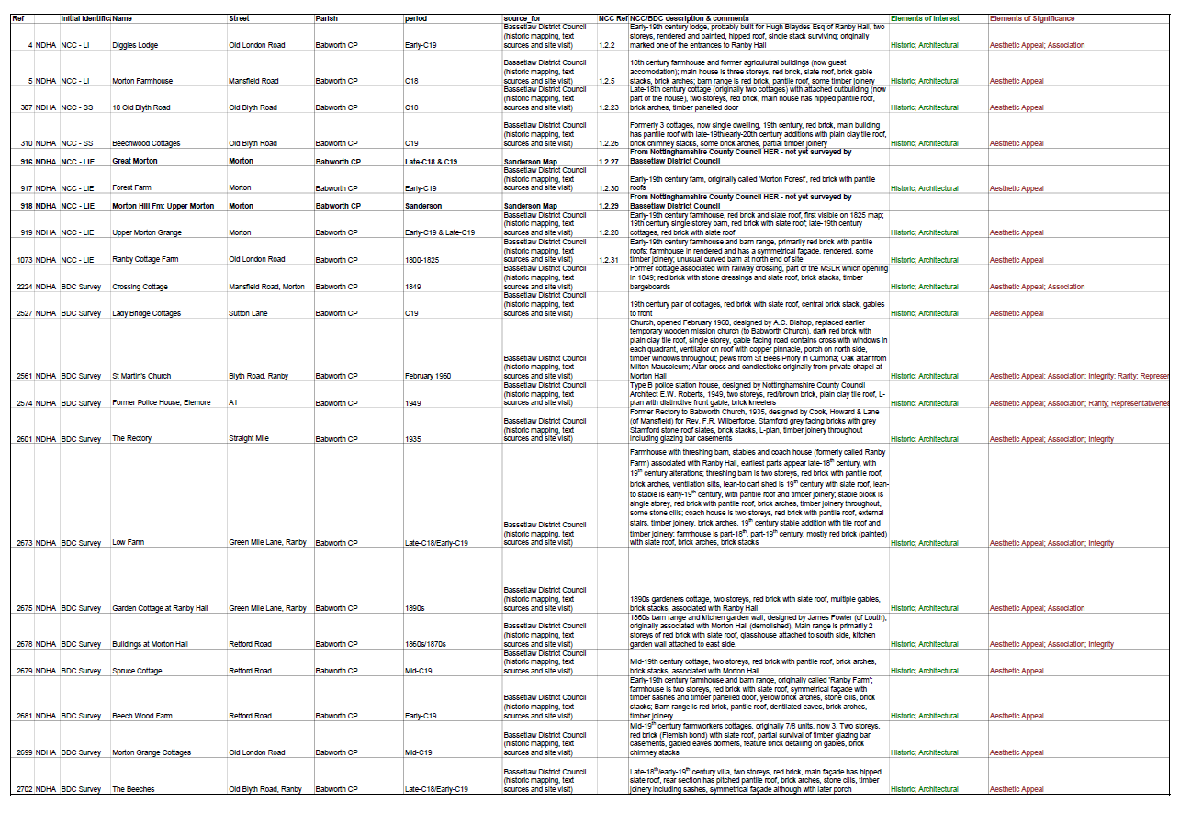

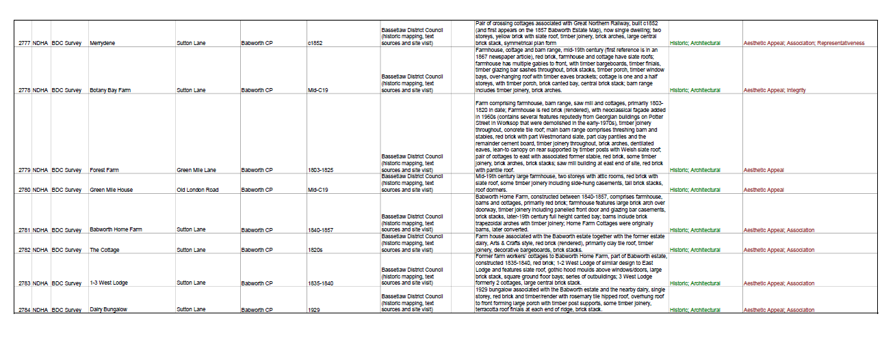

UPG39 – Morton Hall.pdf

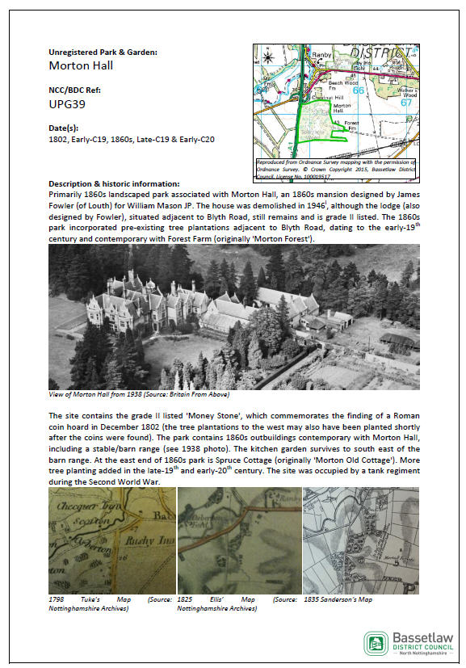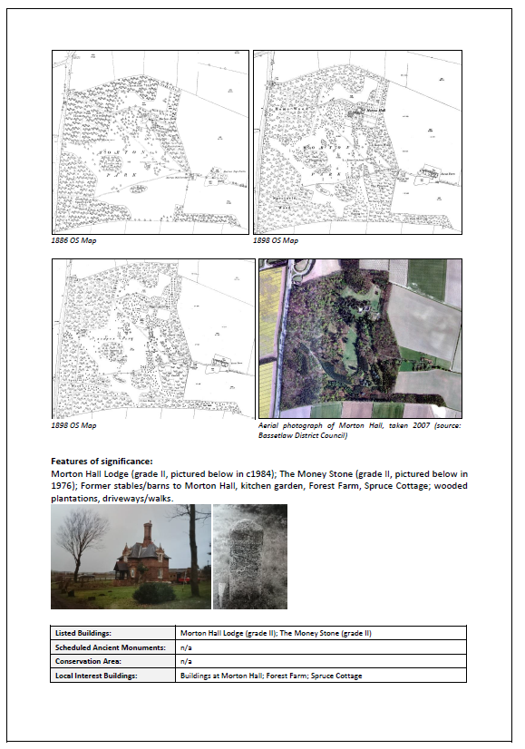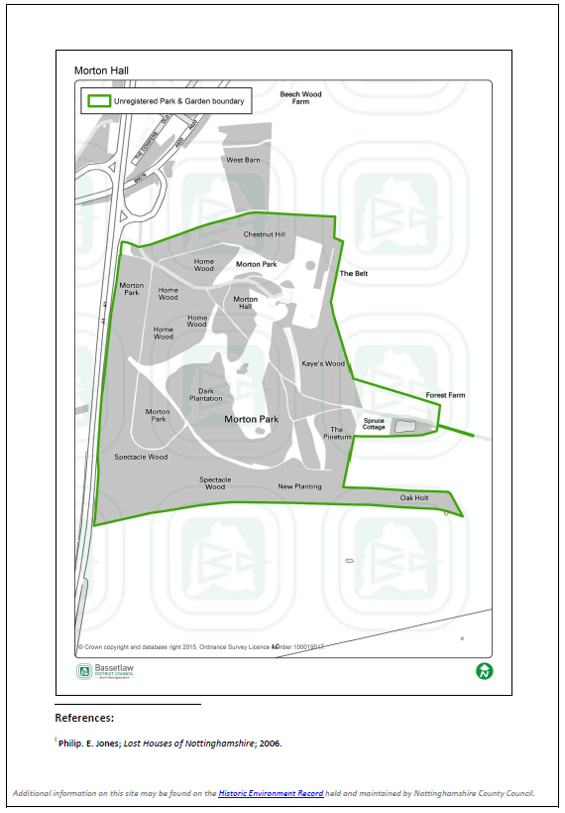 UPG44 – Ranby Hall.pdf

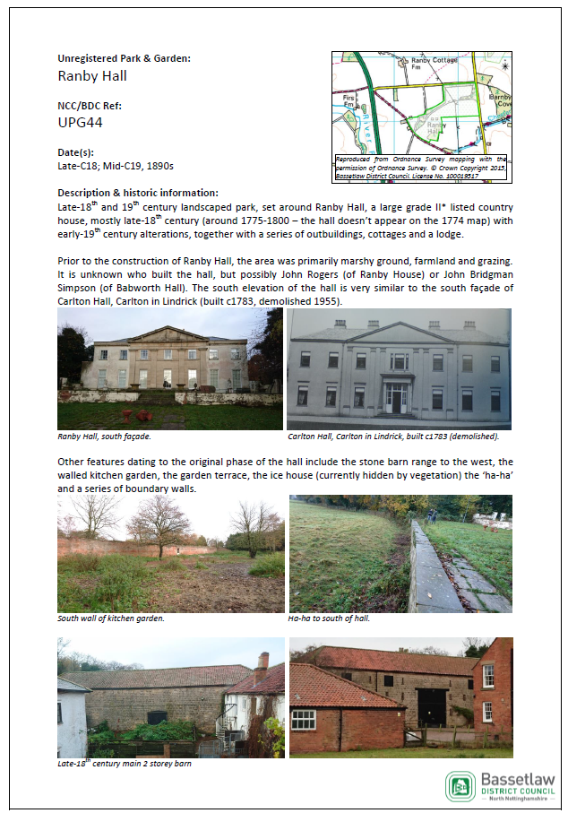 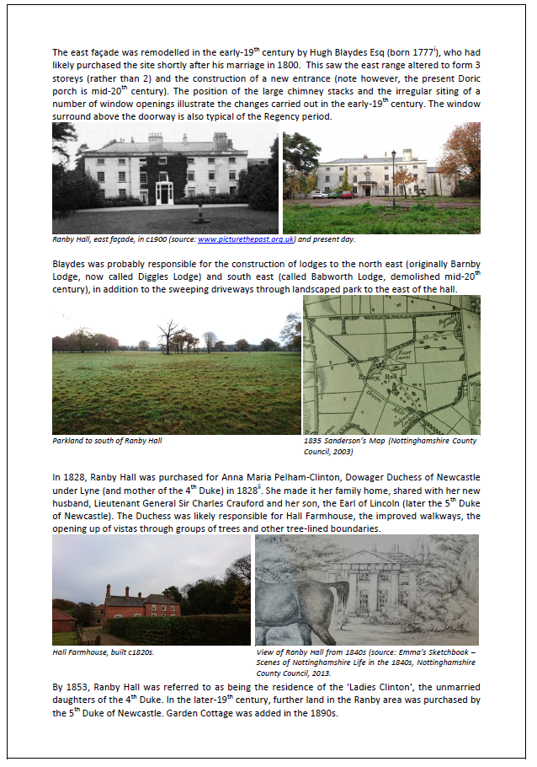

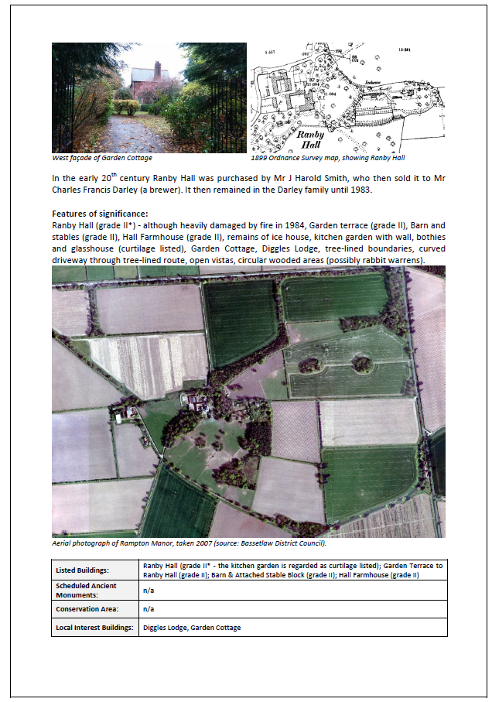 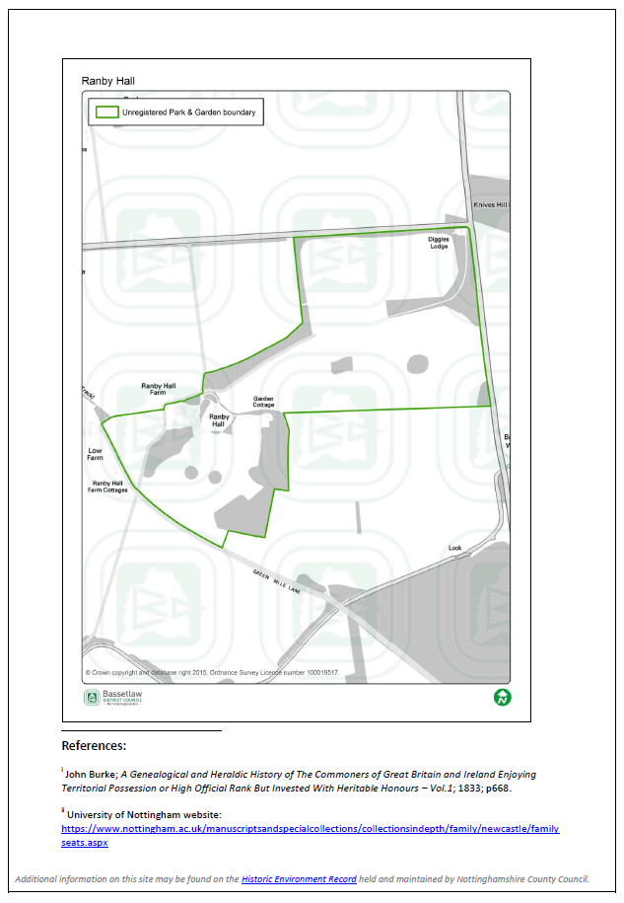

UPG45 – Ranby House.pdf

