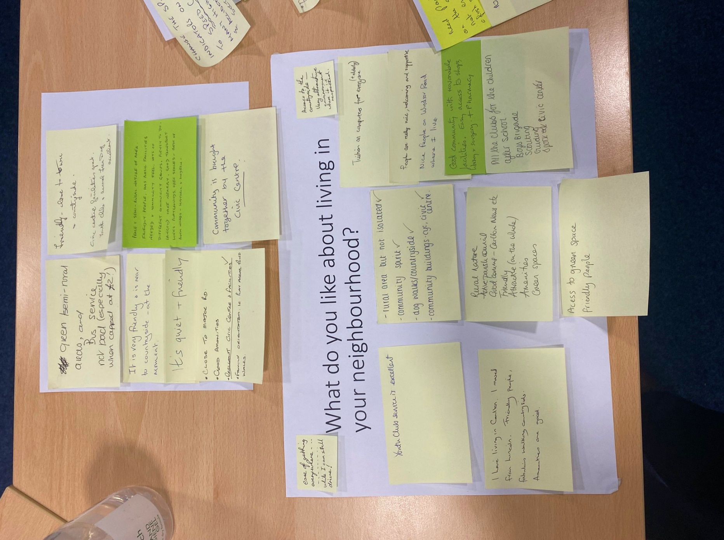

**Know your Place: Carlton in Lindrick**

Response data from community event, held at Civic Centre, Carlton in Lindrick,

28 September 2023

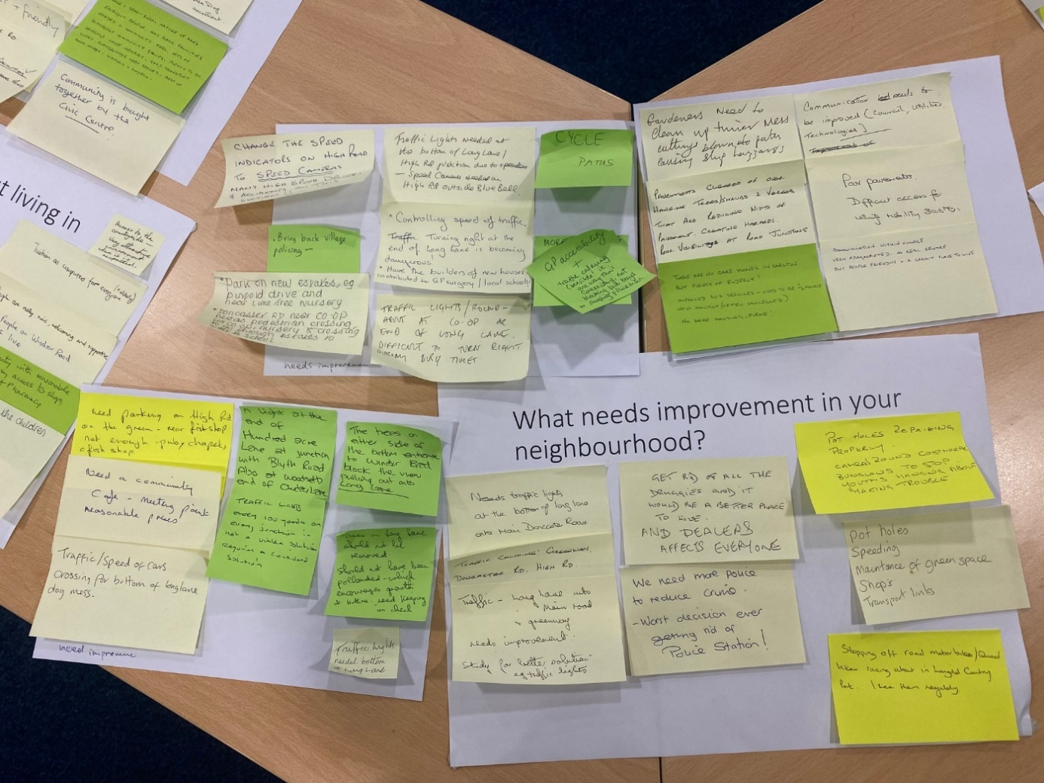

# Overview

This document details all of the comments / submission made during the community event, including post-it notes grouped under the original themes, any notes written on maps, and submissions to the Postcards from the Future exercise. Comments have not been edited, except where personal / identifying information was provided. Any words that were unclear are marked with a (?).

# What matters to you

* Inadequate infrastructure e.g. surgeries, schools, shops to support new housing development.
* Carlton remains a village and does not allow further development.
* Has infrastructure to support resent developments
* Carlton in Lindrick is a lovely village and cannot understand why there’s not a hotel, not large, would also provide jobs.
* Flood risk. We live on Low St and had 10 inches of water in our house in 2007. When the national flood alert database was set up we tried to register and were turned down on the basis that we were not in flood zone - contrary to your map.
* Crime increase, no schools, nothing for children to do as no play area. Flooding, no longer a village.
* No doctors’ appointments available ✓
* Shortage of doctors/dentist (ditto).
* Safety in the village (i.e. Children walking to school, traffic excess).
* Having a nice place to live for my children to grow up in safe.
* Remain a village – not a Worksop overspill!!
* Maintaining an atmosphere of village – drawing in the new inhabitants – enabling them to eat and spend recreational time other than the excellent pubs.
* Eradication of the awful stench of weed!
* Need more GPs and GP resources.
* Impact of population increase especially on roads and facilities. ✓✓
* What are the trees / greenery?
* Exit from Avant estate is dangerous because of bushes.
* More doctors / schools.
* Use traffic calming measures, more speed cameras, and speed bumps.

# What do you like about living in your neighbourhood?

* Green semi-rural areas, and bus service not bad (especially when capped at £2).
* It is very friendly and is near to countryside – at the moment.
* It’s quiet and friendly.
* Close to major road.
* Good amenities.
* Excellent Civic Centre and facilities. ✓
* Family orientated i.e. Play areas, Pond, Walks.
* Friendly - close to town and countryside.
* Civic Centre facilities great.
* Youth club and annual fun day excellent.
* Peace and semi-rural nature of area. Friendly people has basic facilities needed and community feel. Lots of different community groups, plenty to do. Langold Lake nearby. Good transport links. Playgrounds, open spaces - best of both worlds – historic and modern.
* Community is brought together by the Civic Centre.
* Ease of getting everywhere - while I can still drive!
* Youth club service is excellent.
* I love living in Carlton. I moved from Lincoln. Friendly people, fabulous walking countryside, amenities are good.
* Rural area but not isolated. ✓
* Community sprit.✓
* Dog walks/countryside.✓
* Community buildings - Civic Centre.✓
* Rural nature.
* Active Parish Council.
* Good comms – Carlton News etc.
* Friendly.
* Attractive (on the whole).
* Amenities.
* Green spaces.
* Access to green space.
* Friendly people.
* Access to the countryside – very attractive environment where it is respected.
* Tuition on computers for everyone (+ elderly).
* People are really nice, welcoming and supportive.
* Nice people on Winsor Road where I live.
* Good community with reasonable facilities. Easy access to shops, library, surgery and pharmacy.
* All the clubs for the children after school - boys brigade, scouting, guiding, sports at Civic Centre.

# What needs improvement in your neighbourhood?

* Change the speed indicators on High Road to SPEED CAMERAS. Many high speed drivers and accidents on this section!!
* Bring back village policing. ✓
* Park on new estates, e.g. Pinfold Drive and near Lime Tree Nursery.
* Doncaster Road near Co-Op needs pedestrian crossing for Co-Op, nursery, crossing to go through estates to walk to school.
* Traffic Lights needed at the bottom of Long Lane / High Road junction due to speeding – speed camera needed on High Road outside Blue Bell.
* Controlling speed of traffic. Turning right at the end of Long Lane is becoming dangerous!
* Have the builders of new houses combined to GP surgery/local schools?
* Traffic lights / roundabout at Co-op or end of Long Lane. Difficult to turn right during busy times.
* Cycle paths.
* More policing.
* GP accessibility and traffic calming (sensible!! i.e. one way through Greenway, not blocking bus bays of sleeping policeman.
* Gardeners need to clean up their mess - cuttings blown onto paths causing slip hazards.
* Pavement cleared of overhanging trees/shrubs & verges that are reducing width of pavement creating hazards.
* Poor visibility at road junctions.
* There are no care homes in Carlton but plenty of elderly!
* Improved bus services – used to be ½ hourly now hourly (often cancelled).
* No more housing, please!
* Communication need to be improved (Council, utilities / technologies).
* Poor pavements. Difficult access for using mobility scooters.
* Communication within village, very fragmented - no real centre, but people friendly and a great place to live.
* Need parking on High Road on the green – near fish shop not enough – pub, chapel, fish shop.
* Need a community café –meeting point - reasonable prices.
* Traffic / speed of cars.
* Crossing for bottom of Long Lane.
* Dog mess.
* A light at the end of Hundred Acre Lane at junction with Blyth Road, also at Woodsetts ends end of Owday Lane.
* Traffic lights every 100 yards on every junction – not a viable solution, requires a considered solution.
* The trees on either side of the bottom entrance to Windsor Road block the view pulling out onto Long Lane.
* Trees on Long Lane should not be removed. Should not have been pollarded – which encourages growth at bottom - need keeping in check.
* Traffic lights needed bottom of Long Lane.
* Needs traffic lights at the bottom of Long lane onto main Doncaster Road.
* Traffic calming! Greenway, Doncaster Road, High Road.
* Traffic – Long Lane onto Main Road and Greenway – needs improvement. Study for better solution, e.g. traffic lights.
* Get rid of all the druggies and it would be a better place to live – and dealers affect everyone.
* We need more police to reduce crime – worst decision ever getting rid of police station.
* Pot holes repairing properly.
* Cameras around Costhorpe bungalows to stop youths hanging about making trouble.
* Pot holes.
* Speeding.
* Maintenance of green space.
* Shops.
* Transport links.
* Stopping off road motor bikes/quad bikes racing about in Langold Country Park - I see them regularly.

# Anything else

* Do not build additional housing inc Peaks proposal!
* People need doctors, dentists.
* Buses! Not everyone drives. Consider a bus to Dinnington which has more available than Worksop.
* No more planning permission for housing unless for first time buyers.
* No building on green land.
* Trees to be trimmed in the woods at the rear of Windsor Road please – to improve the light.
* Apparently the Hawfinch Estate is having a lot of trouble with drains and sewage issues.
* What is master plan for Wimpey estate?
* Retrospective planning permission put in, but businesses still allowed to function with no planning permission granted (Howard’s Farm).
* Doctors/surgery and schools - can’t put children to schools.
* Not enough shoping facilities to provide competition with the Co-op.
* ASB needs addressing every year.
* Car parking at front of houses – no soakaway for flood water.
* What about the Peaks Hill development and the through road from Blyth Road to Carlton Road that has been given the go ahead – how will that affect Carlton and the traffic through the village as well as flooding risk on Carlton Road. How close to Carlton are the new houses on the site going to come, especially as in the original plan some of the houses were are the Carlton border.
* Lack of facilities. One Co-op (Onestop has ceased to sell meats and majority of veg!)
* Better communication. Many people cannot access internet or are confident enough to use.
* Flyers apparently distributed - not to Wimpys!
* Please can we have cycle lanes / paths also?
* People living in Costhorpe did not get a flyer about this and so were not aware unless happened to see notice on lamppost.
* Not enough shops for OAPs to go to. Co-op too far them to walk - most are not on internet.
* No building on green field, use brown field.
* A60 is becoming a minor road because of all the islands in the middle. With all the new housing, the road is going to be saturated. Cyclists can do 20mph - It is very difficult and dangerous to overtake then because of the islands in the middle of the road.
* What is the plan for the former James Hince site?
* Please do not make this process online only. Many older people in the village do not have internet or online knowledge but very much want to know what is happening regarding their village.
* Stick to original rules of no more housing in our beautiful village as it’s destroying beautiful countryside all for greed. Effects – flooding, wildlife, doctors, dentist, libraries. ✓✓✓
* National initiative – farm land protected – as larger populations require food – consider land set aside – matching growth of housing.

# Service/Local facilities

* Few more shops for the size of village, and designed “shop fronts”.
* Better accessibility to GP, esp. for older/infirm residents.
* Need more GP resources.
* The post office on High Road is listed in the (Neighbourhood) Plan as a resource but it is a terrible state of repair and has been for many years. It is very useful to have a P.O here but it needs to be better cared for and safer.
* Need dentist plus doctors. The present coop supermarket is too small & I believe it has capacity to be bigger – more houses, more people.
* The village need to remain a village not turn into a small town.
* Coop supermarket is very expensive, an Aldi / or Lidl local store would be better for all.
* A butchers / fruit & vegetable shop instead a beauty shops.
* More allotments needed at moment – 10+ years waiting list.
* Dentist for village.
* Needs a supermarket and petrol station. Over-reliance on Co-op which are expensive.
* No doctors, no police or visible police, no dentists, schools not huge enough to cover new housing.
* A bigger supermarket would be useful.
* Another school would also be useful.
* Another school would also be useful.
* Buses to Doncaster and Worksop could be improved.
* More frequent buses.
* Much bigger population now – services e.g. GPs, Schools, etc. not coping.
* Local dentist required. Hear, Hear!
* Move reliable bus service ✓✓
* No petrol station in village.
* No retirement home/old people’s home.
* It would be good to see small retail business encouraged in the village - we have sufficient fast food outlets and hairdressers.
* Comp School. Need more places or need a comp this side of Worksop or edge of Carlton.
* New people into the village unable to get their children in the local schools.
* More litter bins ✓.
* More provision for older residents - doctors, dentist etc.
* Services not sufficient for size of population.
* No dentists/doctors/schools.
* No enjoyment such as Christmas lights as no money to spend. Spent it all on other things that have little purpose.
* All the notes are good suggestions, but do you wish to live in a town or a village? It would be easy to over develop the village!
* Review public services to meet demands following recent developments.
* More needs to be made of Carlton Pond. It should be maintained better ✓✓✓
* A good fruit and vegetable shop.
* Dentist required✓✓

# Environment

* Music playing and dogs barking (at a specific address).
* Dogs howling all hours of the day.
* Anti-social behaviours.
* The path going down the side of Carlton Park Estate needs attention: rubbish, especially when the shrubs have been cut down at the Civic Centre car park.
* No infrastructure, flooding wildlife, crime increase.
* Humans using behind bushes on Carlton Park at back of Civic Centre for toilets.
* People lighting bonfire before 6 pm.
* Anti-social behaviour and loutishness a problem, as is littering - should be fined!
* General problem with litter and anti-social behaviour.
* Dogs should be on leads.
* Buses taken off due to rocks being thrown.
* Bus taken off route meaning only one bus per hour on Long lane – needs returning.
* Having house owners cut their trees/shrubs that overhang or grow on the pavement.
* No parking on pavement! Cannot access with mobility scooters or prams.
* Dogs to be on leads at all times instead of dogs running everywhere.
* Lots of lovely green spaces.
* Good service from new landscapers. Poor service from District landscaping.
* New grass cutting service is nearly poor compared to other firm that used to do it before.
* Put more bins.
* Dogs to be kept off Spider Park!
* Dogs to be kept on leads, especially on High Road.
* Ban drones!
* They are police drones – used to tackle the anti-social activities?!
* Langold Country Park – part is in Carlton – need improvements / facilities off the A60 entrance. Toilets please, and more parking.
* Planning enforcement seems very slow to respond to obvious breaches.
* There is also a tree preservation order on Stirling Drive (not shown on map).

# Transport/Highway

* One way traffic system – Greenway area.
* Please can we have some cycle paths – but not by narrowing existing roads (less people are riding bikes?).
* Bus service needs improvement.
* Speeding on main road needs some action (and Long Lane). ✓
* Some dangerous junctions on Main Road (with and around Rotherham Baulk) and with Long Lane.
* Before bus deregulation, Carlton had five buses per hour to Worksop – now it is two. These two both run from Doncaster (take different routes) and are prone to delays. Services starting in Langold and / or Carton would be good. After the next round of ‘economies’ we may be left with no services!
* Would like to see on extension of footpath from new cemetery down Hundred Acre Lane to junction with Wigthorpe Road. This would facilitate a safe, circular walk around village and to bench provided.
* Speed cameras required at Blue Bell Carlton, URGENTLY (and Long lane at ramps).
* Traffic calming on Windsor Road to stop speeding delivery vans.
* High Road needs speed cameras.
* Traffic lights at junction of Long Lane and High Road.
* Junction of Co-op car park and opposite housing estate too close.
* Slow down traffic on estates.
* Who implemented the installation of traffic lights at the entrance to Firbeck Pit Entrance? It is not fit for purpose. The A60 from Worksop to Doncaster is a main road for buses and heavy traffic. They need to be dismantled.
* (The Firbeck traffic lights) are a good idea – they only work when needed.
* Most roads in poor state of repair – require more adequate repairs that last! ✓✓
* Road repairs are a joke.
* Effects people who actually do work and cannot get to their place of work as infrequent buses.
* Traffic onto Greenway - also leaving is single lane only – better solution is needed – also Long Lane onto Main Road gets very congested especially at school times and peak times.
* Frequent and more varied bus service would be good – perhaps even within village area.
* Traffic light and crossing bottom of Long Lane.
* Speed camera on Main Road (and Long Lane!!)
* Pot holes.
* Speed cameras.
* We live on the estate opposite the Co-Op. If we have to turn right to Langold it is very dangerous – the hedge needs really cutting back. We currently turn left and turn around to go to Langold to avoid any accidents.
* Need to watch increased traffic using Old Carlton – needs directing to new road. “Old Carlton only” type sign like at Beighton?
* Urgently potholes dealing with ✓✓
* Bucket full of cooling tarmac – does not fix the surface. Too true – it’s now the “STANDARD” The base needs repairing.
* The pothole fixing on Owday Lane will become dangerous in winter especially on the sharp bend.
* Congestion outside Ramsden School is a hazard. Appreciate difficulty, but church has offered use of car park at busy times (by the Parish Centre) – not too far – but rarely used. Possibly issue of insurance if the car park is used.
* The road surfaces are very poor in village - needs potholes/grates repairing.
* Unreliable bus service – never know if it will arrive. Morning – bus on Long Lane 7.40 am – next bus – 8.50. Anyone going to work for 9 am either very early or late. 9.50 service often single decker – usually busy because first bus for bus passes.
* Too far to walk to High Road for a bus if elderly or disabled.
* Need a safe cycling route into Worksop - A60 is busy. ✓
* Infrequent bus services (to Worksop).
* Infrequent bus to anywhere. ✓
* Bus services – people not using bus pass and driving instead. Some people can’t drive and need the buses.
* Bus service quite poor. Can’t rely on the bus to get you to the (hourly) train service.

# Housing

* What is happening to the field opposite the Co-op to the left of Avant estate. I have heard Avant have left an opening on the plans to build more - is the correct? just a matter of time!!
* No infrastructure.
* Are there plans for Carlton to be part of a conurbation from Worksop to Oldcotes?
* James Hince Court – site needs to be used more effectively – maybe a public green space? – agree, walking place for dogs. ✓✓
* James Hince Court needs to be used, Bungalows for elderly-only.
* (James Hince Court site) would make a lovely park.
* If you build bungalows, you have to have access to shops. ✓
* Need to build more bungalows and social housing. ✓
* No more new private houses.
* Too many druggies.
* Motorbikes riding on pavements.
* More bungalows to be built.
* No flats for druggies – got enough.
* Houses opposite Co-op are very ugly and just thrown up and look a mess - just look like been dumped anywhere. No proper roads.
* No more please - too many already.
* Too much housing surrounding gone on ground Carlton it is ceasing to be a village.
* Build less houses – stop taking agricultural land. Currently council is economically refuse.
* No more housing as no infrastructure. ✓✓✓
* No doctors/dentists/schools. ✓✓✓
* Risk of flooding. ✓✓✓
* Effects wildlife – no space. ✓✓✓
* Increase in crime. ✓✓✓
* Loosing our beautiful village. ✓✓✓
* Bungalows – more bungalows needed in Carlton in Lindrick.
* No more houses, not enough facilities to accommodate them i.e. surgery, dentist, schools.
* Needs more bungalows for those wanting to downsize.
* Council stock needs upgrading.
* Build more bungalows in the new proposed development. Appreciate they take up more land space but they are needed.
* No more (houses) - Carlton has enough for it’s size.

# Infrastructure

* Better bus service. Bus stops to be nearer OAP bungalows as too far for some OAP to walk from factories up to Rotherham Baulk bus stop.
* Secondary school for Carlton, Langold and surrounding villages.
* Lager GP practice is serve increasing population. ✓✓✓
* Cheaper food store in the village.
* NHS dentist - having to travel to Dinnington!
* Better bus service to cover village.
* New housing too far away from buses.
* Secondary school needed this side of Worksop. Valley and Portland oversubscribed for years.
* Chemist, surgery and schools all on overload. ✓✓
* Not enough infrastructure to support current housing being built.
* Infrastructure needs to be more robust and be suitable for the whole community.
* New secondary school needed.
* GP services are very poor and not up to standard, seem a waste of time cannot even get appointment.
* Too much pressure from existing housing, only getting worse with more properties (traffic, schools, GPs).
* Too many new houses, not enough amenities services – doctors, dentist etc.
* Lack of services i.e. dentist, schools etc. Insufficient to support new builds.
* Given that new housing developers are being built all the time, infrastructure needed - supermarket, dentist, shops.
* Not good enough for the expansion of housing. We need better GP services / dentist / more school places.
* Roads and paths need repairs to stop falls and trips.

# Location-specific (from map): Green(G) = Good, Red(R) = Bad.

* Route between Wigthorpe, Crossley Hill Lane / Carlton Forest: Rat run to A1 quickly developing.
* Windsor Road (west end): road construction – when is it going to finish?
* Doncaster Road and Greenway: Speeding. Make people aware to drive appropriate.
* Watercourse to the south / rear of Low Street and Water Lane: Flood risk (R), View (G)
* A60, near Ramsden Primary School: Good chip shop (G)
* James Hince Court: Disused land, needs building (?) – bungalows or maisonettes for over 50s.
* Long Lane: The drainage needs improving – cannot handle heavy rainfall!! (R)
* Long Lane: Apparently the 20MPH signs in Long Lane are only “ADVISORY” and cannot be enforced (Even through the school is nearby!!!) (R)
* Long Lane: Remove the ramps in Long Lane (They only encourage drivers to put their foot down!!) (R).
* Long Lane: The path running down the estate needs cleaning and weeding regular (R)
* Junction of Long Lane and Doncaster Road: Dangerous junction (R)
* A60, between Rotherham Baulk and Pinfold Drive: Needs a crossing to cross the road safely to Co-op nursery, family housing estates (R)
* A60 near Co-op: Busy dangerous junction and dangerous to cross roads (R)

# Postcards from the Future (Greetings from Carlton 2038)

Transcriptions included below:

* 2038: Things have improved in Carlton in Lindrick – The Hotel Lindrick is a success and our Aldi superstore is also a great boost for the community. Bus links have improved.
* Who would have ever thought a graveyard would be a good thing to write about? The inspired addition of our own crematorium has reduced travelling times for many mourners as space has become more of a premium and cremation increased in popularity. Great work on the holiday homes at Langold Lake – under-utilised for far too long. Great to see it restored to some of its former glory. And what a café – award winning food, no less!

**Neighbourhood Planning**

Bassetlaw District Council

October 2023

Email: [neighbourhoodplanning@bassetlaw.gov.uk](mailto:neighbourhoodplanning@bassetlaw.gov.uk)

Tel: 01909 533 495