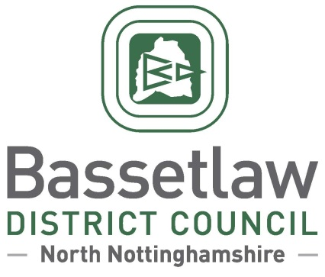

|  |  |
| --- | --- |
| Mr Ed Knox  Clerk to Clayworth Parish Council  VIA EMAIL | Please ask for: Craig Taylor  Direct Dialling: (01909) 533 533  Email: craig.taylor@bassetlaw.gov.uk  26 July 2024 |

Dear Mr Knox,

On 17 May 2024, Bassetlaw District Council received a formal application from Clayworth Parish Council to designate the entire parish area, as per the accompanying map, for the purposes of producing a neighbourhood plan.

A report on the proposals was considered by the District Council on 25 July 2024. It was agreed at the meeting that Clayworth should be designated as a neighbourhood planning area with immediate effect, with the Parish Council acting as the qualifying body. The District Council’s Neighbourhood Planning Team will be in touch shortly to discuss next steps, and to offer their support to the Parish Council in progressing the development of a neighbourhood plan.

Yours Sincerely,

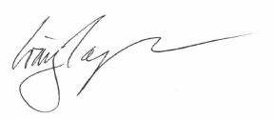

**Craig Taylor**

Director of Regeneration and Neighbourhoods