

**Strategic Environmental Assessment & Habitat Regulations Assessment Screening Statement**

**(Consultation Draft)**

East Drayton Neighbourhood Plan

1 August 2025

# Table of Contents

Table of Contents 1

1 Introduction 2

Strategic Environmental Assessment (SEA) 2

Habitat Regulations Assessment 3

Summary of Findings 3

2 The East Drayton Neighbourhood Plan 4

Plan Overview 4

Vision 4

Community Objectives 4

Development Management Policies 5

3 SEA Screening – Assessment 6

SEA Assessment 6

4 HRA Screening – Assessment 11

HRA Screening Matrix 13

5 In-combination Effects 20

6 Conclusions 21

SEA Screening 21

HRA Screening 21

Consultation 21

Appendix 1: Consultation Responses 22

Appendix 2: Ecological attributes of the European sites 23

# Introduction

* + - * 1. This document contains the Screening Statements for the East Drayton Neighbourhood Plan - (the Plan) - with regard to whether a Strategic Environmental Assessment (SEA) and / or Habitat Regulations Assessment (HRA) are required to be undertaken.
        2. Regulation 15 of the 2012 Neighbourhood Planning (General) Regulations sets out the information that must accompany a Neighbourhood Plan when submitted to the local planning authority. In February 2015 amendments to the Neighbourhood Plan Regulations came into force; this is known as the Neighbourhood Planning (General) (Amendment) Regulations 2015. Regulation 2(4) of these amendments adds additions to the list of documents that a qualifying body must submit to a local planning authority with a Neighbourhood Plan. The additional document which must be submitted is either an environmental report prepared in accordance with the relevant regulations or, if the outcome concludes that an SEA or HRA is not necessary, a statement that sets out how environmental issues have been taken into account and considered during the preparation of the Neighbourhood Plan.
        3. The National Planning Policy Framework (paragraphs 32 to 34) advises that Local Plan and spatial development strategies should be informed throughout their preparation by a sustainability appraisal that meets the relevant legal requirements. Neighbourhood plans may require Strategic Environmental Assessment, but only where there are potentially significant environmental effects. It is also generally understood that assessments should be proportionate and not repeat policy assessment that has already taken place. The Neighbourhood Plan has been prepared in accordance with the [Bassetlaw Local Plan](https://www.bassetlaw.gov.uk/planning-and-building-control/planning-policy/bassetlaw-local-plan-2020-2038/), adopted in 2024, hence this assessment draws upon and should be read in conjunction with the associated higher-level assessments.
        4. As the responsible authority under relevant regulations, Bassetlaw District Council has undertaken the Screening Assessment contained in this document, working with information provided by the East Drayton Neighbourhood Plan Steering Group and their appointed consultant, Planning with People.

### Strategic Environmental Assessment (SEA)

* + - * 1. The requirement for a SEA to be undertaken on development plans and programmes that may have a significant environmental effect is outlined in European Union Directive 200142 / EC. The Environmental Assessment of Plans and Programmes Regulations 2004 (the 2004 Regulations) state that this is determined by a screening process, utilising a specified set of criteria, outlined in Schedule 1 of the Regulations. The results of this process must be set-out in an SEA Screening Statement, which must be publicly available.
        2. The objective of undertaking a SEA is “to provide for a high level of protection of the environment and to contribute to the integration of environmental considerations into the preparation and adoption of plans and programmes with a view to promoting sustainable development, by ensuring that, in accordance with this Directive, an environmental assessment is carried out of certain plans and programmes which are likely to have significant effects on the environment.”[1]

### Habitat Regulations Assessment

* + - * 1. European protected sites (the ‘Natura 2000 Network’) are of exceptional importance for the conservation of important species and natural habitats within the European Union. The network of European protected sites comprises Special Protection Areas (SPAs) designated under the Birds Directive (79/409/EEC), Special Areas of Conservation (SACs) designated under the Habitats Directive (92/43/EEC) and Ramsar sites designated under the Ramsar Convention 1975. Government guidance advises that potential SPAs (pSPA), candidate SACs (cSAC) and potential Ramsar (pRamsar) sites are also included in HRA’s.
        2. As a land use plan, an assessment of the East Drayton Neighbourhood Plan may be required under the Conservation of Habitats and Species (Amendment) Regulations 2012 (the Habitat Regulations) and Article 6(3) of the EU Habitats Directivein order to determine whether the Plan may result in significant effects on identified sites.
        3. As with the SEA, a screening process is employed to establish whether any elements of the Draft Plan could have a significant effect on these sites. Regulation 32 of the Neighbourhood Planning (General) Regulations 2012 (as amended) further reemphasises the importance of carrying out this assessment by stating that one of the basic conditions that must be met before the Plan may be ‘made’ is that “*the making of the neighbourhood plan is not likely to have a significant effect on a European site (as defined in the Conservation of Habitats and Species Regulations 2012) or a European offshore marine site (as defined in the Offshore Marine Conservation (Natural Habitats, &c.) Regulations 2007 (either alone or in combination with other plans or projects*)”[2].

### Summary of Findings

* + - * 1. Following the undertaking of the Screening Assessments, it is concluded that the Plan, in its current form, **will not have any significant negative effects on the environment or any identified European sites**. It is considered, therefore, that **a full environmental assessment and habitat regulations assessment is not required.**
        2. This determination has been reached by assessing the contents of the [Pre-Submission Draft of the Neighbourhood Plan](https://www.bassetlaw.gov.uk/media/gxyjczty/east-drayton-pre-submission-draft-neighbourhood-plan.pdf), issued for public and stakeholder consultation in May 2025. The Plan has been assessed against criteria provided in Schedule 1 of the 2004 Regulations and with regard to Regulation 32 of the 2015 Neighbourhood Planning Regulations & the Habitat Regulations. The conclusions are detailed in full in Section 6 (p21) of this report.

# The East Drayton Neighbourhood Plan

* + - * 1. The development of the East Drayton Neighbourhood Plan is being progressed by the East Drayton Neighbourhood Plan Steering Group, a sub-group of East Drayton Parish Council, the Qualifying Body for the East Drayton Neighbourhood Area in Bassetlaw District, Nottinghamshire. The Neighbourhood Area, depicted in Figure 1 below, covers the whole of East Drayton Civil Parish. The Plan has been devised to cover the period to 2038.

**Figure 1: Designated Neighbourhood Area**

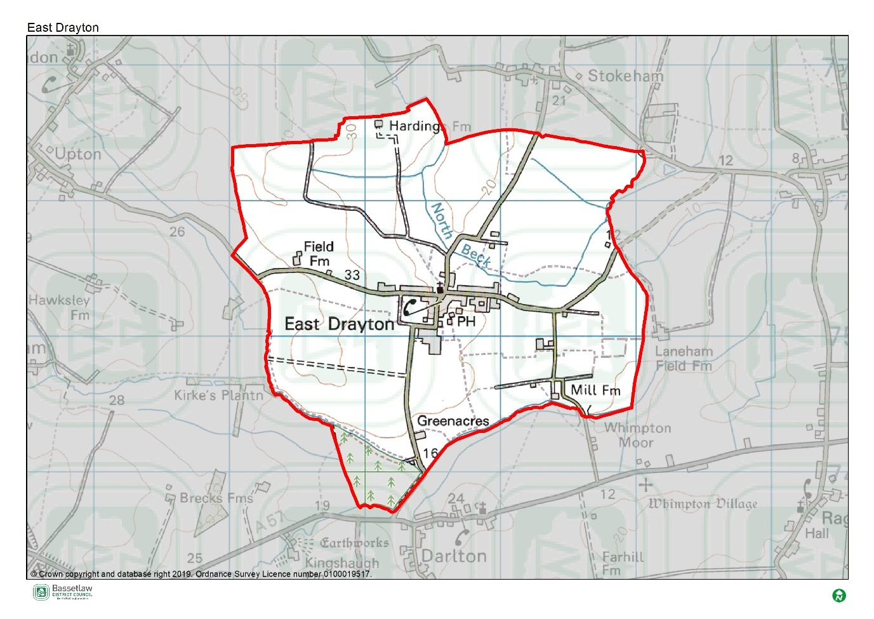

### Plan Overview

* + - * 1. As detailed below, the priorities of the Plan are captured in the Vision and Community Objectives (see pages 10 and 11 of the Plan), to be delivered through the application of 11 development management policies specific to the Neighbourhood Area.

### Vision

* + - * 1. The vision for East Drayton Parish is stated as follows:

*East Drayton will remain an inclusive rural Parish, with a visually coherent appearance*

*reflecting its agricultural past, with indoor and outdoor spaces and access to the countryside*

*that ensures its residents can thrive.*

### Community Objectives

* + - * 1. This vision is underpinned by seven objectives, intended to help deliver the vision:
* To seek opportunities to maintain and enhance the social and economic vitality of the village including protecting and enhancing existing services and facilities.
* To maintain the historic character of the built environment so that new development integrates with the existing built form to preserve its rural character.
* To ensure development is of a scale that is proportionate to the Parish’s limited facilities and infrastructure and does not exacerbate the drainage and flood risk in the Parish.
* To protect and enhance the Parish landscape, its green spaces and surrounding open countryside and to recognise the value of long views and vistas into and out of the village.
* To promote energy efficiency in new and existing buildings. To ensure new development minimises the use of carbon in its construction and operation.
* Where infill housing is provided, it should be varied in size to meet local needs.
* To ensure development is designed to a high quality that respects the materials, style and layout of its surroundings to protect and reinforce the positive character of the Parish.
* To ensure development does not increase surface water flooding and to encourage design solutions that incorporate sustainable drainage systems that have multi benefits like increasing the biodiversity of the area.

### Development Management Policies

* + - * 1. The 11 development management policies included in the Neighbourhood Plan are summarised in the following table.

| Policy | Summary |
| --- | --- |
| Policy 1: Sustainable Development, Infill and the Development Boundary | An overarching policy that identifies the development boundary, and the expectations of development that can take place within it, and the limitations on development external to it. |
| Policy 2: Protecting the Landscape Character | Requires that new developments respect the identified areas of landscape sensitivity, key views, mature street trees and hedges, and the public right of way network. |
| Policy 3: Protecting and Enhancing Biodiversity | Requires that development proposals, where relevant, seek to deliver biodiversity net gain of at least 10%, and respect the habitat connectivity provided by identified wildlife corridors across the Plan area. Also encourages the inclusion of SUDs within developments, and careful management of trees. |
| Policy 4: Designation of Local Green Spaces | Identifies 5 local green spaces (LGS) for designation, in accordance with the regulations. |
| Policy 5: Reducing the Risk of Flooding | Requires a sequential approach to flood risk management and supports flood management and surface water management schemes. |
| Policy 6: Achieving Well Designed Places | Seeks to maintain and enhance the character and distinctiveness of the Neighbourhood Area, through reference to the accompanying East Drayton Design Guide 2024. |
| Policy 7: Housing Mix | Translates the findings of the Housing Need Assessment into policy, including stipulations on the mix of sizes and types, and consideration of accessible design. |
| Policy 8: Protecting and Enhancing Heritage Assets | Requires consideration of the impact of new development on identified features of historical significance. |
| Policy 9: Supporting the Local Economy | Provides support to development associated with business uses, subject to certain criteria, and in accordance with District-level policies. |
| Policy 10: Protecting Facilities for the Community | Identifies and seeks to protect or enhance community facilities within the Plan area. |
| Policy 11: Renewable Energy, Energy Efficiency and Low Carbon Technologies | Encourages the incorporation of sustainable design features and energy efficiency measures as part of new developments. |

# SEA Screening – Assessment

* + - * 1. The table below includes the assessment of the East Drayton Neighbourhood Plan, including its Objectives and Development Management Policies, against the criteria included in Schedule 1 of the 2004 Regulations. The Neighbourhood Plan is being assessed as a whole against the criteria listed below to allow for the consideration of its effects on the environment.

### SEA Assessment

| Criteria for determining the likely significance of effects (Annex II SEA Directive) | Significant effect likely? | Comment |
| --- | --- | --- |
| 1a The degree to which the plan or programme sets a framework for projects and other activities, either with regard to the location, nature, size and operating conditions or by allocating resources. | NO | The East Drayton Neighbourhood Plan (the Plan) sets-out a spatial vision for the designated Neighbourhood Area and an accompanying framework to guide development proposals. This framework will be delivered by the development management policies contained within the Plan. The framework will have some impacts on the environment, noticeably the support for development proposals. However, it is deemed that these impacts will not be significant, due to their small-scale, localised nature, and the stipulations detailed in the policies. |
| 1b The degree to which the plan or programme influences other plans and programmes including those in a hierarchy. | NO | The Plan will respond to rather than influence other plans and programmes. It is part of a hierarchy, but is at the lowest tier, sitting below the Bassetlaw Local Plan (District level) and National Planning Policy Framework (National level), and has thus been influenced by these higher-tier and pre-existing plans, rather than having an influence on them.  The policies within a neighbourhood plan apply only within the designated neighbourhood area, hence the Plan will not have a direct impact on adjoining areas. |
| 1c The relevance of the plan or programme for the integration of environmental considerations in particular with a view to promoting sustainable development. | NO | The Plan promotes sustainable development within the Neighbourhood Area through balancing environmental, social and economic objectives. The Vision & Objectives (pages 10 - 11), in conjunction with the development management policies, work to ensure that all development proposals brought forward in the area will take this balance into account.  Specifically, the forms of development supported by policies 1, 6, 7, 9, 10, and 11 are viewed as key to ensuring the long-term sustainability of the Neighbourhood Area. This projected growth is balanced by the protection of key environmental and social / cultural assets, both through criteria in the above policies themselves, and through policies 2, 3, 4, 5, and 8.  As a result, it is considered that the Plan effectively integrates and balances potential environmental considerations, and that potential impacts are, therefore, not likely to be significant. |
| 1d Environmental problems relevant to the plan or programme. | NO | As noted above, the Plan supports development on a number of fronts, including residential development and economic development, all of which could have some effects on the environment. However, existing national and local planning policies, the specific criteria included within the policies in the Plan, and the planning application process, will collectively ensure that these effects are not significant. |
| 1e The relevance of the plan or programme for the implementation of Community legislation on the environment (for example, plans and programmes linked to waste management or water protection). | NO | The Plan is intended to be in compliance with the Bassetlaw Local Plan, which has taken into account the existing European and National legislative framework for environmental protection. The Plan will therefore have a positive effect on compliance with regards to relevant legislation and programmes. It is considered that none of the proposals within the Plan will compromise this position. |
| 2a The probability, duration, frequency and reversibility of the effects. | NO | It is deemed highly unlikely that there will be any irreversible damaging environmental impacts associated with the Plan. The policies within the Plan seek to ensure new development is sustainable in context and promotes the enhancement and protection of environmental assets.  The intention to monitor the Plan and to review / update it when required will allow for any unforeseen significant effects to be identified and addressed (see Section 20 of the Neighbourhood Plan, *Monitoring and Review /* page 57). |
| 2b The cumulative nature of the effects. | NO | It is considered that the policies contained in the Plan, cumulatively, will have minimal negative effects on the environment and will, moreover, have moderate to significant positive effects through the stipulations included. It is considered that all effects will be at a local level. |
| 2c The transboundary nature of the effects. | NO | Effects will be local, with no expected impacts on neighbouring areas. |
| 2d The risks to human health or the environment (for example, due to accidents). | NO | No obvious risks have been identified, as the overall aim of the Plan is to ensure the careful management of development and the continued sustainability of the Plan area. |
| 2e The magnitude and spatial extent of the effects (geographical area and size of the population likely to be affected). | NO | The Plan relates to, and will have an influence over, a designated neighbourhood area of approximately 628 hectares, and includes approximately 111 dwellings, home to approximately 270 people. It is deemed that the Plan will have a positive impact on local residents through the protection and enhancement of local environmental and social / cultural assets, and the promotion of sustainable development. |
| 2f The value and vulnerability of the area likely to be affected due to:  (i) special natural characteristics or cultural heritage;  (ii) exceeded environmental quality standards or limit values; or  (iii) intensive land-use. | NO | The Plan is deemed unlikely to have an adverse effect on the natural characteristics and cultural heritage of the neighbourhood area and, moreover, is likely to enhance the protection afforded to such assets.  **Natural characteristics**  There are no SSSI within the Neighbourhood Area, but it is intersected by the outer Impact Risk Zones for two proximate SSSI, namely [Gamston and Eaton Woods and Roadside Verges](https://designatedsites.naturalengland.org.uk/SiteDetail.aspx?SiteCode=s1000737), and [Treswell Wood](https://designatedsites.naturalengland.org.uk/SiteDetail.aspx?SiteCode=s1001921). There is one Local Wildlife Site within the Neighbourhood Area, Dolegate Road, a species-rich roadside verge.  The Plan includes three policies specifically designed to protect and enhance the natural assets in the Neighbourhood Area. Policy 2 provides protection to identified areas of landscape sensitivity, key views, trees and hedges, and access to the countryside. Policy 3 requires developments to deliver biodiversity net gain, and to respect habitat connectivity across the Neighbourhood Area, whilst Policy 4 identifies four Local Green Spaces (LGS).  **Cultural heritage**  There are no World Heritage Sites, Protected Wreck Sites, Registered Battlefields, Scheduled Ancient Monuments, or Registered or Unregistered Park and Gardens in the Neighbourhood Area.  There are 7 Listed Buildings in the Neighbourhood Area, namely:   * [The Cottage](https://historicengland.org.uk/listing/the-list/list-entry/1045687) (Grade II) * [Pair of Headstones in Churchyard of Church of St Peter](https://historicengland.org.uk/listing/the-list/list-entry/1045688) (Grade II) * [Church of St Peter](https://historicengland.org.uk/listing/the-list/list-entry/1212946) (Grade I) * [The Old Harrow Inn](https://historicengland.org.uk/listing/the-list/list-entry/1212969) (Grade II) * [Field Farmhouse](https://historicengland.org.uk/listing/the-list/list-entry/1213011) (Grade II) * [Old Vicarage and Attached Outbuildings](https://historicengland.org.uk/listing/the-list/list-entry/1370122) (Grade II) * [Yew Tree Farmhouse](https://historicengland.org.uk/listing/the-list/list-entry/1370123) (Grade II)   The core of East Drayton village is covered by the East Drayton Conservation Area, designated in 1975. There is a sizeable number of Positive Buildings in a Conservation Area within this area, and two Non-Designated Heritage Assets in the wider Parish.  Neighbourhood Plan Policy 8 requires consideration of the impact of new developments on all of the above-mentioned heritage assets. The [Design Guidance and Codes](https://www.eastdrayton.org/media/Council%20Documents/Local%20Plan/East%20Drayton%20-%20FINAL%20Jan%2024.pdf), produced to support the Neighbourhood Plan, provides further information about the context of the cultural heritage of the Neighbourhood Area.  It is considered that the development supported by the Plan will not result in significant effects on the natural or cultural heritage assets. Furthermore, the Plan does not exceed environmental quality standards or limit values and does not provide specific policies in relation to intensive land uses. |
| 2g The effects on areas or landscapes which have a recognised national, community or international protection status. | NO | It is considered that the Plan will not adversely affect areas of landscape which have recognised community, national or international protection. The need for new development to respect their landscape and townscape setting is included as part of the criteria within the respective Policies. |

# HRA Screening – Assessment

* + - * 1. For the HRA screening assessment, the Designated Neighbourhood Area was assessed to identify if any Special Protection Areas (SPA), Special Areas of Conservation sites (SAC), or Ramsar sites were located within the boundary, as well as those considered as potential sites (pSPA, ppSPA, cSAC & pRamsar). The assessment also identified if any of these internationally important sites were located within a 15km radius from the Neighbourhood Plan area. The results of this exercise are detailed on the map included as Figure 4 on page 12 (overleaf). The Birklands and Bilhaugh SAC is located approximately 13 km to the south west of the border of the Neighbourhood Area. A description of the ecological attributes of the Birklands and Bilhaugh SAC is included as Appendix 2.
        2. Although not formally a pSPA, Natural England has advised that there is a possibility of a Sherwood Forest pSPA being designated in the future, on reflection of populations of breeding nightjar and woodlark. In [a note to Local Planning Authorities](http://www.mansfield.gov.uk/CHttpHandler.ashx?id=7529&p=0) dated March 2014, Natural England advocates a precautionary approach to any plans or projects which could affect such a site. This approach should ideally cover the potential direct, indirect and cumulative impacts, which may include, but may not be limited to, the following;
* disturbance to breeding birds from people, their pets and traffic;
* loss, fragmentation and/or damage to breeding and/or feeding habitat;
* bird mortality arising from domestic pets and/or predatory mammals and birds;
* bird mortality arising from road traffic and/or wind turbines.
  + - * 1. No formal assessments of the boundary of any future SPA has been made, therefore, it is not possible to definitively identify whether individual sites would fall inside or outside any possible future designated area. However, the Natural England note encloses a map which highlights the areas of greatest ornithological interest for breeding nightjar and woodlark. This has been included on Figure 4, and identifies that the ppSPA is approximately 10.7 km west of the Neighbourhood Area.
        2. The Screening Assessment on page 13 has considered the main potential sources of effects on the identified European sites arising from the Plan, possible pathways to the sites, and the effects on possible sensitive receptors. The assessment considers the direct and indirect impacts of the policies in the Plan on the identified sites.

**Figure 4:** **Map of Special Protection Areas and Special Areas of Conservation in relation to the East Drayton Neighbourhood Area**

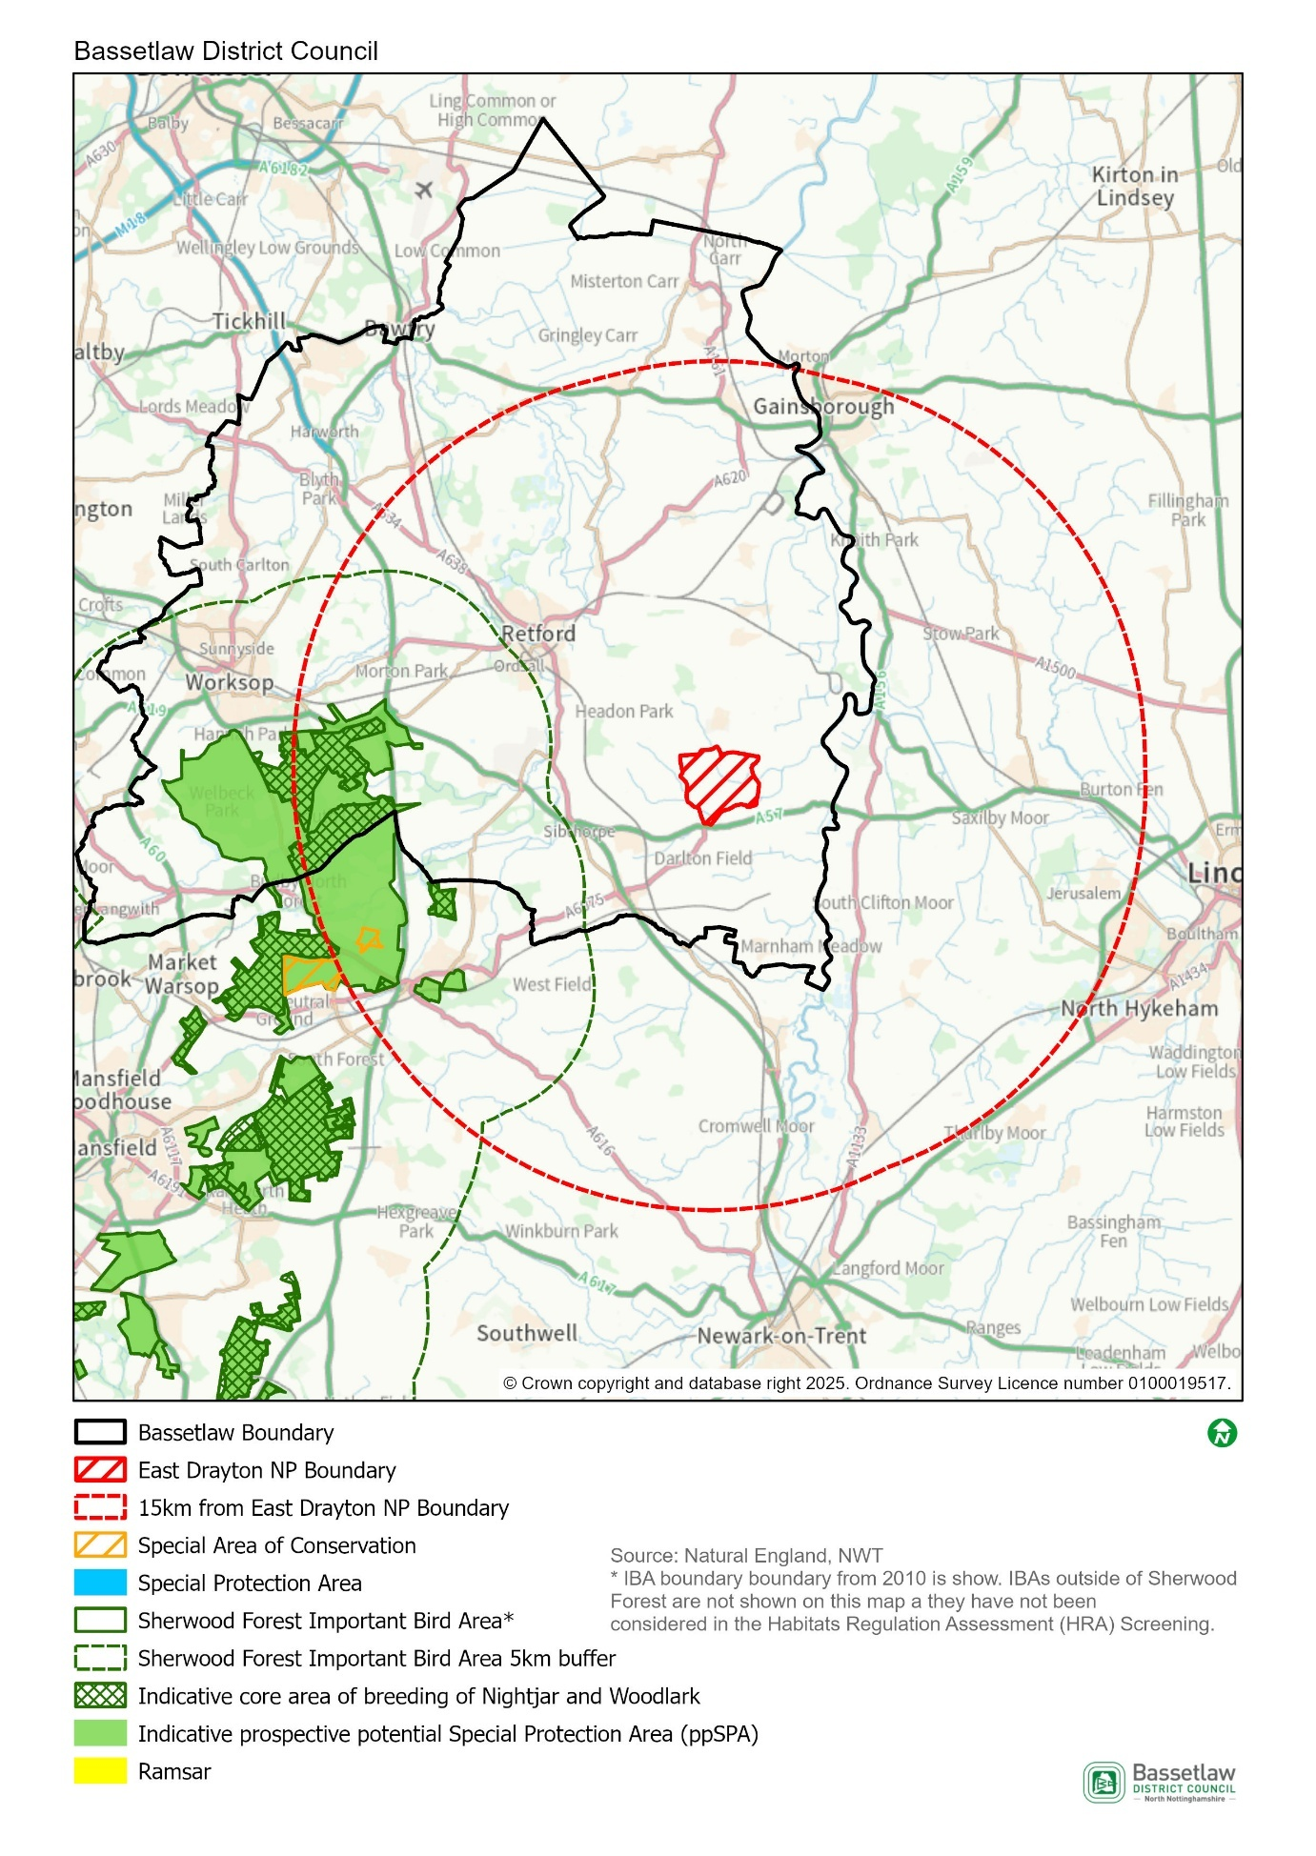

### HRA Screening Matrix

The screening matrix below shows which types of impacts on European sites could potentially result from each of the policies and sites allocated in the East Drayton Neighbourhood Plan. Where a site is not expected to have a particular impact, the relevant cell is shaded green. Where a site could potentially have a particular impact, this is shown in orange. The final column sets out the screening conclusions.

| **Policy** | **Likely activities (operation) to result as a consequence of the proposal** | **Likely effects if proposal**  **implemented** | **European site(s) potentially affected** | **Could the proposal have likely significant effects on European sites?** |
| --- | --- | --- | --- | --- |
| Policy 1: Sustainable Development, Infill and the Development Boundary | Residential development.  Economic development. | Physical loss and damage.  Air pollution.  Disturbance from recreation.  Increase in vehicular traffic.  Increase in recreational pressure. | Birklands and Bilhaugh SAC    Sherwood Forest prospective potential Special Protection Area (ppSPA) | No significant effects anticipated.  The areas where development is supported by the Policy (within the development boundary) are approximately 14 km at the nearest from the Birklands and Bilhaugh SAC, and 12.2 km at the nearest from the Sherwood Forest ppSPA. Physical loss and damage is, therefore, not possible.    The full extent of the Neighbourhood Area is outside of the 5km buffer zone around the ppSPA. It would not be expected that birds associated with the ppSPA will be dependent on the habitat in East Drayton.  This policy alone would not be expected to cause a significant increase in traffic and air pollution in the area and should help to deliver the residential development required by the Bassetlaw Local Plan in the most sustainable locations.  Regarding pathways, it is considered that the nature and small scale of the development supported in this Policy, including the distance between the Neighbourhood Area and the European sites, and intervening infrastructure, will not result in significant effects occurring. |
| Policy 2: Protecting the Landscape Character | None – this policy seeks to protect a range of features that constitute the landscape character of the Neighbourhood Area. It will not itself result in development or increase traffic or visitor numbers. | n/a | n/a | No |
| Policy 3: Protecting and Enhancing Biodiversity | None. This policy supports the improvement of environment assets and biodiversity in the Plan area - it will not itself result in new development. | n/a | n/a | No |
| Policy 4: Designation of Local Green Spaces | None – this policy seeks to provide protection to five valued open spaces through defining them as Local Green Spaces (LGS). The policy will not itself result in development or increase traffic or visitor numbers. | n/a | n/a | No |
| Policy 5: Reducing the Risk of Flooding | None. This policy ensures that development plays appropriate reference to flood risk management and incorporates measures to avoid or mitigate impacts – it will not itself result in new development. | n/a | n/a | No |
| Policy 6: Achieving Well Designed Places | None. This policy sets out principles to influence the design and layout of development enabled by other policies - it will not itself result in new development. | n/a | n/a | No |
| Policy 7: Housing Mix | None – this policy is designed to influence the mix and specification of residential development enabled by other policies. It will not itself result in new development. | n/a | n/a | No |
| Policy 8: Protecting and Enhancing Heritage Assets | None. This policy ensures that the heritage assets within the Plan area are respected and, where possible, enhanced – it will not itself result in new development. | n/a | n/a | No |
| Policy 9: Supporting the Local Economy | Economic development. | Physical loss and damage.  Air pollution.  Increase in vehicular traffic. | Birklands and Bilhaugh SAC    Sherwood Forest prospective potential Special Protection Area (ppSPA) | No significant ‘new’ effects anticipated.  The Neighbourhood Area is approximately 13 km at the nearest from the Birklands and Bilhaugh SAC, and 10.7 km at the nearest from the Sherwood Forest ppSPA. Physical loss and damage is, therefore, not possible.  The full extent of the Neighbourhood Area is outside of the 5km buffer zone around the ppSPA. It would not be expected that birds associated with the ppSPA will be dependent on the habitat in East Drayton.  This policy alone would not be expected to cause a significant increase in traffic and air pollution in the area.  Regarding pathways, it is considered that the nature and small scale of the development supported in this Policy, including the distance between the Neighbourhood Area and the European sites, and intervening infrastructure, will not result in significant effects occurring. |
| Policy 10: Protecting Facilities for the Community | Development of community facilities. | Physical loss and damage.  Air pollution.  Increase in vehicular traffic. | Birklands and Bilhaugh SAC    Sherwood Forest prospective potential Special Protection Area (ppSPA) | No significant effects anticipated.  The Neighbourhood Area is approximately 13 km at the nearest from the Birklands and Bilhaugh SAC, and 10.7 km at the nearest from the Sherwood Forest ppSPA. Physical loss and damage is therefore not possible.  The full extent of the Neighbourhood Area is outside of the 5km buffer zone around the ppSPA. It would not be expected that birds associated with the ppSPA will be dependent on the habitat in East Drayton.  This Policy alone would not be expected to cause a significant increase in traffic and air pollution in the area.  Regarding pathways, it is considered that the nature and small scale of the development supported in this Policy, including the distance between the Neighbourhood Area and the European sites, and intervening infrastructure, will not result in significant effects occurring. |
| Policy 11: Renewable Energy, Energy Efficiency, and Low Carbon Technologies | None – this policy is designed to encourage the incorporation of energy efficiency measures into the design of new buildings and the retrofit of features. It will not itself result in new development. | n/a | n/a | No. |

# In-combination Effects

* + - * 1. Regulation 105 of the Amended Habitats Regulations 2017 requires an Appropriate Assessment where “a land use plan is likely to have a significant effect on a European site (either alone or in combination with other plans or projects) and is not directly connected with or necessary to the management of the site”. Therefore, it is necessary to consider whether there may be significant effects from the East Drayton Neighbourhood Plan in combination with other plans or projects.
        2. The first stage in identifying ‘in-combination’ effects involves identifying which other plans and projects in addition to the East Drayton Neighbourhood Plan may affect the European sites that were the focus of this assessment. There are a large number of potentially relevant plans and projects which could be considered, therefore, the review focused on planned spatial growth within Bassetlaw District, with the [Habitats Regulations Assessment](https://www.bassetlaw.gov.uk/media/8085/appendix-5-habitats-regulations-assessment.pdf) (August 2023) of the adopted Bassetlaw Local Plan (May 2024) the key source of reference.
        3. In respect to the Sherwood Forest ppSPA, the HRA initially identified likely significant effects resulting from the development proposed in the Bassetlaw Local Plan. Through further investigation of the impact pathways and proposed mitigation, however, it was concluded that no adverse effects on the integrity of the ppSPA would occur. In respect to the Birklands and Bilhaugh SAC, the assessment identified potential effects as a result of increased recreational pressure. However, protections proposed in the Plan (Policy ST38 – Biodiversity and Geodiversity), and an ongoing Recreational Impact Assessment, allowed for potential adverse effects on the integrity of the SAC to be ruled-out.
        4. The scale of development proposed by the East Drayton Neighbourhood Plan is in conformity with the Bassetlaw Local Plan, contributing to the Local Plan’s housing growth projections for Bassetlaw as a whole. The scale of housing development proposed, together with the Neighbourhood Area’s distance from the Sherwood Forest ppSPA and the Birklands and Bilhaugh SAC, as above, means that its in-combination effect is insignificant.

# Conclusions

### Consultation

* + - * 1. As required by the regulation, a draft version of this report was issued for the purposes of consultation with the statutory bodies, specifically the Environment Agency, Historic England, and Natural England. On conclusion of the five-week consultation (30 June to 4 August 2025), responses had been received from all three bodies. The responses are included in full at Appendix 1, and can be summarised as follows:

**Environment Agency:** takes no issues with the SEA being screened out.

**Historic England:** concurs with the view that the preparation of a Strategic Environmental Assessment is not required and does not disagree that a HRA is not required, but defers to other consultees on this matter.

**Natural England:** agrees with the conclusion that significant effects on statutorily designated nature conservation sites or landscapes are unlikely, and significant effects on habitats sites, either alone or in combination, are unlikely.

### SEA Screening

* + - * 1. On the basis of the SEA Screening Assessment set out in this document, the conclusion is that the East Drayton Neighbourhood Plan will not result in significant environmental effects in relation to any of the criteria set out in Schedule 1 of the SEA Regulations, and therefore **does not need to be subject to a full SEA**.

### HRA Screening

* + - * 1. The HRA Screening Assessment concludes that the implementation of the Neighbourhood Plan is unlikely to result in significant effects on the integrity of the Birklands and Bilhaugh SAC and Sherwood Forest ppSPA. As such, **a full HRA is not required to be undertaken**.
        2. The main reason for the above conclusions is:
* The development that is supported in the Plan is in conformity with the overarching Bassetlaw Local Plan, and is deemed to be of a scale and nature and located on sites that will not result in any significant effects on the identified European sites.

# Appendix 1: Consultation Responses

**Environment Agency**

Received 1 July 2025

Thank you for the notification. We take no issue with the SEA being screened out.

**Historic England**

Received 2 July 2025

Thank you for your consultation and the invitation to comment on the SEA Screening Document for the above Neighbourhood Plan.

For the purposes of consultations on SEA Screening Opinions, Historic England confines its advice to the question, “Is it likely to have a significant effect on the environment?” in respect of our area of concern, cultural heritage.

Our comments are based on the information supplied with the screening request. On the basis of the information supplied and in the context of the criteria set out in Schedule 1 of the Environmental Assessment Regulations [Annex II of the ‘SEA’ Directive], Historic England concurs with your view that the preparation of a Strategic Environmental Assessment is not required.

Regarding HRA Historic England does not disagree with your conclusions but would defer to the opinions of the other statutory consultees.

The views of the other statutory consultation bodies should be taken into account before the overall decision on the need for a SEA is made. If a decision is made to undertake a SEA, please note that Historic England has published guidance on Sustainability Appraisal / Strategic Environmental Assessment and the Historic Environment that is relevant to both local and neighbourhood planning and available at: <https://www.historicengland.org.uk/images-books/publications/sustainability-appraisal-and-strategic-environmental-assessment-advice-note-8/>

I trust the above comments will be of help in taking forward the Neighbourhood Plan.

**Natural England**

Received 1 August 2025

Thank you for your consultation on the above dated and received by Natural England on 30 June 2025.

Natural England is a non-departmental public body. Our statutory purpose is to ensure that the natural environment is conserved, enhanced, and managed for the benefit of present and future generations, thereby contributing to sustainable development.

Screening Request: Strategic Environmental Assessment (SEA) and Habitats Regulations Assessment (HRA)

It is Natural England’s advice, on the basis of the material supplied with the consultation, that:

* significant effects on statutorily designated nature conservation sites or landscapes are unlikely; and,
* significant effects on Habitats sites[3], either alone or in combination, are unlikely.

The proposed neighbourhood plan is unlikely to significantly affect any Site of Special Scientific Interest (SSSI), Marine Conservation Zone (MCZ), Special Areas of Conservation (SAC), Special Protection areas (SPA), Ramsar wetland or sites in the process of becoming SACs or SPAs (‘candidate SACs’, ‘possible SACs’, ‘potential SPAs’) or a Ramsar wetland. The plan area is unlikely to have a significant effect on a National Park, Area of Outstanding Natural Beauty or Heritage Coast, and is unlikely to impact upon the purposes for which these areas are designated or defined.

Guidance on the assessment of Neighbourhood Plans, in line with the Environmental Assessment of Plans and Programmes Regulations 2004 is contained within the Planning Practice Guidance. This identifies three triggers that may require the production of an SEA:

* a neighbourhood plan allocates sites for development
* the neighbourhood area contains sensitive natural or heritage assets that may be affected by the proposals in the plan
* the neighbourhood plan may have significant environmental effects that have not already been considered and dealt with through a sustainability appraisal of the Local Plan.

Natural England does not hold information on the location of significant populations of protected species, so is unable to advise whether this plan is likely to affect protected species to such an extent as to require an SEA. Further information is included in Natural England’s standing advice on protected species.

Furthermore, Natural England does not routinely maintain locally specific data on all environmental assets. The plan may have environmental impacts on priority species and/or habitats, local wildlife sites, soils and best and most versatile agricultural land, or on local landscape character that may be sufficient to warrant an SEA. Information on ancient woodland, ancient and veteran trees is set out in Natural England/Forestry Commission standing advice.

We therefore recommend that advice is sought from your ecological, landscape and soils advisers, local record centre, recording society or wildlife body on the local soils, best and most versatile agricultural land, landscape, geodiversity and biodiversity receptors that may be affected by the plan before determining whether a SEA is necessary.

Natural England reserves the right to provide further advice on the environmental assessment of the plan. This includes any third party appeal against any screening decision you may make. If a SEA is required, Natural England must be consulted at the scoping and environmental report stages.

Please send any new consultations, or further information on this consultation to [consultations@naturalengland.org.uk](mailto:consultations@naturalengland.org.uk).

# Appendix 2: Ecological attributes of the European sites

**Birklands and Bilhaugh Special Area of Conservation (SAC)**

**Description**

Covering an approximate area of 271.84 hectares, Birklands and Bilhaugh SAC is a landscape-remnant of the historic Sherwood Forest, which is of World renowned cultural significance due to the high concentration of ancient oak trees and associated folklore. The trees and open woodland- pasture habitat have been utilised over the centuries as a medieval Royal hunting forest, as a source of timber for the construction of cathedrals and English naval fleets, and more recently for public amenity, recreation and tourism. There is high public usage across the

SAC supported by a network of Public Rights of Way and permissive paths. Part of the SAC forms part of the Sherwood Forest National Nature Reserve.

The site lies on freely-draining, acidic, sandy soils and is notable for its rich invertebrate fauna, particularly spiders, and for a diverse fungal assemblage, including Grifoa suphurea and Fistulina hepatica. The oak population consists of approximately equal numbers of the pedunculate oak Quercus robur and the sessile oak Q. petraea covering a wide range of size and age, including an exceptional population of ancient standing oaks. Although birch (mainly Betula verrucosa) forms groves between the oaks the canopy is, over large areas, still rather open allowing a dense bracken field layer to develop. A wide variety of fungi are present. Within the woodland occur glades of acid grassland dominated by the tussock-forming wavy-hair grass Deschampsia flexuosa and which contain such characteristic herbs as heath bedstraw Galium saxatile and tormentil Potentilla erecta.

**Area**

270.5ha

**Qualifying Features**

H9190: Old acidophilous oak woods with Quercus robur on sandy plains

Site Status (an assessment by Natural England of the status of the SSSIs within the SAC):

* 96.87% in unfavourable (recovering) condition
* 3.13% in unfavourable (no change) condition

**Special Area of Conservation objectives**

Ensure that the integrity of the site is maintained or restored as appropriate, and ensure that the site contributes to achieving the Favourable Conservation Status of its Qualifying Features, by maintaining or restoring:

* The extent and distribution of qualifying natural habitats
* The structure and function (including typical species) of the qualifying natural habitats, and
* The supporting processes on which the qualifying natural habitat rely.

**Site Improvement Plan: pressures, threats and related development**

The main pressures and threats to this site include public access and disturbance in that the current visitor’s centre complex that is located within the SAC, is preventing the necessary restoration of the full extent of the oak woodland. The visitor centre complex needs to be physically removed and the area restored, but planning permission is proving problematic. Other issues include change in land management which has created a large age gap between the ancient trees, physical modification, impact of atmospheric nitrogen deposition, disease and invasive species.

**Sherwood Forest prospective potential Special Protection Area (ppSPA)**

**Description**

As the Sherwood Forest prospective potential SPA (ppSPA) is not currently designated as a European Site, there is no Standard Data form or SIP for it. However, the Sherwood Forest Important Bird Area is being used as a proxy for the purposes of this assessment, and the indicative core areas for breeding for nightjar and woodlark as identified by Natural England, are likely to be the most sensitive areas.

The Sherwood Forest IBA covers 7,320 ha and consists of several geographic sites stretching from south of Worksop to north of Nottingham. Once part of the 10,000 acre Royal Forest of Sherwood, the woodland is dominated by native oaks and other native trees such as silver birch, rowan, holly and hawthorn. It has been continuously forested since the end of the Ice Age.

Approximately 424.75ha of the Sherwood Forest ppSPA is also a designated National Nature Reserve (NNR). The reserve contains more than a thousand ancient oaks most of which are known to be more than 500 years old.

Sherwood Forest has the highest concentration of ancient trees in Europe and provides habitat for very rare invertebrates, particularly beetles, flies and spiders, many of which rely on the decaying and ageing timber of the veteran trees. Budby South Forest, in the northern half of the site, is dominated by link heather and supports a diverse range of insects and ground nesting birds such as woodlark, nightjar and tree pipit.

In 2004, it was estimated that there were approximately 63 male European Nightjar (females unknown) within in the IBA and approximately 25 breeding pairs of Woodlark.

**Qualifying Features**

The primary reasons for potential designation of this site are that the population of Caprimulgus europaeus; European nightjar represents 1.88% of the total UK breeding population and the population of Lullula arborea; Woodlark, is 2.51% of the total UK breeding population.

**Site Status** (an assessment by Natural England of the status of the SSSIs within the SAC):

The condition of the site was not assessed in the most recent IBA monitoring assessment. However, the IBA factsheet states that the mixed woodland habitat is in ‘very unfavourable’ condition, but the conditions of the nightjar and woodlark populations are favourable.

**Prospective potential Special Protection Area objectives**

As this area does not relate to an existing designated site, no conservation objectives have been established for it. However, it is anticipated that, were the site to be designated, any conservation objectives would reflect those for other SPAs, as follows:

* Ensure that the integrity of the site is maintained or restored as appropriate, and ensure that the site contributes to achieving the aims of the Wild Birds Directive, by maintaining or restoring:
  + The extent and distribution of the habitats of the qualifying features
  + The structure and function of the habitats of the qualifying features
  + The supporting processes on which the habitats of the qualifying features rely
  + The population of each of the qualifying features, and,
  + The distribution of the qualifying features within the site.

**Site Improvement Plan: pressures, threats and related development**

The main current threats to the site include logging and wood harvesting, climate change, changes in land use for energy production, housing and economic development, tourism and recreation and air pollution. War, civil unrest and military exercises are identified as a past threat, which is unlikely to return.

These threats have been rated low to very high, depending on the proportion of the area and/or population they are likely to affect and the severity of the threat. Recreational activities are identified as being the highest level of threat, followed by logging and wood harvesting and residential and commercial development. The IBA factsheet also identifies ‘other threat’ as being a high threat, but no details are given.

1. SEA Directive, Article 1
2. Planning Guidance - Paragraph: 079: Reference ID: 41-079-20140306
3. Habitats sites are those referred to in the National Planning Policy Framework (Annex 2 - glossary) as “any site which would be included within the definition at regulation 8 of the Conservation of Habitats and Species Regulations 2017 for the purpose of those regulations, including candidate Special Areas of Conservation, Sites of Community Importance, Special Areas of Conservation, Special Protection Areas and any relevant Marine Sites”.