**IN ACCORDANCE WITH THE NEIGHBOURHOOD PLANNING (GENERAL) REGULATIONS 2012 (AS AMENDED)**

**MODIFICATION OF A DESIGNATED NEIGHBOURHOOD AREA**

On 23rd January 2025 Bassetlaw District Council received an application requesting a modification to the boundary of the existing **Carlton in Lindrick Neighbourhood Area**, so as to exclude the recent development at Aviary Way, off Thievesdale Lane, on the edge of Worksop. Under Article 7 of the above regulations, the District Council has **APPROVED** the request at the meeting held on 19 June 2025, and duly modified the boundary of the Neighbourhood Area, as detailed on the map below.

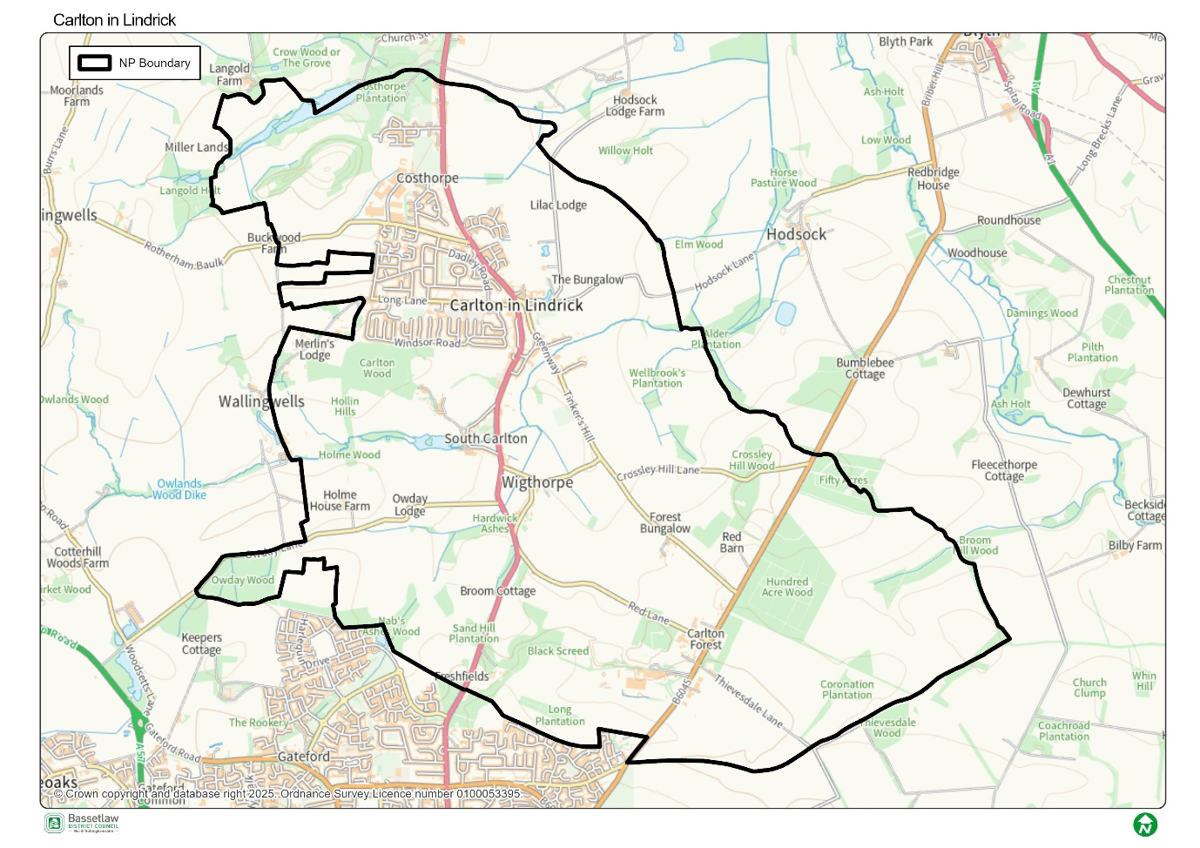

**Carlton in Lindrick Parish Council** will continue to fulfil the role of Qualifying Body for the Neighbourhood Area, leading the development of the review of the associated Neighbourhood Plan.

All documentation relating to this decision is available from the [Bassetlaw District Council website](https://www.bassetlaw.gov.uk/planning-and-building-control/planning-policy/neighbourhood-plans/all-neighbourhood-plans/carlton-in-lindrick-neighbourhood-plan/).

Signed: **Alastair Curran**

Head of Planning and Place

20th June 2025