



Response data provided at the community event

5 - 8pm, 11th June, and 11 - 3pm, 14th June 2025



Overview
This document details the full range of comments provided during the Know your Place community events held in Walkeringham in June 2025. Its aim is to assist the ongoing work to review the existing Walkeringham Neighbourhood Plan, and to provide a reference point for other potential project work.

Comments provided on the policies of the existing Neighbourhood Plan are detailed first, followed by the SWOT (Strengths, Weaknesses, Opportunities, and Threats) analysis completed for Walkeringham. This is followed by comments on the Flood zone map, and then the Postcards from the Future submissions.

Comments are presented as originally written-down, with explanatory notes added [in italics] where relevant. Also in italics are notations of support for a particular comment, e.g. (x3) noting that the comment was supported by two people in addition to the original contributor. Where relevant, similar comments have been grouped together to help better appreciate the topic in question.

What is Know your Place?
Know your Place is a social learning tool developed by Bassetlaw District Council following involvement in a government funded-pilot to explore new ways of supporting community-led planning. It aims to encourage curiosity and discussion around local issues, and to assist communities to identify and document local priorities. It is based on the premise that developing a better understanding of a place in the first instance will provide a firm foundation on which to consider if and how the themes raised could be responded to. This could, for example, include community projects, land use planning strategies, or further discussions or investigative work. Equally, better understanding of local issues may be a justifiable outcome in its own right.

What happens next?
There are various ways that the response data included in this report might prove useful. What actually happens next is down to you – and we are keen to help to consider and facilitate this.

Neighbourhood Planning, Bassetlaw District Council
8 July 2025
- Walkeringham Neighbourhood Plan 2019-2035

Walkeringham in context (Page 16)
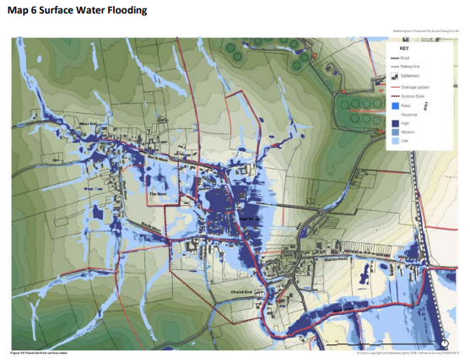
Comments:
- Surface Water Flood Risk - Surface water flood risk, not mitigated by the Flood Alleviation Scheme of 2017, is described in the current Plan at paragraph 49, page 17, viz:
In November 2019, Walkeringham suffered once again from severe surface water flooding. The School and several homes were affected. The new overflow dyke worked well and protected the west of the village but surface water runoff from the east did all the damage. The flooding problem in Walkeringham is clearly not totally solved.
A similar event occurred on 6 January 2025 when runoff from the east along Mill Baulk Road inundated High Street before flowing overland into the Moor Drain. This event was well documented by objectors to planning application Ref. 24/01412/FUL.
These events indicate a need for further surface water flood alleviation, namely cutting off overland flow at Mill Baulk Road to the east of the School and conveying the floodwater beneath High Street to enter the Moor Drain.

- Foul Sewer Flood Risk - The foul sewer in High Street is understood to have surcharged on several occasions in the past during heavy rain and backed up into private properties. Addressing this issue is a matter for Severn Trent Water who are understood to have been aware of the problem for more than a decade but appear reluctant to deal with it.

- Revised Plan – Flood Risk - A revised Plan should include appropriate policies for dealing with the above flood risks.

Community Vision (Page 27)

Comments:
- Leave us as a village.

Community Objectives (page 27)

Comments:
- Objective 2: Quantify “small in scale”?

Policy 1: Sustainable Development, Infill and the Development Boundary (pages 31 - 32) / Map3 Designated areas of Nature Conservation

Comments:
- The field behind the chapel should become a designated nature conservation area.

Policy 5: Designation of Local Green Spaces (page 54) /Map 15 Local Green Spaces Designations

Comments:
- Suggest adding field by chapel to list of designated green spaces.

Policy 7: Enhancing the provision of community facilities (page 56)

Comments:
- Church Building - As a Grade 1 listed building, some 800 years old, the Church is a very valuable community asset. According to the current Plan, the Church is closed due to structural damage and the future of the building and church yard is uncertain. At that time, the Church had been closed owing to a localised ceiling collapse, but in June 2021, the Archdeacon of Newark wrote to inform villagers that repairs had been completed and the building had been declared safe for use. Subsequently, a well-attended Festival Service has held on 22 July 2021, but nothing has been heard since from the Church of England authorities.
- Church Tower and Clock - Although the Church building is officially safe, this is not the case for the tower where the structure is purported to be so hazardous that the clock winder is not permitted access and the clock has been stopped for the past seven years. As with the Church building, the clock is valuable community asset which is being allowed to deteriorate into a poor state of repair.
- Revised Plan – Church - Although the future of the Church and its tower and clock is a matter for the Church of England authorities, advantage might be taken of a revised Neighbourhood Plan to make a statement emphasising the value of these assets to the village community. This would be particularly pertinent in the case of the clock, a secular amenity whose wound-down condition reflects badly on the village as a whole. An obvious solution for the clock would be to install an automatic winding mechanism.

Map 16 Site Allocations (page 59)

Comments:
- This site (next to Chapel, High Street) should be a designated nature reserve for the community. It is a natural soakaway and not fit to build on!
- Stop High Street development (next to Chapel) - leave as nature soakaway.
- Flooding risk increased by building more houses.
- High Street already flooded. Houses on High Street suffer toilets backing up in wet months. Can’t cope with houses already there.
- Current Allocations - Map 16 of the current Plan allocates 9 No sites for housing development. To date, one site has been built out (Policy 8 – 2 No units out of 3 No. allocated (21/00440/FUL)); one has been approved (Policy 13 – 9 No units out of 12 No allocated (20/01026/FUL)); one refused (Policy15 – 14 No units (as part of a mixed development) out of 15 No allocated (22/00176/FUL)) and one where an application is believed imminent (Policy 12 – 12 No units allocated). No applications have been made on the remaining 5 No sites (Policies 9, 10, 11 and 14 – 24 No units allocated in total). At present, therefore, only 11 No units have been granted planning permission, of which 2 No have been built, out of the total allocation of 66 No. In this respect, the Plan has not been a success.
- Unplanned Developments - Four unplanned housing developments, albeit derived from earlier applications, have made significant progress during the period of the Plan to date, namely:
    - 15/00565/OUT - Station Road - 32 No units - built and occupied (St Mary’s Close/Trent Grove).
    - 21/00445/FUL - Birdcroft Lane – 3 No units - built out and occupied (Orchard Close).
    - 21/01588/RES - Beckingham Road – 25 No units – permission implemented.
    - 17/00353/OUT - High Street – 14 No units – permission implemented.
Hence, a total of 74 No unplanned units have been permitted, 35 No of which are already built, without any reference to the Plan and its Policies. This has made a mockery of the Plan.
- Revised Plan – Housing - A revised Plan should:
- Remove those sites previously allocated where a planning application is not submitted within a reasonable period of time, say one year from notification.
- Recognise the existence of the built or implemented unplanned developments and include their numbers in a revised Plan and future allocations.
- Promote the principle of a single large site rather than several small sites so as to maximise developer contributions and improve infrastructure to a degree not possible with small sites. Such a proposal would require careful consideration with regard to its impact on the character of the village. Lessons might be learned from similar large developments in Gringley, Misterton and Beckingham.
Several possible locations present themselves for a single large site, such as between High Street and Brickenhole Lane, south of Station Road, south of South Moor Road (outline application 17/01317/OUT for 1 No unit on this site was refused) and north and south of Mill Baulk Road.

Land north of Mill Baulk Road and east of the School was the subject of application 17/01432/OUT for 46 No units, subsequently withdrawn. One of the issues at this site was surface water flood risk. Allocation of this, or preferably a larger site for, say, 100 No units, might encourage the applicant to re-apply and provide inter alia an opportunity to solve the current flooding problems.

Policy 8: Land at The Laurels, Station Road (pages 60 - 62)

Comments:
- Developed.
- The existing tract of real estate should be better maintained. Gives a bad impression!

Policy 9: Land south of Kilmeaden, West Moor Road (pages 63 – 64)

Comments:
- Access?
- Floods (both the site itself, and the field to the west).

Policy 10: Land north of Fountain Hill Road (pages 64 – 65)

Comments:
- Question mark in the site boundary (suggesting progress / intentions for development of this site are unclear).

Policy 11: Land north and south of Fountain Hill Road (pages 65 - 67)

Comments:
- Question marks on both portions of the allocation (suggesting progress / intentions for development of this site are unclear).
- Site of the former Brickmakers Arms annotated with “new houses 6 years ago”.

Policy 12: Land east of Stockwith Road (pages 67 - 69)

Comments:
- Linear only. No estates.
- Needs to be linear infill only.
- Planning imminent.

Policy 13: Land east of Brickenhole Lane (pages 69 – 71)

Comments:
- Has full planning.
- Needs progressing.

Policy 15: Land adjacent to South Moor Lodge, south of South Moor Road and west of Brickenhole Lane (page 74)

Comments:
- I’m one of the owners of this land and would like to include extra care housing and a village shop and café to the development.
- Village doesn’t need a shop and extra traffic and danger that brings.
- Too many old people’s residential homes – 3 bed homes of high quality required with large gardens.
- Shop and café welcome and needed due to the growth of the village and provide jobs!

Are there any additional issues or themes that you think the Neighbourhood Plan should address?

Comments:
- Yes, speeding though village and state of roads.
- Older people accommodation and extra care.
- Stage of road and footpaths after building work (e.g., extension at South Moor Lodge).
- Safety issues when construction traffic is using narrow roads.

- SWOT analysis

Strengths
- We are a village and “small”.
- Maintaining village as a village. (x4)
- Peace and quiet – keep village small! – agree – agree! (x8)
- Quiet and peaceful village (mostly!).
- Green areas and nature reserves.
- Varied mix of housing, dispersed nature of development.
- Generally tidy, clean and well-presented.
- Do not lose the feel of the “Village” (x4)
- Small community feel. Quiet Roads (x2).
- Pretty, rural area – Fountain Hill Road, lovely road and village lined by trees. (x3)
- The church/market cross
- Are there any plans to save the Church Gate or is it owned by the Diocese?
- (In response to above) Owned by the Diocese and being left to ruin!
- Re-open church. Beautiful church. It would be used. (x3)
- Friendly village.
- Very friendly village. Very active village hall (x4).
- Great village hall with plenty events. (x4)
- Lovely village hall crew! (x2).
- Village Hall crew, nothing too much trouble put on amazing events. Keep it up. Every village should have a crew like this one! (x2)
- Knit and Natter ladies amazing (x2).

Weaknesses
- Poor condition of A161! (x4)
- A161 road needs total resurfacing. (x3)
- Does the oil depot company contribute to road repairs as their tankers run frequently?
- Potholes and the poor cheap repair of them that does not last. (x2)
- North Moor Road - from Fountain Hill traffic is allowed to speed – no discouragement.
- Speed of traffic especially on bend near pub and Wright Gardens. (x5)
- Fountain Hill to Northmoor Road in a really poor state.
- A161 at Newell’s Terrace: needs slow down flashing sign (x2)
- A161 at Newell’s Terrace: needs concealed entrance sign for residents coming out (of back lane) onto roundabout. (x6)
- Cars coming out of Newell’s back Lane onto roundabout near Vets not given any priority. (x2)
- No Newell’s sign near vets to show where delivery vans are. (x2)
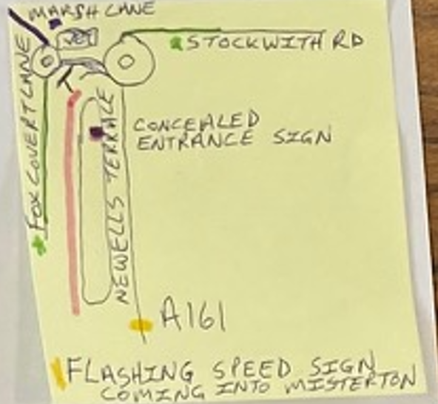
Diagram of suggested enhancements near Newell’s Terrace
- Footpaths in poor condition especially for the elderly. (x2)
- Addition of footpath to cemetery would be good. (x2)
- Need footpath from centre of village all the way to Mill Lane. May need to acquire land from nearby field owners. (x2)
- Lack of older people extra care provision, community shop and café.
- Re-site Memorial - not central to village.
- Positioning of bottle bank rear of elderly properties. Needs moving as causing distress to elderly, coming at 6am to empty. People coming all hours of night to empty, purposely waking residents smashing bottles, making it a game.
- (Responding to above). Disagree. Recycling and place to park safely. (x2)
- Dog poo!!
- Number of litter bins could be increased.
- Football field could be dog-friendly. (Poo bins definitely needed)
- (Responding to above) Not possible. Not child friendly! People don’t pick up their dog’s poo!! Fact.
- State of church and its grounds. (x2)
- Church grounds are noted as a “Green space” Who is responsible for the management of the grounds? (x3)
- Ensure that builders pay CIL. The builders who did the Station Road development did not. (x5)
- Who is enforcing outstanding enforcement orders? Urgent.
- Do not build on “Flood Plains” e.g. Development on High Street/North Moor Road. (x3)

Opportunities
- Repair the A161! (x3)
- Fill all potholes.
- Fill in potholes! A must.
- Definitely a shop and cafe needed. Somewhere to meet and it will help promote the village as a place to visit. (x2)
- (In response to above) there wouldn’t be enough footfall.
- A shop central in the village would be appreciated.
- (In response to above) But where? By who?
- Proposed marina is a great opportunity but keeps getting blocked by council narrow mindedness.
- (In response to above) Would really enhance Chesterfield Canal – eyesore at present + create jobs for locals.
- As a village we would welcome the opening of the Marina, they would provide a restaurant and wonderful facilities.
- The proposed Marina.
- Development down Brickyard Lane (Marina) would be so beneficial to Walkeringham.
- Sympathetic introduction of green energy initiatives for the village (e.g. solar panels, small wind turbines).
- Bury high voltage powerlines to east of village (aesthetics).
- HGV restriction through the village. (x3)
- Tractors from farm travel too fast down North Moor Road.
- Change speed limit on South Moor Road from 60mph to 30mph.
- Traffic calming down Fountain Hill Road.
- Speed camera needed from entering village to exiting 30mph.
- Change speed limit going through Walkeringham to 20mph. (x2)
- NCC and LCC seriously need to consider a new bridge and flyover on the A631 Gainsborough. It needs attention of it’s a nightmare getting into Gainsborough with the high volume of traffic as if an accident occurs.
- We need a by-pass and another road bridge across the Trent. (x3)
- Flashing slow down sign for Newell’s Terrace (in Walkeringham Parish) coming into Misterton. (x4)
- Parking down Sidsaph Hill not good.
- Resumption of local bus service in village?
- Bus route needs to revert back – to go through Village as the elderly are suffering! (x3)
- Railway station in Misterton. (x2)
- Cycleway along Trent Bank to West Stockwith.
- The Trent bank (could be so much more).
- Improve footpaths (not fit for purpose) – not suitable for disability access! (x2)
- Improve the footpaths everywhere in the village. (x2)
- Footpaths needed along Brickenhole to cemetery.
- Nature reserve – open R.O.W from Caves Lane to Nature reserve. (x2) ✓ -
- (In response to above) And bring back parking at nature reserve.

Threats
- Would like the village to remain as it is (small). (x3)
- Lack of decent pedestrian paths. (x3)
- Too many new houses being built. (x2)
- Losing our countryside. (x2)
- Social media – negative comments are ruining what was a true village community feel.
- I think it’s important to maintain the open spaces within the village to ensure the general character is kept.
- Currently people walking from the village to the cemetery have to navigate along a narrow road with fast-moving traffic and blind bends – there is a risk that someone will be killed, because there are no footpaths along this route.
- Too many parked cars on the road!
- Speeding through the village.
- Road network is not able to cope with lots of new housing. (x2)
- Building on edge of village where it floods from fields.
- Too much building taking up valuable drainage land. (x3)
- We become joined to other villages losing identity and heritage.
- Over development without the structure to support. (x3)
- Building in fields that are documented as flooding. (x2)
- Speculative development – and relaxation of planning legislation.
- No building in fields that are at risk of flooding (x3) or have a history of flooding. (listen to residents). (x3)
- Dr’s/Dentists - not enough.
- Lack of services – e.g. buses, village shop.
- Lack of infrastructure. (x2)
- Lack of facilities (shops, doctors, dentists).
- Sewage and drainage system not up to spec for future development.
- Closure of pub – needs to be cherished.
- School not big enough to support building development.
- High voltage powerlines as part of “great grid upgrade”. (x2)
- Reopening of Doncaster Airport.

- Scoping Map /Floodzone
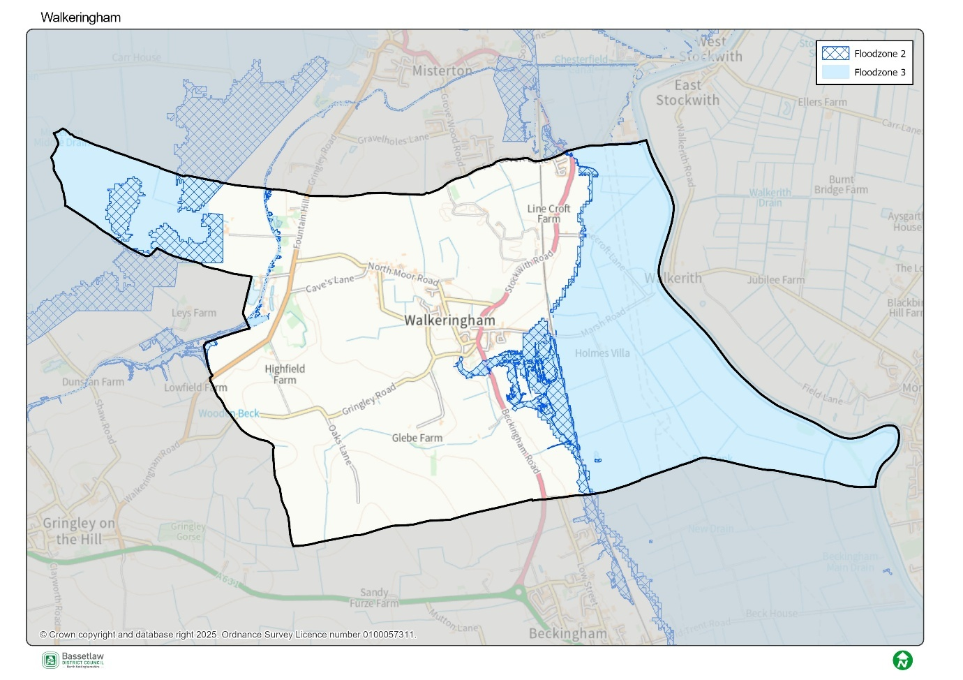
This whole area flooded 2024

A postcard from the Future: Greetings from 2038…
Contribution 1:
- Nature reserve – how are we to get involved as a village?
- Notts Wildlife Trust is a charity – or does it receive funding from council?
- How will boundary changes affect us as a village - positive? Negative?
- Could we benefit from a community hub for donations of toiletries etc. There will be hygiene as well as food poverty in the village.
- Do we have a list of potential volunteers?
- Who cleans and maintain Moor Drain?
- Is there an Emergency Plan?
Contribution 2:
- Would love to be greener
- More nature wildlife areas.
- An orchard or green spaces on green spaces for the school to teach children about nature, perhaps growing “stuff” + wildlife.



Know your Place: what’s in a name?
The name ‘Know Your Place’ has an intentional dual meaning. On one hand it reflects the opportunity the initiative provides for all involved to learn more about the local area. This could be through viewing the information on display, through reading the contributions made by attendees, or through discussion both at and following community events. The name is also a conscious acknowledgement of the invaluable role communities have in shaping spatial knowledge and informing local priorities. Collectively, the initiative works on the basis that all parties have valuable knowledge and experience to share, but also the capacity to learn from the valuable knowledge and experience of other people.

Neighbourhood Planning
Bassetlaw District Council
Queen’s Buildings,
Potter Street,
Worksop,
S80 2AH
Tel: 01909 533 495
Email: neighbourhoodplanning@bassetlaw.gov.uk
Website: https://www.bassetlaw.gov.uk/planning-and-building-control/planning-policy/neighbourhood-plans/know-your-place/


Know your Place website

