Strategic Environmental Assessment & Habitat Regulations Assessment Screening Statement

Misson Neighbourhood Plan (Review)
April 2024

Table of Contents

1 Introduction 2
Strategic Environmental Assessment (SEA) 2
Habitat Regulations Assessment 3
Summary of Findings 3
2 The Misson Neighbourhood Plan 4
Plan Overview 5
Vision 5
Community Objectives 5
Development Management Policies 6
3 SEA Screening – Assessment 7
SEA Assessment 7
4 HRA Screening – Assessment 12
HRA Screening Matrix 14
5 In-combination Effects 20
6 Conclusions 21
Consultation 21
SEA Screening 21
HRA Screening 21
Appendix 1: Consultation Responses 22
Appendix 2: Ecological attributes of the European sites 25

Introduction
        - This document contains the Screening Statements for the Misson Neighbourhood Plan (Review) - (the Plan) - with regard to whether a Strategic Environmental Assessment (SEA) and / or Habitat Regulations Assessment (HRA) are required to be undertaken. The document also includes an assessment of the policies proposed in the Plan with regard to Impact Risk Zones for Sites of Special Scientific Interest (SSSI).
        - Regulation 15 of the 2012 Neighbourhood Planning (General) Regulations sets out the information that must accompany a Neighbourhood Plan when submitted to the local planning authority. In February 2015 amendments to the Neighbourhood Plan Regulations came into force; this is known as the Neighbourhood Planning (General) (Amendment) Regulations 2015. Regulation 2(4) of these amendments adds additions to the list of documents that a qualifying body must submit to a local planning authority with a Neighbourhood Plan. The additional document which must be submitted is either an environmental report prepared in accordance with the relevant regulations or, if the outcome concludes that an SEA or HRA is not necessary, a statement that sets out how environmental issues have been taken into account and considered during the preparation of the Neighbourhood Plan.
        - The National Planning Policy Framework (para 167) advises that assessments should be proportionate, and should not repeat policy assessment that has already taken place. In view of this, only a high level screening assessment of the Plan has been undertaken, and this assessment should be read in conjunction with the relevant reports produced for Bassetlaw District Councils Local Development Framework.
        - As the responsible authority under relevant regulations, Bassetlaw District Council has undertaken the Screening Assessment contained in this document, working with the Misson Neighbourhood Plan Steering Group.

Strategic Environmental Assessment (SEA)
        - The requirement for a SEA to be undertaken on development plans and programmes that may have a significant environmental effect is outlined in European Union Directive 200142/EC. The Environmental Assessment of Plans and Programmes Regulations 2004 (the 2004 Regulations) state that this is determined by a screening process, utilising a specified set of criteria, outlined in Schedule 1 of the Regulations. The results of this process must be set-out in an SEA Screening Statement, which must be publicly available.
        - The objective of undertaking a SEA is “to provide for a high level of protection of the environment and to contribute to the integration of environmental considerations into the preparation and adoption of plans and programmes with a view to promoting sustainable development, by ensuring that, in accordance with this Directive, an environmental assessment is carried out of certain plans and programmes which are likely to have significant effects on the environment.”

Habitat Regulations Assessment
        - European protected sites (the ‘Natura 2000 Network’) are of exceptional importance for the conservation of important species and natural habitats within the European Union. The network of European protected sites comprises Special Protection Areas (SPAs) designated under the Birds Directive (79/409/EEC), Special Areas of Conservation (SACs) designated under the Habitats Directive (92/43/EEC) and Ramsar sites designated under the Ramsar Convention 1975. Government guidance advises that potential SPAs (pSPA), candidate SACs (cSAC) and potential Ramsar (pRamsar) sites are also included in HRA’s.
        - As a land use plan, an assessment of the Misson Neighbourhood Plan may be required under the Conservation of Habitats and Species (Amendment) Regulations 2012 (the Habitat Regulations) and Article 6(3) of the EU Habitats Directive in order to determine whether the Plan may result in significant effects on identified sites.
        - As with the SEA, a screening process is employed to establish whether any elements of the Draft Plan could have a significant effect on these sites. Regulation 32 of the Neighbourhood Planning (General) Regulations 2012 (as amended) further reemphasises the importance of carrying out this assessment by stating that one of the basic conditions that must be met before the Plan may be ‘made’ is that “the making of the neighbourhood plan is not likely to have a significant effect on a European site (as defined in the Conservation of Habitats and Species Regulations 2012) or a European offshore marine site (as defined in the Offshore Marine Conservation (Natural Habitats, &c.) Regulations 2007 (either alone or in combination with other plans or projects)”.

Summary of Findings
        - Following the undertaking of the Screening Assessments, it is concluded that the Plan, in its current form, will not have any significant negative effects on the environment or any identified European sites. It is considered, therefore, that a full environmental assessment and habitat regulations assessment is not required.
        - This determination has been reached by assessing the contents of a pre-release version of the Submission Draft of the reviewed Neighbourhood Plan, issued to the District Council in February 2024. The Plan has been assessed against criteria provided in Schedule 1 of the 2004 Regulations and with regard to Regulation 32 of the 2015 Neighbourhood Planning Regulations & the Habitat Regulations. The conclusions are detailed in full in Section 6 (p28) of this report.

The Misson Neighbourhood Plan

        - The Neighbourhood Plan is being developed by Misson Parish Council, the Qualifying Body for the Misson Neighbourhood Area in Bassetlaw District, Nottinghamshire, as depicted in Figure 1, below. The Plan has been devised to cover the period to 2031.
Figure 1: Designated Neighbourhood Area
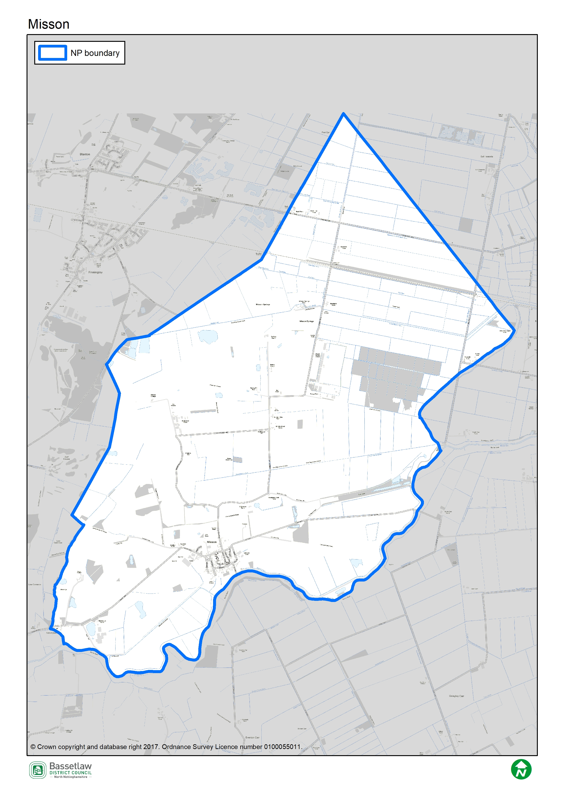

Plan Overview
        - As detailed below, the priorities of the Plan are captured in the Vision and Community Objectives (see page 19 of the Plan), to be delivered through the application of 10 development management policies specific to the Neighbourhood Area.

Vision
In 20 years’, time Misson will continue to be a village and a close, friendly community. It will value the countryside and those that live and/or work in the Parish. It will provide people with the options to stay (whether leaving home or getting old). It will be a rural place where there are local work opportunities and where everyone can enjoy the rural environment.

Community Objectives
Community Objective 1: Ensuring that new development is designed to a high quality and is located so that it minimises its impact on the natural and built environment, whilst providing direct benefit to local people by:

- being located adjacent to or within the existing settlement;
- being suitable to meet Parish needs;
- being underpinned by extensive local consultation.
Community Objective 2: Ensuring that new housing development provides a mix of house types to meet local as well as district needs including affordable housing, which can be for either rent or sale, is for those whose needs are not met by the market. Different tenures may include social rent, affordable rent and shared ownership, among others.
Community Objective 3: Allocating a site at the former Misson Mill for a mixed-use development of housing, employment and leisure uses.
Community Objective 4: Ensuring that new development
- protects, enhances and sustains the historic built environment and its setting;
- enhances the existing character of Misson parish.
Community Objective 5: Protecting the landscape character of Misson particularly the local wildlife sites and seeking ways of improving pedestrian or cycle links to them and between them. Including providing stronger connectivity between all greenspace to the benefit of wildlife and people
Community Objective 6: Seeking opportunities, whenever possible, to maintain and enhance the amenities within Misson like the school, the pubs and to provide a village shop.
Community Objective 7: Protecting and enhancing the existing village green and seeking opportunities to provide additional public open space for the enjoyment of local people of all ages.
Community Objective 8: Enhancing the social and economic vitality of the village by encouraging better broadband connection.
Community Objective 9: Seeking opportunities to maximise energy efficiency, minimise energy use and become less reliant on non-renewable energy either in the construction or operation of the development.
Community Objective 10: Mitigating the impact of flooding, extreme weather, and water consumption on new developments and generally within the landscape and infrastructure and ensuring that such impacts are not exacerbated by new development.

Development Management Policies
        - The 10 development management policies included in the Neighbourhood Plan are summarised in the following table.
Policy | Summary
Policy 1: Sustainable Development | Supports developments that meet local needs and deliver local amenities. Also, encourages the use of local energy for transport and business through construction processes.
Policy 2: Design Principles for Residential Development | Encourages maintaining local character with tree planting, a locally inspired range of materials, and existing settlement patterns.
Policy 3: Types and Mix of Housing | Seeks to deliver housing that meets local needs, particularly for young and older people, including accessible and adaptable housing for the mobility needs of residents.
Policy 4: Infill and Brownfield Development in Misson Village | Supports infill development and redevelopment that is of high quality and consistent with local character, and will not reduce local amenity.
Policy 5: Protecting and enhancing the Provision of Community Facilities | Identifies 8 community facilities that should be protected or enhanced.
Policy 6: Protecting and Enhancing Heritage Assets | Seeks to preserve or enhance the listed building’s special  Interest. Supports proposals to provide additional facilities at St Johns Church.
Policy 7: Potential Development Opportunities at Misson Mill | A site-specific policy supporting the future redevelopment of Misson Mill, subject to appropriate mitigation of identified constraints, including flooding risk and open space preservation.
Policy 8: Energy Efficiency, Renewable Energy and Low Carbon Technologies in New Developments and Retrofitting Existing Developments | Requires the instalment of materials that improves energy efficiency for all new buildings.
Policy 9: Better Broadband | Requires that all new developments demonstrate digital connectivity and support developments that provide access to superfast broadband.
Policy 10a: Improving Green Infrastructure and the Natural Environment | Requires that development proposals achieve a Biodiversity Net Gain of at least 10%, and improve linkages both between existing and new green infrastructure assets and with residential areas.  Requires that existing trees are protected, or replaced where removal is unavoidable.
Policy 10b: Local Green Spaces | Identifies 7 Local Green Spaces (LGS) for designation, in accordance with the regulations.
Policy 10c: Trees | Seeks to protect existing trees during development, and requires that all new development schemes are accompanied by an appropriate tree planting scheme.

SEA Screening – Assessment
        - The table below includes the assessment of the reviewed Misson Neighbourhood Plan, including its Objectives and Development Management Policies, against the criteria included in Schedule 1 of the 2004 Regulations. The Neighbourhood Plan is being assessed as a whole against the criteria listed below to allow for the consideration of its effects on the environment.

SEA Assessment

Criteria for determining the likely significance of effects (Annex II SEA Directive) | Significant effect likely? | Comment
1a The degree to which the plan or programme sets a framework for projects and other activities, either with regard to the location, nature, size and operating conditions or by allocating resources. | NO | The Misson Neighbourhood Plan (the Plan) sets-out a spatial vision for the designated Neighbourhood Area and an accompanying framework to guide development proposals. This framework will be delivered by the development management policies contained within the Plan. The framework will have some impacts on the environment, noticeably the support for development proposals. However, it is deemed that these impacts will not be significant, due to their small-scale and localised nature.
1b The degree to which the plan or programme influences other plans and programmes including those in a hierarchy. | NO | The Plan, where possible, will respond to rather than influence other plans and programmes. It is part of a hierarchy, but is at the lowest tier, sitting below the Bassetlaw Core Strategy DPD (District level) and National Planning Policy Framework (National level), and has thus been influenced by these higher-tier and pre-existing plans, rather than having an influence on them.  The Plan has been developed with a view towards the emerging Bassetlaw Local Plan but will remain below it in the policy hierarchy.  The policies within a neighbourhood plan apply only within the designated neighbourhood area, hence the Plan will not have a direct impact on adjoining areas.
1c The relevance of the plan or programme for the integration of environmental considerations in particular with a view to promoting sustainable development. | NO | The Plan promotes sustainable development within the Neighbourhood Area; this is clearly articulated in Policy 1 (page 22). The Vision & Objectives (page 19), in conjunction with the development management policies, work to ensure that all development proposals brought forward in the area will take this balance into account.  Specifically, the forms of development supported by policies 1, 3, 4, and 7 are viewed as key to ensuring the long-term sustainability of the Plan area. This projected growth is balanced by the protection of key environmental and social / cultural assets, both through criteria in the above policies themselves, and through policies 2, 5, 6, 8, 9 and 10.  As a result, it is considered that the Plan effectively integrates and balances all potential environmental considerations, and that potential impacts are, therefore, unlikely to be significant.
1d Environmental problems relevant to the plan or programme. | NO | As noted above, the Plan supports development on a number of fronts, including residential development and employment development, all of which could have some effects on the environment. However, existing national and local planning policies, the specific criteria included within the policies in the Plan, and the planning application process, will collectively ensure that these effects are not significant.
1e The relevance of the plan or programme for the implementation of Community legislation on the environment (for example, plans and programmes linked to waste management or water protection). | NO | The Plan is intended to be in compliance with the Bassetlaw Local Development Framework, which has taken into account the existing European and National legislative framework for environmental protection. The Plan will therefore have a positive effect on compliance with regards to relevant legislation and programmes. It is considered that none of the proposals within the Plan will compromise this position.
2a The probability, duration, frequency and reversibility of the effects. | NO | It is deemed highly unlikely that there will be any irreversible damaging environmental impacts associated with the Plan. The policies within the Plan seek to ensure new development is sustainable in context, and promotes the enhancement and protection of environmental assets. The Plan is intended to cover the period up to 2031.  Should any unforeseen significant effects on the environment arise as a result of the Plan, the intention to monitor the Plan and also to review/update the Plan when required will allow these effects to be addressed (see Section 22: Monitoring and Review (page 43).
2b The cumulative nature of the effects. | NO | It is considered that the Policies contained in the Plan, cumulatively, will have minimal negative effects on the environment and will in fact have moderate to significant positive effects through the stipulations included. It is considered that all effects will be at a local level.
2c The transboundary nature of the effects. | NO | Effects will be local, with no expected impacts on neighbouring areas.
2d The risks to human health or the environment (for example, due to accidents). | NO | No obvious risks have been identified, as the overall aim of the Plan is to ensure the careful management of development and the continued sustainability of the Plan area.
2e The magnitude and spatial extent of the effects (geographical area and size of the population likely to be affected). | NO | The Plan relates to, and will have an influence over, a designated neighbourhood area of approximately 2,497 hectares, with a usual resident population of approximately 712 people (Census 2021).  It is deemed the Plan as a whole will have a positive impact upon local residents through the protection and enhancement of local environmental and social / cultural assets, and the promotion of sustainable development.
2f The value and vulnerability of the area likely to be affected due to:  (i) special natural characteristics or cultural heritage;  (ii) exceeded environmental quality standards or limit values; or  (iii) intensive land-use. | NO | The Plan is deemed unlikely to have an adverse effect on the natural characteristics and cultural heritage of the neighbourhood area.  Natural characteristics  There are three SSSIs in the Plan area, namely:  - Misson Line Bank  - Misson Training Area  - River Idle Washlands  There are a number of SSSI outside, but in relative proximity to, the Neighbourhood Area, namely:  - Haxey Grange Fen  - Barrow Hills Sandpit  - Chesterfield Canal  - Mother Drain, Misterton  The impact risk zones for the first two of these designations intersect the Neighbourhood Area.  There are 19 Local Wildlife Sites within the Plan area, namely:  - Misson Grassland  - Misson Carr  - Misson Line Bank  - Misson Pumphouse Flash  - Snow Sewer (East), Misson  - Snow Sewer [West], Misson  - Top Road Sand Pit  - North Carr Drain Washland  - North Carr Drain, SW of Idle Stop  - North Carr Drain  - Slaynes Lane Washland  - Slaynes Lane  - Newington Washland  - Rugged Butts  - River Idle - Everton Carr  - Levels Farm Drain, Misson  - Levels Lane Drain  - Chapel Baulk  - Misson Bank and Sanderson's Bank Drains  The Plan includes three policies in particular designed to protect and enhance the natural assets in the Neighbourhood Area. Policies 10a, b, and c address green infrastructure and the natural environment. In particular, Policy 10b provides specific protection to 7 sites through designation as Local Green Spaces.  Policy 7: Potential Development Opportunities at Misson Mill, has the potential to have an impact upon the River Idle Washlands SSSI, due to its hydrological connectivity to the site. However, the potential impacts are mitigated by Policy ST40 of the Bassetlaw Local Plan (Main Modifications version, 2023), which provides protection to nationally-designated sites, including SSSI. The Bassetlaw Local Plan Sustainability Appraisal November 2020 assessed all site options, including Misson Mill (LAA464), although this site was not eventually allocated. The proforma in table A6-61 concluded that “there are no statutory international/national nature conservation designations within 500m of the site and no local designations within 100m of the site. As such, a negligible effect is likely”.  Cultural heritage  There are no World Heritage Sites, Protected Wreck Sites, Registered Battlefields, or Registered Park and Gardens in the Neighbourhood Area. Misson Cemetery, in Top Road, is identified as an Unregistered Park and Garden. There is one Scheduled Ancient Monument in the Parish, a moated site and fishpond, located to the east of Gibdyke, on the edge of Misson village.  Much of the core of Misson village is identified as an area of archaeological interest, with other smaller areas of interest located around the Plan area. The core of Misson village is also designated as a conservation area.  Policy 6 (Heritage Assets) specifically addresses local heritage assets and their setting, and encourages proposals to provide additional facilities at St John’s Church.  There are 17 Listed Buildings in the Neighbourhood Area, 16 of which are Grade II. The Church of St John the Baptist and Boundary Wall, addressed specifically by Policy 6, is Grade I listed. There are also a significant number of non-designated heritage assets.  Policy 7 (Potential Development Opportunities at Misson Mill) supports the potential redevelopment of this brownfield site, but takes a precautionary approach, including the need to protect and enhance biodiversity within and beyond the site, mitigation of flood risk, and retention or replacement of on-site open space.  It is considered that the development supported by the Plan will not result in significant effects on the identified natural or cultural heritage assets. Furthermore, the Plan does not exceed environmental quality standards or limit values, and does not provide specific policies in relation to intensive land uses.
2g The effects on areas or landscapes which have a recognised national, community or international protection status. | NO | It is considered that the Plan will not adversely affect areas of landscape which have recognised community, national or international protection. The need for new development to respect landscape setting is included as part of the criteria within the respective Policies.

HRA Screening – Assessment

        - For the HRA screening assessment, the designated neighbourhood area was assessed to identify if any Special Protection Areas (SPA), Special Areas of Conservation sites (SAC), or Ramsar sites were located within the boundary, as well as those considered as potential sites (pSPA, ppSPA, cSAC & pRamsar). The assessment also identified if any of these internationally important sites were located within a 15km radius from the Neighbourhood Plan area. The results of this exercise are detailed on the map included as Figure 4 on page 13. The Thorne and Hatfield Moors SPA and Hatfield Moor SAC are located approximately 2.6km to the north of the border of the Neighbourhood Area. The Humber Estuary SAC is located just beyond the threshold distance, at 16.4km from the Neighbourhood Area. Descriptions of the ecological attributes of the two sites within the 15km threshold are included as Appendix 2.
        - The Screening Assessment on page 14 has considered the main potential sources of effects on the identified European sites arising from the Plan, possible pathways to the sites, and the effects on possible sensitive receptors. The assessment considers the impacts of the policies in the Plan directly on the identified sites, as these are land use policies, hence mostly expected to have some direct or indirect impact on the local environment.

Figure 4: Map of Special Protection Areas and Special Areas of Conservation in relation to the Misson Neighbourhood Area
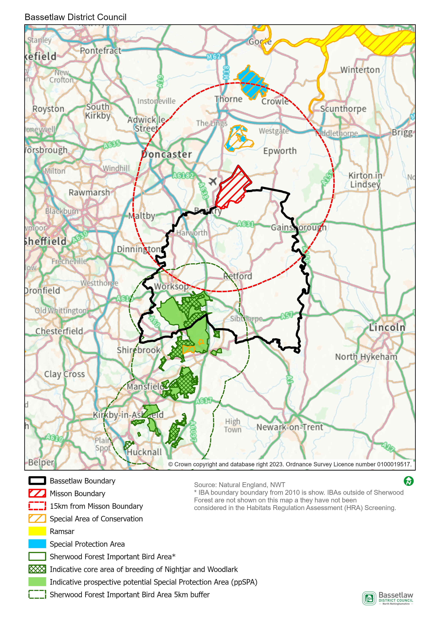

HRA Screening Matrix
The screening matrix below shows which types of impacts on European sites could potentially result from each of the policies and sites allocated in the reviewed Misson Neighbourhood Plan. Where a site is not expected to have a particular type of impact, the relevant cell is shaded green. Where a site could potentially have a certain type of impact, this is shown in orange. The final column sets out the screening conclusions.
Policy | Likely activities (operation) to result as a consequence of the proposal | Likely effects if proposal  implemented | European site(s) potentially affected | Could the proposal have likely significant effects on European sites?
Policy 1: Sustainable Development | Residential development.  Economic development.  Increase in vehicular traffic.  Increase in recreation pressure. | Physical loss and damage.  Air pollution.  Disturbance from recreation. | Thorne and Hatfield Moors SPA  Hatfield Moor SAC | No significant effects anticipated.  The sites where development is supported by the Policy (within the development boundary) are approximately 8.5km at the nearest from Thorne and Hatfield Moors SPA and Hatfield Moor SAC. Physical loss and damage is, therefore, not possible.  It would not be expected for birds to be dependent on the habitat within the development boundary.  This Policy alone would not be expected to cause a significant increase in traffic and air pollution in the area.  With regard to pathways, it is considered that the nature and small scale of the development supported in this Policy, including the distance between the potential development sites and the European sites, and intervening infrastructure and settlements, will not result in significant effects occurring.
Policy 2: Design Principles for Residential Development | None. This policy encourages maintaining local characters with tree planting, locally inspired range of materials, and existing settlement patterns. | N/A | N/A | No
Policy 3: Types and Mix of Housing | None. This policy seeks to deliver housing that meets local needs, particularly for young and older people, including accessible and adaptable housing for the mobility needs of residents. | N/A | N/A | No
Policy 4: Infill and Brownfield Development in Misson Village | Residential development.  Increase in vehicular traffic.  Increase in recreation pressure. | Physical loss and damage.  Air pollution.  Disturbance from recreation. | Thorne and Hatfield Moors SPA  Hatfield Moor SAC | No significant effects anticipated.  The sites where development is supported by the Policy (within the development boundary) are approximately 8.5km at the nearest from Thorne and Hatfield Moors SPA and Hatfield Moor SAC. Physical loss and damage is, therefore, not possible.  It would not be expected for birds to be dependent on the habitat within the development boundary.  This Policy alone would not be expected to cause a significant increase in traffic and air pollution in the area.  With regard to pathways, it is considered that the nature and small scale of the development supported in this Policy, including the distance between the potential development sites and the European sites, and intervening infrastructure and settlements, will not result in significant effects occurring.
Policy 5: Protecting and Enhancing the Provision of Community Facilities | None. This policy identifies 8 community facilities that should be protected or enhanced from new developments. | N/A | N/A | No
Policy 6: Protecting and Enhancing Heritage Assets | None. This policy seeks to preserve or enhance the listed building’s special  Interest. Supports proposals to provide additional facilities at St Johns Church. | N/A | N/A | No
Policy 7: Potential Development Opportunities at Misson Mill | Residential development.  Economic development.  Increase in vehicular traffic.  Increase in recreation pressure. | Physical loss and damage.  Air pollution.  Disturbance from recreation. | Thorne and Hatfield Moors SPA  Hatfield Moor SAC | No significant effects anticipated.  The Misson Mill site is approximately 8.7km at the nearest from Thorne and Hatfield Moors SPA and Hatfield Moor SAC. Physical loss and damage is, therefore, not possible.  It would not be expected for birds to be dependent on the habitat within the site boundary.  This Policy alone would not be expected to cause a significant increase in traffic and air pollution in the area.  With regard to pathways, it is considered that the nature and small scale of the development supported in this Policy, including the distance between the Misson Mill site and the European sites, and intervening infrastructure and settlements, will not result in significant effects occurring.
Policy 8: Energy Efficiency, Renewable Energy and Low Carbon Technologies in New Developments and Retrofitting Existing Developments | None. This policy encourages the use of materials that improve energy efficiency for all new buildings. | N/A | N/A | No
Policy 9: Better Broadband | None. This policy ensures that all new developments demonstrate digital connectivity and support developments that provide access to superfast broadband. | N/A | N/A | No
Policy 10a: Improving Green Infrastructure and the Natural Environment  Policy 10b: Local Green Spaces  Policy 10c: Trees | None. Policy 10a ensures that development proposals achieve a Biodiversity Net Gain of at least 10%, and improve linkages both between existing and new green infrastructure assets and with residential areas. Policy10b identifies 7 local green spaces (LGS) for designation, in accordance with the regulations.  Policy10c ensures that existing trees are protected and a tree planting scheme is included in new development sites. | N/A | N/A | No

In-combination Effects
        - Regulation 105 of the Amended Habitats Regulations 2017 requires an Appropriate Assessment where “a land use plan is likely to have a significant effect on a European site (either alone or in combination with other plans or projects) and is not directly connected with or necessary to the management of the site”. Therefore, it is necessary to consider whether there may be significant effects from the reviewed Misson Neighbourhood Plan in combination with other plans or projects.
        - The first stage in identifying ‘in-combination’ effects involves identifying which other plans and projects in addition to the Misson Neighbourhood Plan may affect the European sites that were the focus of this assessment. There are a large number of potentially relevant plans and projects which could be considered, therefore, the review focused on planned spatial growth within Bassetlaw District, with the Habitats Regulations Assessment of the emerging Bassetlaw Local Plan (August 2021) the key source of reference.
        - The HRA Screening of the Bassetlaw Local Plan concluded that strategy would not result in likely significant effects on the Thorne and Hatfield Moor SPA and Hatfield Moor SAC, on account of distance and / or a lack of pathways by which impacts could travel between source and receptor.
        - The scale of development proposed by the reviewed Misson Neighbourhood Plan is in conformity with the Bassetlaw Local Plan, contributing to the Draft Local Plan’s housing growth projections for Bassetlaw as a whole. The scale of housing development proposed, together with the Neighbourhood Area’s distance from the Thorne and Hatfield Moor SPA and Hatfield Moor SAC, as above, means that its ‘incombination’ effect is insignificant.

Conclusions

Consultation
        - As required by the regulation, a draft version of this report was issued for the purposes of consultation with the statutory bodies, specifically the Environment Agency, Historic England, and Natural England. On conclusion of the five-week consultation (22 February to 28 March 2023), responses had been received from all three bodies. The responses are included in full at Appendix 1, and can be summarised as follows:
        - Environment Agency: clarifies that the organisation does not advise on whether the Plan falls under the requirements of the SEA Directive, but may be able to assist by advising on whether it will result in significant environmental impacts within their remit (no comments made as such in the response).
        - Historic England: concurs with the view that the preparation of a Strategic Environmental Assessment is not required, and does not disagree that a HRA is not required, but defers to other consultees on this matter.
        - Natural England: agrees with the conclusion that a HRA is not required but, in respect of the SEA, raised a number of points that would benefit from clarification on the subject of the Misson Mill site (Policy 7), as follows:
- The draft SEA Screening did not reference the hydrological connectivity between the Misson Mill site and the River Idle Washlands SSSI, and the resultant potential impacts.
- Policy 10a point 8 of the Neighbourhood Plan has been removed as part of the review, which called for the regard of and avoidance of adverse effects on notified features of SSSI.
- The above is counteracted by Policy ST40 of the emerging Bassetlaw Local Plan (publication version), which offers protection to nationally designated sites which includes SSSIs – but this was not mentioned in the draft SEA Screening.
        - On the basis of the responses received, consequential changes have been made to the comments included under Criteria 2f of the SEA Screening (pages 9 to 11, above), to reflect the points raised by Natural England. The comments have also been raised with the Neighbourhood Plan Steering Group, with a view to potential incorporation into the body of the Neighbourhood Plan. In spite of these changes, the initial conclusions of the screening are upheld, as detailed below.

SEA Screening
        - On the basis of the SEA Screening Assessment set out in this document, the conclusion is that the reviewed Misson Neighbourhood Plan will not have significant environmental effects in relation to any of the criteria set out in Schedule 1 of the SEA Regulations, and therefore does not need to be subject to a full SEA.

HRA Screening
        - The HRA Screening Assessment concludes that no significant effects are likely to occur with regard to the integrity of the Thorne and Hatfield Moor SPA and Hatfield Moor SAC as a consequence of the implementation of the Plan. As such, a full HRA is not required to be undertaken.
        - The main reason for these conclusions is:
- The development that is supported in the Plan is deemed to be of a scale and nature and located on sites that will not result in any significant effects on the identified European sites.

Appendix 1: Consultation Responses

Environment Agency
Received 12 March 2024
Thank you for consulting us on the Strategic Environmental Assessment (SEA) & Habitat Regulations Assessment (HRA) Screening Report as part of the mission Neighbourhood Plan.
The Environment Agency, together with other bodies in England and Wales, is a statutory consultee in the SEA process. We must be consulted by plan-makers (or “responsible authorities”) at certain key stages.
We appreciate that a neighbourhood development plan may require a strategic environmental assessment (SEA) under the Directive and early SEA screening is advised. The Environment Agency may be able to assist the Local Planning Authority at this stage by advising on whether your plan will result in significant environmental impacts within our remit. However please note that we do not advise on whether the plan falls under the requirements of the SEA Directive.
Should the local authority determine that a Neighbourhood Plan does require SEA, we must be consulted on the scope to ensure our key environmental issues are addressed.

Historic England
Received 4 March 2024
Thank you for your consultation and the invitation to comment on the SEA Screening Document for the above Neighbourhood Plan.
For the purposes of consultations on SEA Screening Opinions, Historic England confines its advice to the question, “Is it likely to have a significant effect on the environment?” in respect of our area of concern, cultural heritage.
Our comments are based on the information supplied with the screening request. On the basis of the information supplied and in the context of the criteria set out in Schedule 1 of the Environmental Assessment Regulations [Annex II of the ‘SEA’ Directive], Historic England concurs with your view that the preparation of a Strategic Environmental Assessment is not required.
Regarding HRA Historic England does not disagree with your conclusions but would defer to the opinions of the other statutory consultees.
The views of the other statutory consultation bodies should be taken into account before the overall decision on the need for a SEA is made. If a decision is made to undertake a SEA, please note that Historic England has published guidance on Sustainability Appraisal / Strategic Environmental Assessment and the Historic Environment that is relevant to both local and neighbourhood planning and available at: <https://www.historicengland.org.uk/images-books/publications/sustainability-appraisal-and-strategic-environmental-assessment-advice-note-8/>
I trust the above comments will be of help in taking forward the Neighbourhood Plan.

Natural England
Received 14 March 2024
Thank you for your consultation on the above dated 22 February 2024.
Natural England is a non-departmental public body. Our statutory purpose is to ensure that the natural environment is conserved, enhanced, and managed for the benefit of present and future generations, thereby contributing to sustainable development.
Natural England is a statutory consultee in neighbourhood planning and must be consulted on draft neighbourhood development plans by the Parish/Town Councils or Neighbourhood Forums where they consider our interests would be affected by the proposals made.
Natural England agrees with the conclusion that a HRA is not required on the basis that it will not have any significant negative effects on the environment or any identified European sites. Therefore, a full environmental assessment and habitat regulations assessment is not required.
Natural England advises that it should be clarified within the SEA in respect of the modifications to the Misson Mill development.
- We note that Policy 7: Potential Development Opportunities at Misson Mill has the potential to impact River Idle Washlands Site of Special Scientific Interest (SSSI) due to its hydrological connectivity to the site.
- The allocation at Misson Mill has not been allocated in the Bassetlaw Local Plan 2020-2037 as such but was reviewed within the Sustainability Appraisal with no potential impact identified to the SSSI.
- Criteria 2f of the SEA Screening report notes unlikely adverse effects to natural characteristics including the River Idle Washlands SSSI.
- Policy 10a point 8 of the Neighbourhood Plan has been removed, which called for the regard of and avoid adverse effects to notified features of the SSSI.
- We acknowledge that Policy ST40: Biodiversity and Geodiversity of the Bassetlaw Local Plan (Publication version) does offer protection to nationally designated sites which includes SSSIs.
We would therefore advise that you should consider clarifying this within the screening statement to ensure that the River Idle Washlands SSSI, and all SSSIs, have policy protection within the Neighbourhood Plan, i.e. from Policy ST40 within the Bassetlaw Local Plan (Publication version).
We also refer you to the attached annex which covers the issues and opportunities that should be considered when preparing a Neighbourhood Plan and to the following information.
Natural England does not hold information on the location of significant populations of protected species, so is unable to advise whether this plan is likely to affect protected species to such an extent as to require an SEA. Further information is included in Natural England’s standing advice on protected species.

Furthermore, Natural England does not routinely maintain locally specific data on all environmental assets. The plan may have environmental impacts on priority species and/or habitats, local wildlife sites, soils and best and most versatile agricultural land, or on local landscape character that may be sufficient to warrant an SEA. Information on ancient woodland, ancient and veteran trees is set out in Natural England/Forestry Commission standing advice.

We therefore recommend that advice is sought from your ecological, landscape and soils advisers, local record centre, recording society or wildlife body on the local soils, best and most versatile agricultural land, landscape, geodiversity and biodiversity receptors that may be affected by the plan before determining whether a SEA is necessary.

Natural England reserves the right to provide further advice on the environmental assessment of the plan. This includes any third party appeal against any screening decision you may make. If a SEA is required, Natural England must be consulted at the scoping and environmental report stages.

Please send any new consultations, or further information on this consultation to
consultations@naturalengland.org.uk

Appendix 2: Ecological attributes of the European sites

Hatfield Moor Special Area of Conservation (SAC)
Description
Hatfield Moors, which covers an area of 1363.55 hectares, is a remnant of an extensive lowland raised bog which once occupied the Humberhead levels. Hatfield is unique in having developed directly upon nutrient deficient gravels without an initial reed-swamp phase. Much of the bog has been cut for peat yet a restricted representative flora and fauna persists within a mosaic of mire and dry heath habitats beneath birch scrub. The mire communities are dominated by cottongrasses Eriophorum vaginatum and E. angustifolium, cross-leaved heath Erica tetralix and bogmosses Sphagnum spp., but include locally rare species such as cranberry Vaccinium oxycoccus, bog myrtle Myrica gale and bog rosemary Andromeda polifolia.
Area
1359.45ha
Qualifying Features
H7120: Degraded raised bogs still capable of natural regeneration
Site Status (an assessment by Natural England of the status of the SSSIs within the SAC):
- 92.23% in unfavourable (recovering) condition
- 6.5% in unfavourable (no change) condition
- 1.27% in favourable condition
Special Area of Conservation objectives
Ensure that the integrity of the site is maintained or restored as appropriate, and ensure that the site contributes to achieving the Favourable Conservation Status of its Qualifying Features, by maintaining or restoring:
- The extent and distribution of qualifying natural habitats
- The structure and function (including typical species) of the qualifying natural habitat, and
- The supporting processes on which the qualifying natural habitat rely.
Site Improvement Plan: pressures, threats and related development
The main pressures and threats to this site include drainage, inappropriate scrub control, impacts of atmospheric nitrogen deposition, public access/disturbance, peat extraction and invasive species. Additionally, planning permission is a problem in that wind farms have been erected or are planned in the wider area surrounding the SAC, yet investigation is needed to better understand the cumulative impact of existing and planned wind farm and other local developments on the nightjar population.
Thorne and Hatfield Moors Special Protection Area (SPA)
Description
Covering an approximate area of 2449.2 hectares, Thorne and Hatfield Moors SPA is an extensive lowland raised mire system adjacent to the Humber estuary on the north-east coast of England and is the largest remaining lowland peatland in England. Despite a long history of extensive peat extraction since the late nineteenth century, the site retains substantial areas of Sphagnum bog, which has been changed by succession to wet scrub woodland dominated by Birch Betula sp., sallows and Alder Alnus glutinosa. Where the peat surface has been removed, subsequent restoration of active bog has depended upon shallow flooding to allow Sphagnum and other bog plants to re-colonise. The mire communities are dominated by Hare’s-tail Eriophorum vaginatum and Common Cottongrass E. augustifolium, Cross-leaved Heath Erica tetralix, Soft-rush Juncus effuses and Sphagnum mosses, and include a variety of scarcer bog plants such as Bog-rosemary Andromeda polifolia and Cranberry Vaccinium oxycoccos. Drier heath is dominated by Heather Calluna vulgaris, Bracken Pteridium aquilinum and Purple Moorgrass Molinia caerulea. Birch Betula sp. scrub, some of it dense, occurs throughout both moors. The diverse mosaic of habitats contribute greatly to the ornithological interest, which comprises breeding species, notably Caprimulgus europaeus.
Area
2449.2ha
Qualifying Features
A224: Caprimulgus europaeus; European nightjar (Breeding)
Site Status (an assessment by Natural England of the status of the SSSIs within the SAC):
- 92.23% in unfavourable (recovering) condition
- 6.5% in unfavourable (no change) condition
- 1.27% in favourable condition
Special Area of Conservation objectives
Ensure that the integrity of the site is maintained or restored as appropriate, and ensure that the site contributes to achieving the aims of the Wild Birds Directive, by maintaining or restoring:
- The extent and distribution of the habitats of the qualifying features
- The structure and function of the habitats of the qualifying features
- The supporting processes on which the habitats of the qualifying features rely
- The population of each of the qualifying features, and,
- The distribution of the qualifying features within the site.
Site Improvement Plan: pressures, threats and related development
The main pressures and threats to this site include drainage, inappropriate scrub control, impacts of atmospheric nitrogen deposition, public access/disturbance, peat extraction and invasive species. Additionally, planning permission is a problem in that wind farms have been erected or are planned in the wider area surrounding the SAC, yet investigation is needed to better understand the cumulative impact of existing and planned wind farm and other local developments on the nightjar population.

SEA Directive, Article 1
Planning Guidance - Paragraph: 079: Reference ID: 41-079-20140306

