March 2024

Community Response Data (Updated)

Thoughts and ideas. See inside for full details of the comments made at the community feedback events held in South Leverton on in October 2023 and January 2024.

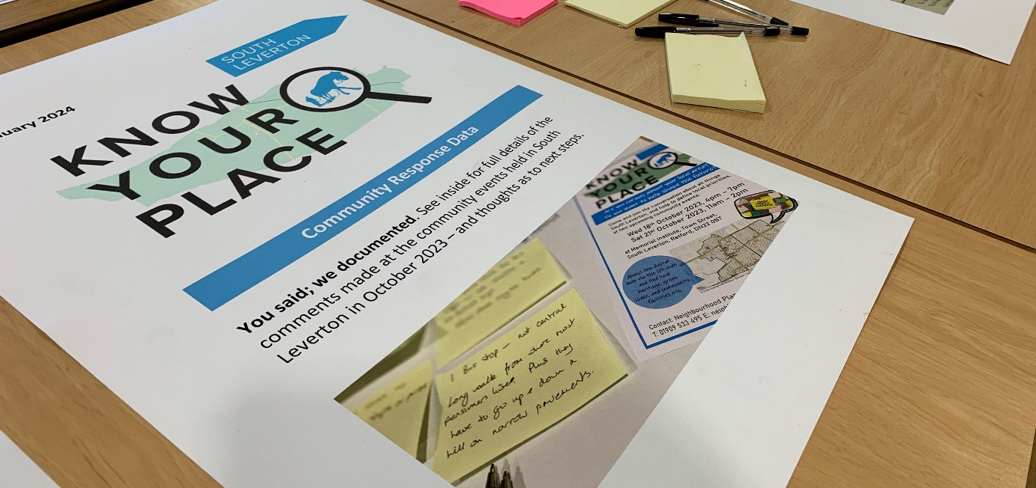

What is Know Your Place?
Know Your Place is a new tool developed by Bassetlaw District Council to encourage curiosity and discussion around local issues, and to assist communities to identify and document local priorities. The aim is that this new understanding about the local area could be used in various ways, depending on what has been identified and who is involved. This could, for example, include community projects, land use planning strategies, or further discussions or investigative work. Equally, better understanding of local issues may be a justifiable outcome in its own right.

How has Know Your Place been employed in South Leverton?
South Leverton was one of a number of communities in the District identified to trial and refine Know Your Place in practice. In the case of South Leverton, initial work was focussed upon commissioning new background studies about the Parish, specifically a Housing Need Assessment and Design Codes. These studies were funded by central government, and undertaken by subject specialists working for consultants AECOM. The final reports are available to view and download using the links below:
- South Leverton Housing Need Assessment
- South Leverton Design Guide and Codes
The second stage of activity saw the District Council hosting two Know Your Place community events in the Memorial Institute during October 2023. The events provided the opportunity to inspect a range of maps and associated information about the local area, alongside activities that encouraged people to share their views, queries, and aspirations for the Parish.
In January 2024, all of the responses provided during the course of the initial two community events were published in a Feedback Report. Alongside, a further community event was hosted in the Memorial Institute on 24 January, providing the opportunity for the response data to be viewed, and for supplementary comments and reflections to be captured as part of consideration of next steps.
What is the purpose of this report?
This report collates all of the responses provided at the initial Know your Place events held in October 2023 and the feedback event held in January 2024. The aim of the report is to provide a reference point for further discussion. Comments are presented as originally written-down, but with some adjustment to themes / groupings for consistency, with explanatory notes added in italics where relevant.

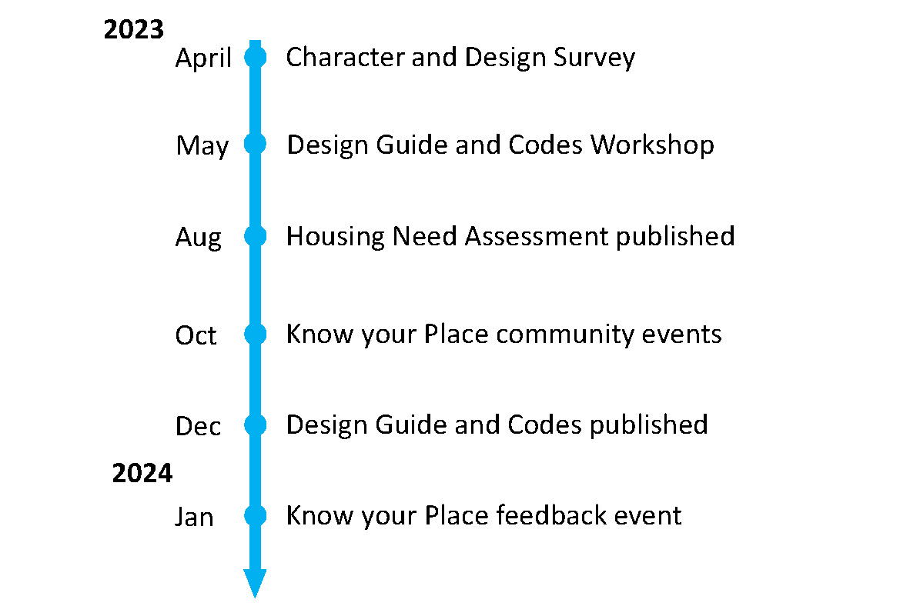

What happens next?
This publication of this report marks the conclusion of Know your Place activities in South Leverton – but hopefully marks the start of consideration of next steps. As detailed over the following pages, the process has helped to identify a range of topics and issues of interest to the community. Some of these may simply be useful observations, or help to affirm existing perceptions of the local area. Others may have more obvious implications that merit further exploration, whether by individuals, the Parish Council, or other parties – or through partnership working. The District Council will be glad to be involved in further discussion, and in supporting certain forms of responsive action, such as the development of a neighbourhood plan or a neighbourhood priorities statement (once new legislation to enable the latter is enacted).

Response Data from Community Events

What do you like about living in your neighbourhood?

- Countryside extends into village in places, making us feel a part of it.
- Country walks and access easy.
- Village pub.
- Village hall.
- People.
- Good access to walks / countryside (footpaths, stiles etc. need maintaining).
- Friendly people, some people willing to volunteer for village life e.g. South Leverton Memorial Institute, Parish Council.
- Everything. But roads - these are a real hazard.
- Wildlife – bats, deer, badgers, hares etc.
- Great walking.
- Quiet.
- Village hall functions.
- Friendly residents.
- Rural life.
- Rural.
- Peaceful.
- Pub.
- Conveniently connected to main artery – road/rail.

What needs improvement in your neighbourhood?

- Speeding.
- Public transport for more elderly villagers.
- Is it safe for school bus to be turning down Glover Close?
- Maintain beck, widen with a pond and seating area past pub.
- Speed restraints, particularly Town St.
- Pot holes.
- Road quality, speeding traffic.
- Local participation in village events + support of local public house.
- Access to doctor.
- Public transport.
- Awareness of need to maintain beck-flow through awareness.
- Riparian ownership.
- (In response to above) Residents should be informed about this – and exactly which bits are whose responsibility!

- Quality of roads, maintenance of hedgerows, reduce flooding potential.

Environment / Open Space

- Need an area for a play park in the village.
- Definitely an area for play park and small fetes to be held, even rented.
- A green space open to village hall for village events.
- Field in centre of village turned into nature walk & flood relief.
- Importance of preserving the small areas of green/woodland as well as the larger ones.
- The area is not suitable for turning a village into a small town.
- Lovely walks from the area around… not suitable for building locally.
- Open Space is fantastic for locals + walkers.
- Importance of small things, like finger posts, hedgerows…
- Keep land for agricultural use – do NOT plant solar panels on land that we need to grow our food.
- (In response to above) Not all land is used for growing food – we need to move with the times.
- Quality of roads, maintenance of hedgerows, reduce flooding potential.
- Land west of Church Street: important wildlife corridor along course of beck.
- Grounds of the Orchard School: Important parkland area – open breathing space/grazing area, also buffer to North Leverton.
- Land south of Station Road / north of Town Street: Open spaces and views are important to the feel of the village.
- Land between Glover Close and Bacon’s farm on south side of High Street: High Street - leave as green space.
- Fields south of Meetinghouse Lane: Lovely open space with lots of wildlife. Special quiet spot.
- Old railway line: Potential for using Cottam rail line into a cycle path to Retford or to the Trentside.
- Land between Glover Close and Bacon’s farm on south side of High Street: No more building on High Street. Small narrow road with major access problems.

Infrastructure

- Poor quality of the roads. Heavy lorries pass through very regularly (large haulage company also is based in the village). The poor road surface combined with excessive speeds cause houses on, the main road to vibrate.
- Very poorly maintained. Not capable of taking big development.
- Community wind turbine, before large developers monopolise.
- Tram line / Cottam rail line footpath.
- Roads, footpaths and hedgerows. All need much better maintenance.
- Flooding problem mainly caused by lack of regular cleaning of dykes – this must be done on at least 2 year programme.
- Make the potholes into a tourist attraction or national monument. I drive on the opposite side of the road to avoid. Can be dangerous in face of oncoming traffic. <- Ditto. I worry about cyclists. It’s a death trap.
- Poor state of footpaths spoiling the beauty of the village. Some are impossible to walk safely on. Damage by off-road vehicles + motor bikes + quad bikes.
- Improve footpath signs and better maintenance of hedgerows.
- General: The drainage system was not build to cope with modern hard standing. More development would exacerbate this problem for the overworked drains.

Services / Local Facilities

- The services we have are not sufficient to serve the current population – i.e. doctors, bus service, road structure, play areas. Before any new development is considered these areas need attention first.
- Local service infrastructure needs improvement but must not alter the charm of the village.
- Where is a school locally? So many things to be thought about!
- The pub could be the heart / centre of the community – family events, support local events i.e. Jubilee.

Transport / Getting About

- Speed limits, calming system in Town Street.
- (In response to above) Church Street and Retford Road first please – think this road name is an error.
- (Also in response to above) Church Street is worse, along with Retford Road – more traffic.
- Not enough policing of speed limits and traffic generally “speeds” through the village.
- Speed limit enforcement.
- Control of vehicle speed in village.
- Definitely speed reduction – we live on main road + the speeding is ridiculous.
- Not enough buses per day. A trip to town (Retford/Gainsborough) needs careful planning.
- Two bus stops where no bus actually stops or passes.
- Bus stop on main Treswell Road for elderly folk who live in the Glover Close bungalows. They have quite a trek to get to bus stop on Retford Road.
- Only 1 place where the bus stops – no shelter and no actual sign. How does anyone know?
- 1 Bus stop – not central. Long walk from where most pensioners live. Plus, they have to go up and down a hill on narrow pavements.
- Some people are complaining about a lack of used bus stops but there has also been a comment about the safety of buses turning down Glover Close – not really any other option?!
- Suggestion made about the need to promote the demand responsive bus service offered by Notts CC, in light of the recent changes to the routing of Stagecoach service bus 95).
- Too much parking on main roads whilst construction work is ongoing.
- Footpaths – historic footpaths on both east and west have NOT been maintained, although clearly marked.
- There are numerous historic footpaths on both east and west sides of the village which are presently unmarked.
- Old rail line to Cottam made into trail for cycling and walking.
- Junction of Church Street, High Street and Meetinghouse Lane: Access from High Street onto Church Street is poor – the view down the hill is only partial. The view and access is dangerous and creating more houses down High Street will lead to accident at the Cross Road.
- (In response to above) Can only be helped with a mirror on the corner of Meeting House Lane as houses obstruct view - but one was previously removed (by the Council?).

Housing

- We do not have the facilities (doctors, play areas, bus service or road structure) to serve more housing/bigger population, without developing the above.
- Better provision for existing villages down sizing and young families wanting to stay or move to the village.
- The setting of Listed Buildings should be preserved from development.
- (In response to above) Listed buildings need to be maintained to an acceptable standard to be preserved from development.
- Balance community need with growth, in migration, new residents etc. to keep village thriving.
- Housing needs to move with the times. Planning is sometimes so strict for no reason. It stops younger people staying as they don’t want to live in 50s, 60s, 70s houses.
- (In response to above) Newer buildings need to blend in with the village e.g. apartments that look like barns.
- The village has to move with the times! Allow some development – more affordable housing.
- Complete prior developments before applying for more (approved) e.g. (unclear) Farm.
- Orchard school ideal for turning into flats or maybe an old peoples home. But please, please keep the land as parkland and not for building land.
- More coordination needed between utilities and planned development.

Anything else

- Important not to take development in South Leverton in isolation. The impact of development at the Cottam and West Burton sites will have a joint effect on South Leverton, i.e. traffic, services etc.
- Concerns over major infrastructure/projects in the area; impact on village, roads etc: - Cottam (+ West Burton) Power stations redevelopment, - Proposed new power lines, pylons, etc.
- No large solar panel developments – during the 6 months of winter they contribute little or no generation into the grid.
- Huge solar farm (as a supplement to comment about concerns over infrastructure projects in the area).
- Clarity required with regard to the proposed 400 KV transmission lines.

Postcards from the Future: Imagine South Leverton in 2038

- People seem to love and know the village and its strong points. They strive to keep it this way and as you walk round there are so many lovely touches, i.e. the millennium sculpture – many locals took part in its development and build - its excellent! The “poppy” remembrance day mini statue, etc, etc. Local events take place regularly in the village hall where locals get together. It’s a thriving village, loved by all who live here. Roads definitely need ‘tweaking’! But why change something which is so good?
- 2038. Everything is maintained and footpaths open. Nothing drastically changed as south Leverton is beautiful. Hear! Hear!

Potential next steps

- We need structure (a framework) before any new development.
- I think we are now at the stage to hand over the “villager” comments to transform them into a full-blown neighbourhood plan by a professional NP writer.
- Needs to be a consistent approach e.g. a planning application to render a property was refused in one part of the village, yet half of a semi-detached ex-council property on main road was rendered.
- This (the Design Code) would help make planning decisions more fair – rather than it depending on villagers’ personal opinions – evidence-led!
- All this work needs moving forwards and developing into documentation supported by population of S. Leverton and Bassetlaw District Council.
- Design Code needs adopting – so we have more certainty.
- Need a definitive neighbourhood plan. Would require involvement and ownership of Parish Council – and a steering group.
- To do nothing would be waste of all the time, energy, and resources spent to-date. A document which has some “teeth” to take views into consideration (what this is?) needs to be drawn-up with the participation of local residents with a “steering group” with professional guidance heading it. Needs Parish Council to lead.
- Progress public open space offer – would this work on the Orchard School site? Could this be a project?
- If Not Now When (a trust, managing a public open space in Suffield, Norfolk - country walks, flora and fauna, seating, trees, small play area). Is this an option for the Orchard School site?

Neighbourhood Planning
Bassetlaw District Council

Queen’s Buildings,
Potter Street,
Worksop,
S80 2AH

Tel: 01909 533 495
Know Your Place
website

