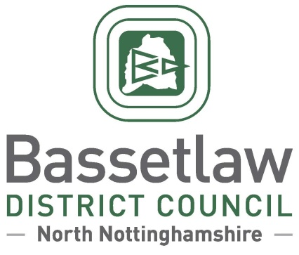

Nether Langwith Neighbourhood Plan – Decision Statement
(Examination and Referendum)

Summary
        - In accordance with Regulation 18 of the Neighbourhood Planning (General) Regulations 2012, Bassetlaw District Council has produced this ‘Decision Statement’ in relation to the Nether Langwith Neighbourhood Plan (the ‘Plan’).
        - Following independent examination, Bassetlaw District Council confirms that the Plan will proceed to a neighbourhood planning referendum, following enactment of the modifications specified in the Examination Report.
        - The referendum is scheduled for 23 May 2024, based on the Nether Langwith Neighbourhood Area, as approved by Bassetlaw District Council on 24 September 2020.
        - This Decision Statement, along with the Examination Report, can also be viewed on the Bassetlaw District Council website.

Background
        - On 13 August 2020, Nether Langwith Parish Council submitted an application to Bassetlaw District Council for the designation of Nether Langwith Parish as a Neighbourhood Area. The designation request was approved by Bassetlaw District Council at a meeting held on 24 September 2020, allowing work on the preparation of the Nether Langwith Neighbourhood Plan to commence.
        - The Pre-Submission Draft of the Nether Langwith Neighbourhood Plan was made available for consultation in accordance with Regulation 14 of the Neighbourhood Planning regulations between 12 June and 31 July 2023.
        - The Plan was formally submitted to the District Council on 15 November 2023. Bassetlaw District Council duly consulted the public and statutory bodies on the Plan for a seven week period between 17 November 2023 and 5 January 2024, in accordance with Regulation 16 of the Neighbourhood Planning regulations.
        - An Independent Examiner was appointed to undertake the examination of the Submission version of the Neighbourhood Plan. The Examiner’s Report was sent to the District Council on 21 February 2024 and shared with Nether Langwith Parish Council and uploaded to the District Council’s website the same day.

Decisions and Reasons
        - The Independent Examiner has concluded that, subject to the specified modifications being enacted, the Plan meets the Basic Conditions and other relevant legal requirements. The District Council concurs with this view.
        - The Head of Planning and Place, in consultation with the Council’s Cabinet Member for Identity and Place, has determined that all the recommended modifications set out in the Examiner’s Report will be enacted to ensure that the Plan meets the Basic Conditions. Furthermore, to meet the requirements of the Localism Act 2011, a referendum which poses the question “Do you want Bassetlaw District Council to use the Neighbourhood Plan for Nether Langwith to help it decide planning applications in the Neighbourhood Area?” will be held in the Nether Langwith Neighbourhood Area on Thursday 23 May 2024.

Beverley Alderton-Sambrook
Head of Planning and Place, Bassetlaw District Council
7 March 2024

