January 2024

Community Response Data

You said; we documented. See inside for full details of the comments made at the community events held in South Leverton in October 2023 – and thoughts as to next steps.

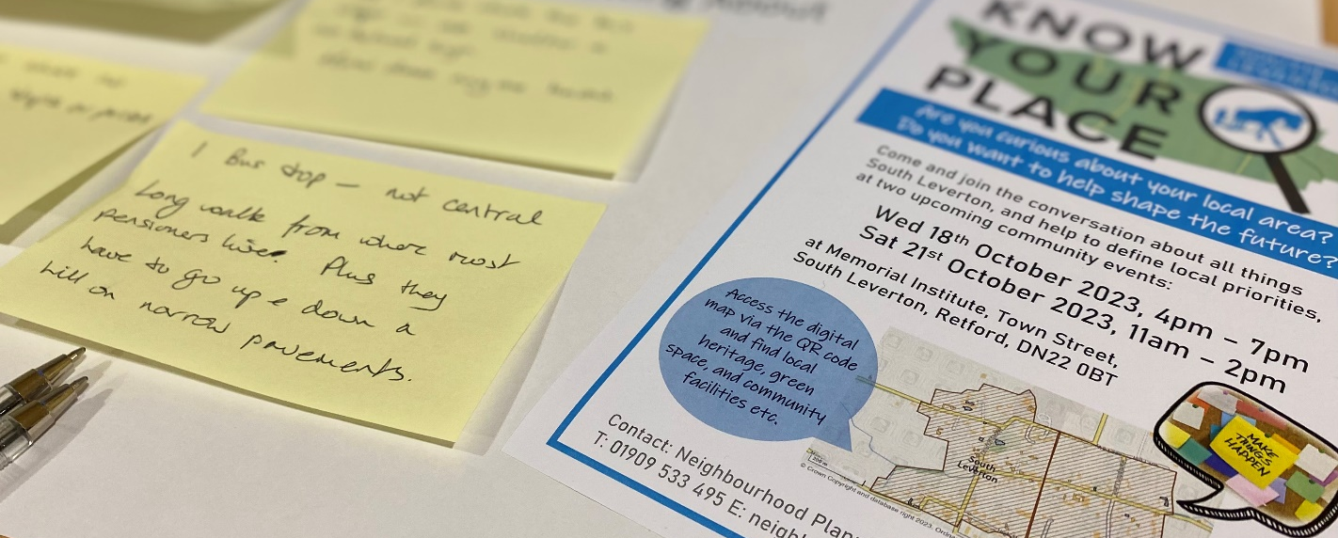

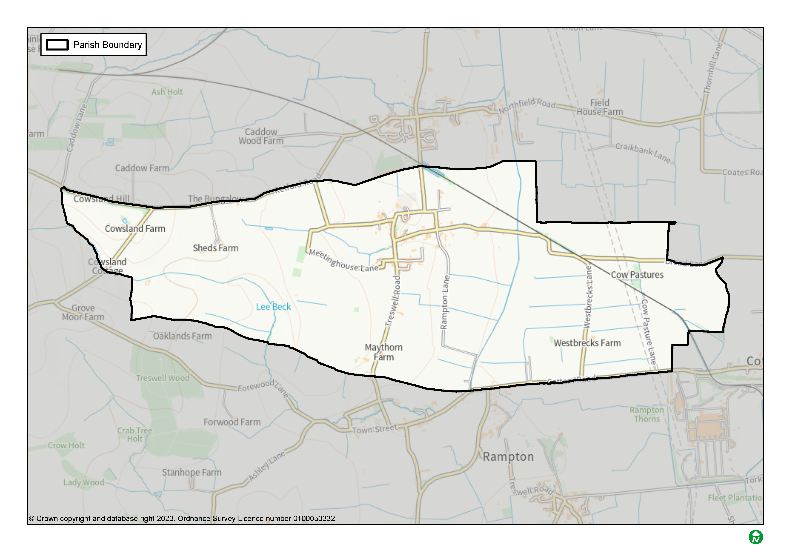
What is Know Your Place?
Know Your Place is a new tool developed by Bassetlaw District Council to encourage curiosity and discussion around local issues, and to assist communities to identify and document local priorities. The aim is that this new understanding about the local area could be used in various ways, depending on what has been identified and who is involved. This could, for example, include community projects, land use planning strategies, or further discussions or investigative work. Equally, better understanding of local issues may be a justifiable outcome in its own right.

How has Know Your Place been employed in South Leverton?
South Leverton was one of a number of communities in the District identified to trial and refine Know Your Place in practice. In the case of South Leverton, initial work was focussed upon commissioning new background studies about the Parish, specifically a Housing Need Assessment and Design Codes. These studies were funded by central government, and undertaken by subject specialists working for consultants AECOM. The final reports are available to view and download using the links below:

- South Leverton Housing Need Assessment
- South Leverton Design Guide and Codes

The second stage of activity saw the District Council hosting two Know Your Place community events in the Memorial Institute during October 2023. The events provided the opportunity to inspect a range of maps and associated information about the local area, alongside activities that encouraged people to share their views, queries, and aspirations for the Parish. All of the responses provided during the course of the two events are detailed across the following pages.

Response Data

Detailed below are all of the responses provided at the Know your Place events held in South Leverton during October 2023, as originally written-down, and grouped under the original headings.

As you read through, we encourage you to think about what the comments mean, if anything surprises you, and if, how, and by whom, they could or should be responded to – this will form the next part of the discussion.

What do you like about living in your neighbourhood?

- Countryside extends into village in places, making us feel a part of it.
- Country walks and access easy.
- Village pub.
- Village hall.
- People.
- Good access to walks / countryside (footpaths, stiles etc. need maintaining).
- Friendly people, some people willing to volunteer for village life e.g. South Leverton Memorial Institute, Parish Council.
- Everything. But roads - these are a real hazard.
- Wildlife – bats, deer, badgers, hares etc.
- Great walking.
- Quiet.
- Village hall functions.
- Friendly residents.
- Rural life.
- Rural.
- Peaceful.
- Pub.
- Conveniently connected to main artery – road/rail.

What needs improvement in your neighbourhood?

- Speeding.
- Public transport for more elderly villagers.
- Is it safe for school bus to be turning down Glover Close?
- Maintain beck, widen with a pond and seating area past pub.
- Speed restraints, particularly Town St.
- Pot holes.
- Road quality, speeding traffic.
- Local participation in village events + support of local public house.
- Access to doctor.
- Public transport.
- Awareness of need to maintain beck-flow through awareness.
- Riparian ownership.
- Quality of roads, maintenance of hedgerows, reduce flooding potential.

Environment / Open Space

- Need an area for a play park in the village.
- The area is not suitable for turning a village into a small town.
- Importance of preserving the small areas of green/woodland as well as the larger ones.
- Definitely an area for play park and small fetes to be held, even rented.
- A green space open to village hall for village events.
- Lovely walks from the area around… not suitable for building locally.
- Field in centre of village turned into nature walk & flood relief.
- Open Space is fantastic for locals + walkers.
- Importance of small things, like finger posts, hedgerows…

Services / Local Facilities

- The services we have are not sufficient to serve the current population – i.e. doctors, bus service, road structure, play areas. Before any new development is considered these areas need attention first.
- Local service infrastructure needs improvement but must not alter the charm of the village.
- Where is a school locally? So many things to be thought about!

Infrastructure

- Poor quality of the roads. Heavy lorries pass through very regularly (large haulage company also is based in the village). The poor road surface combined with excessive speeds cause houses on, the main road to vibrate.
- Very poorly maintained. Not capable of taking big development.
- Community wind turbine, before large developers monopolise.
- Tram line / Cottam rail line footpath.
- Roads, footpaths and hedgerows. All need much better maintenance.
- Flooding problem mainly caused by lack of regular cleaning of dykes – this must be done on at least 2 year programme.
- Make the potholes into a tourist attraction or national monument. I drive on the opposite side of the road to avoid. Can be dangerous in face of oncoming traffic. <- Ditto. I worry about cyclists. It’s a death trap.
- Poor state of footpaths spoiling the beauty of the village. Some are impossible to walk safely on. Damage by off-road vehicles + motor bikes + quad bikes.
- Improve footpath signs and better maintenance of hedgerows.
Transport / Getting About

- Speed limits, calming system Town ST.
- Old rail line to Cottam made into trail for cycling and walking.
- Not enough buses per day. A trip to town (Retford/Gainsborough) needs careful planning.
- Not enough policing of speed limits and traffic generally “speeds” through the village.
- Two bus stops where no bus actually stops or passes.
- Bus stop on main Treswell Road for elderly folk who live in the Glover Close bungalows. They have quite a trek to get to bus stop on Retford Road.
- Only 1 place where the bus stops – no shelter and no actual sign. How does anyone know?
- 1 Bus stop – not central. Long walk from where most pensioners live. Plus, they have to go up and down a hill on narrow pavements.
- Speed limit enforcement.
- Too much parking on main roads whilst construction work is ongoing.
- Control of vehicle speed in village.
- Definitely speed reduction – we live on main road + the speeding is ridiculous.

Housing

- We do not have the facilities (Doctors, play areas, bus service or road structure). To serve more housing/bigger population, without developing the above.
- Better provision for existing villages down sizing and young families wanting to stay or move to the village.
- The setting of Listed Buildings should be preserved from development.
- Balance community need with growth, in migration, new residents etc. to keep village thriving.
- Housing needs to move with the times. Planning is sometimes so strict for no reason. It stops younger people staying as they don’t want to live in 50s, 60s, 70s houses.
- Complete prior developments before applying for more (approved) e.g. (unclear) Farm
- Orchard school ideal for turning into flats or maybe an old peoples home. But please, please keep the land as parkland and not for building land.

Location-specific comments (from map): Positives

- Land west of Church Street: important wildlife corridor along course of beck.
- Grounds of the Orchard School: Important parkland area – open breathing space/grazing area, also buffer to North Leverton.
- Land south of Station Road / north of Town Street: Open spaces and views are important to the feel of the village.

- Fields south of Meetinghouse Lane: Lovely open space with lots of wildlife. Special quiet spot.
- Land between Glover Close and Bacon’s farm on south side of High Street: High Street - leave as green space.
- Old railway line: Potential for using Cottam rail line into a cycle path to Retford or to the Trentside.

Location-specific comments (from map): Negatives

- General: The drainage system was not build to cope with modern hard standing. More development would exacerbate this problem for the overworked drains.
- Junction of Church Street, High Street and Meetinghouse Lane: Access from High Street onto Church Street is poor – the view down the hill is only partial. The view and access is dangerous and creating more houses down High Street will lead to accident at the Cross Road.
- Land between Glover Close and Bacon’s farm on south side of High Street: No more building on High Street. Small narrow road with major access problems.

Anything else

- Important not to take development in South Leverton in isolation. The impact of development at the Cottam and West Burton sites will have a joint effect on South Leverton, i.e. traffic, services etc.
- Concerns over major infrastructure/projects in the area; impact on village, roads etc: - Cottam (+ West Burton) Power stations redevelopment, - Proposed new power lines, pylons, etc.

Postcards from the Future: Imagine South Leverton in 2038

- People seem to love and know the village and its strong points. They strive to keep it this way and as you walk round there are so many lovely touches, i.e. the millennium sculpture – many locals took part in its development and build - its excellent! The “poppy” remembrance day mini statue, etc, etc. Local events take place regularly in the village hall where locals get together. It’s a thriving village, loved by all who live here. Roads definitely need ‘tweeking’! But why change something which is so good?
- 2038. Everything is maintained and footpaths open. Nothing drastically changed as south Leverton is beautiful. Hear! Hear!

What happens next?
As outlined at the beginning of this report, there are various possible ways that the response data included in this report might prove useful. What actually happens next is down to you – and we are keen to help to consider and facilitate this.
A follow-on community event is due to be held in South Leverton this month to assist consideration of next steps:

- Wednesday 24 January 2024, between 4pm and 7.30pm, Memorial Institute, Town Street, South Leverton, DN22 0BT

The event will provide an opportunity to view the maps, reports, and response data, share your thoughts, and to discuss with fellow attendees and officers from the District Council.
Your thoughts on next steps are also welcome via email, letter, or over the telephone, using the contact details on the back page; we’re here to help.

Neighbourhood Planning
Bassetlaw District Council

Queen’s Buildings,
Potter Street,
Worksop,
S80 2AH
Tel: 01909 533 495
Email: neighbourhoodplanning@bassetlaw.gov.uk
Know your Place website
Know Your Place
website

