Strategic Environmental Assessment & Habitat Regulations Assessment Screening Statement

Retford Town Centre
Neighbourhood Plan
December 2023

Table of Contents

1 Introduction 2
Strategic Environmental Assessment (SEA) 2
Habitat Regulations Assessment 3
Summary of Findings 3
2 The Retford Town Centre Neighbourhood Plan 4
Plan Overview 5
Vision 5
Community Objectives 5
Development Management Policies 5
3 SEA Screening – Assessment 8
SEA Assessment 8
4 HRA Screening – Assessment 13
HRA Screening Matrix 15
5 In-combination Effects 23
6 Conclusions 24
SEA Screening 24
HRA Screening 24
Appendix 1: Consultation Responses 25
Appendix 2: Ecological attributes of the European sites 26

Introduction
        - This document contains the Screening Statements for the Retford Town Centre Neighbourhood Plan - (the Plan) - with regard to whether a Strategic Environmental Assessment (SEA) and / or Habitat Regulations Assessment (HRA) are required to be undertaken. The document also includes an assessment of the policies proposed in the Plan with regard to Impact Risk Zones for Sites of Special Scientific Interest (SSSI).
        - Regulation 15 of the 2012 Neighbourhood Planning (General) Regulations sets out the information that must accompany a Neighbourhood Plan when submitted to the local planning authority. In February 2015 amendments to the Neighbourhood Plan Regulations came into force; this is known as the Neighbourhood Planning (General) (Amendment) Regulations 2015. Regulation 2(4) of these amendments adds additions to the list of documents that a qualifying body must submit to a local planning authority with a Neighbourhood Plan. The additional document which must be submitted is either an environmental report prepared in accordance with the relevant regulations or, if the outcome concludes that an SEA or HRA is not necessary, a statement that sets out how environmental issues have been taken into account and considered during the preparation of the Neighbourhood Plan.
        - The National Planning Policy Framework (para 167) advises that assessments should be proportionate, and should not repeat policy assessment that has already taken place. In view of this, only a high level screening assessment of the Plan has been undertaken, and this assessment should be read in conjunction with the relevant reports produced for Bassetlaw District Councils Local Development Framework.
        - As the responsible authority under relevant regulations, Bassetlaw District Council has undertaken the Screening Assessment contained in this document, working with the Retford Town Centre Neighbourhood Planning Group.

Strategic Environmental Assessment (SEA)
        - The requirement for a SEA to be undertaken on development plans and programmes that may have a significant environmental effect is outlined in European Union Directive 200142/EC. The Environmental Assessment of Plans and Programmes Regulations 2004 (the 2004 Regulations) state that this is determined by a screening process, utilising a specified set of criteria, outlined in Schedule 1 of the Regulations. The results of this process must be set-out in an SEA Screening Statement, which must be publicly available.
        - The objective of undertaking a SEA is “to provide for a high level of protection of the environment and to contribute to the integration of environmental considerations into the preparation and adoption of plans and programmes with a view to promoting sustainable development, by ensuring that, in accordance with this Directive, an environmental assessment is carried out of certain plans and programmes which are likely to have significant effects on the environment.”

Habitat Regulations Assessment
        - European protected sites (the ‘Natura 2000 Network’) are of exceptional importance for the conservation of important species and natural habitats within the European Union. The network of European protected sites comprises Special Protection Areas (SPAs) designated under the Birds Directive (79/409/EEC), Special Areas of Conservation (SACs) designated under the Habitats Directive (92/43/EEC) and Ramsar sites designated under the Ramsar Convention 1975. Government guidance advises that potential SPAs (pSPA), candidate SACs (cSAC) and potential Ramsar (pRamsar) sites are also included in HRA’s.
        - As a land use plan, an assessment of the Retford Town Centre Neighbourhood Plan may be required under the Conservation of Habitats and Species (Amendment) Regulations 2012 (the Habitat Regulations) and Article 6(3) of the EU Habitats Directive in order to determine whether the Plan may result in significant effects on identified sites.
        - As with the SEA, a screening process is employed to establish whether any elements of the Draft Plan could have a significant effect on these sites. Regulation 32 of the Neighbourhood Planning (General) Regulations 2012 (as amended) further reemphasises the importance of carrying out this assessment by stating that one of the basic conditions that must be met before the Plan may be ‘made’ is that “the making of the neighbourhood plan is not likely to have a significant effect on a European site (as defined in the Conservation of Habitats and Species Regulations 2012) or a European offshore marine site (as defined in the Offshore Marine Conservation (Natural Habitats, &c.) Regulations 2007 (either alone or in combination with other plans or projects)”.

Summary of Findings
        - Following the undertaking of the Screening Assessments, it is concluded that the Plan, in its current form, will not have any significant negative effects on the environment or any identified European sites. It is considered, therefore, that a full environmental assessment and habitat regulations assessment is not required.
        - This determination has been reached by assessing the contents of a pre-release version of the Submission Draft of the Neighbourhood Plan, issued to the District Council in September 2023. The Plan has been assessed against criteria provided in Schedule 1 of the 2004 Regulations and with regard to Regulation 32 of the 2015 Neighbourhood Planning Regulations & the Habitat Regulations. The conclusions are detailed in full in Section 6 (p25) of this report.

The Retford Town Centre Neighbourhood Plan

        - The Neighbourhood Plan is being developed by the Retford Town Centre Neighbourhood Planning Group, a designated neighbourhood forum, and the Qualifying Body for the Retford Town Centre Neighbourhood Area in Bassetlaw District, Nottinghamshire. The Neighbourhood Area is depicted in Figure 1, below. The Plan has been devised to cover the period to 2038.
Figure 1: Designated Neighbourhood Area
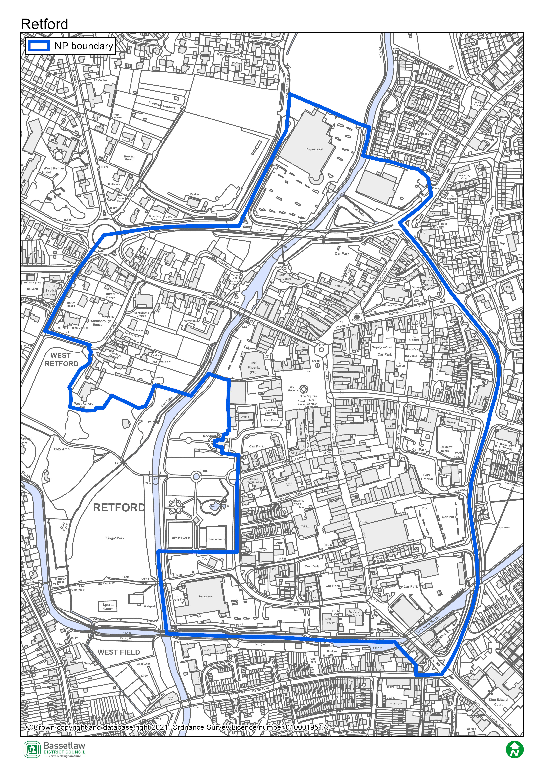

Plan Overview
        - As detailed below, the priorities of the Plan are captured in the Vision and Community Objectives (see pages 12 and 13 of the Plan), to be delivered through the application of 22 development management policies specific to the Neighbourhood Area.

Vision
By 2038, Retford Town Centre will be safe, healthy, accessible and sustainable, supporting people of all ages. Its heritage buildings will remain attractive to businesses. It will be a place to grow and prosper, providing a range of employment sites and premises.
Retford Town Centre is future facing, the home of people and businesses looking to reduce their carbon footprint. The value of natural assets will be enhanced and extended, and investment will create a rich mix of shopping, leisure, sports, health, cultural and social facilities making Retford Town Centre appealing as a place to live, learn, develop, work and spend quality leisure time.

Community Objectives
- To promote the development of key spaces and vacant or underutilised properties to the benefit of businesses and residents.
- To protect and enhance the historic character of the Town Centre to ensure that all new development is designed to a high standard in accordance with the Retford Town Centre Neighbourhood Plan 2022-2038. All development will:
a) respect the materials, style and layout of the historic Town Centre and Conservation Area
b) enhance the character of the Town Centre.
- To support and encourage development of the wide range of community facilities in the Town Centre.
- To upgrade Retford’s landscape and public realm to enhance its attractiveness as a destination.
- To support the growth of a vibrant and varied daytime and evening economy attracting micro, small and medium sized businesses.
- To create a well-connected street network, facilitating its harmonious use by all, to promote health and well-being.
- To promote improvements in public and private spaces that will enhance biodiversity and mitigate climate change and flood resilience measures.
- To support and promote innovative solutions to accelerate the Town Centre to Net Zero by 2035, including the promotion of solar energy, increasing the provision of electric charging points.

Development Management Policies
        - The 22 development management policies included in the Neighbourhood Plan are summarised in the following table.
Policy | Summary
Policy 1: Protecting and Enhancing Heritage Assets | Requires consideration of the impact of new development on identified features of historical significance.
Policy 2: Achieving Well Designed Places | Seeks to maintain and enhance the character and distinctiveness of the Neighbourhood Area, through reference to the accompanying Design Guidance and Codes, and identified character areas.
Policy 3: Protecting Significant Views | Identifies and describes a series of key views, and requires that development proposals evidence how they will conserve and enhance them.
Policy 4a: Improving The Square | Identifies certain requirements that development that will impact upon The Square need to meet, including in respect to design, movement, and use / function.
Policy 4b: Improving Canon Square | Provides support for development that will enhance non-vehicular movement and environmental improvements in the vicinity of Canon Square.
Policy 4c: Improving Carolgate | Provides support for development that will enhance non-vehicular movement, and the visual coherence of the street scene in Carolgate.
Policy 5a: Acceptable uses in the Town Centre | Provides direction as to appropriate land uses within and outside the Primary Shopping Area, particularly at ground floor level.
Policy 5b: Shop Fronts | Details criteria that proposals for retail frontages are required to address in order to be supported.
Policy 5c: Improving Broadband and Mobile Connectivity | Seeks to support improvements to broadband and mobile connectivity, subject to any required infrastructure respecting the historic character of the Plan area.
Policy 6a: Greening the Streets | Identifies a range of requirements relating to the retention and improvement of green infrastructure as part of the public realm.
Policy 6b: Protecting and Enhancing Biodiversity | Requires that development proposals safeguard blue and green infrastructure, seek to deliver biodiversity net gain of at least 10%, include sustainable drainage systems where appropriate, and mitigation and / or compensation measures if negative ecological impacts are anticipated.
Policy 7: Improving the Canal and River Corridors | Identifies statutory easements alongside the canal and river corridors, encourages developments to include active frontages, and provides support for the development of a connected waterside walkway.
Policy 8: Significant Green Areas | Requires that any development within the identified Significant Green Areas respect their sense of openness and / or landscape value.
Policy 9: Extending the Footpath and Cycle Routes | Provides support for developments that seek to improve or extend the network of foot and cycle paths, including a number of specific areas of interest.
Policy 10a: Housing Mix | Translates the findings of the Housing Need Assessment into policy, including stipulations on the mix of sizes, and support for developments that meet higher standards of accessibility / adaptability.
Policy 10b: Housing Tenure | Provides support for developments that seek to increase the provision of affordable routes to home ownership.
Policy 10c: Accommodation for Older People | Provides support for the development of new accommodation for older people.
Policy 11: Renewable Energy, Energy Efficiency, and Low Carbon Technologies | Encourages the inclusion of energy and water efficiency measures within new development and retrofit of existing buildings.
Policy 12: Reducing the Risk of Flooding | Recognises the potential impacts of flood risk in the Neighbourhood Area, and requires these to be addressed by all development proposals.
Policy 13a: The Renovation or Redevelopment of Ebsworth Hall | Site-specific policy that provides support for the renovation or redevelopment of Ebsworth Hall, subject to a range of stipulations.
Policy 13b: Land between Amcott Way, Bridgegate and River Lane | Site-specific policy, providing support for mixed-use development, subject to a range of stipulations.
Policy 13c: Redevelopment of Goodwin Hall and Registry Office Buildings | Site-specific policy, providing support for mixed-use development across two adjoining sites, subject to a range of stipulations, particularly consideration of potential flood risk.

SEA Screening – Assessment
        - The table below includes the assessment of the Retford Town Centre Neighbourhood Plan, including its Objectives and Development Management Policies, against the criteria included in Schedule 1 of the 2004 Regulations. The Neighbourhood Plan is being assessed as a whole against the criteria listed below to allow for the consideration of its effects on the environment.

SEA Assessment

Criteria for determining the likely significance of effects (Annex II SEA Directive) | Significant effect likely? | Comment
1a The degree to which the plan or programme sets a framework for projects and other activities, either with regard to the location, nature, size and operating conditions or by allocating resources. | NO | The Retford Town Centre Neighbourhood Plan (the Plan) sets-out a spatial vision for the designated Neighbourhood Area and an accompanying framework to guide development proposals. This framework will be delivered by the development management policies contained within the Plan. The framework will have some impacts on the environment, noticeably the support for development proposals. However, it is deemed that these impacts will not be significant, due to their small-scale, localised nature, and the stipulations detailed in the policies.
1b The degree to which the plan or programme influences other plans and programmes including those in a hierarchy. | NO | The Plan, where possible, will respond to rather than influence other plans and programmes. It is part of a hierarchy, but is at the lowest tier, sitting below the Bassetlaw Core Strategy DPD (District level) and National Planning Policy Framework (National level), and has thus been influenced by these higher-tier and pre-existing plans, rather than having an influence on them.  The Plan has been developed with a view towards the emerging Bassetlaw Local Plan, but will remain below it in the policy hierarchy.  The policies within a neighbourhood plan apply only within the designated neighbourhood area, hence the Plan will not have a direct impact on adjoining areas.
1c The relevance of the plan or programme for the integration of environmental considerations in particular with a view to promoting sustainable development. | NO | The Plan promotes sustainable development within the Neighbourhood Area through balancing environmental, social and economic objectives. The Vision & Objectives (page 12), in conjunction with the development management policies, work to ensure that all development proposals brought forward in the area will take this balance into account.  Specifically, the forms of development supported by policies 13a, 13b, and 13c are viewed as key to ensuring the long-term sustainability of the Plan area. This projected growth is balanced by the protection of key environmental and social / cultural assets, both through criteria in the above policies themselves, and through the other policies in the Plan.  As a result, it is considered that the Plan effectively integrates and balances all potential environmental considerations, and that potential impacts are, therefore, unlikely to be significant.
1d Environmental problems relevant to the plan or programme. | NO | As noted above, the Plan supports development on a number of fronts, including residential development and economic development, all of which could have some effects on the environment. However, existing national and local planning policies, the specific criteria included within the policies in the Plan, and the planning application process, will collectively ensure that these effects are not significant.
1e The relevance of the plan or programme for the implementation of Community legislation on the environment (for example, plans and programmes linked to waste management or water protection). | NO | The Plan is intended to be in compliance with the Bassetlaw Local Development Framework, which has taken into account the existing European and National legislative framework for environmental protection. The Plan will therefore have a positive effect on compliance with regards to relevant legislation and programmes. It is considered that none of the proposals within the Plan will compromise this position.
2a The probability, duration, frequency and reversibility of the effects. | NO | It is deemed highly unlikely that there will be any irreversible damaging environmental impacts associated with the Plan. The policies within the Plan seek to ensure new development is sustainable in context, and promotes the enhancement and protection of environmental assets.  Should any unforeseen significant effects on the environment arise as a result of the Plan, the intention to monitor the Plan and also to review/update the Plan when required will allow these effects to be addressed (see Section 21: Monitoring and Review (page 78).
2b The cumulative nature of the effects. | NO | It is considered that the Policies contained in the Plan, cumulatively, will have minimal negative effects on the environment and will, moreover, have significant positive effects through the stipulations included. It is considered that all effects will be at a local level.
2c The transboundary nature of the effects. | NO | Effects will be local, with no expected impacts on neighbouring areas.
2d The risks to human health or the environment (for example, due to accidents). | NO | No obvious risks have been identified, as the overall aim of the Plan is to ensure the careful management of development and the continued sustainability of the Plan area.
2e The magnitude and spatial extent of the effects (geographical area and size of the population likely to be affected). | NO | The Plan relates to, and will have an influence over, a designated neighbourhood area of approximately 39.6 hectares, and includes approximately 487 dwellings, home to approximately 750 people. It is deemed the Plan as a whole will have a positive impact upon local residents through the protection and enhancement of local environmental and social / cultural assets, and the promotion of sustainable development.
2f The value and vulnerability of the area likely to be affected due to:  (i) special natural characteristics or cultural heritage;  (ii) exceeded environmental quality standards or limit values; or  (iii) intensive land-use. | NO | The Plan is deemed unlikely to have an adverse effect on the natural characteristics and cultural heritage of the neighbourhood area and, moreover, is likely to enhance the protection afforded to such assets.  Natural characteristics  The Chesterfield Canal is a notable feature in the Plan area, and has wider regional significance, and is designated a Local Wildlife Site. There are no SSSI within the Plan area, but there a number in relative proximity for which the impact risk zones intersect the boundary, namely:  - Sutton and Lound Gravel Pits (Bellmoor)  - Chesterfield Canal (Clarborough South)  - Castle Hill Wood  The Plan includes three policies in particular designed to protect and enhance the natural assets in the Neighbourhood Area. Policy 3R addresses green and blue infrastructure and biodiversity. Policy 6a supports enhancements to green infrastructure, whilst Policy 6b seeks to safeguard blue and green infrastructure and secure biodiversity net gain. Policy 7 supports the protection and enhancement of the canal and river corridors. Policy 8 identifies a series of significant green areas for protection, whilst Policy 12 addresses the need to manage the risk of flooding in the Neighbourhood Area.  Cultural heritage  There are no World Heritage Sites, Protected Wreck Sites, Registered Battlefields, Registered Park and Gardens, or Scheduled Ancient Monuments in the Neighbourhood Area. Kings’ Park, immediately adjoining the Neighbourhood Area, is identified as an Unregistered Park and Garden, and elements of the designation overlap.  The majority of the Neighbourhood Area is included within the Retford Conservation Area, with the exception of the portion north of Amcott Way. The same is true in respect to areas of archaeological interest, with the exception of the Morrison’s site north of Amcott Way.  There are 88 Listed Buildings in the Neighbourhood Area, the majority of which are Grade II. Retford War Memorial, St Swithun’s Church, St Michael’s Church, Sloswick’s Hospital Almshouses, Amcott House, and 25 Grove Street are all Grade II*. There are also a significant number of Positive Buildings in a Conservation Area. Policy 1 (Protecting and Enhancing Heritage Assets) specifically addresses local heritage assets and their setting, reinforcing the existing designations.  The three site-specific allocations (Policies 13a to 13b inclusive) provided detailed stipulations as to the forms of development that will be acceptable, and take a cautious approach in respect to flood risk. The allocations are underpinned by site assessment, consultation, and engagement with consultees, which informed the policy stipulations.  The range of supporting studies / evidence base documents play an invaluable role in in detailing the character of the Neighbourhood Area, but also inform policies that seek to protect and enhance these assets. This includes the Design Code and Masterplan, and two ecology studies.  It is considered that the development supported by the Plan will not result in significant effects on the identified natural or cultural heritage assets. Furthermore, the Plan does not exceed environmental quality standards or limit values, and does not provide specific policies in relation to intensive land uses.
2g The effects on areas or landscapes which have a recognised national, community or international protection status. | NO | It is considered that the Plan will not adversely affect areas of landscape which have recognised community, national or international protection. The need for new development to respect their landscape and townscape setting is included as part of the criteria within the respective Policies.

HRA Screening – Assessment

        - For the HRA screening assessment, the designated neighbourhood area was assessed to identify if any Special Protection Areas (SPA), Special Areas of Conservation sites (SAC), or Ramsar sites were located within the boundary, as well as those considered as potential sites (pSPA, ppSPA, cSAC & pRamsar). The assessment also identified if any of these internationally important sites were located within a 15km radius from the Neighbourhood Plan area. The results of this exercise are detailed on the map included as Figure 4 on page 14. The Birklands and Bilhaugh SAC is located approximately 12.8 km to the south west of the border of the Neighbourhood Area. Descriptions of the ecological attributes of the Birklands and Bilhaugh SAC are included as Appendix 2.
        - Although not formally a pSPA, Natural England has advised that there is a possibility of a Sherwood Forest pSPA being designated in the future, on reflection of populations of breeding nightjar and woodlark. In a note to Local Planning Authorities dated March 2014, Natural England advocates a precautionary approach to any plans or projects which could affect such a site. This approach should ideally cover the potential direct, indirect and cumulative impacts, which may include, but may not be limited to, the following;
- disturbance to breeding birds from people, their pets and traffic;
- loss, fragmentation and/or damage to breeding and/or feeding habitat;
- bird mortality arising from domestic pets and/or predatory mammals and birds;
- bird mortality arising from road traffic and/or wind turbines.
        - No formal assessments of the boundary of any future SPA has been made, therefore, it is not possible to definitively identify whether individual sites would fall inside or outside any possible future designated area. However, the Natural England note encloses a map which highlights the areas of greatest ornithological interest for breeding nightjar and woodlark. This has been included on Figure 4, and identifies that the ppSPA is approximately 6 km south west of the Plan area.
        - The Screening Assessment on page 15 has considered the main potential sources of effects on the identified European sites arising from the Plan, possible pathways to the sites, and the effects on possible sensitive receptors. The assessment considers the impacts of the policies in the Plan directly on the identified sites, as these are land use policies, hence mostly expected to have some direct or indirect impact on the local environment.

Figure 4: Map of Special Protection Areas and Special Areas of Conservation in relation to the Retford Town Centre Neighbourhood Area
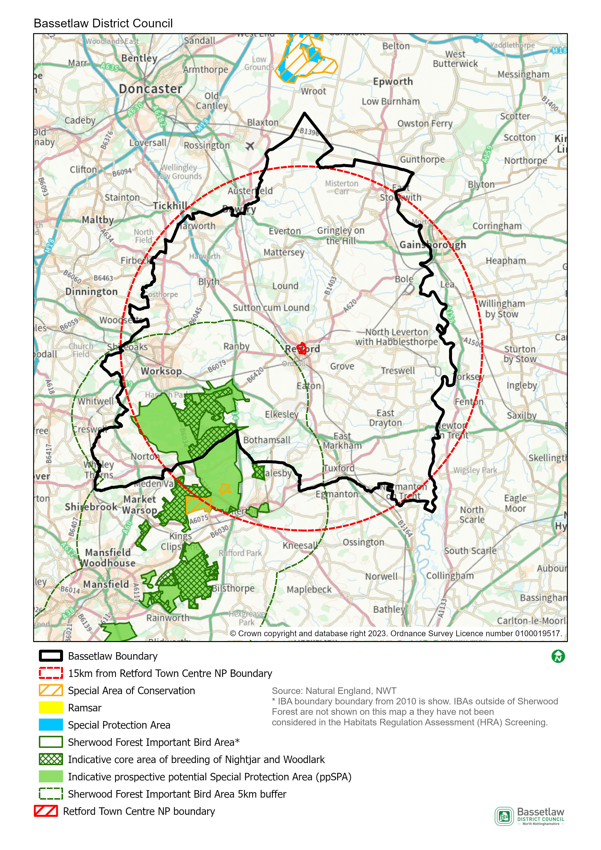

HRA Screening Matrix
The screening matrix below shows which types of impacts on European sites could potentially result from each of the policies and sites allocated in the Retford Town Centre Neighbourhood Plan. Where a site is not expected to have a particular type of impact, the relevant cell is shaded green. Where a site could potentially have a certain type of impact, this is shown in orange. The final column sets out the screening conclusions.
Policy | Likely activities (operation) to result as a consequence of the proposal | Likely effects if proposal  implemented | European site(s) potentially affected | Could the proposal have likely significant effects on European sites?
Policy 1: Protecting and Enhancing Heritage Assets | None. This policy ensures that the heritage assets within the Plan area are respected and, where possible, enhanced – it will not itself result in new development. | N/A | N/A | No
Policy 2: Achieving Well Designed Places | None. This policy sets out principles to influence the design and layout of development - it will not itself result in new development. | N/A | N/A | No
Policy 3: Protecting Significant Views | None. The policy provides protection for identified key views– it does not, itself, support development.
Policy 4a: Improving The Square
Policy 4b: Improving Canon Square
Policy 4b: Improving Canon Square
Policy 4c: Improving Carolgate
Policy 5a: Acceptable uses in the Town Centre | None. The policy provides direction on appropriate land uses, but does not itself support new development. | N/A | N/A | No
Policy 5b: Shop Fronts | None. The policy provides instruction as to the design of shop fronts, but does not itself support new development. | N/A | N/A | No
Policy 5c: Improving Broadband and Mobile Connectivity | None. The policy supports the provision of improvements to communications infrastructure as part of new development – it will not itself result in new development. | N/A | N/A | No
Policy 6a: Greening the Streets | None. The policy encourages the retention and / or inclusion of green infrastructure as part of development proposals – it will not itself result in new development.
Policy 6b: Protecting and Enhancing Biodiversity | None. The policy seeks to protect and enhance green and blue infrastructure and biodiversity. | N/A | N/A | No
Policy 7: Improving the Canal and River Corridors | None. The policy requires any development proposals alongside the canal and river corridors to respect and, where possible, enhance their location – it does not, itself, support development. | N/A | N/A | No
Policy 8: Significant Green Areas | None. The policy provides new protections to identified areas of open space / green infrastructure – it does not, itself, support development. | N/A | N/A | No
Policy 9: Extending the Footpath and Cycle Routes | None. The policy supports the inclusion of enhancements to the cycle and footpath network as part of development proposals – it does not, itself, support development. | N/A | N/A | No
Policy 10a: Housing Mix | None. The policy seeks to ensure the type and size of housing reflects local needs – it does not, itself, support development. | N/A | N/A | No
Policy 10b: Housing Tenure | None. The policy seeks to ensure the type and size of housing reflects local needs – it does not, itself, support development. | N/A | N/A | No
Policy 10c: Accommodation for Older People | Residential development.  Increase in vehicular traffic.  Increase in recreation pressure. | Physical loss and damage.  Air pollution.  Disturbance from recreation. | Birklands and Bilhaugh SAC  Sherwood Forest ppSPA | No significant effects anticipated.  The Neighbourhood Area is approximately 12.8 km at the nearest from the Birklands and Bilhaugh SAC, and 6 km at the nearest from the Sherwood Forest ppSPA. Physical loss and damage is, therefore, not possible.  It would not be expected for birds to be dependent on the habitat within Retford Town Centre.  This Policy alone would not be expected to cause a significant increase in traffic and air pollution in the area.  With regard to pathways, it is considered that the nature and small scale of the development supported by this Policy, including the distance between the Neighbourhood Area and the European sites, and intervening infrastructure, will not result in significant effects occurring.
Policy 11: Renewable Energy, Energy Efficiency, and Low Carbon Technologies | None. This policy encourages the incorporation of sustainable design features and energy efficiency measures as part of new developments – it will not itself result in new development. | N/A | N/A | No
Policy 12: Reducing the Risk of Flooding | None. This policy ensures that development plays appropriate reference to flood risk management and incorporates measures to avoid or mitigate impacts – it will not itself result in new development. | N/A | N/A | No
Policy 13a: The Renovation or Redevelopment of Ebsworth Hall | Community facility development.  Economic development.  Increase in vehicular traffic. | Physical loss and damage.  Air pollution.  Disturbance from recreation. | Birklands and Bilhaugh SAC  Sherwood Forest ppSPA | No significant effects anticipated.  The site in question is approximately 13.4 km at the nearest from the Birklands and Bilhaugh SAC, and 6.53 km at the nearest from the Sherwood Forest ppSPA. Physical loss and damage is, therefore, not possible.  It would not be expected for birds to be dependent on the habitat within Retford Town Centre.  This Policy alone would not be expected to cause a significant increase in traffic and air pollution in the area.  With regard to pathways, it is considered that the nature and small scale of the development supported in this Policy, including the distance between the potential development site and the European sites, and intervening infrastructure, will not result in significant effects occurring.
Policy 13b: Land between Amcott Way, Bridgegate and River Lane | Residential development.  Economic development.  Increase in vehicular traffic.  Increase in recreation pressure. | Physical loss and damage.  Air pollution.  Disturbance from recreation. | Birklands and Bilhaugh SAC  Sherwood Forest ppSPA | No significant effects anticipated.  The site in question is approximately 13.2 km at the nearest from the Birklands and Bilhaugh SAC, and 6.26 km at the nearest from the Sherwood Forest ppSPA. Physical loss and damage is, therefore, not possible.  It would not be expected for birds to be dependent on the habitat within Retford Town Centre.  This Policy alone would not be expected to cause a significant increase in traffic and air pollution in the area.  With regard to pathways, it is considered that the nature and small scale of the development supported by this Policy, including the distance between the potential development site and the European sites, and intervening infrastructure, will not result in significant effects occurring.
Policy 13c: Redevelopment of Goodwin Hall and Registry Office Buildings | Residential development.  Economic development.  Community facility development.  Increase in vehicular traffic.  Increase in recreation pressure. | Physical loss and damage.  Air pollution.  Disturbance from recreation. | Birklands and Bilhaugh SAC  Sherwood Forest ppSPA | No significant effects anticipated.  The site in question is approximately 13 km at the nearest from the Birklands and Bilhaugh SAC, and 6.11 km at the nearest from the Sherwood Forest ppSPA. Physical loss and damage is, therefore, not possible.  It would not be expected for birds to be dependent on the habitat within Retford Town Centre.  This Policy alone would not be expected to cause a significant increase in traffic and air pollution in the area.  With regard to pathways, it is considered that the nature and small scale of the development supported by this Policy, including the distance between the potential development site and the European sites, and intervening infrastructure, will not result in significant effects occurring.

In-combination Effects
        - Regulation 105 of the Amended Habitats Regulations 2017 requires an Appropriate Assessment where “a land use plan is likely to have a significant effect on a European site (either alone or in combination with other plans or projects) and is not directly connected with or necessary to the management of the site”. Therefore, it is necessary to consider whether there may be significant effects from the Retford Town Centre Neighbourhood Plan in combination with other plans or projects.
        - The first stage in identifying ‘in-combination’ effects involves identifying which other plans and projects in addition to the Retford Town Centre Neighbourhood Plan may affect the European sites that were the focus of this assessment. There are a large number of potentially relevant plans and projects which could be considered, therefore, the review focused on planned spatial growth within Bassetlaw District, with the Habitats Regulations Assessment of the emerging Bassetlaw Local Plan (August 2021) the key source of reference.
        - In respect to the Sherwood Forest ppSPA, the HRA initially identified likely significant effects resulting from the development proposed in the Bassetlaw Local Plan. Through further investigation of the impact pathways and proposed mitigation, however, it was concluded that no adverse effects on the integrity of the ppSPA would occur. In respect to the Birklands and Bilhaugh SAC, the assessment identified potential effects as a result of increased recreational pressure. However, protections proposed in the Plan (then Policy ST40 – Biodiversity and Geodiversity), and an ongoing Recreational Impact Assessment, allowed for potential adverse effects on the integrity of the SAC to be ruled-out.
        - The scale of development proposed by the Retford Town Centre Neighbourhood Plan is in conformity with the Bassetlaw Local Plan. This, together with the area’s distance from the Birklands and Bilhaugh SAC and Sherwood Forest ppSPA, means that its ‘incombination’ effect is judged as insignificant.

Conclusions

Consultation
        - As required by the regulations, a draft version of this report was issued for the purposes of consultation with the statutory bodies, specifically the Environment Agency, Historic England, and Natural England. On conclusion of the five-week consultation (27 October to 1 December 2023), responses had been received from all three bodies. The responses are included in full at Appendix 1, and can be summarised as follows:
        - Environment Agency: clarifies that the organisation does not advise on whether the Plan falls under the requirements of the SEA Directive, but may be able to assist by advising on whether it will result in significant environmental impacts within their remit (no comments made as such in the response).
        - Historic England: concurs with the view that the preparation of a Strategic Environmental Assessment is not required, and does disagree that a HRA is not required, but defers to other consultees on this matter.
        - Natural England: on the basis of the material supplied with the consultation, that:
- significant effects on statutorily designated nature conservation sites or landscapes are unlikely; and,
- significant effects on Habitats sites, either alone or in combination, are unlikely.
        - On the basis of the responses received, the initial conclusions are upheld, and no consequential amendments have been made to the report; the conclusions are detailed below.

SEA Screening
        - On the basis of the SEA Screening Assessment set out in this document, the conclusion is that the Retford Town Centre Neighbourhood Plan will not have significant environmental effects in relation to any of the criteria set out in Schedule 1 of the SEA Regulations, and therefore does not need to be subject to a full SEA.

HRA Screening
The HRA Screening Assessment concludes that no significant effects are likely to occur with regards to the integrity of the Birklands and Bilhaugh SAC or the Sherwood Forest ppSPA as a consequence of the implementation of the Plan. As such a full HRA is not required to be undertaken.
        - The main reason for these conclusions is:
- The development that is supported in the Plan is deemed to be of a scale and nature and located on sites that will not result in any significant effects on the identified European sites.

Appendix 1: Consultation Responses

Environment Agency
Received 6 December 2023.
Thank you for consulting us on the Strategic Environmental Assessment (SEA) & Habitat Regulations Assessment (HRA) Screening Report as part of the Retford Town Centre Neighbourhood Plan. Please accept my apologies for the delay in responding to you.
The Environment Agency, together with other bodies in England and Wales, is a statutory consultee in the SEA process. We must be consulted by plan-makers (or “responsible authorities”) at certain key stages.
We appreciate that a neighbourhood development plan may require a strategic environmental assessment (SEA) under the Directive and early SEA screening is advised. The Environment Agency may be able to assist the Local Planning Authority at this stage by advising on whether your plan will result in significant environmental impacts within our remit. However please note that we do not advise on whether the plan falls under the requirements of the SEA Directive.
Should the local authority determine that a Neighbourhood Plan does require SEA, we must be consulted on the scope to ensure our key environmental issues are addressed.

Historic England
Received 31 October 2023.
Thank you for your consultation and the invitation to comment on the SEA Screening Document for the above Neighbourhood Plan.
For the purposes of consultations on SEA Screening Opinions, Historic England confines its advice to the question, “Is it likely to have a significant effect on the environment?” in respect of our area of concern, cultural heritage.
Our comments are based on the information supplied with the screening request. On the basis of the information supplied and in the context of the criteria set out in Schedule 1 of the Environmental Assessment Regulations [Annex II of the ‘SEA’ Directive], Historic England concurs with your view that the preparation of a Strategic Environmental Assessment is not required.
Regarding HRA Historic England does not disagree with your conclusions but would defer to the opinions of the other statutory consultees.
The views of the other statutory consultation bodies should be taken into account before the overall decision on the need for a SEA is made. If a decision is made to undertake a SEA, please note that Historic England has published guidance on Sustainability Appraisal / Strategic Environmental Assessment and the Historic Environment that is relevant to both local and neighbourhood planning and available at: https://www.historicengland.org.uk/images-books/publications/sustainability-appraisal-and-strategic-environmental-assessment-advice-note-8/
I trust the above comments will be of help in taking forward the Neighbourhood Plan.

Natural England
Received 29 November 2023.
Thank you for your consultation on the above dated 27 October 2023which was received by Natural
England on 27 October 2023.

Natural England is a non-departmental public body. Our statutory purpose is to ensure that the natural environment is conserved, enhanced, and managed for the benefit of present and future generations, thereby contributing to sustainable development.

Screening Request: Strategic Environmental Assessment (SEA) and Habitats Regulations Assessment (HRA)

It is Natural England’s advice, on the basis of the material supplied with the consultation, that:
- significant effects on statutorily designated nature conservation sites or landscapes are unlikely; and,
- significant effects on Habitats sites1, either alone or in combination, are unlikely.

The proposed neighbourhood plan is unlikely to significantly affect any Site of Special Scientific Interest (SSSI), Marine Conservation Zone (MCZ), Special Areas of Conservation (SAC), Special Protection areas (SPA), Ramsar wetland or sites in the process of becoming SACs or SPAs (‘candidate SACs’, ‘possible SACs’, ‘potential SPAs’) or a Ramsar wetland. The plan area is unlikely to have a significant effect on a National Park, Area of Outstanding Natural Beauty or Heritage Coast, and is unlikely to impact upon the purposes for which these areas are designated or defined.

Guidance on the assessment of Neighbourhood Plans, in line with the Environmental Assessment of Plans and Programmes Regulations 2004 is contained within the Planning Practice Guidance. This identifies three triggers that may require the production of an SEA:

- a neighbourhood plan allocates sites for development
- the neighbourhood area contains sensitive natural or heritage assets that may be affected by the proposals in the plan
- the neighbourhood plan may have significant environmental effects that have not already been considered and dealt with through a sustainability appraisal of the Local Plan.

Natural England does not hold information on the location of significant populations of protected species, so is unable to advise whether this plan is likely to affect protected species to such an extent as to require an SEA. Further information is included in Natural England’s standing advice on protected species.

Furthermore, Natural England does not routinely maintain locally specific data on all environmental assets. The plan may have environmental impacts on priority species and/or habitats, local wildlife sites, soils and best and most versatile agricultural land, or on local landscape character that may be sufficient to warrant an SEA. Information on ancient woodland, ancient and veteran trees is set out in Natural England/Forestry Commission standing advice.

We therefore recommend that advice is sought from your ecological, landscape and soils advisers, local record centre, recording society or wildlife body on the local soils, best and most versatile agricultural land, landscape, geodiversity and biodiversity receptors that may be affected by the plan before determining whether a SEA is necessary.

Natural England reserves the right to provide further advice on the environmental assessment of the plan. This includes any third party appeal against any screening decision you may make. If a SEA is required, Natural England must be consulted at the scoping and environmental report stages.

Please send any new consultations, or further information on this consultation to
consultations@naturalengland.org.uk

Appendix 2: Ecological attributes of the European sites

Birklands and Bilhaugh Special Area of Conservation (SAC)
Description
Covering an approximate area of 271.84 hectares, Birklands and Bilhaugh SAC is a landscape-remnant of the historic Sherwood Forest, which is of World renowned cultural significance due to the high concentration of ancient oak trees and associated folklore. The trees and open woodland- pasture habitat have been utilised over the centuries as a medieval Royal hunting forest, as a source of timber for the construction of cathedrals and English naval fleets, and more recently for public amenity, recreation and tourism. There is high public usage across the
SAC supported by a network of Public Rights of Way and permissive paths. Part of the SAC forms part of the Sherwood Forest National Nature Reserve.
The site lies on freely-draining, acidic, sandy soils and is notable for its rich invertebrate fauna, particularly spiders, and for a diverse fungal assemblage, including Grifoa suphurea and Fistulina hepatica. The oak population consists of approximately equal numbers of the pedunculate oak Quercus robur and the sessile oak Q. petraea covering a wide range of size and age, including an exceptional population of ancient standing oaks. Although birch (mainly Betula verrucosa) forms groves between the oaks the canopy is, over large areas, still rather open allowing a dense bracken field layer to develop. A wide variety of fungi are present. Within the woodland occur glades of acid grassland dominated by the tussock-forming wavy-hair grass Deschampsia flexuosa and which contain such characteristic herbs as heath bedstraw Galium saxatile and tormentil Potentilla erecta.
Area
270.5ha
Qualifying Features
H9190: Old acidophilous oak woods with Quercus robur on sandy plains
Site Status (an assessment by Natural England of the status of the SSSIs within the SAC):
- 96.87% in unfavourable (recovering) condition
- 3.13% in unfavourable (no change) condition
Special Area of Conservation objectives
Ensure that the integrity of the site is maintained or restored as appropriate, and ensure that the site contributes to achieving the Favourable Conservation Status of its Qualifying Features, by maintaining or restoring:
- The extent and distribution of qualifying natural habitats
- The structure and function (including typical species) of the qualifying natural habitats, and
- The supporting processes on which the qualifying natural habitat rely.
Site Improvement Plan: pressures, threats and related development
The main pressures and threats to this site include public access and disturbance in that the current visitor’s centre complex that is located within the SAC, is preventing the necessary restoration of the full extent of the oak woodland. The visitor centre complex needs to be physically removed and the area restored, but planning permission is proving problematic. Other issues include change in land management which has created a large age gap between the ancient trees, physical modification, impact of atmospheric nitrogen deposition, disease and invasive species.

Sherwood Forest prospective potential Special Protection Area (ppSPA)
Description
is being used as a proxy for the purposes of this assessment, and the indicative core areas for breeding for nightjar and woodlark as identified by Natural England, are likely to be the most sensitive areas.
The Sherwood Forest IBA covers 7,320 ha and consists of several geographic sites stretching from south of Worksop to north of Nottingham. Once part of the 10,000 acre Royal Forest of Sherwood, the woodland is dominated by native oaks and other native trees such as silver birch, rowan, holly and hawthorn. It has been continuously forested since the end of the Ice Age.
Approximately 424.75ha of the Sherwood Forest ppSPA is also a designated National Nature Reserve (NNR). The reserve contains more than a thousand ancient oaks most of which are known to be more than 500 years old.
Sherwood Forest has the highest concentration of ancient trees in Europe and provides habitat for very rare invertebrates, particularly beetles, flies and spiders, many of which rely on the decaying and ageing timber of the veteran trees. Budby South Forest, in the northern half of the site, is dominated by link heather and supports a diverse range of insects and ground nesting birds such as woodlark, nightjar and tree pipit.
In 2004, it was estimated that there were approximately 63 male European Nightjar (females unknown) within in the IBA and approximately 25 breeding pairs of Woodlark.
Qualifying Features
The primary reasons for potential designation of this site are that the population of Caprimulgus europaeus; European nightjar represents 1.88% of the total UK breeding population and the population of Lullula arborea; Woodlark, is 2.51% of the total UK breeding population.
Site Status (an assessment by Natural England of the status of the SSSIs within the SAC):
The condition of the site was not assessed in the most recent IBA monitoring assessment. However, the IBA factsheet states that the mixed woodland habitat is in ‘very unfavourable’ condition, but the conditions of the nightjar and woodlark populations are favourable.
Prospective potential Special Protection Area objectives
As this area does not relate to an existing designated site, no conservation objectives have been established for it. However, it is anticipated that, were the site to be designated, any conservation objectives would reflect those for other SPAs, as follows:
- Ensure that the integrity of the site is maintained or restored as appropriate, and ensure that the site contributes to achieving the aims of the Wild Birds Directive, by maintaining or restoring:
  - The extent and distribution of the habitats of the qualifying features
  - The structure and function of the habitats of the qualifying features
  - The supporting processes on which the habitats of the qualifying features rely
  - The population of each of the qualifying features, and,
  - The distribution of the qualifying features within the site.
Site Improvement Plan: pressures, threats and related development
The main current threats to the site include logging and wood harvesting, climate change, changes in land use for energy production, housing and economic development, tourism and recreation and air pollution. War, civil unrest and military exercises are identified as a past threat, which is unlikely to return.
These threats have been rated low to very high, depending on the proportion of the area and/or population they are likely to affect and the severity of the threat. Recreational activities are identified as being the highest level of threat, followed by logging and wood harvesting and residential and commercial development. The IBA factsheet also identifies ‘other threat’ as being a high threat, but no details are given.

SEA Directive, Article 1
Planning Guidance - Paragraph: 079: Reference ID: 41-079-20140306

