Bassetlaw District Council response to Examiner’s Action List
Action 8
We believe the following is the BCIS build cost extract for supermarket buildings referred to by Cushman Wakefield.
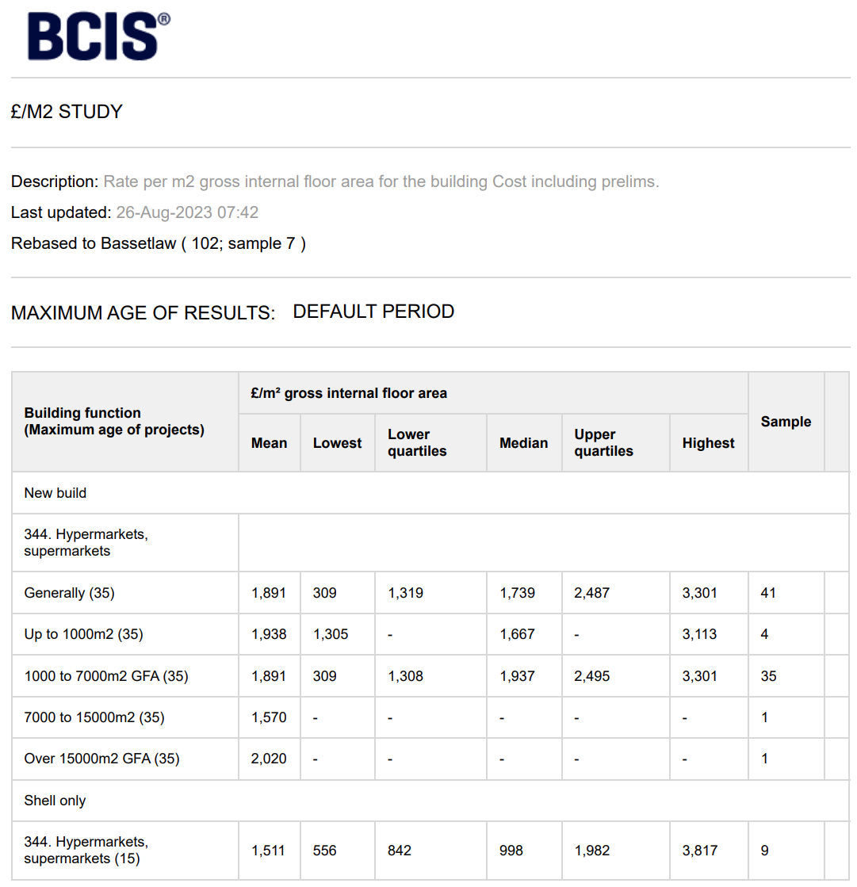

The quoted figure of £1739sqm relates to supermarket buildings of unknown specification and complexity.

As discussed at the examination our consultants base the costs and values in their appraisals on developer provided shell buildings for lease and fit out by retail operators. We note the shell build cost for supermarkets in the above BCIS table is £998sqm. We therefore remain of the view that the £1250sqm figure provided by Gleeds (which includes the standard additional allowance for external works) remains robust.

