Strategic Environmental Assessment & Habitat Regulations Assessment Screening Statement

Misterton Neighbourhood Plan (Review)
13 June 2023

Table of Contents
Table of Contents 0
1 Introduction 2
Strategic Environmental Assessment (SEA) 2
Habitat Regulations Assessment 3
Summary of Findings 3
2 The Misterton Neighbourhood Plan 4
Plan Overview 4
Vision 4
Community Objectives 4
Development Management Policies 5
3 SEA Screening – Assessment 7
SEA Assessment 7
4 HRA Screening – Assessment 12
HRA Screening Matrix 14
5 In-combination Effects 27
6 Conclusions 28
Consultation 28
SEA Screening 28
HRA Screening 28
Appendix 1: Consultation Responses 29
Appendix 2: Ecological attributes of the European sites 31

Introduction
        - This document contains the Screening Statements for the Misterton Neighbourhood Plan (Review) - (the Plan) - with regard to whether a Strategic Environmental Assessment (SEA) and / or Habitat Regulations Assessment (HRA) are required to be undertaken. The document also includes an assessment of the policies proposed in the Plan with regard to Impact Risk Zones for Sites of Special Scientific Interest (SSSI).
        - Regulation 15 of the 2012 Neighbourhood Planning (General) Regulations sets out the information that must accompany a Neighbourhood Plan when submitted to the local planning authority. In February 2015 amendments to the Neighbourhood Plan Regulations came into force; this is known as the Neighbourhood Planning (General) (Amendment) Regulations 2015. Regulation 2(4) of these amendments adds additions to the list of documents that a qualifying body must submit to a local planning authority with a Neighbourhood Plan. The additional document which must be submitted is either an environmental report prepared in accordance with the relevant regulations or, if the outcome concludes that an SEA or HRA is not necessary, a statement that sets out how environmental issues have been taken into account and considered during the preparation of the Neighbourhood Plan.
        - The National Planning Policy Framework (para 167) advises that assessments should be proportionate, and should not repeat policy assessment that has already taken place. In view of this, only a high level screening assessment of the Plan has been undertaken, and this assessment should be read in conjunction with the relevant reports produced for Bassetlaw District Councils Local Development Framework.
        - As the responsible authority under relevant regulations, Bassetlaw District Council has undertaken the Screening Assessment contained in this document, working with the Misterton Neighbourhood Plan Steering Group.

Strategic Environmental Assessment (SEA)
        - The requirement for a SEA to be undertaken on development plans and programmes that may have a significant environmental effect is outlined in European Union Directive 200142/EC. The Environmental Assessment of Plans and Programmes Regulations 2004 (the 2004 Regulations) state that this is determined by a screening process, utilising a specified set of criteria, outlined in Schedule 1 of the Regulations. The results of this process must be set-out in an SEA Screening Statement, which must be publicly available.
        - The objective of undertaking a SEA is “to provide for a high level of protection of the environment and to contribute to the integration of environmental considerations into the preparation and adoption of plans and programmes with a view to promoting sustainable development, by ensuring that, in accordance with this Directive, an environmental assessment is carried out of certain plans and programmes which are likely to have significant effects on the environment.”

Habitat Regulations Assessment
        - European protected sites (the ‘Natura 2000 Network’) are of exceptional importance for the conservation of important species and natural habitats within the European Union. The network of European protected sites comprises Special Protection Areas (SPAs) designated under the Birds Directive (79/409/EEC), Special Areas of Conservation (SACs) designated under the Habitats Directive (92/43/EEC) and Ramsar sites designated under the Ramsar Convention 1975. Government guidance advises that potential SPAs (pSPA), candidate SACs (cSAC) and potential Ramsar (pRamsar) sites are also included in HRA’s.
        - As a land use plan, an assessment of the Misterton Neighbourhood Plan may be required under the Conservation of Habitats and Species (Amendment) Regulations 2012 (the Habitat Regulations) and Article 6(3) of the EU Habitats Directive in order to determine whether the Plan may result in significant effects on identified sites.
        - As with the SEA, a screening process is employed to establish whether any elements of the Draft Plan could have a significant effect on these sites. Regulation 32 of the Neighbourhood Planning (General) Regulations 2012 (as amended) further reemphasises the importance of carrying out this assessment by stating that one of the basic conditions that must be met before the Plan may be ‘made’ is that “the making of the neighbourhood plan is not likely to have a significant effect on a European site (as defined in the Conservation of Habitats and Species Regulations 2012) or a European offshore marine site (as defined in the Offshore Marine Conservation (Natural Habitats, &c.) Regulations 2007 (either alone or in combination with other plans or projects)”.

Summary of Findings
        - Following the undertaking of the Screening Assessments, it is concluded that the Plan, in its current form, will not have any significant negative effects on the environment or any identified European sites. It is considered, therefore, that a full environmental assessment and habitat regulations assessment is not required.
        - This determination has been reached by assessing the contents of a pre-release version of the Submission Draft of the reviewed Neighbourhood Plan, issued to the District Council in April 2023. The Plan has been assessed against criteria provided in Schedule 1 of the 2004 Regulations and with regard to Regulation 32 of the 2015 Neighbourhood Planning Regulations & the Habitat Regulations. The conclusions are detailed in full in Section 6 (p28) of this report.

The Misterton Neighbourhood Plan

        - The Neighbourhood Plan is being developed by Misterton Parish Council, the Qualifying Body for the Misterton Neighbourhood Area in Bassetlaw District, Nottinghamshire, as depicted in Figure 1, below. The Plan has been devised to cover the period to 2038.
Figure 1: Designated Neighbourhood Area
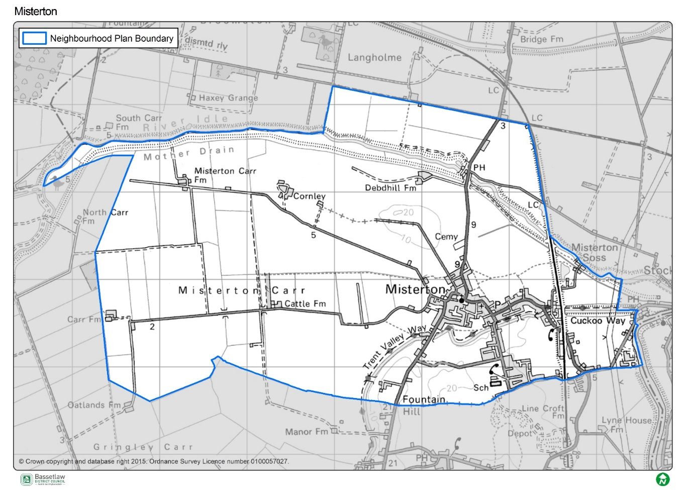

Plan Overview
        - As detailed below, the priorities of the Plan are captured in the Vision and Community Objectives (see page 10 and 11 of the Plan), to be delivered through the application of 18 development management policies specific to the Neighbourhood Area.

Vision
Misterton will be a thriving, diverse, sustainable community which is an attractive place for people to visit, live and work. The rural and historic character of the village will be protected and preserved for current and future generations

Community Objectives
- To support sustainable housing growth of an amount, type and tenure that meets objectively assessed local and district need. Most growth will be on allocated sites.
- To maintain the density and historic character of the built environment so that new housing integrates into the village to preserve its rural character.
- To protect and enhance the landscape, its green spaces and surrounding open countryside, ensuring development minimises its impact on the natural and built environment.
- To ensure development is designed to a high quality that reflects local character, topography, landscape sensitivity, green gaps and views as detailed in the Misterton Design Code 2022.
- To encourage local employment opportunities and support local economic growth and development in identified sustainable locations, accessible by public and sustainable transport methods.
- To contribute to an improving quality of life for its residents by promoting a level of growth that is balanced with an expansion in the range of local facilities and services (where possible) that will enable Misterton to thrive.
- To encourage developers to consult with the community early in the planning application process (at pre-application stage) via mechanisms outlined in the Neighbourhood Plan.

Development Management Policies
        - The 18 development management policies included in the Neighbourhood Plan are summarised in the following table.
Policy | Summary
Policy 1R: Sustainable Development and the Development Boundary | An overarching policy that Identifies the development boundary, and the expectations of development that can take place within it, and the limitations on development external to it.
Policy 2R: Infill Development and Density | Seeks to inform the design of infill developments to ensure they are contextually appropriate to the character area in which they are located.
Policy 3R: Improving Green and Blue Infrastructure and Biodiversity | Requires that development proposals safeguard blue and green infrastructure, seek to deliver biodiversity net gain of at least 10%, and respect the habitat connectivity provided by identified wildlife corridors across the Plan area. Also encourages the inclusion of tree planting within developments.
Policy 4R: Protecting and Enhancing the Landscape Character | Requires the new developments respect the identified landscape character, key views, significant green gaps, and accessibility to the natural environment via the rights of way network.
Policy 5R: Designation of Local Green Spaces | Identifies 11 local green spaces (LGS) for designation, in accordance with the regulations.
Policy 6R: Achieving High-Quality Design | Seeks to maintain and enhance the character and distinctiveness of the Neighbourhood Area, through reference to the accompanying Misterton Design Guide 2022.
Policy 7R: Renewable Energy, Energy Efficiency and Low Carbon Technologies | Encourages the incorporation of sustainable design features and energy efficiency measures as part of new developments.
Policy 8R: Redevelopment of Newell’s Site | Provides outline support for the redevelopment of this brownfield site, subject to mitigation of identified flood risk issues.
Policy 9R: Protecting and Enhancing Heritage Assets | Requires consideration of the impact of new development on identified features of historical significance. Also proposes to identify the Chesterfield Canal as a non-designated heritage asset.
Policy 10R: Supporting Local Businesses | Provides support development associated with business uses within the development boundary, subject to certain criteria.
Policy 11R: Improving Broadband and Mobile Connectivity | Seeks to support improvements to broadband and mobile connectivity, subject to any required infrastructure respecting the landscape designations identified elsewhere in the Plan.
Policy 12R: A Mix of Housing Types | Translates the findings of the Housing Need Assessment into policy, including stipulations on the mix of sizes.
Policy 13R: Enhancing the Provision of Community Facilities and Services | Identifies and seeks to protect community facilities within the Plan area.
Policy 14R: NP01 Land off Haxey Road | A site-specific residential allocation west of Haxey Road, including criteria to inform development of the site.
Policy 15R: NP02 Land off Church Street | A site-specific residential allocation west of Church Street, including criteria to inform development of the site.
Policy 16R: NP06 Land off Meadow Drive | A site-specific residential allocation south of Meadow Drive, including criteria to inform development of the site.
Policy 17R: NP11 Land off Grange Walk | A site-specific residential allocation east of Grange Walk / north of Fox Covert Lane, including criteria to inform development of the site.
Policy 18R: NP12 Land off Fox Covert Lane | A site-specific residential allocation north of Fox Covert Lane, including criteria to inform development of the site.

SEA Screening – Assessment
        - The table below includes the assessment of the reviewed Misterton Neighbourhood Plan, including its Objectives and Development Management Policies, against the criteria included in Schedule 1 of the 2004 Regulations. The Neighbourhood Plan is being assessed as a whole against the criteria listed below to allow for the consideration of its effects on the environment.

SEA Assessment

Criteria for determining the likely significance of effects (Annex II SEA Directive) | Significant effect likely? | Comment
1a The degree to which the plan or programme sets a framework for projects and other activities, either with regard to the location, nature, size and operating conditions or by allocating resources. | NO | The Misterton Neighbourhood Plan (the Plan) sets-out a spatial vision for the designated Neighbourhood Area and an accompanying framework to guide development proposals. This framework will be delivered by the development management policies contained within the Plan. The framework will have some impacts on the environment, noticeably the support for development proposals. However, it is deemed that these impacts will not be significant, due to their small-scale and localised nature.
1b The degree to which the plan or programme influences other plans and programmes including those in a hierarchy. | NO | The Plan, where possible, will respond to rather than influence other plans and programmes. It is part of a hierarchy, but is at the lowest tier, sitting below the Bassetlaw Core Strategy DPD (District level) and National Planning Policy Framework (National level), and has thus been influenced by these higher-tier and pre-existing plans, rather than having an influence on them.  The Plan has been developed with a view towards the emerging Bassetlaw Local Plan but will remain below it in the policy hierarchy.  The policies within a neighbourhood plan apply only within the designated neighbourhood area, hence the Plan will not have a direct impact on adjoining areas.
1c The relevance of the plan or programme for the integration of environmental considerations in particular with a view to promoting sustainable development. | NO | The Plan promotes sustainable development within the Neighbourhood Area through balancing environmental, social and economic objectives; this is clearly articulated in paragraph 19 of the Plan and the subsequent table (pages 8 to 10). The Vision & Objectives (pages 10 – 11), in conjunction with the development management policies, work to ensure that all development proposals brought forward in the area will take this balance into account.  Specifically, the forms of development supported by policies 1R, 2R, 8R, 10R, and 14R to 18R are viewed as key to ensuring the long-term sustainability of the Plan area. This projected growth is balanced by the protection of key environmental and social / cultural assets, both through criteria in the above policies themselves, and through policies 3R, 4R, 5R, 6R, 7R, 9R, and 13R.  As a result, it is considered that the Plan effectively integrates and balances all potential environmental considerations, and that potential impacts are, therefore, unlikely to be significant.
1d Environmental problems relevant to the plan or programme. | NO | As noted above, the Plan supports development on a number of fronts, including residential development and employment development, all of which could have some effects on the environment. However, existing national and local planning policies, the specific criteria included within the policies in the Plan, and the planning application process, will collectively ensure that these effects are not significant.
1e The relevance of the plan or programme for the implementation of Community legislation on the environment (for example, plans and programmes linked to waste management or water protection). | NO | The Plan is intended to be in compliance with the Bassetlaw Local Development Framework, which has taken into account the existing European and National legislative framework for environmental protection. The Plan will therefore have a positive effect on compliance with regards to relevant legislation and programmes. It is considered that none of the proposals within the Plan will compromise this position.
2a The probability, duration, frequency and reversibility of the effects. | NO | It is deemed highly unlikely that there will be any irreversible damaging environmental impacts associated with the Plan. The policies within the Plan seek to ensure new development is sustainable in context, and promotes the enhancement and protection of environmental assets.  Should any unforeseen significant effects on the environment arise as a result of the Plan, the intention to monitor the Plan and also to review/update the Plan when required will allow these effects to be addressed (see Section 21: Monitoring and Review (page 76).
2b The cumulative nature of the effects. | NO | It is considered that the Policies contained in the Plan, cumulatively, will have minimal negative effects on the environment and will in fact have moderate to significant positive effects through the stipulations included. It is considered that all effects will be at a local level.
2c The transboundary nature of the effects. | NO | Effects will be local, with no expected impacts on neighbouring areas.
2d The risks to human health or the environment (for example, due to accidents). | NO | No obvious risks have been identified, as the overall aim of the Plan is to ensure the careful management of development and the continued sustainability of the Plan area.
2e The magnitude and spatial extent of the effects (geographical area and size of the population likely to be affected). | NO | The Plan relates to, and will have an influence over, a designated neighbourhood area of approximately 1678 hectares, with a usual resident population of approximately 2,200 people (Census 2021).  It is deemed the Plan as a whole will have a positive impact upon local residents through the protection and enhancement of local environmental and social / cultural assets, and the promotion of sustainable development.
2f The value and vulnerability of the area likely to be affected due to:  (i) special natural characteristics or cultural heritage;  (ii) exceeded environmental quality standards or limit values; or  (iii) intensive land-use. | NO | The Plan is deemed unlikely to have an adverse effect on the natural characteristics and cultural heritage of the neighbourhood area.  Natural characteristics  The Chesterfield Canal is a notable feature in the Plan area, and has wider regional significance. The western portion of the Canal in the Parish is designated as a Site of Special Scientific Interest (SSSI). There are two further SSSI in the Plan area, namely the Mother Drain, in the north east of the Parish, and the River Idle Washlands, at the westernmost extreme of the Parish.  There are 8 Local Wildlife Sites within the Plan area, namely:  - Chesterfield Canal (Misterton to West Stockwith)  - Chesterfield Canal (Welham to Misterton)  - Idle Stop Washland  - Misterton Pasture  - Misterton Soss Ponds  - Mother Drain  - River Idle and Banks  - Soss Lane Grassland  There are a number of SSSI outside, but in relative proximity to, the Neighbourhood Area, namely:  - Haxey Grange Fen  - Misson Line Bank  - Misson Training Area  The impact risk zones for these designations intersect the Neighbourhood Area.  The Plan includes three policies in particular designed to protect and enhance the natural assets in the Neighbourhood Area. Policy 3R addresses green and blue infrastructure and biodiversity. Policy 4R addresses landscape character, including protection of key views and rights of way, whilst Policy 5R provides specific protection to 11 sites through designation as Local Green Spaces.  Cultural heritage  There are no World Heritage Sites, Protected Wreck Sites, Registered Battlefields, Registered Park and Gardens, or Scheduled Ancient Monuments in the Neighbourhood Area. Misterton Cemetery, in Haxey Road, is identified as an Unregistered Park and Garden.  Much of the core of Misterton village is identified as an area of archaeological interest, with other smaller areas of interest located around the Plan area.  There are 25 Listed Buildings in the Neighbourhood Area, 22 of which are Grade II. The North and South Engine Houses and associated structures at Misterton Soss Pumping Station are both Grade II* listed, whilst the Church of All Saints is Grade I listed. There are also a significant number of non-designated heritage assets.  The five site-specific housing allocations (Policies 14R to 18R inclusive) have been carried-over from the original Neighbourhood Plan. However, the policies now include significantly more detailed stipulations as to the form of new development and respect for site context, reflecting the contents of the new Misterton Design Guide 2022.  The Misterton Design Guide has also fed-into Policy 6R (Achieving High Quality Design), which takes a proactive stance in seeking to reflect or complement the established character of the Parish as a whole and the identified character zones.  Policy 9R (Protecting and Enhancing Heritage Assets) specifically addresses local heritage assets and their setting, and also proposes the identification of the Chesterfield Canal as an addition non-designated heritage asset.  It is considered that the development supported by the Plan will not result in significant effects on the identified natural or cultural heritage assets. Furthermore, the Plan does not exceed environmental quality standards or limit values, and does not provide specific policies in relation to intensive land uses.
2g The effects on areas or landscapes which have a recognised national, community or international protection status. | NO | It is considered that the Plan will not adversely affect areas of landscape which have recognised community, national or international protection. The need for new development to respect landscape setting is included as part of the criteria within the respective Policies.

HRA Screening – Assessment

        - For the HRA screening assessment, the designated neighbourhood area was assessed to identify if any Special Protection Areas (SPA), Special Areas of Conservation sites (SAC), or Ramsar sites were located within the boundary, as well as those considered as potential sites (pSPA, ppSPA, cSAC & pRamsar). The assessment also identified if any of these internationally important sites were located within a 15km radius from the Neighbourhood Plan area. The results of this exercise are detailed on the map included as Figure 4 on page 13. The Thorne and Hatfield Moors SPA and Hatfield Moor SAC are located approximately 7.6km to the north west of the border of the Neighbourhood Area. The Humber Estuary SAC is located just beyond the threshold distance, at 15.5km from the Neighbourhood Area. Descriptions of the ecological attributes of the two sites within the 15km threshold are included as Appendix 2.
        - The Screening Assessment on page 14 has considered the main potential sources of effects on the identified European sites arising from the Plan, possible pathways to the sites, and the effects on possible sensitive receptors. The assessment considers the impacts of the policies in the Plan directly on the identified sites, as these are land use policies, hence mostly expected to have some direct or indirect impact on the local environment.

Figure 4: Map of Special Protection Areas and Special Areas of Conservation in relation to the Misterton Neighbourhood Area
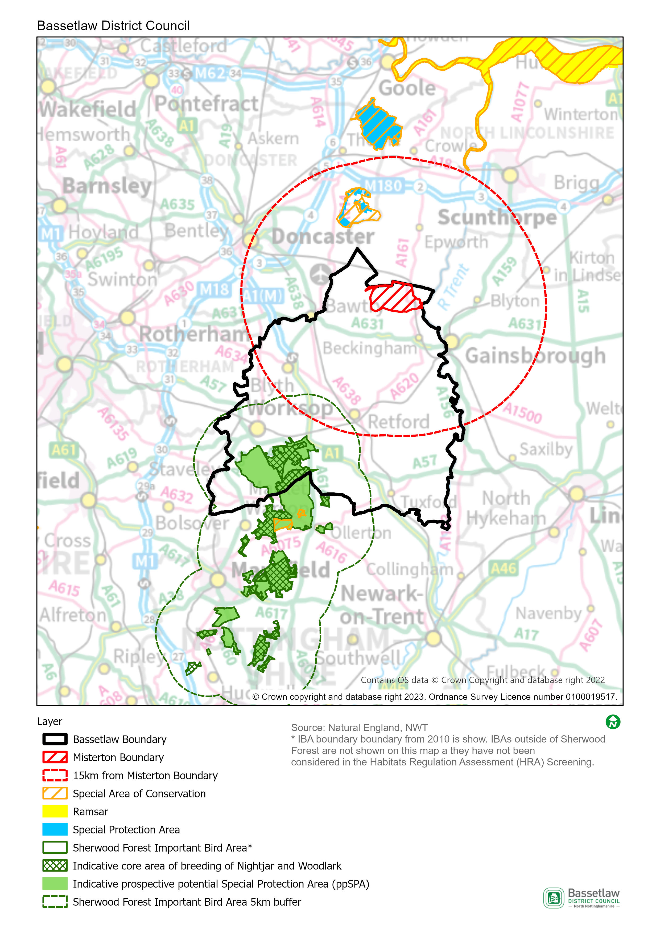

HRA Screening Matrix
The screening matrix below shows which types of impacts on European sites could potentially result from each of the policies and sites allocated in the reviewed Misterton Neighbourhood Plan. Where a site is not expected to have a particular type of impact, the relevant cell is shaded green. Where a site could potentially have a certain type of impact, this is shown in orange. The final column sets out the screening conclusions.
Policy | Likely activities (operation) to result as a consequence of the proposal | Likely effects if proposal  implemented | European site(s) potentially affected | Could the proposal have likely significant effects on European sites?
Policy 1R: Sustainable Development and the Development Boundary | Residential development.  Economic development.  Increase in vehicular traffic.  Increase in recreation pressure. | Physical loss and damage.  Air pollution.  Disturbance from recreation. | Thorne and Hatfield Moors SPA  Hatfield Moor SAC | No significant effects anticipated.  The sites where development is supported by the Policy (within the development boundary) are approximately 10km at the nearest from Thorne and Hatfield Moors SPA and Hatfield Moor SAC. Physical loss and damage is, therefore, not possible.  It would not be expected for birds to be dependent on the habitat within the development boundary.  This Policy alone would not be expected to cause a significant increase in traffic and air pollution in the area.  With regard to pathways, it is considered that the nature and small scale of the development supported in this Policy, including the distance between the potential development sites and the European sites, and intervening infrastructure and settlements, will not result in significant effects occurring.
Policy 2R: Infill Development and Density | Residential development.  Increase in vehicular traffic.  Increase in recreation pressure. | Physical loss and damage.  Air pollution.  Disturbance from recreation. | Thorne and Hatfield Moors SPA  Hatfield Moor SAC | No significant effects anticipated.  The sites where development is supported by the Policy (within the development boundary) are approximately 10km at the nearest from Thorne and Hatfield Moors SPA and Hatfield Moor SAC. Physical loss and damage is, therefore, not possible.  It would not be expected for birds to be dependent on the habitat within the development boundary.  This Policy alone would not be expected to cause a significant increase in traffic and air pollution in the area.  With regard to pathways, it is considered that the nature and small scale of the development supported in this Policy, including the distance between the potential development sites and the European sites, and intervening infrastructure and settlements, will not result in significant effects occurring.
Policy 3R: Improving Green and Blue Infrastructure and Biodiversity | None. The policy seeks to protect and enhance green and blue infrastructure and biodiversity. | N/A | N/A | No
Policy 4R: Protecting and Enhancing the Landscape Character | None. The policy provides protection for landscape character, identified key views, significant green gaps, and the rights of way network – it does not, itself, support development. | N/A | N/A | No
Policy 5R: Designation of Local Green Spaces | None. This policy identifies 11 sites to be protected using Local Green Space designations (LGS) – it will not itself result in new development. | N/A | N/A | No
Policy 6R: Achieving High-Quality Design | None. This policy sets out principles to influence the design and layout of residential developments - it will not itself result in new development. | N/A | N/A | No
Policy 7R: Renewable Energy, Energy Efficiency and Low Carbon Technologies | None. This policy encourages the incorporation of sustainable design features and energy efficiency measures as part of new developments – it will not itself result in new development. | N/A | N/A | No
Policy 8R: Redevelopment of Newell’s Site | Residential development.  Economic development.  Increase in vehicular traffic.  Increase in recreation pressure. | Physical loss and damage.  Air pollution.  Disturbance from recreation. | Thorne and Hatfield Moors SPA  Hatfield Moor SAC | No significant effects anticipated.  The site where development is supported by the Policy is approximately 11.5km at the nearest from Thorne and Hatfield Moors SPA and Hatfield Moor SAC. Physical loss and damage is, therefore, not possible.  It would not be expected for birds to be dependent on the habitat within the area proposed for development.  This Policy alone would not be expected to cause a significant increase in traffic and air pollution in the area.  With regard to pathways, it is considered that the nature and small scale of the development supported in this Policy, including the distance between the potential development site and the European sites, and intervening infrastructure and settlements, will not result in significant effects occurring.
Policy 9R: Protecting and Enhancing Heritage Assets | None. This policy ensures that the heritage assets within the Plan area are respected and, where possible, enhanced – it will not itself result in new development. | N/A | N/A | No
Policy 10R: Supporting Local Business | Commercial development.  Increase in vehicular traffic. | Physical loss and damage.  Air pollution. | Thorne and Hatfield Moors SPA  Hatfield Moor SAC | No significant effects anticipated.  The sites where development is supported by the Policy (within the development boundary) are approximately 10km at the nearest from Thorne and Hatfield Moors SPA and Hatfield Moor SAC. Physical loss and damage is, therefore, not possible.  It would not be expected for birds to be dependent on the habitat within the development boundary.  This Policy alone would not be expected to cause a significant increase in traffic and air pollution in the area.  With regard to pathways, it is considered that the nature and small scale of the development supported in this Policy, including the distance between the potential development sites and the European sites, and intervening infrastructure and settlements, will not result in significant effects occurring.
Policy 11R: Improving Broadband and Mobile Connectivity | None – this policy supports the provision of improvements to communications infrastructure as part of new development – it will not itself result in new development. | N/A | N/A | No
Policy 12R: A Mix of Housing Types | None. The policy seeks to ensure the type and size of housing reflects local needs – it does not, itself, support development. | N/A | N/A | No
Policy 13R: Enhancing the Provision of Community Facilities and Services | None. The Policy is designed to protect existing community facilities, but does not provide support for additional development. | N/A | N/A | No
Policy 14R: NP01 Land off Haxey Road | Residential development.  Increase in vehicular traffic.  Increase in recreation pressure. | Physical loss and damage.  Air pollution.  Disturbance from recreation. | Thorne and Hatfield Moors SPA  Hatfield Moor SAC | No significant effects anticipated.  The site where development is supported by the Policy is approximately 10km at the nearest from Thorne and Hatfield Moors SPA and Hatfield Moor SAC. Physical loss and damage is, therefore, not possible.  It would not be expected for birds to be dependent on the habitat within the area proposed for development.  This Policy alone would not be expected to cause a significant increase in traffic and air pollution in the area.  With regard to pathways, it is considered that the nature and small scale of the development supported in this Policy, including the distance between the potential development site and the European sites, and intervening infrastructure and settlements, will not result in significant effects occurring.
Policy 15R: NP02 Land off Church Street |  |  | Thorne and Hatfield Moors SPA  Hatfield Moor SAC | No significant effects anticipated.  The site where development is supported by the Policy is approximately 10.3km at the nearest from Thorne and Hatfield Moors SPA and Hatfield Moor SAC. Physical loss and damage is, therefore, not possible.  It would not be expected for birds to be dependent on the habitat within the area proposed for development.  This Policy alone would not be expected to cause a significant increase in traffic and air pollution in the area.  With regard to pathways, it is considered that the nature and small scale of the development supported in this Policy, including the distance between the potential development site and the European sites, and intervening infrastructure and settlements, will not result in significant effects occurring.
Policy 16R: NP06 Land off Meadow Drive |  |  | Thorne and Hatfield Moors SPA  Hatfield Moor SAC | No significant effects anticipated.  The site where development is supported by the Policy is approximately 10.6km at the nearest from Thorne and Hatfield Moors SPA and Hatfield Moor SAC. Physical loss and damage is, therefore, not possible.  It would not be expected for birds to be dependent on the habitat within the area proposed for development.  This Policy alone would not be expected to cause a significant increase in traffic and air pollution in the area.  With regard to pathways, it is considered that the nature and small scale of the development supported in this Policy, including the distance between the potential development site and the European sites, and intervening infrastructure and settlements, will not result in significant effects occurring.
Policy 17R: NP11 Land off Grange Walk |  |  | Thorne and Hatfield Moors SPA  Hatfield Moor SAC | No significant effects anticipated.  The site where development is supported by the Policy is approximately 11.3km at the nearest from Thorne and Hatfield Moors SPA and Hatfield Moor SAC. Physical loss and damage is, therefore, not possible.  It would not be expected for birds to be dependent on the habitat within the area proposed for development.  This Policy alone would not be expected to cause a significant increase in traffic and air pollution in the area.  With regard to pathways, it is considered that the nature and small scale of the development supported in this Policy, including the distance between the potential development site and the European sites, and intervening infrastructure and settlements, will not result in significant effects occurring.
Policy 18R: NP12 Land off Fox Covert Lane |  |  | Thorne and Hatfield Moors SPA  Hatfield Moor SAC | No significant effects anticipated.  The site where development is supported by the Policy is approximately 11.4km at the nearest from Thorne and Hatfield Moors SPA and Hatfield Moor SAC. Physical loss and damage is, therefore, not possible.  It would not be expected for birds to be dependent on the habitat within the area proposed for development.  This Policy alone would not be expected to cause a significant increase in traffic and air pollution in the area.  With regard to pathways, it is considered that the nature and small scale of the development supported in this Policy, including the distance between the potential development site and the European sites, and intervening infrastructure and settlements, will not result in significant effects occurring.

In-combination Effects
        - Regulation 105 of the Amended Habitats Regulations 2017 requires an Appropriate Assessment where “a land use plan is likely to have a significant effect on a European site (either alone or in combination with other plans or projects) and is not directly connected with or necessary to the management of the site”. Therefore, it is necessary to consider whether there may be significant effects from the reviewed Misterton Neighbourhood Plan in combination with other plans or projects.
        - The first stage in identifying ‘in-combination’ effects involves identifying which other plans and projects in addition to the Misterton Neighbourhood Plan may affect the European sites that were the focus of this assessment. There are a large number of potentially relevant plans and projects which could be considered, therefore, the review focused on planned spatial growth within Bassetlaw District, with the Habitats Regulations Assessment of the emerging Bassetlaw Local Plan (August 2021) the key source of reference.
        - The HRA Screening of the Bassetlaw Local Plan concluded that strategy would not result in likely significant effects on the Thorne and Hatfield Moor SPA and Hatfield Moor SAC, on account of distance and / or a lack of pathways by which impacts could travel between source and receptor.
        - The scale of development proposed by the reviewed Misterton Neighbourhood Plan is in conformity with the Bassetlaw Local Plan, contributing to the Draft Local Plan’s housing growth projections for Bassetlaw as a whole. The scale of housing development proposed, together with the Neighbourhood Area’s distance from the Thorne and Hatfield Moor SPA and Hatfield Moor SAC, as above, means that its in-combination effect is insignificant.

Conclusions

Consultation
        - As required by the regulations, a draft version of this report was issued for the purposes of consultation with the statutory bodies, specifically the Environment Agency, Historic England, and Natural England. On conclusion of the six-week consultation (3 May to 13 June 2023), responses had been received from all three bodies. The responses are included in full at Appendix 1, and can be summarised as follows:
        - Environment Agency: no formal comments to make.
        - Historic England: on the basis of the information provided in the draft report, it is considered that the preparation of a SEA is not likely to be required.
        - Natural England: agrees with the conclusions that neither a full SEA nor HRA is required.
        - On the basis of the above, the initial conclusions are upheld, and no consequential amendments have been made to the report; the conclusions are detailed below.

SEA Screening
        - On the basis of the SEA Screening Assessment set out in this document, the conclusion is that the reviewed Misterton Neighbourhood Plan will not have significant environmental effects in relation to any of the criteria set out in Schedule 1 of the SEA Regulations, and therefore does not need to be subject to a full SEA.

HRA Screening
The HRA Screening Assessment concludes that no significant effects are likely to occur with regard to the integrity of the Thorne and Hatfield Moor SPA and Hatfield Moor SAC as a consequence of the implementation of the Plan. As such, a full HRA is not required to be undertaken.
        - The main reason for these conclusions is:
- The development that is supported in the Plan is deemed to be of a scale and nature and located on sites that will not result in any significant effects on the identified European sites.

Appendix 1: Consultation Responses

Environment Agency
Received 17 May 2023
The EA have no formal comments to make in regard to the SEA and HRA Screening as we do not make the final decision on whether a SEA or HRA is required. Generally the EA will not comment on a HRA as this falls within the remit of Natural England.
Historic England
Received 16 January 2023
Thank you for your consultation of 3 May 2023 and the request for a Screening Opinion in respect of the Misterton Neighbourhood Plan.
For the purposes of consultations on SEA Screening Opinions, Historic England confines its advice to the question, “Is it likely to have a significant effect on the environment?” in respect of our area of concern, cultural heritage. Our comments are based on the information supplied with the screening request.
On the basis of the information supplied and in the context of the criteria set out in Schedule 1 of the Environmental Assessment Regulations [Annex II of ‘SEA’ Directive], Historic England is of the view that the preparation of a Strategic Environmental Assessment is not likely to be required.
The views of the other statutory consultation bodies should be taken into account before the overall decision on the need for a SEA is made. If a decision is made to undertake a SEA, please note that Historic England has published guidance on Sustainability Appraisal / Strategic Environmental Assessment and the Historic Environment that is relevant to both local and neighbourhood planning and available at:
<https://historicengland.org.uk/images-books/publications/sustainability-appraisal-and-strategic-environmental-assessment-advice-note-8/>
Should it be concluded that, overall, a SEA will be required for the Plan, Historic England would be pleased to discuss the scope of the assessment in relation to the historic environment in due course.
I hope that this information is of use to you at this time. Should you have any queries, please do not hesitate to contact me.
Natural England
Received 9 June 2023
Thank you for your consultation on the above dated and received by Natural England on 03 May 2023.
Natural England is a non-departmental public body. Our statutory purpose is to ensure that the natural environment is conserved, enhanced, and managed for the benefit of present and future generations, thereby contributing to sustainable development.

Screening Request: Strategic Environmental Assessment
It is our advice, on the basis of the material supplied with the consultation, that, in so far as our strategic environmental interests (including but not limited to statutory designated sites, landscapes and protected species, geology and soils) are concerned, that there are unlikely to be significant environmental effects from the proposed plan.

Neighbourhood Plan
Guidance on the assessment of Neighbourhood Plans, in light of the Environmental Assessment of Plans and Programmes Regulations 2004 (as amended), is contained within the National Planning Practice Guidance. The guidance highlights three triggers that may require the production of an SEA, for instance where:
- a neighbourhood plan allocates sites for development
- the neighbourhood area contains sensitive natural or heritage assets that may be affected by the proposals in the plan
- the neighbourhood plan may have significant environmental effects that have not already been considered and dealt with through a sustainability appraisal of the Local Plan.

We have checked our records and based on the information provided, we can confirm that in our view the proposals contained within the plan will not have significant effects on sensitive sites that Natural England has a statutory duty to protect.

We are not aware of significant populations of protected species which are likely to be affected by the policies / proposals within the plan. It remains the case, however, that the responsible authority should provide information supporting this screening decision, sufficient to assess whether protected species are likely to be affected.

Notwithstanding this advice, Natural England does not routinely maintain locally specific data on all potential environmental assets. As a result the responsible authority should raise environmental issues that we have not identified on local or national biodiversity action plan species and/or habitats, local wildlife sites or local landscape character, with its own ecological and/or landscape advisers, local record centre, recording society or wildlife body on the local landscape and biodiversity receptors that may be affected by this plan, before determining whether an SA/SEA is necessary.
Please note that Natural England reserves the right to provide further comments on the environmental assessment of the plan beyond this SEA/SA screening stage, should the responsible authority seek our views on the scoping or environmental report stages. This includes any third party appeal against any screening decision you may make.
Habitats Regulations Assessment (HRA) Screening
Natural England agrees with the report’s conclusions that the Misterton Neighbourhood Plan would not be likely to result in a significant effect on any European Site, either alone or in combination and therefore no further assessment work would be required.

Appendix 2: Ecological attributes of the European sites

Hatfield Moor Special Area of Conservation (SAC)
Description
Hatfield Moors, which covers an area of 1363.55 hectares, is a remnant of an extensive lowland raised bog which once occupied the Humberhead levels. Hatfield is unique in having developed directly upon nutrient deficient gravels without an initial reed-swamp phase. Much of the bog has been cut for peat yet a restricted representative flora and fauna persists within a mosaic of mire and dry heath habitats beneath birch scrub. The mire communities are dominated by cottongrasses Eriophorum vaginatum and E. angustifolium, cross-leaved heath Erica tetralix and bogmosses Sphagnum spp., but include locally rare species such as cranberry Vaccinium oxycoccus, bog myrtle Myrica gale and bog rosemary Andromeda polifolia.
Area
1359.45ha
Qualifying Features
H7120: Degraded raised bogs still capable of natural regeneration
Site Status (an assessment by Natural England of the status of the SSSIs within the SAC):
- 92.23% in unfavourable (recovering) condition
- 6.5% in unfavourable (no change) condition
- 1.27% in favourable condition
Special Area of Conservation objectives
Ensure that the integrity of the site is maintained or restored as appropriate, and ensure that the site contributes to achieving the Favourable Conservation Status of its Qualifying Features, by maintaining or restoring:
- The extent and distribution of qualifying natural habitats
- The structure and function (including typical species) of the qualifying natural habitat, and
- The supporting processes on which the qualifying natural habitat rely.
Site Improvement Plan: pressures, threats and related development
The main pressures and threats to this site include drainage, inappropriate scrub control, impacts of atmospheric nitrogen deposition, public access/disturbance, peat extraction and invasive species. Additionally, planning permission is a problem in that wind farms have been erected or are planned in the wider area surrounding the SAC, yet investigation is needed to better understand the cumulative impact of existing and planned wind farm and other local developments on the nightjar population.
Thorne and Hatfield Moors Special Protection Area (SPA)
Description
Covering an approximate area of 2449.2 hectares, Thorne and Hatfield Moors SPA is an extensive lowland raised mire system adjacent to the Humber estuary on the north-east coast of England and is the largest remaining lowland peatland in England. Despite a long history of extensive peat extraction since the late nineteenth century, the site retains substantial areas of Sphagnum bog, which has been changed by succession to wet scrub woodland dominated by Birch Betula sp., sallows and Alder Alnus glutinosa. Where the peat surface has been removed, subsequent restoration of active bog has depended upon shallow flooding to allow Sphagnum and other bog plants to re-colonise. The mire communities are dominated by Hare’s-tail Eriophorum vaginatum and Common Cottongrass E. augustifolium, Cross-leaved Heath Erica tetralix, Soft-rush Juncus effuses and Sphagnum mosses, and include a variety of scarcer bog plants such as Bog-rosemary Andromeda polifolia and Cranberry Vaccinium oxycoccos. Drier heath is dominated by Heather Calluna vulgaris, Bracken Pteridium aquilinum and Purple Moorgrass Molinia caerulea. Birch Betula sp. scrub, some of it dense, occurs throughout both moors. The diverse mosaic of habitats contribute greatly to the ornithological interest, which comprises breeding species, notably Caprimulgus europaeus.
Area
2449.2ha
Qualifying Features
A224: Caprimulgus europaeus; European nightjar (Breeding)
Site Status (an assessment by Natural England of the status of the SSSIs within the SAC):
- 92.23% in unfavourable (recovering) condition
- 6.5% in unfavourable (no change) condition
- 1.27% in favourable condition
Special Area of Conservation objectives
Ensure that the integrity of the site is maintained or restored as appropriate, and ensure that the site contributes to achieving the aims of the Wild Birds Directive, by maintaining or restoring:
- The extent and distribution of the habitats of the qualifying features
- The structure and function of the habitats of the qualifying features
- The supporting processes on which the habitats of the qualifying features rely
- The population of each of the qualifying features, and,
- The distribution of the qualifying features within the site.
Site Improvement Plan: pressures, threats and related development
The main pressures and threats to this site include drainage, inappropriate scrub control, impacts of atmospheric nitrogen deposition, public access/disturbance, peat extraction and invasive species. Additionally, planning permission is a problem in that wind farms have been erected or are planned in the wider area surrounding the SAC, yet investigation is needed to better understand the cumulative impact of existing and planned wind farm and other local developments on the nightjar population.

SEA Directive, Article 1
Planning Guidance - Paragraph: 079: Reference ID: 41-079-20140306

