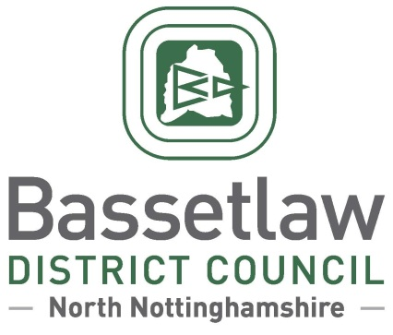

Steve Rose  Clerk to Gringley on the Hill Parish Council  VIA EMAIL | Please ask for: Beverley Alderton-Sambrook  Direct Dialling: (01909) 533 533  Email:beverley.alderton-sambrook @bassetlaw.gov.uk  26 June 2023

Dear Steve,
On 30 May 2023, Bassetlaw District Council received a formal application from Gringley on the Hill Parish Council to designate the entire parish area, as per the accompanying map, for the purposes of producing a neighbourhood plan.
A report on the proposals was considered by the District Council on 22 June 2023. It was agreed at the meeting that Gringley on the Hill should be designated as a neighbourhood planning area with immediate effect, with the Parish Council acting as the qualifying body. The District Council’s Neighbourhood Planning Team will be in touch shortly to discuss next steps, and to offer their support to the Parish Council in progressing the development of a neighbourhood plan.

Yours Sincerely,
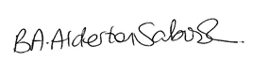
Beverley Alderton-Sambrook
Head of Regeneration

