Retford Town Centre Neighbourhood Plan

Potential Local Green Space Designations

Site Maps

February 2023

Potential Local Green Space LGS1: Land north of Amcott Way and south of The Beck

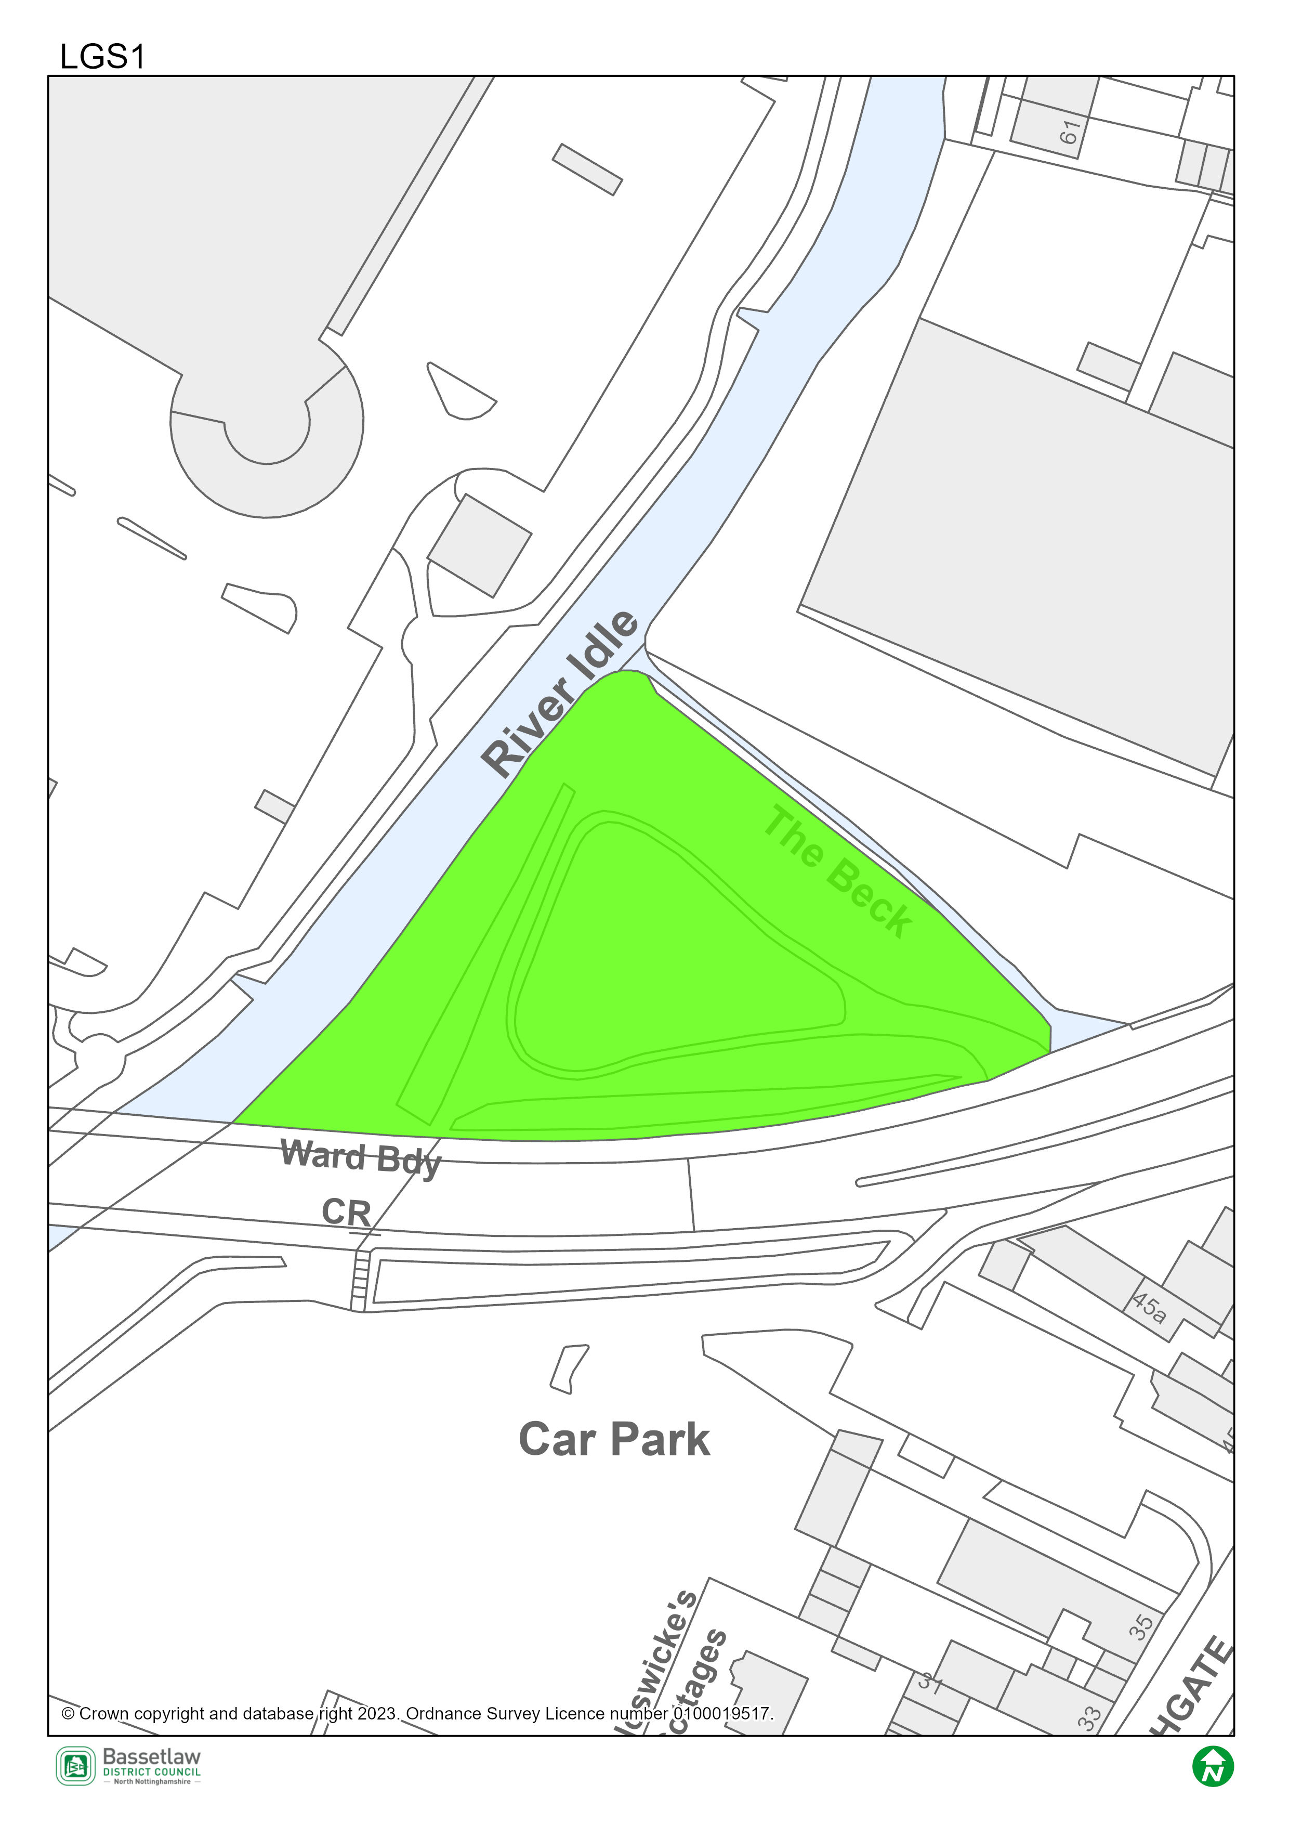

Potential Local Green Space LGS2: St Swithun’s Churchyard, Churchgate

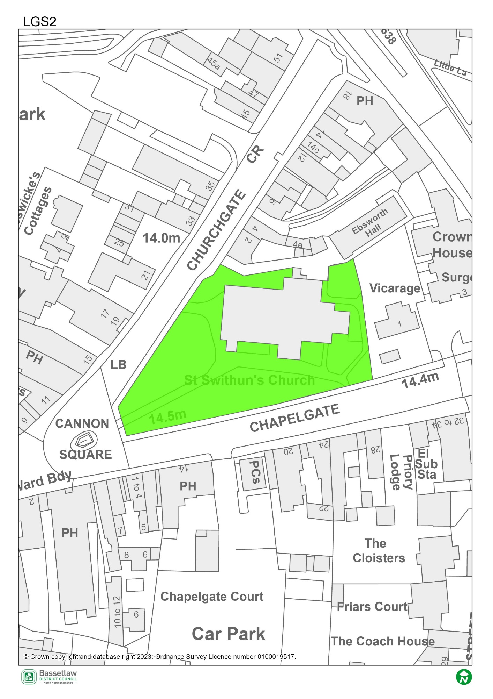

Potential Local Green Space LGS3: St Michael’s Churchyard, Bridgegate

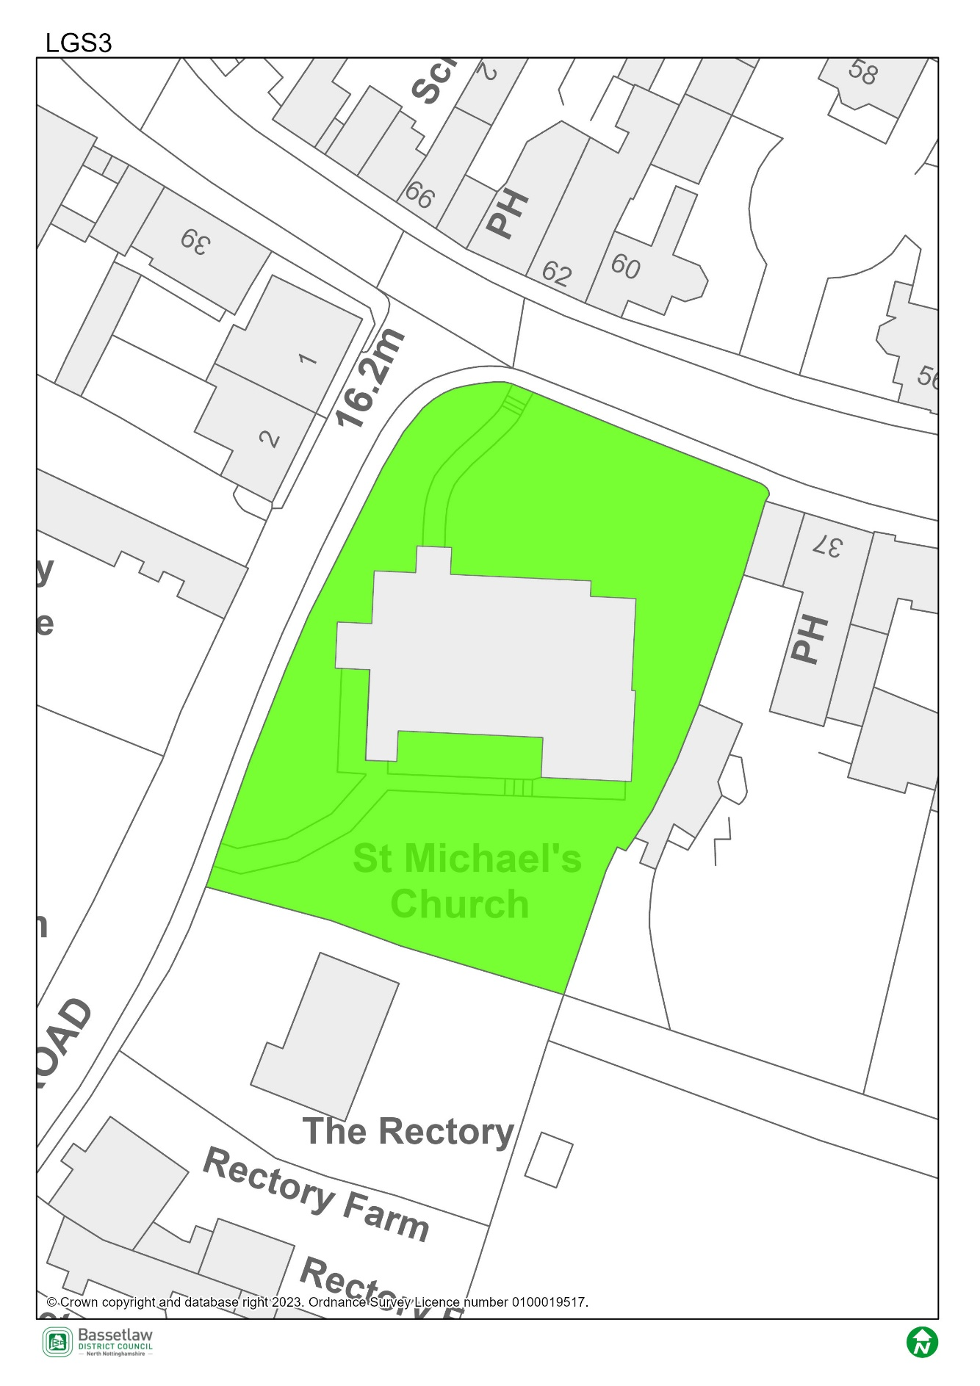

Potential Local Green Space LGS4: Bassetlaw Museum Garden, Grove Street

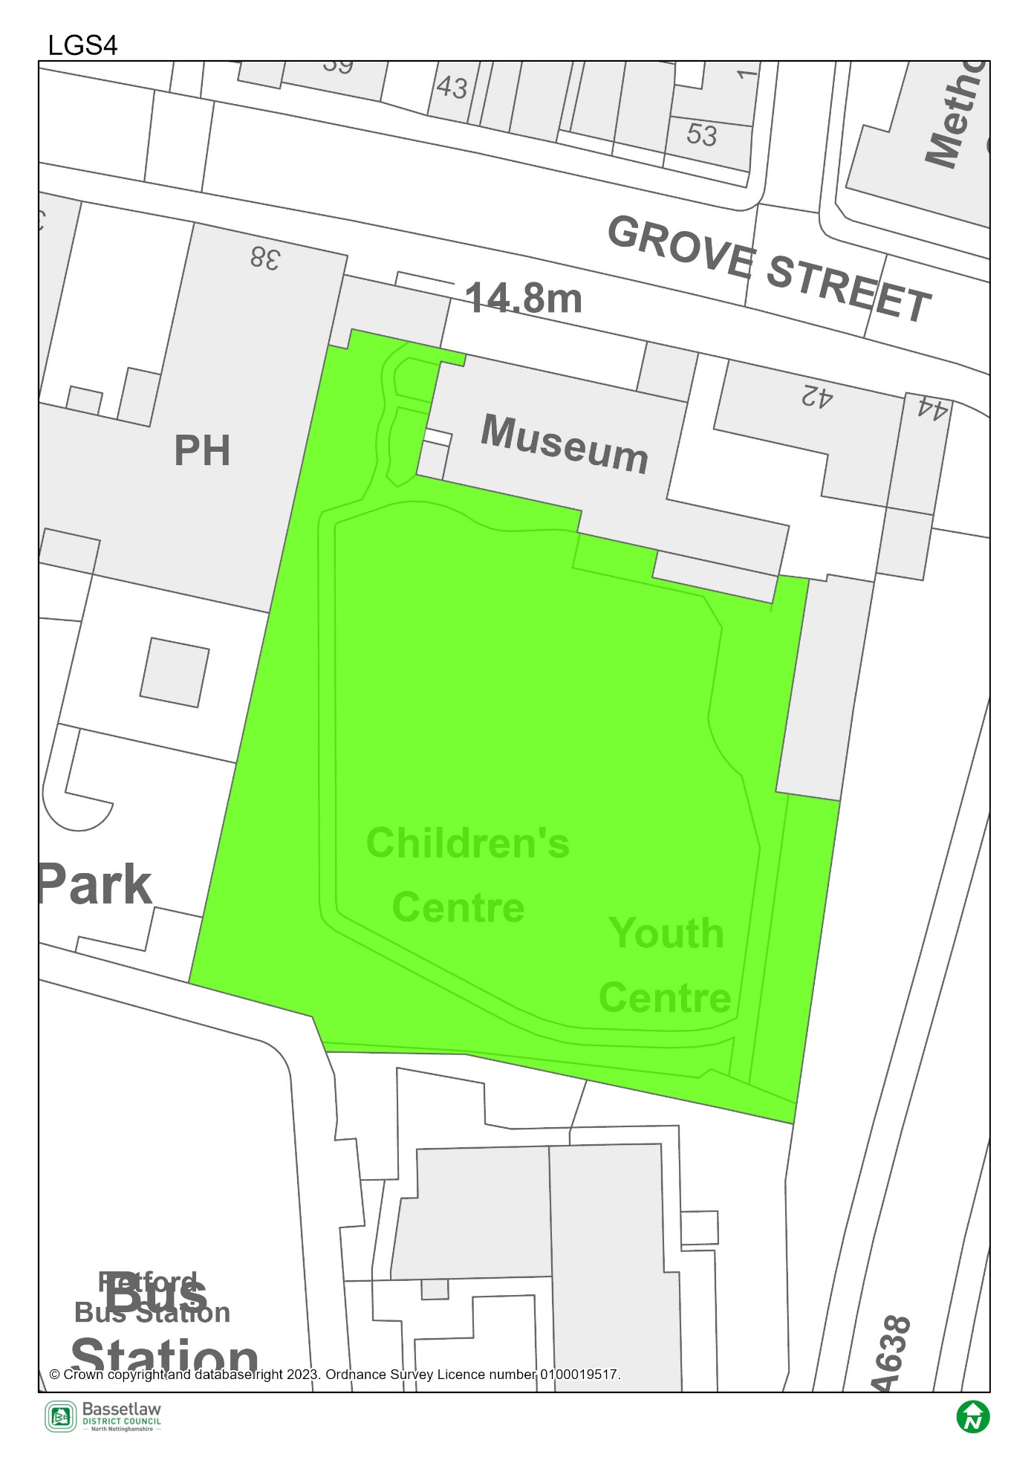

Potential Local Green Space LGS5: Land to the west of Arlington Way

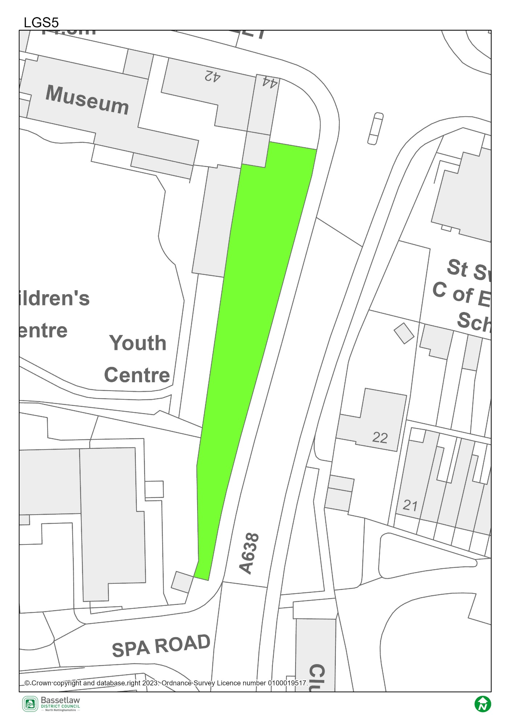

Potential Local Green Space LGS6: Land at the junction of West Street and Wharf Road

