Retford Town Centre Neighbourhood Plan

Potential Development Site NP01: Land west of Moorgate and north of Amcott Way

Maps and Technical Assessments

February 2023

Site Plan

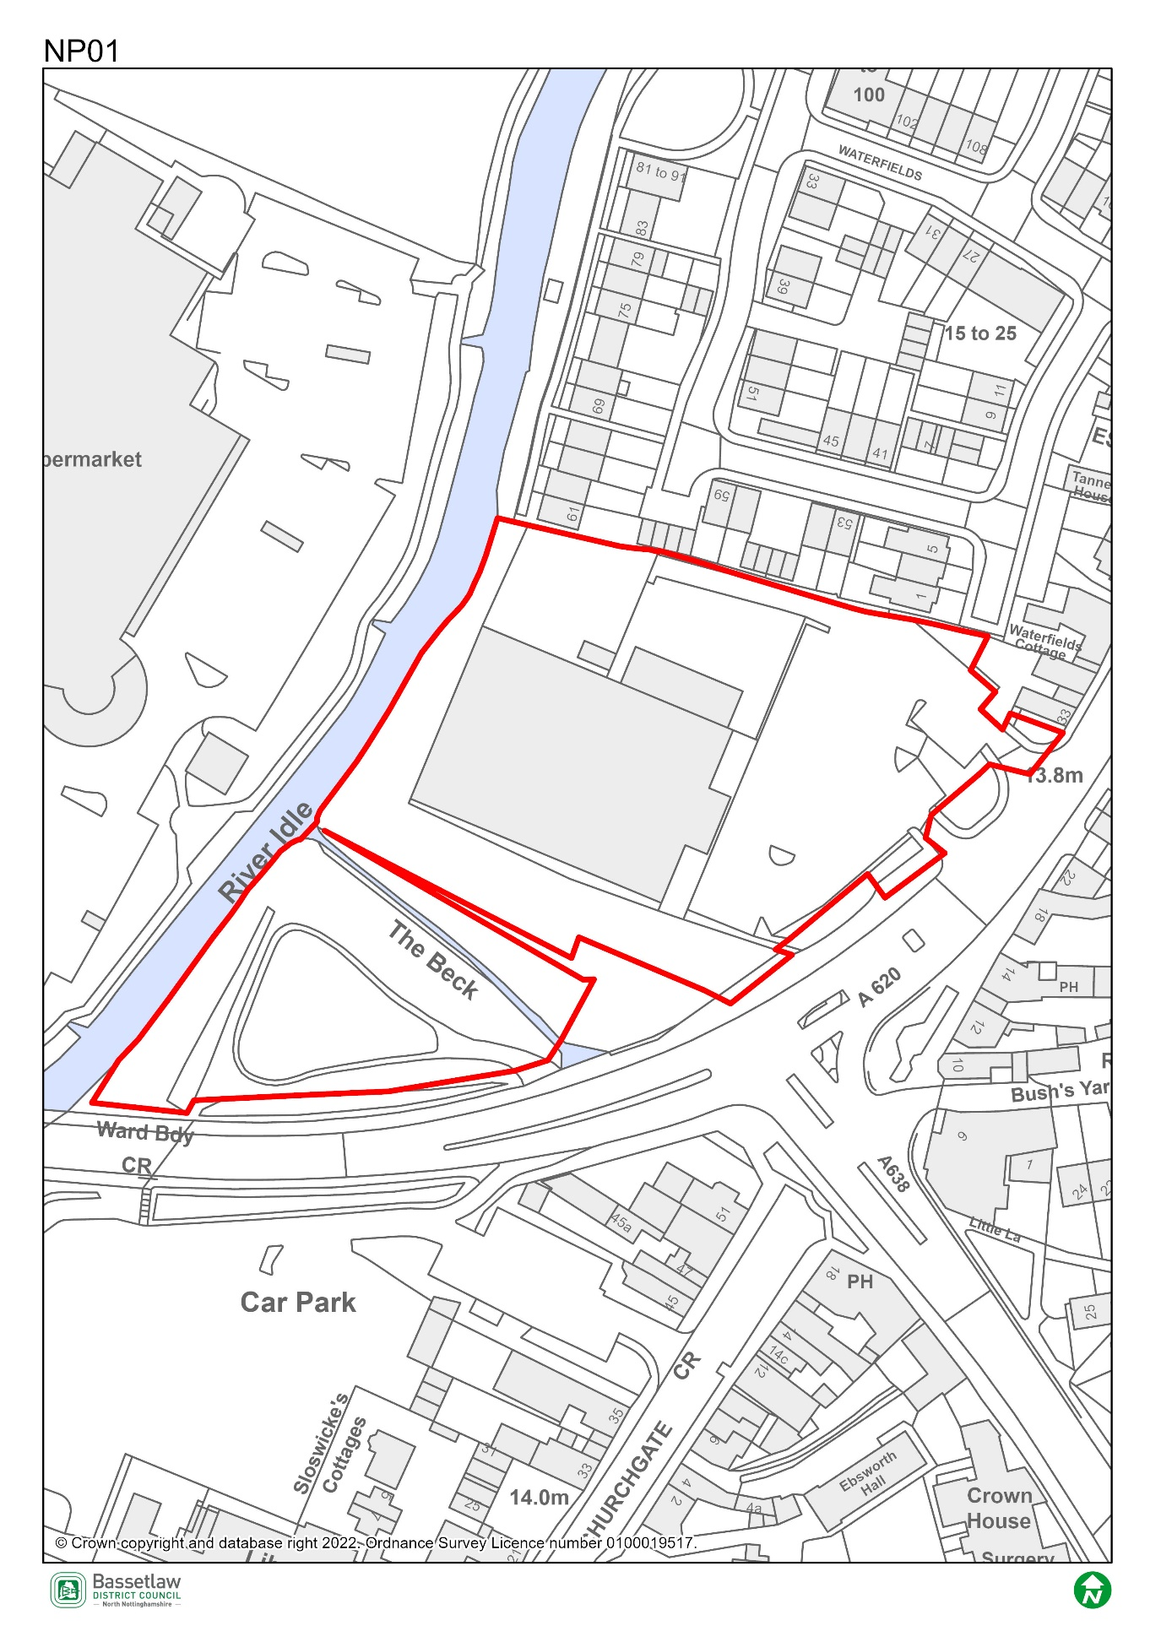

Constraints Plan
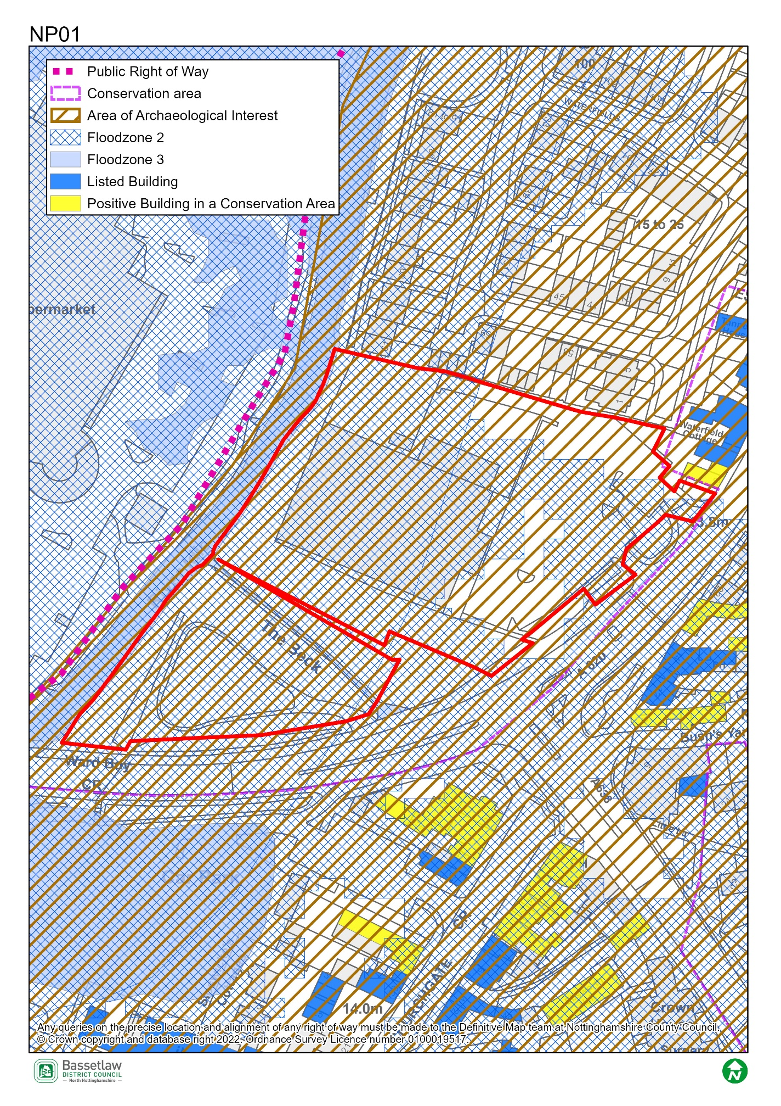

AECOM Site Assessment Report, 2022

Score: Red
Conclusions (please see full report for more detail)
While the [current planning] application covers the entire site, the proposal does not involve any development on the southern part of the site, which is almost entirely separated from the developed part of the site by a strip of land in unknown ownership, and physically separated by a small stream which runs across the site into the River Idle. The Neighbourhood Plan ecological survey identifies this part of the site as providing foraging habitat for a variety of species. There is potential for any future development of this area to result in loss of habitats and mature trees, and the flood risk means that it would not be suitable for vulnerable uses. It may also conflict with adopted policy CS3 which seeks to support flood alleviation measures associated with Retford Beck, which runs east to west through the centre of the site. There may be opportunities to enhance the biodiversity value of this part of the site or to create public green space, subject to discussions with the landowner.
Since the [current] planning application does not involve a change in existing use, and no development is proposed on the undeveloped southern part of the site, it is not considered to be available for development other than the proposed retail expansion. Therefore, it is not currently suitable for allocation in the Neighbourhood Plan on the grounds of its current availability.
However, some additional development could potentially be accommodated on the southern part of the site. Should this part of the site be made available for further development, it may become suitable for allocation subject to mitigation of the constraints identified above and to consideration of relevant Local Plan policies for the proposed uses.

Bassetlaw District Council Planning Policy

National planning policy requires Plans to steer development to areas at low risk from flooding i.e. Flood Zone 1, in preference to areas at higher risk i.e. Flood Zones 2 and 3, and this should be applied to all prospective development areas and sites. Approx 80% of Site NP01 is wholly within Flood Zone 2: as having a medium probability of river flooding.
As such, before progressing the Plan, its recommended that a Sequential Test is undertaken for the sites in the neighbourhood plan to ensure the requirements of the sequential test in national policy are satisfied. Bassetlaw District Council, with advice from the Environment Agency, are responsible for considering the extent to which Sequential Test considerations have been met. This will include whether the proposed development would be safe, that occupiers can safely leave the development in times of a flood, and that the proposed development would not lead to increased flood risk on or off site.
To undertake the sequential test an understanding of the type of development proposed would be required. National policy classifies development into vulnerability categories, guidance is provided for each vulnerability category by flood zone.

Bassetlaw District Council Conservation

Whilst Conservation would defer to the views of our Tree Officer on the matter of tree health, there are concerns with the likely impact the loss of trees on the west part of this site would have on the setting of the Conservation Area and the setting of nearby Listed Buildings. This large grouping of trees is prominent in the locality and also helps to screen the large retail buildings (Morrisons and Home Bargains) from views within and around the Conservation Area. Any allocation here would need to have regard to the protection of a tree buffer along the front (south) boundary to help screen any development in the context of heritage setting.

Nottinghamshire County Council Highways

There does not appear to be a reasonable prospect of providing vehicular access to the site from the A620 Amcott Way without materially effecting the capacity of the local highway network and impacting on highway safety. It is therefore unlikely that the Highway Authority would be able to support the development.

