Retford Town Centre Neighbourhood Plan

Potential Development Site NP06: Goodwin Hall, Chancery Lane

Maps and Technical Assessments

February 2023

Site Plan

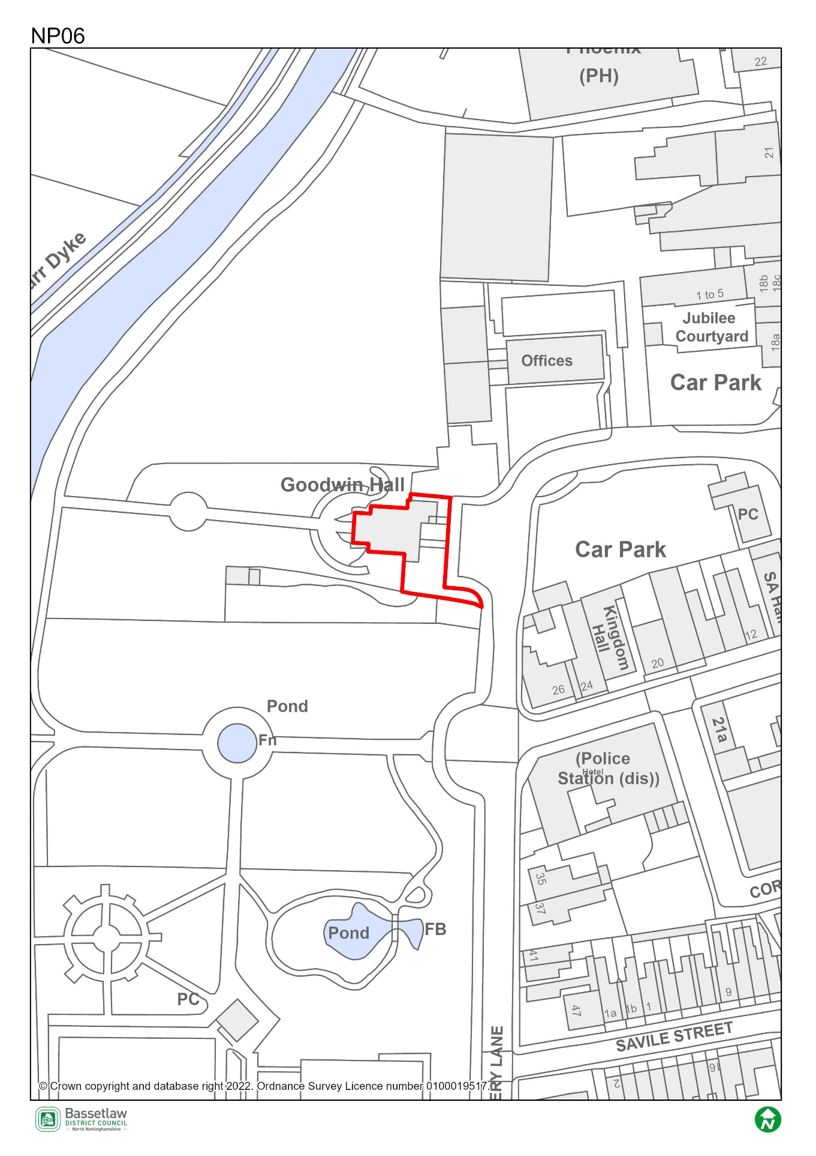

Constraints Plan
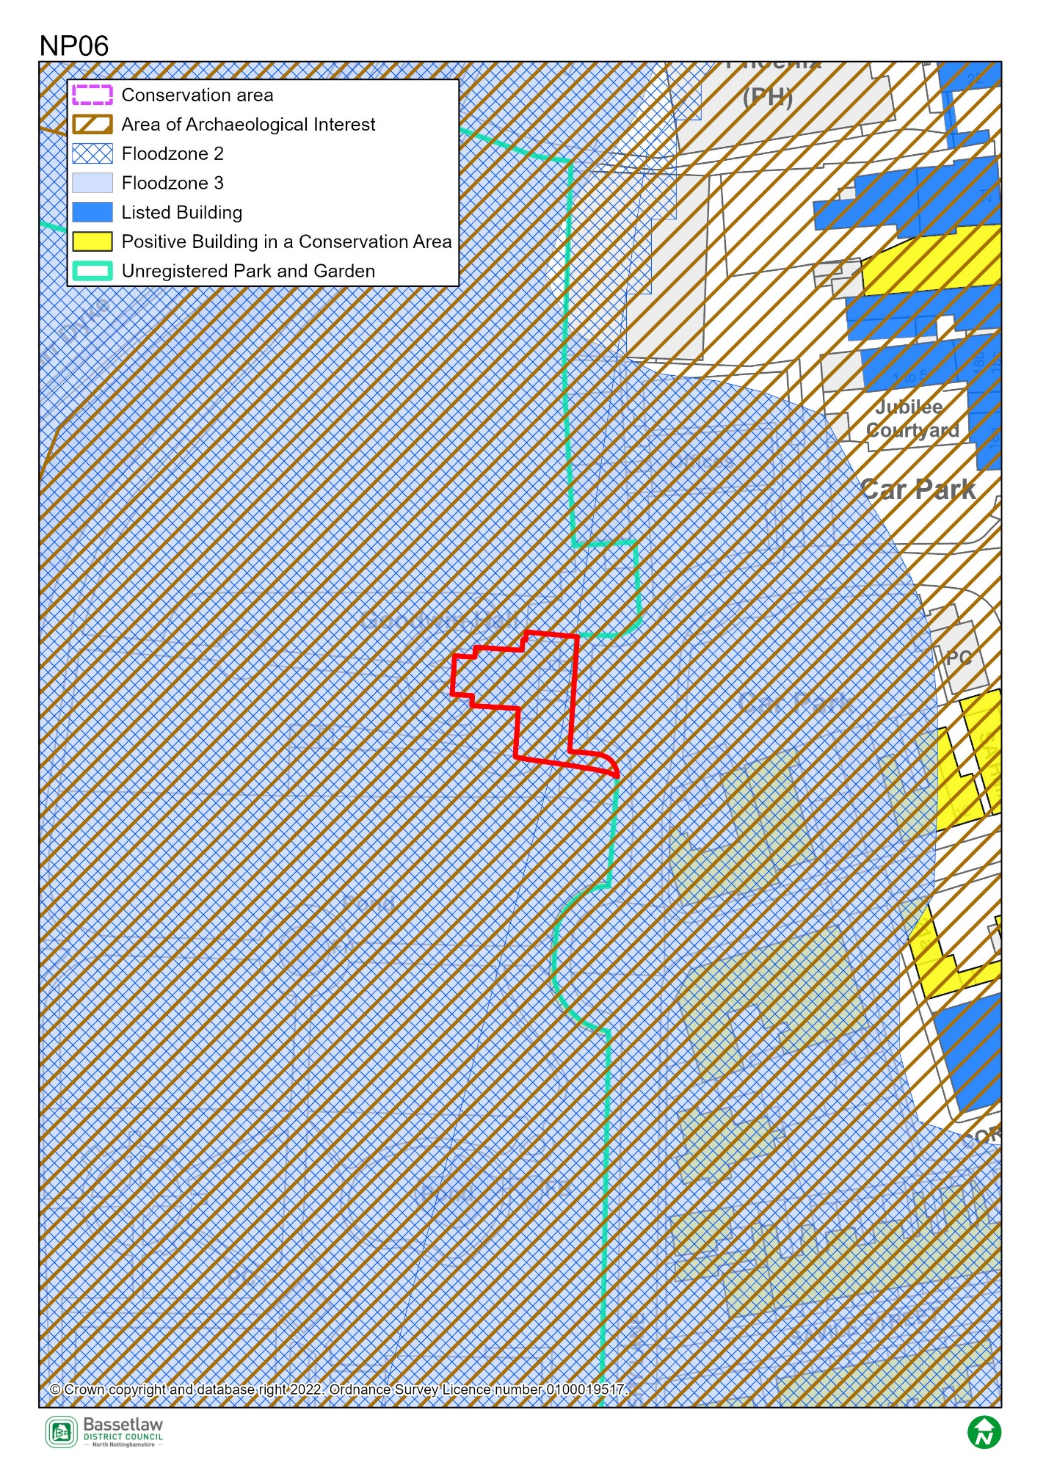

AECOM Site Assessment Report, 2022

Score: Amber
Conclusions (please see full report for more detail)
The site is currently occupied by a single-storey community centre. Demolition or repurposing of this building has the potential to increase the costs of development.
The site is entirely in Flood Zone 3, and its suitability for residential development would therefore be subject to a sequential and exception test. Site-specific flood risk assessment is likely to be required along with on-site mitigation measures. Sensitive/vulnerable uses should be kept off the ground floor to minimise risk to future occupiers.
It is entirely within the Conservation Area, and there is some limited intervisibility with listed buildings to the east. It is also situated at the entrance to King's Park (an unregistered park and garden) and has a high degree of intervisibility with the park. Due to the potential impact on the setting of the park, building heights are likely to be restricted to one or two-storeys, reducing the potential for vulnerable/sensitive uses (including residential) which should be kept off the ground floor due to flood risk. The site is adjacent to Site NP05, which is in the same ownership, and there is potential for a comprehensive redevelopment of the two sites, with the existing community use on Site NP06 either being retained in its current location or relocated onto Site NP05.
The site is potentially suitable for allocation for community or mixed-use development (residential/community use), either on its own or in combination with Site NP05, subject to mitigation of the identified constraints.

Bassetlaw District Council Planning Policy

National planning policy requires Plans to steer development to areas at low risk from flooding i.e. Flood Zone 1, in preference to areas at higher risk i.e. Flood Zones 2 and 3, and this should be applied to all prospective development areas and sites. Site NP06 is wholly within Flood Zone 3: as having a high probability of river flooding.
As such, before progressing the Plan, its recommended that a Sequential Test is undertaken for the sites in the neighbourhood plan to ensure the requirements of the sequential test in national policy are satisfied. Bassetlaw District Council, with advice from the Environment Agency, are responsible for considering the extent to which Sequential Test considerations have been met. This will include whether the proposed development would be safe, that occupiers can safely leave the development in times of a flood, and that the proposed development would not lead to increased flood risk on or off site.
To undertake the sequential test an understanding of the type of development proposed would be required. National policy classifies development into vulnerability categories, guidance is provided for each vulnerability category by flood zone.

Bassetlaw District Council Conservation

This was constructed in 1963 as a hall for “the elderly and physically handicapped” (Coventry Telegraph, 29th Oct 1963), paid for by Sheffield Industrialist and philanthropist Sir Stuart Goodwin (£6,000) and opened by his wife, Lady Florence Goodwin, on 28th Oct 1963. Goodwin also provided £10,000 for the maintenance and operation of the building.
Whilst of historic interest, architecturally the building is of a neutral character and appears to be in poor condition. It contributes little to the character of this part of the Conservation Area. On this basis, Conservation has no concerns with the replacement of this building. However, this is subject to a suitable design, materials, layout and scale. It is also recommended that some form of interpretation to the Goodwin family/‘Sir Stuart and Lady Florence Goodwin Charity’ be included in any replacement. Conservation is happy to advise on this element.

Nottinghamshire County Council Highways

The site is likely to be considered suitable for redevelopment subject to satisfactory details of access, parking, and servicing arrangements.
The large apron in front of the site which is marked on the ground as parking for the Hall is public highway. This area may require stopping-up as part of the proposal. The existing footway would then require replacing to the side of the carriageway. This will in effect make the site larger than indicated on the submitted plan.

