Retford Town Centre Neighbourhood Plan

Potential Development Site NP05: Retford Registry Office, Chancery Lane

Maps and Technical Assessments

February 2023

Site Plan

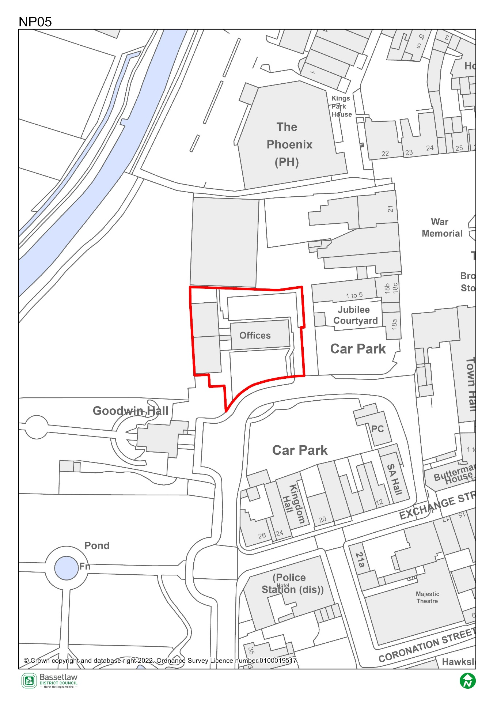

Constraints Plan
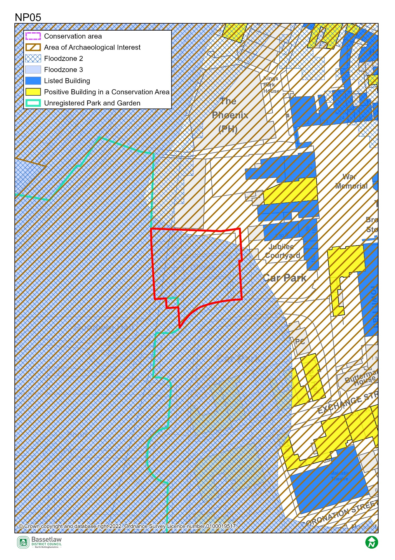

AECOM Site Assessment Report, 2022

Score: Amber
Conclusions (please see full report for more detail)
The site is currently occupied by a two-storey office block and car park. The site is entirely in Flood Zone 3, and its suitability for residential development would therefore be subject to a sequential and exception test. Site-specific flood risk assessment is likely to be required along with on-site mitigation measures. Sensitive/vulnerable uses should be kept off the ground floor to minimise risk to future occupiers.
It is entirely within the Conservation Area, and there are several listed buildings in close proximity, including the Grade II listed 18 and 18a The Square, immediately to the east. Any new development on the site should be sensitively designed to minimise impact on the historic environment and enhance the existing heritage assets.
The site is situated close to King's Park, an unregistered park and garden. In order to minimise impact on the setting of the park, building heights may need to be limited, subject to discussion with the Local Planning Authority.
Subject to appropriate flood risk mitigation, the site is potentially suitable for residential uses, including specialist or older people's accommodation. It is adjacent to Site NP06, which is in the same ownership, and there is potential for a comprehensive redevelopment of the two sites, with the existing community use on Site NP06 either being retained in its current location or relocated onto Site NP05.The indicative capacity is based on conversion or redevelopment of the site, although this has the potential to be increased if combined with Site NP06.
There is potential for the existing office block to be converted to residential/mixed-use, with additional storeys. Demolition of the buildings may increase the cost of development.
The site is potentially suitable for allocation for residential or mixed-use development (including community use), either on its own or in combination with Site NP06, subject to mitigation of the identified constraints.

Bassetlaw District Council Planning Policy
National planning policy requires Plans to steer development to areas at low risk from flooding i.e. Flood Zone 1, in preference to areas at higher risk i.e. Flood Zones 2 and 3, and this should be applied to all prospective development areas and sites. Approximately 98% of Site NP05 is within Flood Zone 3: as having a high probability of river flooding.
As such, before progressing the Plan, its recommended that a Sequential Test is undertaken for the sites in the neighbourhood plan to ensure the requirements of the sequential test in national policy are satisfied. Bassetlaw District Council, with advice from the Environment Agency, are responsible for considering the extent to which Sequential Test considerations have been met. This will include whether the proposed development would be safe, that occupiers can safely leave the development in times of a flood, and that the proposed development would not lead to increased flood risk on or off site.
To undertake the sequential test an understanding of the type of development proposed would be required. National policy classifies development into vulnerability categories, guidance is provided for each vulnerability category by flood zone.

Bassetlaw District Council Conservation

These buildings date to the 1960s and appear to be an example of the CLASP method of construction, typical of administrative buildings such as offices and schools in that period. Whilst their construction method is of a degree of interest, they are of a neutral character, and contribute little to the historic appearance of this part of the Conservation Area and setting of nearby Listed Buildings. On this basis, Conservation is very much supportive of the replacement of these buildings. This is subject to appropriate scale, materials, layout and design.

Nottinghamshire County Council Highways

The site is likely to be considered suitable for residential development subject to satisfactory details of access, parking, and servicing arrangements.

