Retford Town Centre Neighbourhood Plan

Potential Development Site NP04: Land to the rear of 27 – 37 Bridgegate

Maps and Technical Assessments

February 2023

Site Plan

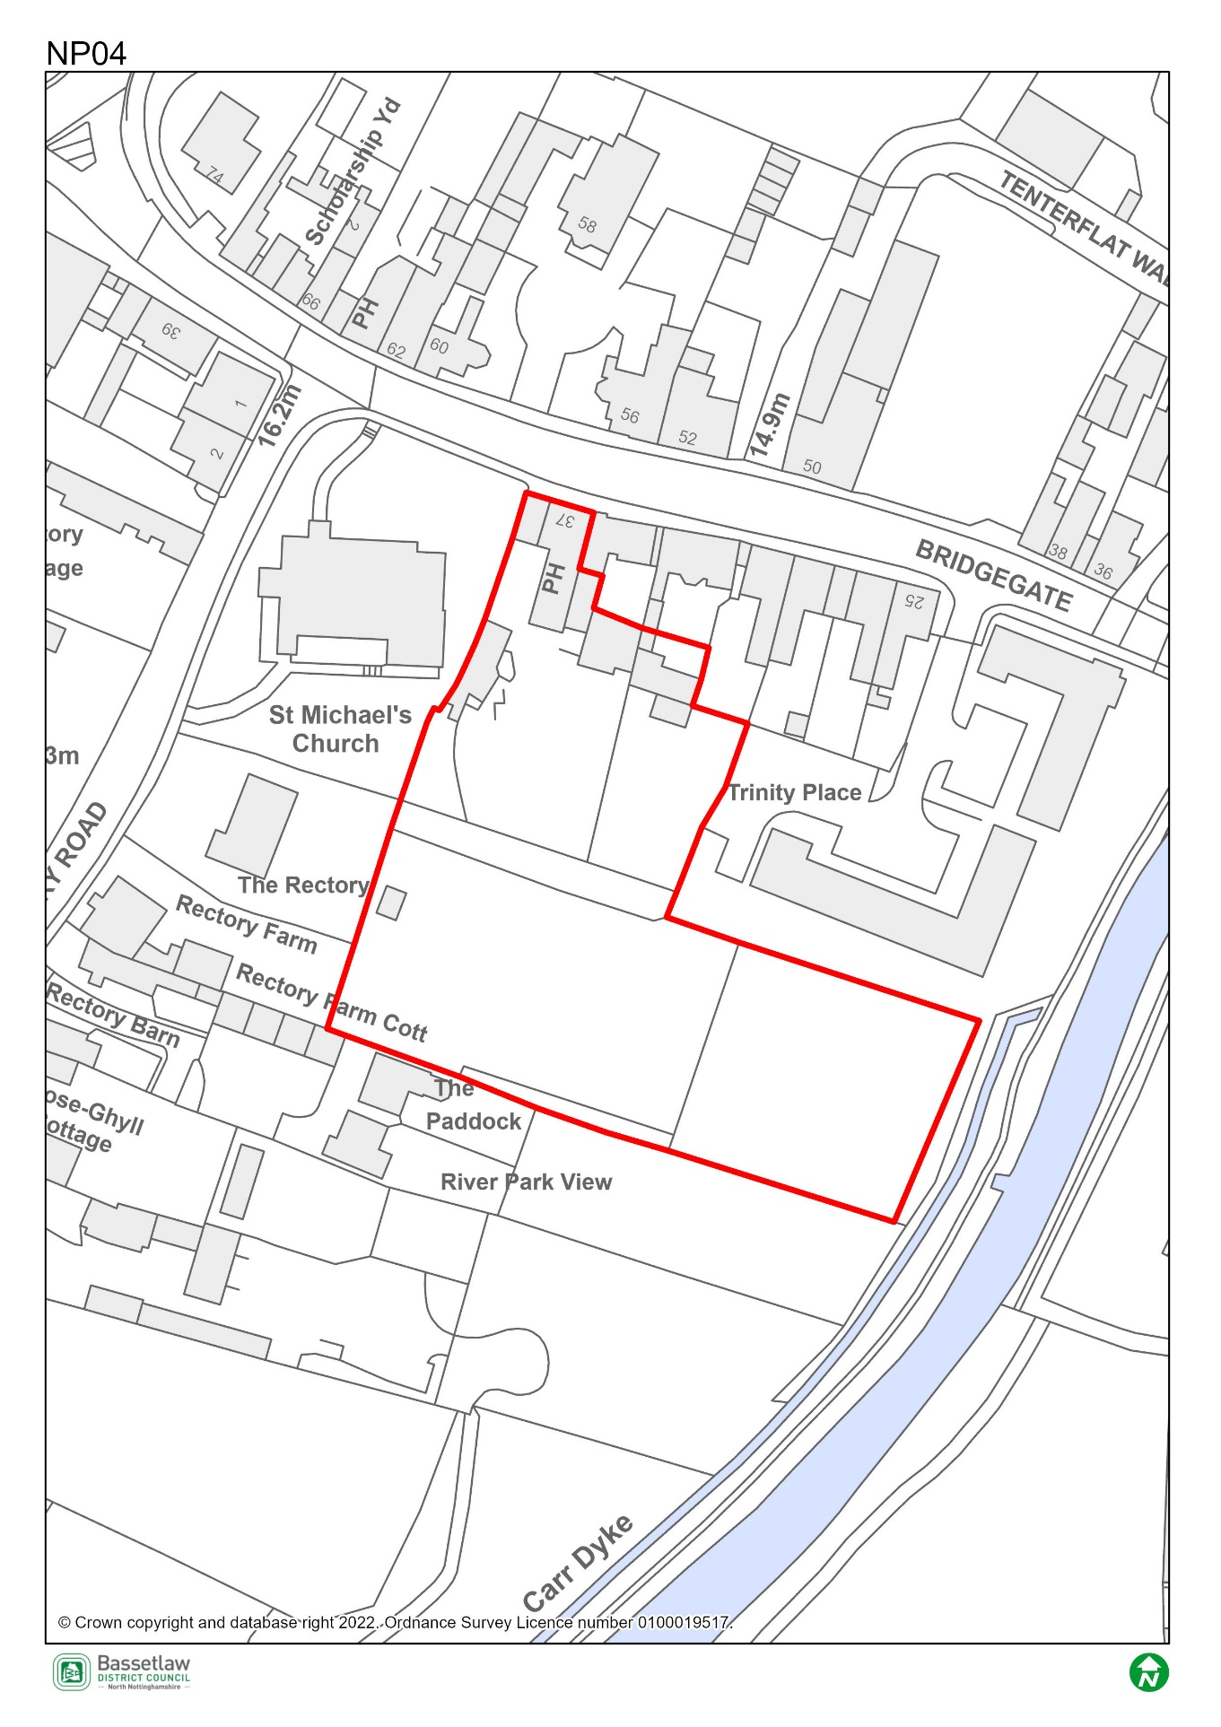

Constraints Plan
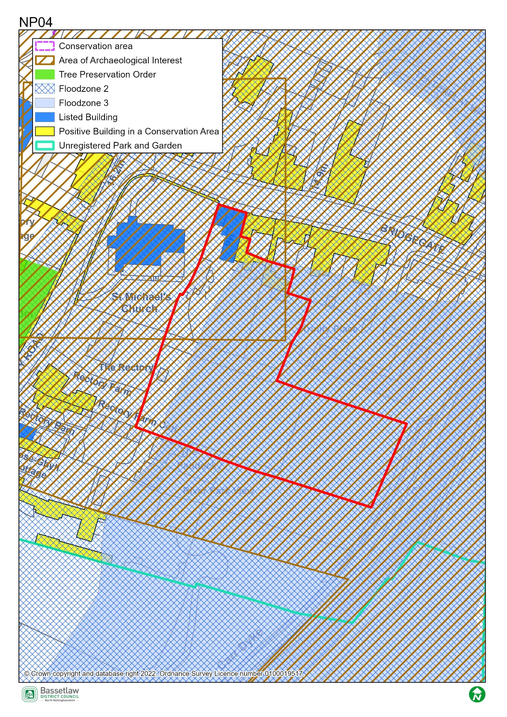

AECOM Site Assessment Report, 2022

Score: Amber
Conclusions (please see full report for more detail)
The existing access via the courtyard entrance to the car park at the rear of 37 Bridgegate (which is Grade II listed) is narrow and could not be widened to serve development of the site. Alternative access could be taken from Trinity Place, immediately east of the site, which is in the same ownership. This could provide two-way access with a footway. Part of the site (the area immediately south of Trinity Place) is identified in the emerging Local Plan as Locally Important Green Space and also falls partly within the 30m buffer associated with the River Idle Major Green Corridor. This part of the site is unsuitable for development, but could form open space as part of a redevelopment of the wider site. The developable area is therefore approximately 0.35ha.
In addition to the Grade II listed 37 Bridgegate, St Michael’s Church to the west is Grade II* listed and the buildings immediately north of the site along Bridgegate are undesignated but make a positive contribution to the Conservation Area. There is a high degree of intervisibility between the heritage assets and the site itself, and sensitive design and landscaping are likely to be required. This should be discussed with the Local Planning Authority.
The entire site is at risk of flooding (Flood Zones 2 and 3), and its suitability for residential development would therefore be subject to a sequential and exception test. A site-specific flood risk assessment is likely to be required to support proposals for development, as are on-site flood mitigation measures.
The site is potentially suitable for allocation for residential development subject to mitigation of the identified constraints.

Bassetlaw District Council Planning Policy
National planning policy requires Plans to steer development to areas at low risk from flooding i.e. Flood Zone 1, in preference to areas at higher risk i.e. Flood Zones 2 and 3, and this should be applied to all prospective development areas and sites. Approximately 90% of Site NP04 is within Flood Zone 3: as having a high probability of river flooding.
As such, before progressing the Plan, its recommended that a Sequential Test is undertaken for the sites in the neighbourhood plan to ensure the requirements of the sequential test in national policy are satisfied. Bassetlaw District Council, with advice from the Environment Agency, are responsible for considering the extent to which Sequential Test considerations have been met. This will include whether the proposed development would be safe, that occupiers can safely leave the development in times of a flood, and that the proposed development would not lead to increased flood risk on or off site.
To undertake the sequential test an understanding of the type of development proposed would be required. National policy classifies development into vulnerability categories, guidance is provided for each vulnerability category by flood zone.

Bassetlaw District Council Conservation

Conservation has strong concerns with the allocation of this site. It is within the Conservation Area and in the setting of several Listed Buildings, including St Michael’s Church. Much of the site is visible from the footpath on the west side of the River Idle, and provides an open setting to the church when viewed from this position (similar views are had from the churchyard). Development on this site would irrevocably harm this open setting, and any discernible public benefits for this development could easily be obtained with a development located elsewhere around the town in far less sensitive locations. On this basis, Conservation cannot support the allocation of this site.
I should point out that there are likely to be considerable flooding issues here too, as the east part of the site appeared to be lower than the river level when the site was visited (10th Jan 2023). I would defer to the views of flood experts on that matter however.

Nottinghamshire County Council Highways

The Highway Authority would be unlikely to support a proposal that is reliant on vehicular access through the existing building No.37. However, there may be a potential for residential development if there is no or a very limited requirement for vehicular access. Provision would be required such that refuse could be collected from Bridgegate without the potential for bins to be left on the footway for collection, possibly from within the undercroft. Alternatively, Trinity Place may be capable of providing suitable access arrangements.

