Retford Town Centre Neighbourhood Plan

Potential Development Site NP03: Land adjacent to Tenterflat Walk

Maps and Technical Assessments

February 2023

Site Plan

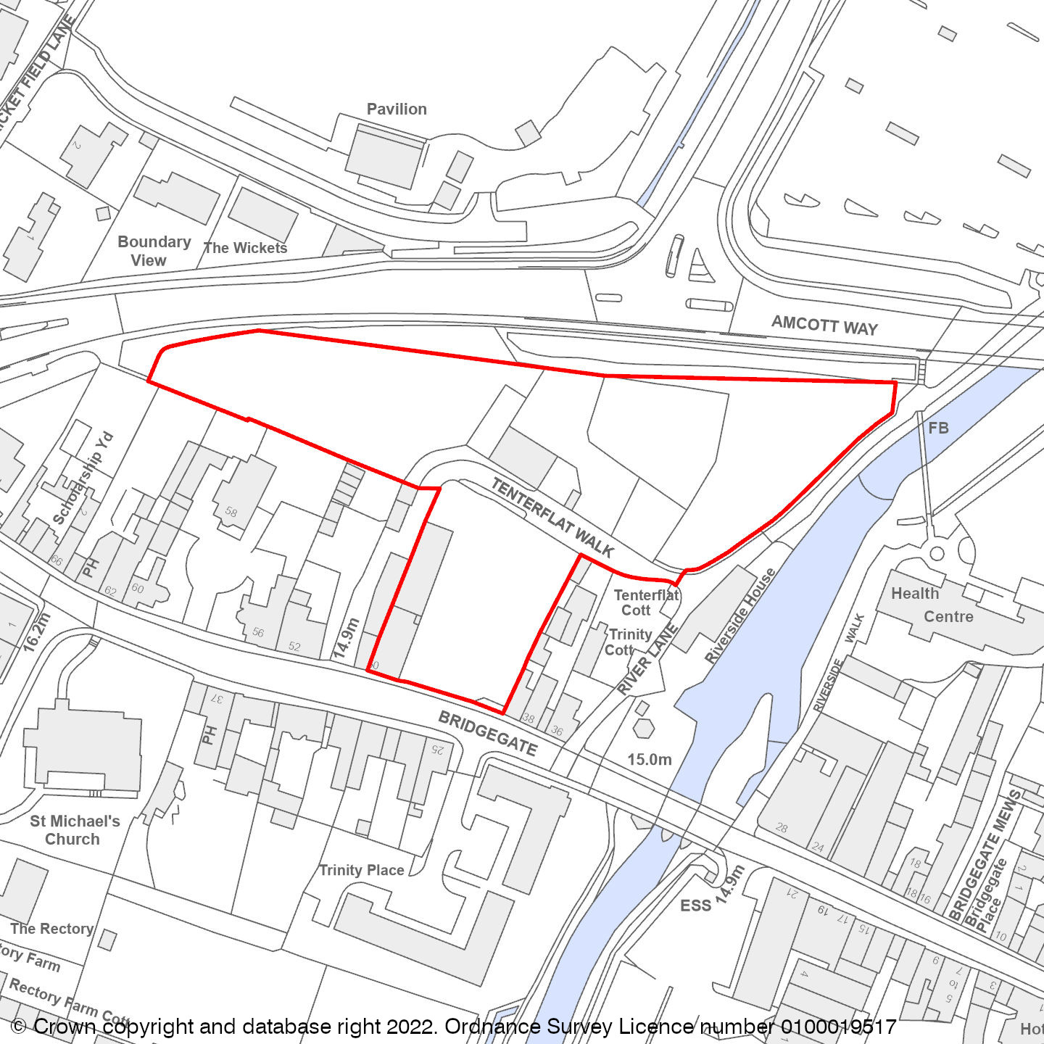

Constraints Plan
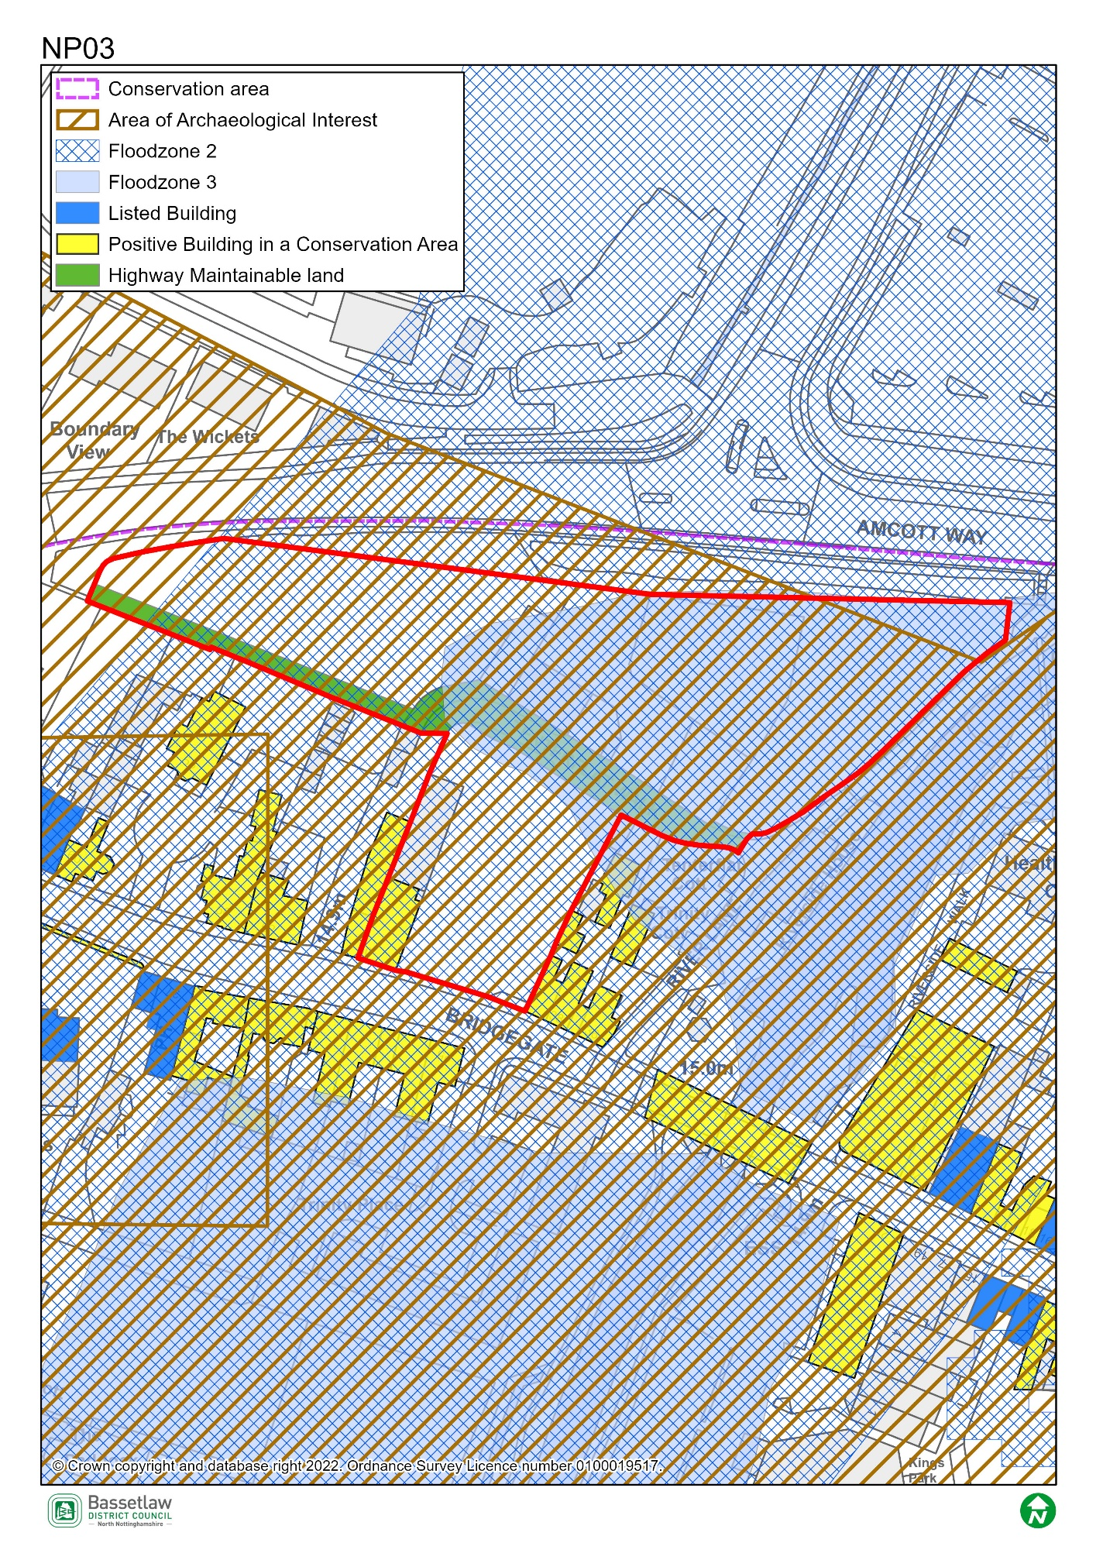

AECOM Site Assessment Report, 2022

Score: Amber
Conclusions (please see full report for more detail)
This is a large site comprising a former (now-demolished) garage and an overgrown area to the north between Tenterflat Walk and Amcott Way. It is within a SSSI Impact Risk Zone and consultation with Natural England is required for residential developments of 50 or more dwellings. The Neighbourhood Plan ecological survey identifies the northern part of the site as providing foraging habitat for badgers and as formerly providing a habitat for hedgehogs. It may be possible to restore or enhance biodiversity by incorporating managed green space into new development.
The entire site is within the Conservation Area, and there are a number of listed buildings and undesignated heritage assets on Bridgegate which runs along the southern boundary of the site. Any new development on the southern part of the site has the potential for adverse impact on heritage assets, and sensitive design would be required to ensure that the historic environment is enhanced.
The entire site is at risk of flooding (Flood Zones 2 and 3), and a site-specific flood risk assessment is likely to be required to support proposals for development, as are on-site flood mitigation measures. The northern (undeveloped) part of the site is in Flood Zone 3 and if there were alternative sites for housing the sequential test would not be met, but it could be allocated for other less vulnerable uses (e.g. retail, commercial or leisure uses). There is potential for noise and atmospheric pollution from Amcott Way to the north, which could be addressed through a landscaped buffer and siting of new development away from the northern boundary.
The site is potentially suitable for allocation for residential or mixed-use development, subject to mitigation of the identified constraints.

Bassetlaw District Council Planning Policy
National planning policy requires Plans to steer development to areas at low risk from flooding i.e. Flood Zone 1, in preference to areas at higher risk i.e. Flood Zones 2 and 3, and this should be applied to all prospective development areas and sites. Approximately 50% of Site NP03 is within Flood Zone 3: as having a high probability of river flooding; and 50% is within Flood Zone 2 as having a medium risk of river flooding.
As such, before progressing the Plan, its recommended that a Sequential Test is undertaken for the sites in the neighbourhood plan to ensure the requirements of the sequential test in national policy are satisfied. Bassetlaw District Council, with advice from the Environment Agency, are responsible for considering the extent to which Sequential Test considerations have been met. This will include whether the proposed development would be safe, that occupiers can safely leave the development in times of a flood, and that the proposed development would not lead to increased flood risk on or off site.
To undertake the sequential test an understanding of the type of development proposed would be required. National policy classifies development into vulnerability categories, guidance is provided for each vulnerability category by flood zone.

Bassetlaw District Council Conservation

This site is in the Conservation Area and in the setting of a range of nearby Listed Buildings, including St Michael’s Church (grade II*). Conservation is very much supportive of the development of this site, subject to suitable design, scale, layout and materials, reflective of the historic context the site is within. Conservation would suggest the 2019 approval, reference 19/00194/FUL, is used as a basis for future proposals, especially for the Bridgegate frontage which is the most heritage-sensitive part of the site.

Nottinghamshire County Council Highways

There is likely to be a reasonable prospect of providing access to new development from Bridgegate. It should be noted that, although largely abandoned, Tenterflat Walk is public highway. Therefore, any development would either need to accommodate the highway as part of the layout or this would require stopping-up prior to the development taking place. The layout may need to make provision for retaining rear access to existing properties. Vehicular access to Amcott Way would not be supported, but a walking and cycle is likely to be sought as well as a pedestrian link to River Lane (East Retford Footpath 20).

