Retford Town Centre Neighbourhood Plan

Potential Development Site NP02: Ebsworth Hall, to the rear of St Swithun’s Church

Maps and Technical Assessments

February 2023

Site Plan

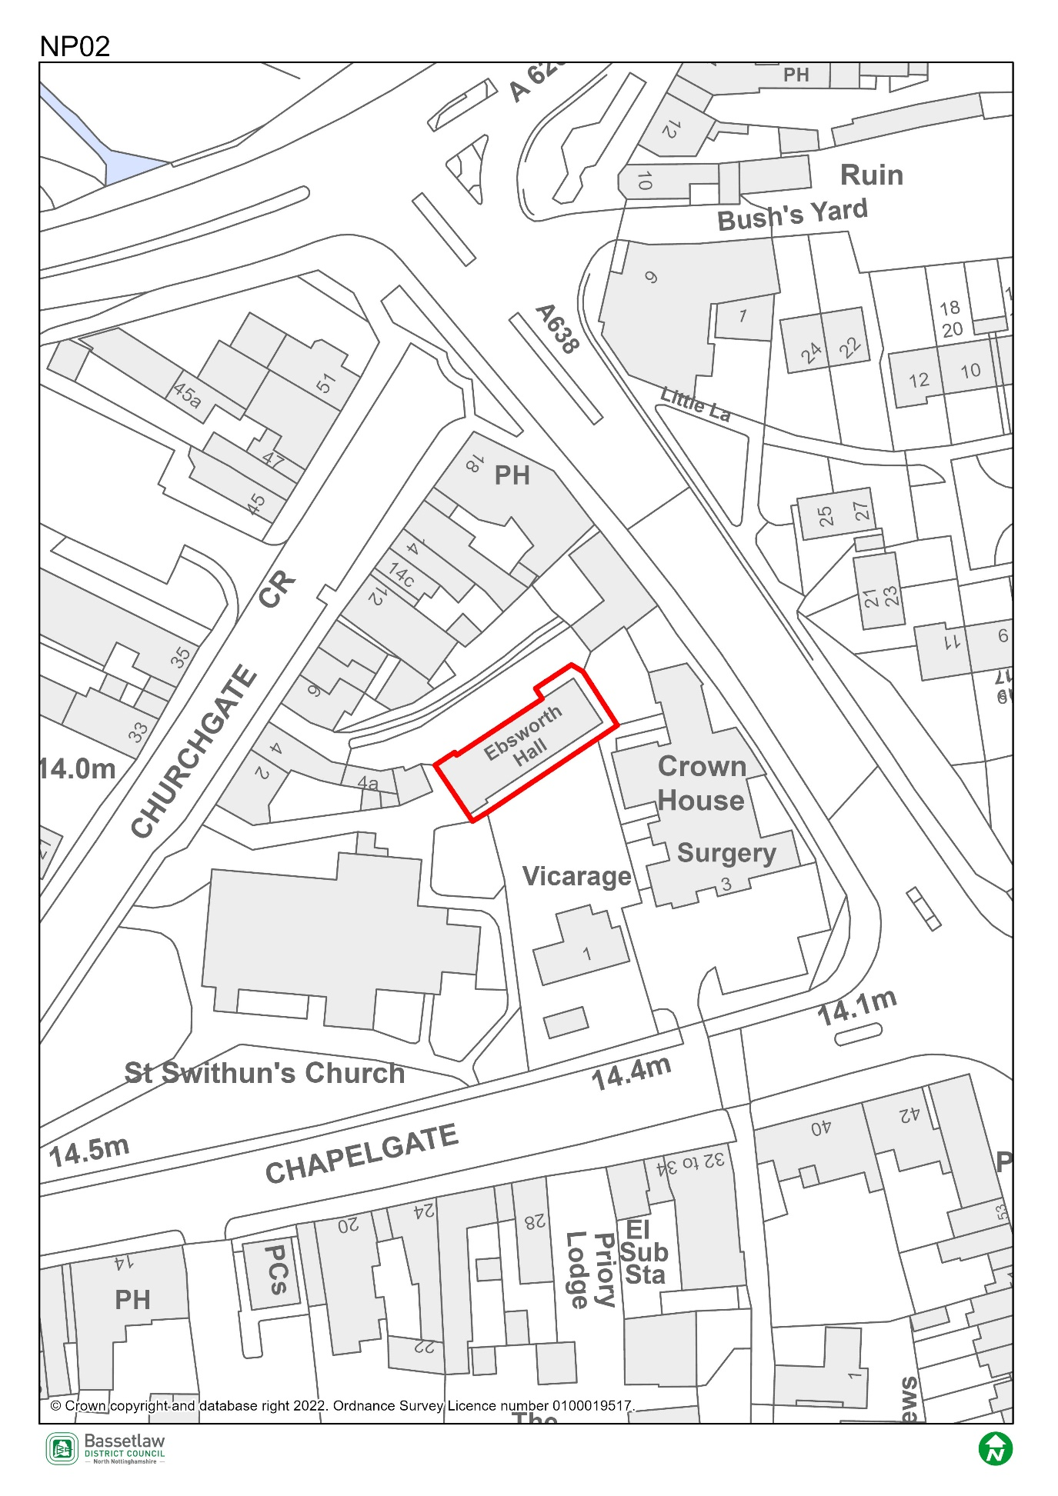

Constraints Plan
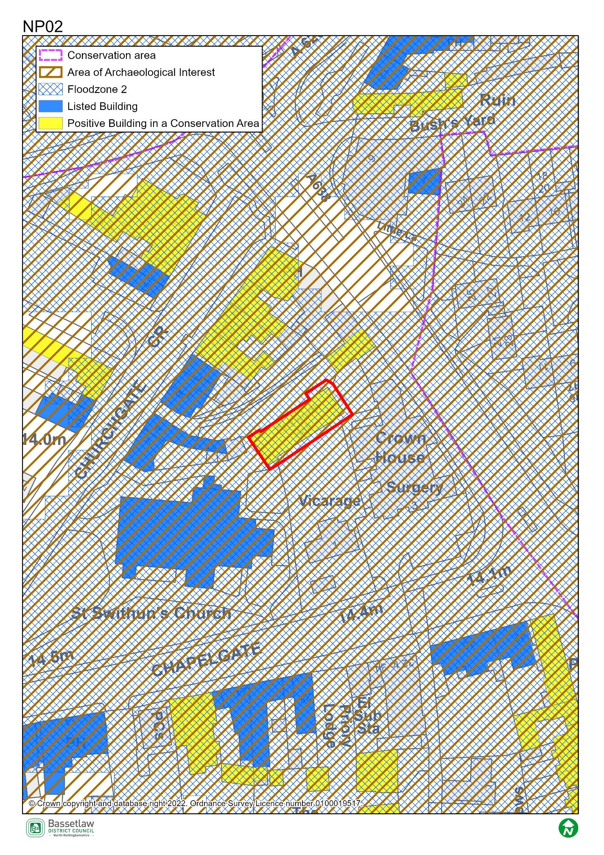

AECOM Site Assessment Report, 2022

Score: Amber
Conclusions (please see full report for more detail)
There is an existing former church hall on the site which does not appear to be in use. The building is identified as making a positive contribution to the Conservation Area, but is in a state of disrepair and is not currently accessible. A replacement building is proposed for community use associated with the adjacent Grade II* listed church. Discussion with the LPA heritage officer is recommended to ensure that the replacement of the church hall would be supported, and to ensure that new development does not have an adverse impact on the Conservation Area or on nearby heritage assets, including the church and listed buildings on Churchgate.
Given the size and enclosed nature of the site, it is unlikely that on-site parking could be provided. There are on-street options and public car parks within close proximity. Vehicular access is therefore likely to be limited to service vehicles, but the suitability of the existing narrow access through the churchyard should be discussed with the highways authority.
The site is entirely in Flood Zone 2, and a site specific flood risk assessment may be required to accompany any proposals for development.
The site is potentially suitable for allocation for community use, subject to mitigation of the identified constraints.

Bassetlaw District Council Planning Policy
National planning policy requires Plans to steer development to areas at low risk from flooding i.e. Flood Zone 1, in preference to areas at higher risk i.e. Flood Zones 2 and 3, and this should be applied to all prospective development areas and sites. Site NP02 is wholly within Flood Zone 2: as having a medium probability of river flooding.
As such, before progressing the Plan, its recommended that a Sequential Test is undertaken for the sites in the neighbourhood plan to ensure the requirements of the sequential test in national policy are satisfied. Bassetlaw District Council, with advice from the Environment Agency, are responsible for considering the extent to which Sequential Test considerations have been met. This will include whether the proposed development would be safe, that occupiers can safely leave the development in times of a flood, and that the proposed development would not lead to increased flood risk on or off site.
To undertake the sequential test an understanding of the type of development proposed would be required. National policy classifies development into vulnerability categories, guidance is provided for each vulnerability category by flood zone.

Bassetlaw District Council Conservation

This building was opened in 1923 as a memorial to the late Canon Ebsworth, who had been vicar of St Swithuns for 32 years. The building is owned by the church, was last used for associated purposes, and is on church land. As such, it is considered listed by curtilage association to the grade II* listed church. It is a building of considerable architectural and historic interest, with the feature entrance porch, roof-mounted vent, front gable oval-shaped vent and foundation stone. Most of the building has a typical early-20th century hall/school arrangement, with full-height windows along its length.
Sadly the building has been poorly maintained in recent years and it is evident that there are water ingress issues with the roof. There is also a degree of brick spalling and many of the windows require repair or replacement. I have also been made aware of internal ceiling/roof problems. However, there is no clear and convincing justification for the loss of this important historic building, considered to be listed by curtilage association.
The building could be brought back into use relatively easily, it is a key part of the character of this part of Retford, and is a memorial to one of its longest serving vicars. The building was also paid for by public subscription. Conservation has discussed the condition of the building with the PCC and Diocese previously and argued strongly for the building’s repair and conservation. On this basis, Conservation cannot support the allocation of this building to be replaced. This element should be removed from the NP.

Nottinghamshire County Council Highways

Presumably the site would be accessed through the existing entrance from Churchgate adjacent to St Swithun’s Church. A replacement or refurbishment of the existing building for community use is likely to be acceptable in principle provided that the use has no or a very limited need for vehicular access.
Appreciating that there may be conservation issues, the Highway Authority would likely wish to explore the possibility of improving the access from Churchgate.

