Strategic Environmental Assessment & Habitat Regulations Assessment Screening Statement

Hayton & Tiln Neighbourhood Plan
January 2023

Table of Contents

1 Introduction 2
Strategic Environmental Assessment (SEA) 2
Habitat Regulations Assessment 3
Summary of Findings 3
2 The Hayton & Tiln Neighbourhood Plan 4
Plan Overview 5
Vision 5
Community Objectives 5
Development Management Policies 6
3 SEA Screening – Assessment 8
SEA Assessment 8
4 HRA Screening – Assessment 13
HRA Screening Matrix 15
5 In-combination effects 26
6 Conclusions 27
Consultation 27
SEA Screening 27
HRA Screening 27
Appendix 1: Consultation Responses 28
Appendix 2: Ecological attributes of the European sites 31

Introduction
        - This document contains the Screening Statements for the Hayton & Tiln Neighbourhood Plan - (the Plan) - with regard to whether a Strategic Environmental Assessment (SEA) and / or Habitat Regulations Assessment (HRA) are required to be undertaken. The document also includes an assessment of the policies proposed in the Plan with regard to Impact Risk Zones for Sites of Special Scientific Interest (SSSI).
        - Regulation 15 of the 2012 Neighbourhood Planning (General) Regulations sets out the information that must accompany a Neighbourhood Plan when submitted to the local planning authority. In February 2015 amendments to the Neighbourhood Plan Regulations came into force; this is known as the Neighbourhood Planning (General) (Amendment) Regulations 2015. Regulation 2(4) of these amendments adds additions to the list of documents that a qualifying body must submit to a local planning authority with a Neighbourhood Plan. The additional document which must be submitted is either an environmental report prepared in accordance with the relevant regulations or, if the outcome concludes that an SEA or HRA is not necessary, a statement that sets out how environmental issues have been taken into account and considered during the preparation of the Neighbourhood Plan.
        - The National Planning Policy Framework (para 167) advises that assessments should be proportionate, and should not repeat policy assessment that has already taken place. In view of this, only a high level screening assessment of the Plan has been undertaken, and this assessment should be read in conjunction with the relevant reports produced for Bassetlaw District Councils Local Development Framework.
        - As the responsible authority under relevant regulations, Bassetlaw District Council has undertaken the Screening Assessment contained in this document, working with the Hayton & Tiln Neighbourhood Plan Steering Group.

Strategic Environmental Assessment (SEA)
        - The requirement for a SEA to be undertaken on development plans and programmes that may have a significant environmental effect is outlined in European Union Directive 200142/EC. The Environmental Assessment of Plans and Programmes Regulations 2004 (the 2004 Regulations) state that this is determined by a screening process, utilising a specified set of criteria, outlined in Schedule 1 of the Regulations. The results of this process must be set-out in an SEA Screening Statement, which must be publicly available.
        - The objective of undertaking a SEA is “to provide for a high level of protection of the environment and to contribute to the integration of environmental considerations into the preparation and adoption of plans and programmes with a view to promoting sustainable development, by ensuring that, in accordance with this Directive, an environmental assessment is carried out of certain plans and programmes which are likely to have significant effects on the environment.”

Habitat Regulations Assessment
        - European protected sites (the ‘Natura 2000 Network’) are of exceptional importance for the conservation of important species and natural habitats within the European Union. The network of European protected sites comprises Special Protection Areas (SPAs) designated under the Birds Directive (79/409/EEC), Special Areas of Conservation (SACs) designated under the Habitats Directive (92/43/EEC) and Ramsar sites designated under the Ramsar Convention 1975. Government guidance advises that potential SPAs (pSPA), candidate SACs (cSAC) and potential Ramsar (pRamsar) sites are also included in HRA’s.
        - As a land use plan, an assessment of the Hayton & Tiln Neighbourhood Plan may be required under the Conservation of Habitats and Species (Amendment) Regulations 2012 (the Habitat Regulations) and Article 6(3) of the EU Habitats Directive in order to determine whether the Plan may result in significant effects on identified sites.
        - As with the SEA, a screening process is employed to establish whether any elements of the Draft Plan could have a significant effect on these sites. Regulation 32 of the Neighbourhood Planning (General) Regulations 2012 (as amended) further reemphasises the importance of carrying out this assessment by stating that one of the basic conditions that must be met before the Plan may be ‘made’ is that “the making of the neighbourhood plan is not likely to have a significant effect on a European site (as defined in the Conservation of Habitats and Species Regulations 2012) or a European offshore marine site (as defined in the Offshore Marine Conservation (Natural Habitats, &c.) Regulations 2007 (either alone or in combination with other plans or projects)”.

Summary of Findings
        - Following the undertaking of the Screening Assessments, it is concluded that the Neighbourhood Plan, in its current form, will not have any significant negative effects on the environment or any identified European sites. It is considered, therefore, that a full environmental assessment and habitat regulations assessment is not required.
        - This determination has been reached by assessing the contents of the pre-release version of the Submission Draft Neighbourhood Plan, issued to the District Council in December 2022. The Plan has been assessed against criteria provided in Schedule 1 of the 2004 Regulations and with regard to Regulation 32 of the 2015 Neighbourhood Planning Regulations & the Habitat Regulations. The conclusions are detailed in full in Section 5 (p27) of this report.

The Hayton & Tiln Neighbourhood Plan

        - The Neighbourhood Plan is being developed by Hayton Parish Council, the Qualifying Body for the Hayton & Tiln Neighbourhood Area in Bassetlaw District, Nottinghamshire, as depicted in Figure 1, below. The Plan has been devised to cover the period to 2038.
Figure 1: Designated Neighbourhood Area
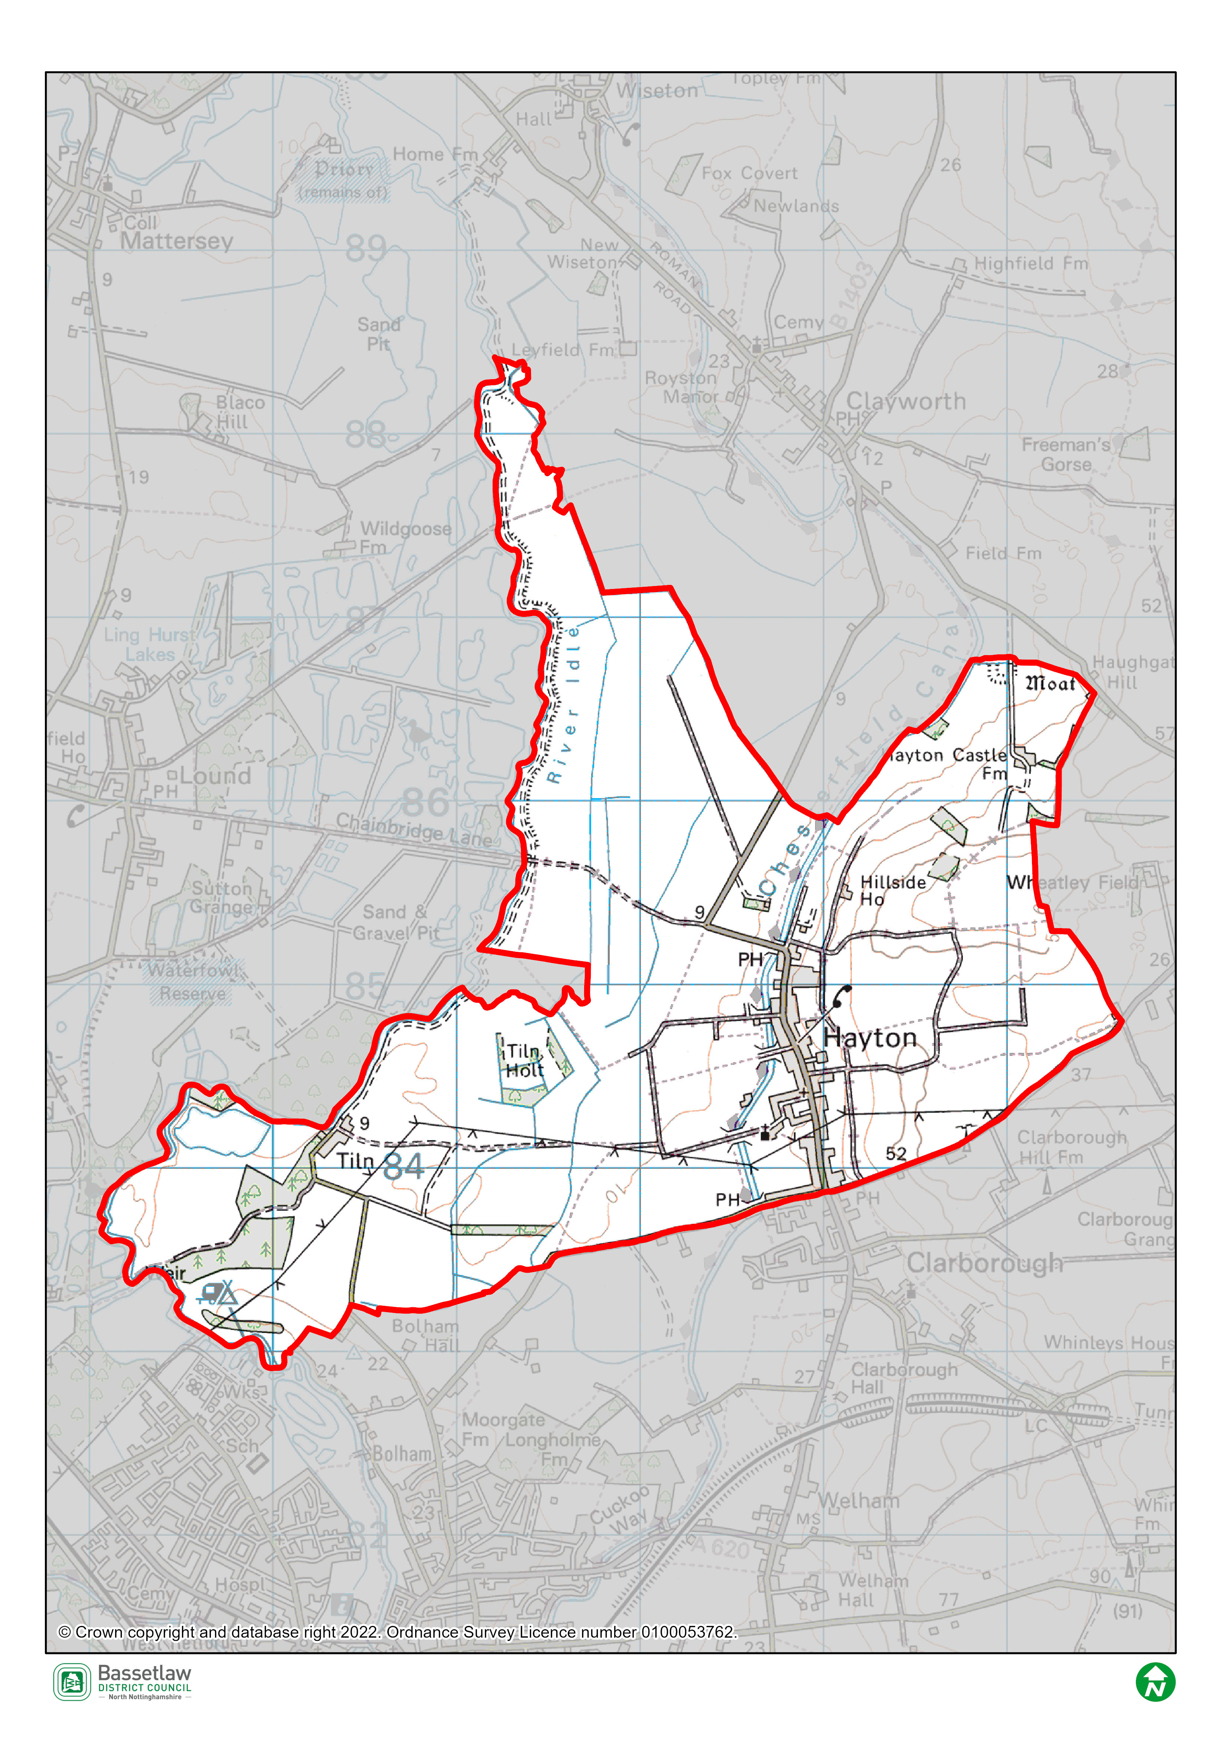

Plan Overview
        - As detailed below, the priorities of the Plan are encapsulated in the Vision and Community Objectives (see page 23 and 24 of the Plan), to be delivered through the application of fifteen development management policies specific to the Neighbourhood Area.

Vision
Hayton Parish will be a welcoming and inclusive place for a diverse community of families and individuals, with a strong community spirit, built upon communication and cooperation among residents.

Hayton and Tiln’s rural character, open recreational spaces and historic heritage assets will be celebrated, cherished and developed.

Hayton and Tiln will remain immersed within their rural surroundings, with people benefiting from enhanced opportunities to access the countryside and enjoy the tranquil rural landscape. Wildlife sites and ecological corridors within the Parish will be nurtured and protected.

The village will progress, with well-designed, appropriately scaled and reasonably priced residential development linked to the development of in-fill sites, brownfield sites and other sites of land and buildings that have become redundant, whilst not compromising core characteristics of the village and the safety and wellbeing of all residents and visitors.

Local small businesses will thrive off the back of improved telecommunications and transport infrastructure, promoting jobs of the future alongside more traditional activities.

The village will be a pleasant, safe and resilient place to live, with the community actively engaged in on-going adaptations to achieve sustainability for future generations.

Community Objectives
- Promote community spirit and social cohesion, creating an interconnected community where residents are active in leading and participating in community activities.
- Promote more sustainable means of transportation, including walking, cycling and use of buses. Promote improved vehicle parking to improve access and safety.
- Celebrate the history and distinctive character of the village, conserving and enhancing its built heritage and ensuring that new developments contribute positively to its character and appearance.
- Enable residential development of appropriate scale, form and type in appropriate locations within the village.
- Enable development of a range of houses that responds to the needs of a diverse population, ensuring appropriate accommodation is available for households of different ages and incomes.
- Provide for employment opportunities in the Parish, including small businesses, working from home opportunities, as well as more traditional activities such as agriculture.
- Promote the development and long-term sustainability of community-oriented commercial activities and community facilities.
- Preserve and maintain the existing network of footpaths and green open spaces, ensuring adequate access for all and equipped spaces for users of different ages.
- Protect the rural countryside, including particular views over the landscape, both during the day and at night.
- Preserve existing green features and plan for the future greening of the village.
- Protect ecological corridors and wildlife sites in the Parish, achieving harmony between human socio-economic development and natural environment quality.
- Improve broadband and mobile phone connectivity.
- Improve resilience to flooding and climate change, ensuring the safety of people and properties and improved access to utilities for existing and new development.

Development Management Policies
        - The fifteen development management policies included in the Neighbourhood Plan are summarised in the following table.
Policy | Summary
Policy 1a: Sustainable development | Provides support for sustainable development, identifying specific expectations for residential development, business development, new services and facilities, and infrastructure.
Policy 1b: Sustainable water management systems | Identifies a range of considerations that new developments should meet in order to make efficient use of water and manage drainage flows in a sustainable way.
Policy 2: Delivering good design | Seeks to maintain and enhance the character and distinctiveness of the Neighbourhood Area, through reference to the accompanying Design Guidance and Codes.
Policy 3: Land for residential development | Provides support for infill development and the redevelopment of brownfield sites within the development boundary, subject to certain criteria.
Policy 4: Local employment | Provides support for specified types of employment, commercial, and business development within the development boundary, subject to certain criteria.
Policy 5: Community facilities | Identifies and seeks to protect community facilities within the Plan area.
Policy 6: Historic environment | Requires consideration of the impact of new development on identified features of historical significance.
Policy 7: Green and blue infrastructure and biodiversity | Requires that development proposals safeguard blue and green infrastructure, seek to deliver biodiversity net gain, and respect the habitat connectivity provided by an identified wildlife corridor across the Plan area. Also provides support for developments that seek to improve or extend the green infrastructure network.
Policy 8: Local green spaces | Identifies seven local green spaces (LGS) for designation, in accordance with the regulations.
Policy 9: Trees | Seeks to protect existing trees and encourages the planting of new ones.
Policy 10: Important views and vistas | Identifies eight key views that development proposals should respect or enhance.
Policy 11a: Corner Farm development | A site-specific residential allocation on the south eastern edge of the village, including criteria to inform development of the site.
Policy 11b: Church Farm development | A site-specific residential allocation on the western side of Main Street including criteria to inform development of the site.
Policy 11c: In-fill development sites, frontage developments (garages, extensions and outbuildings) | Seeks to inform the design of infill and frontage developments through 13 criteria, including design, massing, amenity, and setting.
Policy 12: Housing affordability, housing mix, and tenure | Translates the findings of the Housing Need Assessment into policy, including stipulations on the mix of sizes and tenures.

SEA Screening – Assessment
        - The table below includes the assessment of the Hayton & Tiln Neighbourhood Plan, including its Objectives and Development Management Policies, against the criteria included in Schedule 1 of the 2004 Regulations. The Neighbourhood Plan is being assessed as a whole against the criteria listed below to allow for the consideration of its effects on the environment.

SEA Assessment

Criteria for determining the likely significance of effects (Annex II SEA Directive) | Significant effect likely? | Comment
1a The degree to which the plan or programme sets a framework for projects and other activities, either with regard to the location, nature, size and operating conditions or by allocating resources. | NO | The Hayton & Tiln Neighbourhood Plan (the Plan) sets-out a spatial vision for the designated Neighbourhood Area and an accompanying framework to guide development proposals. This framework will be delivered by the development management policies contained within the Plan. The framework will have some impacts on the environment, noticeably the support for development proposals. However, it is deemed that these impacts will not be significant, due to their small-scale and localised nature.
1b The degree to which the plan or programme influences other plans and programmes including those in a hierarchy. | NO | The Plan, where possible, will respond to rather than influence other plans and programmes. It is part of a hierarchy, but is at the lowest tier, sitting below the Bassetlaw Core Strategy DPD (District level) and National Planning Policy Framework (National level), and has thus been influenced by these higher-tier and pre-existing plans, rather than having an influence on them.  The Plan has been developed with a view towards the emerging Bassetlaw Local Plan but, as above, will remain at the lowest tier of the hierarchy.  The policies within a neighbourhood plan apply only within the designated neighbourhood area, and so the Plan will not have a direct impact on adjoining areas.
1c The relevance of the plan or programme for the integration of environmental considerations in particular with a view to promoting sustainable development. | NO | The Plan promotes sustainable development within the Neighbourhood Area through balancing environmental, social and economic objectives; this is clearly articulated in Section 4 (page 21). The Vision & Objectives, in conjunction with the development management policies, work to ensure that all development proposals brought forward in the area will take this balance into account.  Specifically, the forms of development supported by policies 1a, 3, 4, 11a, 11b, and 11c are viewed as key to ensuring the long-term sustainability of the area. This projected growth is balanced by the protection of key environmental and social / cultural assets, both through criteria in the above policies themselves, and through policies 1b, 2, 5, 6, 7, 8, 9, 10, and 12.  As a result, it is considered that the Plan effectively integrates and balances all potential environmental considerations, and that potential impacts are, therefore, unlikely to be significant.
1d Environmental problems relevant to the plan or programme. | NO | As noted above, the Plan supports development on a number of fronts, including residential development and employment development, all of which could have some effects on the environment. However, existing national and local planning policies, the specific criteria included within the policies in the Plan, and the planning application process, will collectively ensure that these effects are not significant.
1e The relevance of the plan or programme for the implementation of Community legislation on the environment (for example, plans and programmes linked to waste management or water protection). | NO | The Plan is intended to be in compliance with the Bassetlaw Local Development Framework, which has taken into account the existing European and National legislative framework for environmental protection. The Plan will therefore have a positive effect on compliance with regards to relevant legislation and programmes. It is considered that none of the proposals within the Plan will compromise this position.
2a The probability, duration, frequency and reversibility of the effects. | NO | It is deemed highly unlikely that there will be any irreversible damaging environmental impacts associated with the Plan. The policies within the Plan seek to ensure new development is sustainable in context, and promotes the enhancement and protection of environmental assets.  Should any unforeseen significant effects on the environment arise as a result of the Plan, the intention to monitor the Plan and also to review/update the Plan when required will allow these effects to be addressed (see Section 9: Reviewing the Neighbourhood Plan (page 100).
2b The cumulative nature of the effects. | NO | It is considered that the Policies contained in the Plan, cumulatively, will have minimal negative effects on the environment and will in fact have moderate to significant positive effects through the stipulations included. It is considered that all effects will be at a local level.
2c The transboundary nature of the effects. | NO | Effects will be local, with no expected impacts on neighbouring areas.
2d The risks to human health or the environment (for example, due to accidents). | NO | No obvious risks have been identified, as the overall aim of the Plan is to ensure the careful management of development and the continued sustainability of the Plan area.
2e The magnitude and spatial extent of the effects (geographical area and size of the population likely to be affected). | NO | The Plan relates to, and will have an influence over, a designated neighbourhood area of approximately 1141 hectares, with a usual resident population of approximately 385 people (Census 2011).  It is deemed the Plan as a whole will have a positive impact upon local residents through the protection and enhancement of local environmental and social / cultural assets, and the promotion of sustainable development.
2f The value and vulnerability of the area likely to be affected due to:  (i) special natural characteristics or cultural heritage;  (ii) exceeded environmental quality standards or limit values; or  (iii) intensive land-use. | NO | The Plan is deemed unlikely to have an adverse effect on the natural characteristics and cultural heritage of the neighbourhood area.  Natural characteristics  The Chesterfield Canal is a notable feature in the Plan area, and has wider regional significance. The canal is designated as a Site of Special Scientific Interest (SSSI) and a Local Wildlife Site (LWS). There are a further four LWS within the Plan area:  - Cordall Lane Hedge,  - Hangingside and Hollinhill Lanes,  - Tiln North and the Conservation Lake,  - Tiln Wood Track.  There are a number of SSSI outside, but in relative proximity to, the Neighbourhood Area, namely:  - Clarborough Tunnel SSSI  - Sutton and Lound Gravel Pits SSSI.  The impact risk zones for both of these designations intersect the Neighbourhood Area.  Cultural heritage  There are no World Heritage Sites, Protected Wreck Sites, Registered Park and Gardens, or Registered Battlefields in the Neighbourhood Area.  Hayton Castle moated site and fishpond, in the north of the Neighbourhood Area, is designated as a Scheduled Ancient Monument, and the broader setting of Hayton Castle Farm is an Unregistered Park and Garden.  There are 10 Listed Buildings in the Neighbourhood Area, nine of which are Grade II. The Church of St Peter, Hayton, is Grade I listed. There are also 18 non-designated heritage assets.  The two site-specific housing allocations (Policies 11a and 11b) concern sites that have been carefully assessed, with stipulations included to ensure development respects the immediate setting and potential impacts on the wider area. BDC Conservation has been consulted on the Plan, and have made constructive suggestions as to further refinements, and, in the case of Church Farm, notes the potential for development to enhance the setting of nearby heritage assets. Policy 2 (Delivering Good Design) takes a proactive stance in seeking to reflect or complement the established character, as detailed in the accompanying Design Guidance and Codes (Appendix 5). Policy 6 (Historic Environment) specifically addresses local heritage assets, their setting, and views of them (in conjunction with Policy 10 – Important Views).  It is considered that the development supported by the Plan will not result in significant effects on these assets. Furthermore, the Plan does not exceed environmental quality standards or limit values, and does not provide specific policies in relation to intensive land uses.
2g The effects on areas or landscapes which have a recognised national, community or international protection status. | NO | It is considered that the Plan will not adversely affect areas of landscape which have recognised community, national or international protection. The need for new development to respect landscape setting is included as part of the criteria within the respective Policies.

HRA Screening – Assessment

        - For the HRA screening assessment, the designated neighbourhood area was assessed to identify if any Special Protection Areas (SPA), Special Areas of Conservation sites (SAC), or Ramsar sites were located within the boundary, as well as those considered as potential sites (pSPA, ppSPA, cSAC & pRamsar). The assessment also identified if any of these internationally important sites were located within a 15km radius from the Neighbourhood Plan area. The results of this exercise are detailed on the map included as Figure 4 on page 11. The Birklands and Bilhaugh SAC is located approximately 14.9km to the south west of the border of the Plan area. Descriptions of the ecological attributes of this site are included as Appendix 2.
        - Although not formally a SPA, Natural England has advised that there is a possibility of a Sherwood Forest SPA being designated in the future, on reflection of populations of breeding nightjar and woodlark. In a note to Local Planning Authorities dated March 2014, Natural England advocates a precautionary approach to any plans or projects which could affect such a site. This approach should ideally cover the potential direct, indirect and cumulative impacts, which may include, but may not be limited to, the following;
- disturbance to breeding birds from people, their pets and traffic;
- loss, fragmentation and/or damage to breeding and/or feeding habitat;
- bird mortality arising from domestic pets and/or predatory mammals and birds;
- bird mortality arising from road traffic and/or wind turbines.

        - No formal assessments of the boundary of any future SPA has been made, therefore, it is not possible to definitively identify whether individual sites would fall inside or outside any possible future designated area. However, the Natural England note encloses a map which highlights the areas of greatest ornithological interest for breeding nightjar and woodlark. This has been included on Figure 4, and identifies that the potential prospective SPA (ppSPA) is approximately 7.3km south west of the Plan area.
        - The Screening Assessment on page 14 has considered the main potential sources of effects on the identified European sites arising from the Plan, possible pathways to the sites, and the effects on possible sensitive receptors. The assessment considers the impacts of the Policies in the Plan directly on the identified sites, as these are land use Policies which mostly are expected to have some direct or indirect impact on the local environment.

Figure 4: Map of Special Protection Areas and Special Areas of Conservation in relation to the Hayton & Tiln Neighbourhood Area
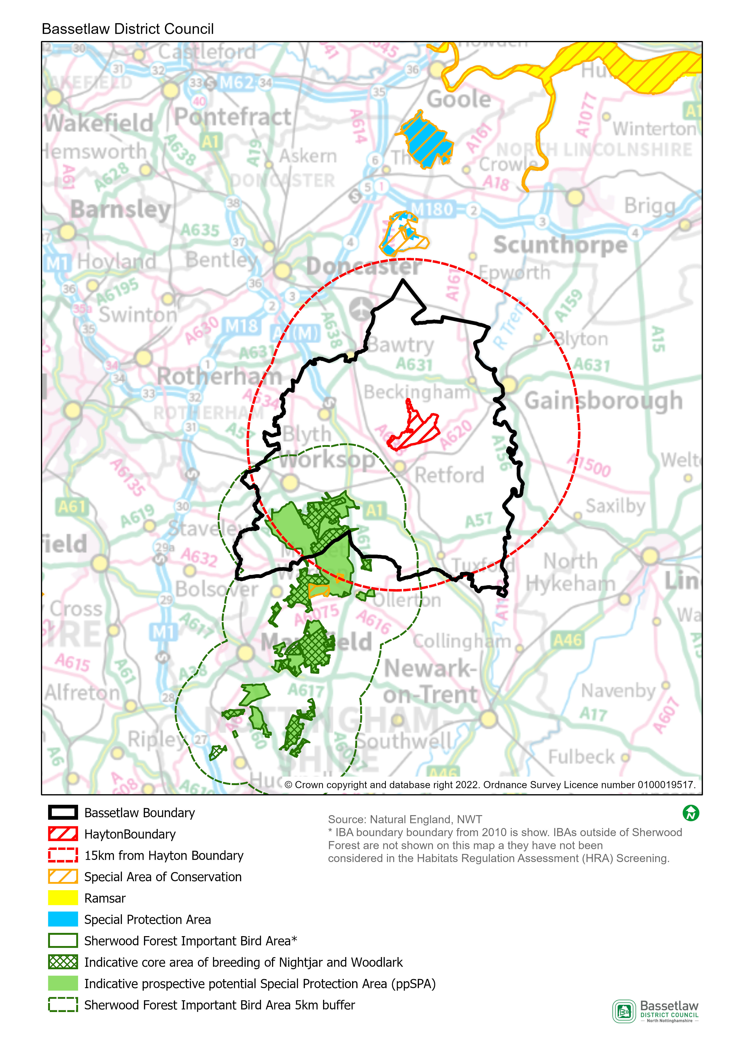

HRA Screening Matrix
The screening matrix below shows which types of impacts on European sites could potentially result from each of the policies and sites allocated in the Hayton & Tiln Neighbourhood Plan. Where a site is not expected to have a particular type of impact, the relevant cell is shaded green. Where a site could potentially have a certain type of impact, this is shown in orange. The final column sets out the screening conclusions.
Policy | Likely activities (operation) to result as a consequence of the proposal | Likely effects if proposal  implemented | European site(s) potentially affected | Could the proposal have likely significant effects on European sites?
Policy 1a: Sustainable development | Residential development.  Economic development.  Increase in vehicular traffic.  Increase in recreation pressure. | Physical loss and damage.  Air pollution.  Disturbance from recreation. | Birklands and Bilhaugh SAC  Sherwood Forest prospective potential Special Protection Area (ppSPA) | No significant effects anticipated.  The areas where development is supported by the Policy are approximately 14.9km at the nearest from the Birklands and Bilhaugh SAC, and 7.3km at the nearest from the Sherwood Forest ppSPA. Physical loss and damage is, therefore, not possible.  It would not be expected for birds to be dependent on the habitat within the existing developed footprint of Hayton Village.  This Policy alone would not be expected to cause a significant increase in traffic and air pollution in the area.  With regard to pathways, it is considered that the nature and small scale of the development supported in this Policy, including the distance between the potential development sites and the European sites, and intervening infrastructure and settlements, will not result in significant effects occurring.
Policy 1b: Sustainable water management systems | None. This policy sets out principles to influence the design and layout of residential developments - it will not itself result in new development. | N/A | N/A | No
Policy 2: Delivering good design | None. This policy sets out principles to influence the design and layout of residential developments - it will not itself result in new development. | N/A | N/A | No
Policy 3: Land for residential development | Residential development.  Increase in vehicular traffic.  Increase in recreation pressure. | Physical loss and damage.  Air pollution.  Disturbance from recreation. | Birklands and Bilhaugh SAC  Sherwood Forest prospective potential Special Protection Area (ppSPA) | No significant effects anticipated.  The areas where development is supported by the Policy (within the development boundary) are approximately 16.6km at the nearest from the Birklands and Bilhaugh SAC, and 9.9km at the nearest from the Sherwood Forest ppSPA. Physical loss and damage is, therefore, not possible.  It would not be expected for birds to be dependent on the habitat within the existing developed footprint of Hayton Village.  This Policy alone would not be expected to cause a significant increase in traffic and air pollution in the area.  With regard to pathways, it is considered that the nature and small scale of the development supported in this Policy, including the distance between the potential development sites and the European sites, and intervening infrastructure and settlements, will not result in significant effects occurring.
Policy 4: Local employment | Commercial development.  Increase in vehicular traffic. | Physical loss and damage.  Air pollution. | Birklands and Bilhaugh SAC  Sherwood Forest prospective potential Special Protection Area (ppSPA) | No significant effects anticipated.  The areas where development is supported by the Policy (within the development boundary) are approximately 16.6km at the nearest from the Birklands and Bilhaugh SAC, and 9.9km at the nearest from the Sherwood Forest ppSPA. Physical loss and damage is, therefore, not possible.  It would not be expected for birds to be dependent on the habitat within the existing developed footprint of Hayton Village.  This Policy alone would not be expected to cause a significant increase in traffic and air pollution in the area.  With regard to pathways, it is considered that the nature and small scale of the development supported in this Policy, including the distance between the potential development sites and the European sites, and intervening infrastructure and settlements, will not result in significant effects occurring.
Policy 5: Community facilities | None. The Policy is designed to protect existing community facilities, but does not provide support for additional development. | N/A | N/A | No
Policy 6: Historic environment | None. This policy ensures that the heritage assets within the Plan area are respected and, where possible, enhanced – it will not itself result in new development. | N/A | N/A | No
Policy 7: Green infrastructure and biodiversity | None. The policy seeks to protect and enhance green and blue infrastructure and biodiversity. | N/A | N/A | No
Policy 8: Local green spaces | None. This policy identifies 7 sites for proposed designation as Local Green Spaces (LGS) – it will not itself result in new development. | N/A | N/A | No
Policy 9: Trees | None. The policy seeks to protect trees in the Neighbourhood Area – it does not, itself, support development. | N/A | N/A | No
Policy 10: Important views and vistas | None. The policy provides protection for identified important views – it does not, itself, support development. | N/A | N/A | No
Policy 11a: Corner Farm development policy | Residential development.  Increase in vehicular traffic.  Increase in recreation pressure. | Physical loss and damage.  Air pollution.  Disturbance from recreation. | Birklands and Bilhaugh SAC  Sherwood Forest prospective potential Special Protection Area (ppSPA) | No significant effects anticipated.  The site where development is supported by the Policy is approximately 16.8km at the nearest from the Birklands and Bilhaugh SAC, and 10.2km at the nearest from the Sherwood Forest ppSPA. Physical loss and damage is, therefore, not possible.  It would not be expected for birds to be dependent on the habitat within the existing developed footprint of Hayton Village.  This Policy alone would not be expected to cause a significant increase in traffic and air pollution in the area.  With regard to pathways, it is considered that the nature and small scale of the development supported in this Policy, including the distance between the potential development sites and the European sites, and intervening infrastructure and settlements, will not result in significant effects occurring.
Policy 11b: Church Farm development | Residential development.  Increase in vehicular traffic.  Increase in recreation pressure. | Physical loss and damage.  Air pollution.  Disturbance from recreation. | Birklands and Bilhaugh SAC  Sherwood Forest prospective potential Special Protection Area (ppSPA) | No significant effects anticipated.  The site where development is supported by the Policy is approximately 17km at the nearest from the Birklands and Bilhaugh SAC, and 10.3km at the nearest from the Sherwood Forest ppSPA. Physical loss and damage is, therefore, not possible.  It would not be expected for birds to be dependent on the habitat within the existing developed footprint of Hayton Village.  This Policy alone would not be expected to cause a significant increase in traffic and air pollution in the area.  With regard to pathways, it is considered that the nature and small scale of the development supported in this Policy, including the distance between the potential development sites and the European sites, and intervening infrastructure and settlements, will not result in significant effects occurring.
Policy 11c: In-fill development sites, frontage developments (garages, extensions and outbuildings) | Residential development.  Increase in vehicular traffic.  Increase in recreation pressure. | Physical loss and damage.  Air pollution.  Disturbance from recreation. | Birklands and Bilhaugh SAC  Sherwood Forest prospective potential Special Protection Area (ppSPA) | No significant effects anticipated.  The areas where development is supported by the Policy (within the development boundary) are approximately 16.6km at the nearest from the Birklands and Bilhaugh SAC, and 9.9km at the nearest from the Sherwood Forest ppSPA. Physical loss and damage is, therefore, not possible.  It would not be expected for birds to be dependent on the habitat within the existing developed footprint of Hayton Village.  This Policy alone would not be expected to cause a significant increase in traffic and air pollution in the area.  With regard to pathways, it is considered that the nature and small scale of the development supported in this Policy, including the distance between the potential development sites and the European sites, and intervening infrastructure and settlements, will not result in significant effects occurring.
Policy 12: Housing affordability, housing mix and tenure | None. The policy seeks to ensure the type, size and tenure of housing reflects local needs – it does not, itself, support development. | N/A | N/A | No

In-combination effects
        - Regulation 105 of the Amended Habitats Regulations 2017 requires an Appropriate Assessment where “a land use plan is likely to have a significant effect on a European site (either alone or in combination with other plans or projects) and is not directly connected with or necessary to the management of the site”. Therefore, it is necessary to consider whether there may be significant effects from the Hayton & Tiln Neighbourhood Plan in combination with other plans or projects.
        - The first stage in identifying ‘in-combination’ effects involves identifying which other plans and projects in addition to the Hayton & Tiln Neighbourhood Plan may affect the European sites that were the focus of this assessment. There are a large number of potentially relevant plans and projects which could be considered, therefore, the review focused on planned spatial growth within Bassetlaw District, with the Habitats Regulations Assessment of the emerging Bassetlaw Local Plan (August 2021) the key source of reference.
        - In respect to the Sherwood Forest ppSPA, the HRA initially identified likely significant effects resulting from the development proposed in the Bassetlaw Local Plan. Through further investigation of the impact pathways and proposed mitigation, however, it was concluded that no adverse effects on the integrity of the ppSPA would occur. In respect to the Birklands and Bilhaugh SAC, the assessment identified potential effects as a result of increased recreational pressure. However, protections proposed in the Plan (then Policy ST40 – Biodiversity and Geodiversity), and an ongoing Recreational Impact Assessment, allowed adverse effects on the integrity of the SAC to be ruled-out.
        - The scale of development proposed by the Hayton & Tiln Neighbourhood Plan is in conformity with the Bassetlaw Local Plan, contributing to the Draft Local Plan’s housing growth projections for Bassetlaw as a whole. The scale of housing development proposed, together with the Neighbourhood Area’s distance from the Birklands and Bilhaugh SAC and Sherwood Forest ppSPA, means that its ‘incombination’ effect is insignificant.

Conclusions

Consultation
        - As required by the regulations, a draft version of this report was issued for the purposes of consultation with the statutory bodies, specifically the Environment Agency, Historic England, and Natural England. On conclusion of the six-week consultation (13 December 2022 to 23 January 2023), responses had been received from all three bodies. The responses are included in full at Appendix 1, and can be summarised as follows:
        - Environment Agency: no formal comments to make.
        - Historic England: on the basis of the information provided in the draft report, it is considered that the preparation of a SEA is not likely to be required.
        - Natural England: agrees with the conclusions that neither a full SEA nor HRA is required.
        - On the basis of the above, the initial conclusions are upheld, and no consequential amendments have been made to the report; the conclusions are detailed below.

SEA Screening
        - On the basis of the SEA Screening Assessment set out in this document, the conclusion is that the Hayton & Tiln Neighbourhood Plan will not have significant environmental effects in relation to any of the criteria set out in Schedule 1 of the SEA Regulations, and therefore does not need to be subject to a full SEA.

HRA Screening
The HRA Screening Assessment concludes that no significant effects are likely to occur with regards to the integrity of the Birklands and Bilhaugh SAC or the Sherwood Forest ppSPA as a consequence of the implementation of the Plan. As such a full HRA is not required to be undertaken.
        - The main reason for these conclusions is:
- The development that is supported in the Plan is deemed to be of a scale and nature and located on sites that will not result in any significant effects on the identified European sites.

Appendix 1: Consultation Responses

Environment Agency
Received 23 January 2023
The EA have no formal comments to make in regard to the SEA and HRA Screening as we do not make the final decision on whether a SEA or HRA is required. Generally the EA will not comment on a HRA as this falls within the remit of Natural England.
We would like to note that we did provide guidance on proposed minor changes to wording within the Neighbourhood Plan and we are pleased to note that these have now been included within the pre submission neighbourhood plan.
Historic England
Received 16 January 2023
Thank you for your consultation of 13 December 2022 and the request for a Screening Opinion in respect of the Hayton and Tiln Neighbourhood Plan.
For the purposes of consultations on SEA Screening Opinions, Historic England confines its advice to the question, “Is it likely to have a significant effect on the environment?” in respect of our area of concern, cultural heritage. Our comments are based on the information supplied with the screening request.
On the basis of the information supplied and in the context of the criteria set out in Schedule 1 of the Environmental Assessment Regulations [Annex II of ‘SEA’ Directive], Historic England is of the view that the preparation of a Strategic Environmental Assessment is not likely to be required.
The views of the other statutory consultation bodies should be taken into account before the overall decision on the need for a SEA is made. If a decision is made to undertake a SEA, please note that Historic England has published guidance on Sustainability Appraisal / Strategic Environmental Assessment and the Historic Environment that is relevant to both local and neighbourhood planning and available at:
<https://historicengland.org.uk/images-books/publications/sustainability-appraisal-and-strategic-environmental-assessment-advice-note-8/>
Should it be concluded that, overall, a SEA will be required for the Plan, Historic England would be pleased to discuss the scope of the assessment in relation to the historic environment in due course.
I hope that this information is of use to you at this time. Should you have any queries, please do not hesitate to contact me.

Natural England
Received 6 January 2023
Thank you for your consultation on the above dated 13 December 2022.
Natural England is a non-departmental public body. Our statutory purpose is to ensure that the natural environment is conserved, enhanced, and managed for the benefit of present and future generations, thereby contributing to sustainable development.
Where Neighbourhood Plans could have significant environmental effects, they may require a Strategic Environmental Assessment (SEA) under the Environment Assessment of Plans and Programmes Regulations 2004 (as amended). Further guidance on deciding whether the proposals are likely to have significant environmental effects and the requirements for consulting Natural England on SEA are set out in the planning practice guidance.
Planning practice guidance also outlines that if an appropriate assessment is required for your neighbourhood plan this will also engage the need for a SEA. One of the basic conditions that will be tested by the independent examiner is whether the neighbourhood plan is compatible with European obligations, including those under the SEA Directive. Where a SEA is required it should be prepared in accordance with regulation 12 of the SEA Regulations.
Natural England welcomes the Screening Report which assesses the requirement for Strategic Environmental Assessment (SEA) and Habitats Regulations Assessment (HRA) for the Hayton & Tiln Neighbourhood Plan.
I can confirm that Natural England agrees with this report’s conclusion that it is not likely there will be significant environmental effects arising from the policies in the plan, which have not already been accounted for within the adopted local plan. Therefore, the Hayton & Tiln Neighbourhood Plan does not require a Strategic Environmental Assessment (SEA) to be undertaken.
Natural England also agrees that the Plan would be unlikely to result in any significant effect to European Sites, either alone or in combination, and therefore an appropriate assessment under the Habitats Regulations is not required.
Aside from this, Natural England has no specific comments at this stage. We would be happy to comment further should the need arise but if in the meantime you have any queries please do not hesitate to contact us. For any queries relating to the specific advice in this letter please contact me on 020 8026 8500 . For any new consultations, or to provide further information on this consultation please send your correspondences to consultations@naturalengland.org.uk.

Appendix 2: Ecological attributes of the European sites

Birklands and Bilhaugh Special Area of Conservation (SAC)
Description
Covering an approximate area of 271.84 hectares, Birklands and Bilhaugh SAC is a landscape-remnant of the historic Sherwood Forest, which is of World renowned cultural significance due to the high concentration of ancient oak trees and associated folklore. The trees and open woodland- pasture habitat have been utilised over the centuries as a medieval Royal hunting forest, as a source of timber for the construction of cathedrals and English naval fleets, and more recently for public amenity, recreation and tourism. There is high public usage across the
SAC supported by a network of Public Rights of Way and permissive paths. Part of the SAC forms part of the Sherwood Forest National Nature Reserve.
The site lies on freely-draining, acidic, sandy soils and is notable for its rich invertebrate fauna, particularly spiders, and for a diverse fungal assemblage, including Grifoa suphurea and Fistulina hepatica. The oak population consists of approximately equal numbers of the pedunculate oak Quercus robur and the sessile oak Q. petraea covering a wide range of size and age, including an exceptional population of ancient standing oaks. Although birch (mainly Betula verrucosa) forms groves between the oaks the canopy is, over large areas, still rather open allowing a dense bracken field layer to develop. A wide variety of fungi are present. Within the woodland occur glades of acid grassland dominated by the tussock-forming wavy-hair grass Deschampsia flexuosa and which contain such characteristic herbs as heath bedstraw Galium saxatile and tormentil Potentilla erecta.
Area
270.5ha
Qualifying Features
H9190: Old acidophilous oak woods with Quercus robur on sandy plains
Site Status (an assessment by Natural England of the status of the SSSIs within the SAC):
- 96.87% in unfavourable (recovering) condition
- 3.13% in unfavourable (no change) condition
Special Area of Conservation objectives
Ensure that the integrity of the site is maintained or restored as appropriate, and ensure that the site contributes to achieving the Favourable Conservation Status of its Qualifying Features, by maintaining or restoring:
- The extent and distribution of qualifying natural habitats
- The structure and function (including typical species) of the qualifying natural habitats, and
- The supporting processes on which the qualifying natural habitat rely.
Site Improvement Plan: pressures, threats and related development
The main pressures and threats to this site include public access and disturbance in that the current visitor’s centre complex that is located within the SAC, is preventing the necessary restoration of the full extent of the oak woodland. The visitor centre complex needs to be physically removed and the area restored, but planning permission is proving problematic. Other issues include change in land management which has created a large age gap between the ancient trees, physical modification, impact of atmospheric nitrogen deposition, disease and invasive species.

Sherwood Forest prospective potential Special Protection Area (ppSPA)
Description
is being used as a proxy for the purposes of this assessment, and the indicative core areas for breeding for nightjar and woodlark as identified by Natural England, are likely to be the most sensitive areas.
The Sherwood Forest IBA covers 7,320 ha and consists of several geographic sites stretching from south of Worksop to north of Nottingham. Once part of the 10,000 acre Royal Forest of Sherwood, the woodland is dominated by native oaks and other native trees such as silver birch, rowan, holly and hawthorn. It has been continuously forested since the end of the Ice Age.
Approximately 424.75ha of the Sherwood Forest ppSPA is also a designated National Nature Reserve (NNR). The reserve contains more than a thousand ancient oaks most of which are known to be more than 500 years old.
Sherwood Forest has the highest concentration of ancient trees in Europe and provides habitat for very rare invertebrates, particularly beetles, flies and spiders, many of which rely on the decaying and ageing timber of the veteran trees. Budby South Forest, in the northern half of the site, is dominated by link heather and supports a diverse range of insects and ground nesting birds such as woodlark, nightjar and tree pipit.
In 2004, it was estimated that there were approximately 63 male European Nightjar (females unknown) within in the IBA and approximately 25 breeding pairs of Woodlark.
Qualifying Features
The primary reasons for potential designation of this site are that the population of Caprimulgus europaeus; European nightjar represents 1.88% of the total UK breeding population and the population of Lullula arborea; Woodlark, is 2.51% of the total UK breeding population.
Site Status (an assessment by Natural England of the status of the SSSIs within the SAC):
The condition of the site was not assessed in the most recent IBA monitoring assessment. However, the IBA factsheet states that the mixed woodland habitat is in ‘very unfavourable’ condition, but the conditions of the nightjar and woodlark populations are favourable.
Prospective potential Special Protection Area objectives
As this area does not relate to an existing designated site, no conservation objectives have been established for it. However, it is anticipated that, were the site to be designated, any conservation objectives would reflect those for other SPAs, as follows:
- Ensure that the integrity of the site is maintained or restored as appropriate, and ensure that the site contributes to achieving the aims of the Wild Birds Directive, by maintaining or restoring:
  - The extent and distribution of the habitats of the qualifying features
  - The structure and function of the habitats of the qualifying features
  - The supporting processes on which the habitats of the qualifying features rely
  - The population of each of the qualifying features, and,
  - The distribution of the qualifying features within the site.
Site Improvement Plan: pressures, threats and related development
The main current threats to the site include logging and wood harvesting, climate change, changes in land use for energy production, housing and economic development, tourism and recreation and air pollution. War, civil unrest and military exercises are identified as a past threat, which is unlikely to return.
These threats have been rated low to very high, depending on the proportion of the area and/or population they are likely to affect and the severity of the threat. Recreational activities are identified as being the highest level of threat, followed by logging and wood harvesting and residential and commercial development. The IBA factsheet also identifies ‘other threat’ as being a high threat, but no details are given.

SEA Directive, Article 1
Planning Guidance - Paragraph: 079: Reference ID: 41-079-20140306

