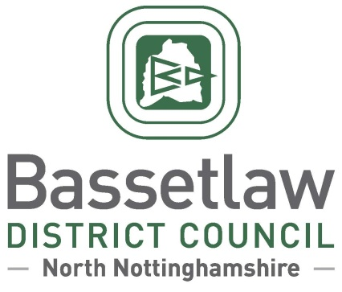

Sturton Ward Neighbourhood Development Plan (Review) – Decision Statement

Summary
        - In accordance with Regulation 18 of the Neighbourhood Planning (General) Regulations 2012, Bassetlaw District Council has produced this ‘Decision Statement’ in relation to the Sturton Ward Neighbourhood Development Plan (Review) (the ‘Plan’).
        - Following an independent examination, Bassetlaw District Council confirms that the Plan will proceed to a neighbourhood planning referendum, following enactment of the modifications specified in the Examination Report.
        - The referendum is scheduled for Thursday 11 November 2021, based on the Sturton Ward Neighbourhood Area, as approved by Bassetlaw District Council on 4 April 2012.
        - This Decision Statement, along with the Independent Examiner’s report, can also be viewed on the Bassetlaw District Council website.

Background
        - The Sturton Ward Neighbourhood Plan currently forms part of the Development Plan for Bassetlaw, having been ‘made’ following a successful public referendum on 11 February 2016. In 2018 work commenced on a review of the Neighbourhood Plan, including an enhanced evidence base to inform new and updated policies, addressing issues including design, green spaces, and housing.
        - The Pre-Submission Draft Sturton Ward Neighbourhood Plan (Review) was made available for consultation in accordance with Regulation 14 of the Neighbourhood Planning regulations from 22 June to 4 September 2020.
        - The Plan was formally submitted to the District Council on 18 March 2021. Bassetlaw District Council duly consulted the public and statutory bodies on the Plan for a 6-week period between 7 May and 18 June 2021, in accordance with Regulation 16 of the Neighbourhood Planning regulations.
        - An Independent Examiner was appointed to undertake the examination of the Submission version of the Neighbourhood Plan. The Examiner’s Report was sent to the District Council and Sturton Ward Neighbourhood Planning Group on 3 September 2021.

Decisions and Reasons
        - The Independent Examiner has concluded that, subject to the specified modifications being enacted, the Plan meets the Basic Conditions and other relevant legal requirements. The District Council concurs with this view. The Independent Examiner has also confirmed that, owing to the scale of the changes proposed over the original version, the reviewed Plan should be the subject of a public referendum.
        - The Head of Regeneration, in consultation with the Council’s Cabinet Member for Regeneration, has determined that all the recommended modifications set out in the Examiner’s Report will be enacted to ensure that the Plan meets the Basic Conditions. Furthermore, to meet the requirements of the Localism Act 2011, a referendum which poses the question “Do you want Bassetlaw District Council to use the Neighbourhood Plan for Sturton Ward to help it decide planning applications in the Neighbourhood Area?” will be held in the Sturton Ward Neighbourhood Area on 11 November 2021.

Beverley Alderton-Sambrook
Head of Regeneration, Bassetlaw District Council
24 September 2021

