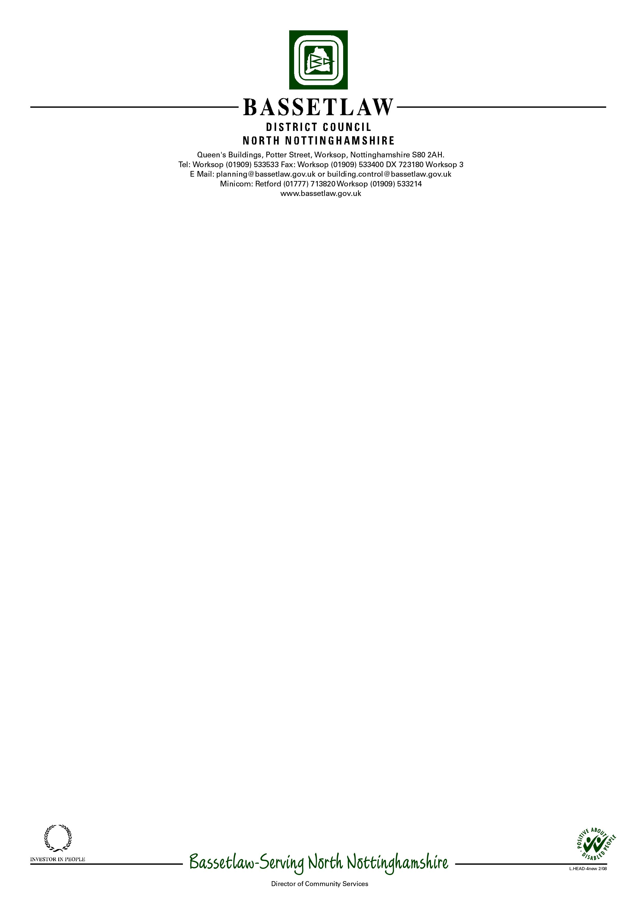

3 All Hallows Close  Ordsall  Retford  DN22 7UP | Please ask for: David Armiger  Direct Dialling: (01909) 535151  Email: david.armiger@bassetlaw.gov.uk  17 March 2014  By Email

Dear Mrs Davies,

On 17 December 2013 Bassetlaw District Council received a formal application from Cuckney Parish Council on behalf of the Parish Councils of Cuckney, Holbeck & Welbeck and Norton Parish Meeting to produce a Neighbourhood Plan for their combined parish area.

Following a statutory six-week public consultation period (17 December 2013 – 30 January 2014) on this proposal, no objections were received. Bassetlaw District Council hereby agree that the combined parish councils, led by Cuckney Parish Council should commence preparation of the Neighbourhood Plan for the designated area (as shown on the attached map), subject to conformity with the requirements of the Neighbourhood Planning Regulations (2012).

Yours Sincerely,

David Armiger
Planning Services Manager

