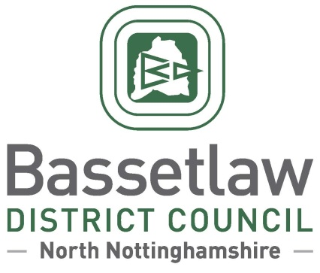

Reviewed Cuckney, Norton, Holbeck and Welbeck (CNHW) Neighbourhood Plan:
Decision Statement (Adoption)

Summary

        - Following a positive referendum result on the 8 September 2022, Bassetlaw District Council is publicising its decision to ‘make’ the reviewed Cuckney, Norton, Holbeck and Welbeck (CNHW) Neighbourhood Plan part of the Bassetlaw Development Plan, in accordance with Regulation 19 of the Neighbourhood Planning (General) Regulations 2012.

Background

        - The Cuckney, Norton, Holbeck and Welbeck (CNHW) Neighbourhood Area was designated by Bassetlaw District Council on 17 March 2014. The original CNHW Neighbourhood Plan was subsequently developed, and was adopted as part of the Development Plan by the District Council following a successful referendum on 9 March 2017.
        - Work to review the original Neighbourhood Plan commenced in 2019. The reviewed Neighbourhood Plan incorporates a range of modifications over the original Plan, summarised as follows (with policy numbers updated to reflect the now-adopted version of the Plan):
- Introduction of development boundaries for Norton and Cuckney villages (Policy R1);
- Identification of key views and significant green gaps, as part of an updated landscape character policy (Policy R2);
- A new policy to support sustainable economic development in Welbeck Village (Policy R5a);
- A new, expanded policy addressing design (Policy R6), supported by a new Design Code;
- A more detailed approach to addressing housing need (Policies R8a – R8c), supported by a new Housing Needs Assessment;
- An expanded policy supporting the improvement of sport, recreation, and community facilities (Policy R11);
- Enhanced policies addressing routes for active travel (Policy R12) and development to support sustainable tourism (Policy R13);
- Modifications to all other policies, and reconfiguration of content between policies, to reflect updated evidence, changes in the broader policy landscape, and to enhance clarity.

        - The reviewed Neighbourhood Plan was formally submitted to the District Council in January 2022, followed by six weeks of consultation with the public and statutory bodies. The consultation concluded in March 2022.
        - Bassetlaw District Council subsequently appointed an independent Examiner, Mr Peter Biggers, to assess whether the reviewed Neighbourhood Plan met the basic conditions required by legislation, and whether the Plan should proceed to referendum.
        - The Examiner’s Report concluded that the Plan meets the Basic Conditions and that, subject to a number of modifications proposed in the report, the Plan should proceed to a public referendum. The Examiner’s Report, proposed modifications, and the intention to hold a referendum, were considered and approved at the Full Council meeting held on 23 June 2022.

Decision & Reasoning

        - A public referendum was held in the CNHW Neighbourhood Area, as proposed, on Thursday 8 September 2022.
        - Paragraph 38A (4)(a) of the Planning and Compulsory Purchase Act 2004, as amended, requires that the District Council must make the Neighbourhood Plan if more than half of those voting have voted in favour of the plan. Bassetlaw District Council is not subject to this duty if the making of the plan would breach, or would otherwise be incompatible with, any EU obligation or any of the Convention rights (within the meaning of the Human Rights Act 1998).
        - The referendum held on 8 September 2022 met the requirements of the Localism Act 2011 and posed the question: 'Do you want Bassetlaw District Council to use the Neighbourhood Plan for Cuckney, Norton, Holbeck and Welbeck to help it decide planning applications in the neighbourhood area?’.
        - The count took place on the evening of the 8 September 2022 and greater than 50% of those who voted were in favour of the plan being used to help decide planning applications in the plan area.
        - The results of the referendum were:
Number cast in favour of a YES - 62
Number cast in favour of a NO - 15
Turnout: 18.69%
        - Bassetlaw District Council has assessed that the plan including its preparation does not breach, and would not otherwise be incompatible, with, any EU obligation or any of the Convention rights (within the meaning of the Human Rights Act 1998).
        - In accordance with the Regulations and the Council’s procedure, the reviewed Cuckney, Norton, Holbeck and Welbeck (CNHW) Neighbourhood Plan is considered ‘made’ following the referendum held on 8 September 2022. Planning applications in the area must be considered against the reviewed CNHW, as well as existing planning policy, such as the Bassetlaw District Core Strategy and its successors and the National Planning Policy Framework and Guidance.

Neighbourhood Planning
Bassetlaw District Council
September 2022

