Strategic Environmental Assessment & Habitat Regulations Assessment Screening

Treswell and Cottam Neighbourhood Plan (Review)
June 2022

Contents

1. Introduction 2
Strategic Environmental Assessment (SEA) 2
Habitat Regulations Assessment 3
Summary of Findings 3
2. The Treswell and Cottam Neighbourhood Plan (Review) 4
Plan Overview 4
Vision 4
Community Objectives 5
Development Management Policies 6
Neighbourhood Plan Policy 6
3. SEA Screening Assessment 7
SEA Assessment 7
4. HRA Screening Assessment 12
HRA Screening Matrix 14
5. In-combination effects 25
6. Impact Risk Zones for Sites of Special Scientific Interest (SSSI) 25
Neighbourhood Plan Policy 26
7. Conclusions 28
Consultation 28
SEA Screening 28
HRA Screening 28
Appendix 1: Consultation Responses 29
Appendix 2: Ecological attributes of the European sites 32

Introduction

  - This document contains the Screening Statements for the Treswell and Cottam Neighbourhood Plan - (the Plan) - with regard to whether a Strategic Environmental Assessment (SEA) and / or Habitat Regulations Assessment (HRA) are required to be undertaken. The document also includes an assessment of the policies proposed in the Plan with regard to Impact Risk Zones for Sites of Special Scientific Interest (SSSI).
  - Regulation 15 of the 2012 Neighbourhood Planning (General) Regulations sets out the information that must accompany a Neighbourhood Plan when submitted to the local planning authority. In February 2015 amendments to the Neighbourhood Plan Regulations came into force; this is known as the Neighbourhood Planning (General) (Amendment) Regulations 2015. Regulation 2(4) of these amendments adds additions to the list of documents that a qualifying body must submit to a local planning authority with a Neighbourhood Plan. The additional document which must be submitted is either an environmental report prepared in accordance with the relevant regulations or, if the outcome concludes that an SEA or HRA is not necessary, a statement that sets out how environmental issues have been taken into account and considered during the preparation of the Neighbourhood Plan.
  - The National Planning Policy Framework (para 167) advises that assessments should be proportionate, and should not repeat policy assessment that has already taken place. In view of this, only a high level screening assessment of the Plan has been undertaken, and this assessment should be read in conjunction with the relevant reports produced for Bassetlaw District Councils Local Development Framework.
  - As the responsible authority under relevant regulations, Bassetlaw District Council has undertaken the Screening Assessment contained in this document, working with the Neighbourhood Plan Steering Group and their appointed consultant.

Strategic Environmental Assessment (SEA)
  - The requirement for a SEA to be undertaken on development plans and programmes that may have a significant environmental effect is outlined in European Union Directive 200142/EC. The Environmental Assessment of Plans and Programmes Regulations 2004 (the 2004 Regulations) state that this is determined by a screening process, utilising a specified set of criteria, outlined in Schedule 1 of the Regulations. The results of this process must be set-out in an SEA Screening Statement, which must be publicly available.
  - The objective of undertaking a SEA is “to provide for a high level of protection of the environment and to contribute to the integration of environmental considerations into the preparation and adoption of plans and programmes with a view to promoting sustainable development, by ensuring that, in accordance with this Directive, an environmental assessment is carried out of certain plans and programmes which are likely to have significant effects on the environment.”

Habitat Regulations Assessment
  - European protected sites (the ‘Natura 2000 Network’) are of exceptional importance for the conservation of important species and natural habitats within the European Union. The network of European protected sites comprises Special Protection Areas (SPAs) designated under the Birds Directive (79/409/EEC), Special Areas of Conservation (SACs) designated under the Habitats Directive (92/43/EEC) and Ramsar sites designated under the Ramsar Convention 1975. Government guidance advises that potential SPAs (pSPA), candidate SACs (cSAC) and potential Ramsar (pRamsar) sites are also included in HRA’s.
  - As a land use plan, an assessment of the reviewed Treswell and Cottam Neighbourhood Plan may be required under the Conservation of Habitats and Species (Amendment) Regulations 2012 (the Habitat Regulations) and Article 6(3) of the EU Habitats Directive in order to determine whether the Plan may result in significant effects on identified sites.
  - As with the SEA, a screening process is employed to establish whether any elements of the Draft Plan could have a significant effect on these sites. Regulation 32 of the Neighbourhood Planning (General) Regulations 2012 (as amended) further reemphasises the importance of carrying out this assessment by stating that one of the basic conditions that must be met before the Plan may be ‘made’ is that “the making of the neighbourhood plan is not likely to have a significant effect on a European site (as defined in the Conservation of Habitats and Species Regulations 2012) or a European offshore marine site (as defined in the Offshore Marine Conservation (Natural Habitats, &c.) Regulations 2007 (either alone or in combination with other plans or projects)”.

Summary of Findings
  - Following the undertaking of the Screening Assessments it is concluded that the Plan, in its current form, will not have any significant negative effects on the environment or any identified European sites. It is considered therefore that a full environmental assessment and habitat regulations assessment is not required.
  - This determination has been reached by assessing the contents of the Pre-Submission Draft Neighbourhood Plan, published in January 2022. The Plan has been assessed against criteria provided in Schedule 1 of the 2004 Regulations and with regard to Regulation 32 of the 2015 Neighbourhood Planning Regulations & the Habitat Regulations. The conclusions are detailed in full in Section 6 (p27) of this report.
  - This screening assessment reflects the fact that the current version of the Treswell and Cottam Neighbourhood Plan is a review of the original, which itself was subject to appropriate assessment, by way of a combined SEA and HRA Screening Statement in mid-2017. At that time, it was concluded that the Neighbourhood Plan be screened-out for both a full SEA and HRA, as its impacts were unlikely to be significant. The proposals in the reviewed version of the Plan, as assessed here, include the addition of site-specific housing allocations, hence the Plan has been assessed in full to allow the impact of the changes to be appreciated.

The Treswell and Cottam Neighbourhood Plan (Review)

  - The Neighbourhood Plan is being developed by Treswell with Cottam Parish Council, the Qualifying Body for the Treswell and Cottam Neighbourhood Area in Bassetlaw District, Nottinghamshire, as depicted in Figure 1, below. The current version of the Plan does not clearly define the plan period, but it is assumed that it is intended to run to 2038, aligning with the emerging Bassetlaw Local Plan.
Figure 1: Designated Neighbourhood Area
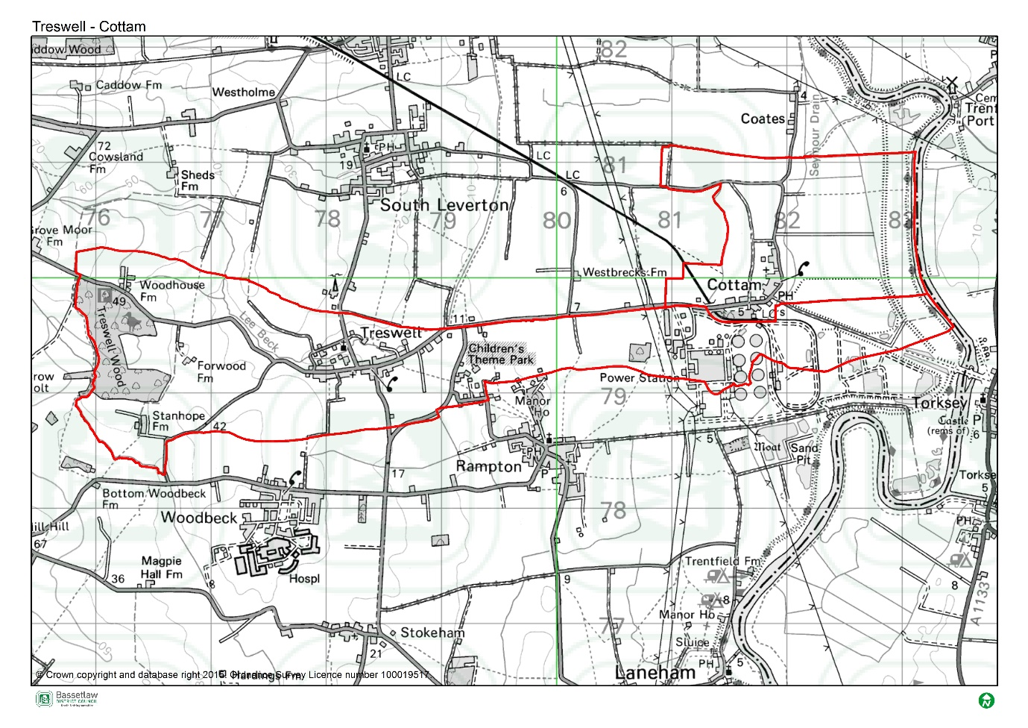

Plan Overview
  - As detailed below, the priorities of the Plan are encapsulated in the Vision and Community Objectives (see page 12 of the Plan), to be delivered through the application of seven Development Management Policies specific to the Neighbourhood Area.

Vision
Treswell and Cottam are two attractive villages in Nottinghamshire and the residents are proud of its appearance, sense of community and amenities. The village will continue to support sustainable and appropriate development that blends in with the traditional elements of the village and which can be accommodated within or beside the wider range of housing within the village. The community is committed to maintaining the quality of the local environment whilst accommodating appropriate developments in lifestyle and technology, creating opportunities for residents now and in the future whilst protecting the unique atmosphere of Treswell and Cottam.

Community Objectives

- To manage new developments in accordance with their location, local character and the housing needs of the local community.

- To minimise the impact of new development on the surrounding countryside, landscape and ecosystems with a development boundary.

- To protect the Playing Field at Cottam as a Local Green Space.

- To preserve our important trees and hedgerows.

- To preserve our Historic Environment.

- To preserve and safeguard our local key amenities and services.

- To reduce road traffic congestion.

- To have a say in the redevelopment of the former Cottam Power Station.

Development Management Policies

Neighbourhood Plan Policy | Intent
Policy 1: Allocation of Site NP01 | Development of up to 2 dwellings is supported on this site, subject to a number of site-specific criteria, including design, layout, and access.
Policy 2: Allocation of Site NP09 | Development of 1 dwelling is supported on this site, subject to a number of site-specific criteria, including design, layout, and access.
Policy 3: Allocation of Site NP10 | Development of 1 dwelling is supported on this site, subject to a number of site-specific criteria, including design, layout, and access.
Policy 4: Allocation of Site NP12 | Development of 1 dwelling is supported on this site, subject to a number of site-specific criteria, including design, layout, and access.
Policy 5: Additional Residential Development | Provides support to limited residential infill development within the development boundary, subject to criteria, including design, layout and access.
Policy 6: Design Principles | Seeks to maintain and enhance the character and distinctiveness of the Neighbourhood Area, through identifying design-based criteria that new development should reflect.
Policy 7: Protecting Existing Community Facilities | Provides protection for existing community facilities, and support for the development of new facilities, subject to appropriate location.
Policy 8: Local Green Space | Proposes one site in the Neighbourhood Area as a Local Green Space, with a view to protecting its value to the community and special characteristics.
Policy 9: Lee Beck Green Corridor | Potential improvements to support the setting, amenity value, and biodiversity of the identified Lee Beck Green Corridor are supported, subject to criteria.
Policy 10: Supporting Local Employment Opportunities | Provides support, where required for employment development, subject to consideration of design, form, and impact on the community.

SEA Screening Assessment
  - The table below includes the assessment of the Treswell and Cottam Neighbourhood Plan (Review), including its Objectives and Development Management Policies, against the criteria included in Schedule 1 of the 2004 Regulations. The Neighbourhood Plan is being assessed as a whole against the criteria listed below to allow for the consideration of its effects on the environment.

SEA Assessment

Criteria for determining the likely significance of effects (Annex II SEA Directive) | Significant effect likely? | Comment
1a The degree to which the plan or programme sets a framework for projects and other activities, either with regard to the location, nature, size and operating conditions or by allocating resources. | NO | The reviewed Treswell and Cottam Neighbourhood Plan (the Plan) sets-out a spatial vision for the designated Neighbourhood Area and an accompanying framework to guide development proposals. This framework will be delivered by the development management policies contained within the Plan. The framework will have some impacts on the environment, noticeably the support for development proposals. However it is deemed that these impacts will not be significant, due to their small-scale and localised nature.  The Plan is considered to be in general conformity with Bassetlaw District Council’s Core Strategy 2011. It is also considered to be in general conformity with the most recent version of the National Planning Policy Framework (NPPF).  In addition to the land use policies, one community aspiration is detailed in Section 11 of the Plan. This project will be delivered in accordance with the policies in the Plan and those in the Bassetlaw Core Strategy, and it is deemed that it will not have any significant effects on the environment.
1b The degree to which the plan or programme influences other plans and programmes including those in a hierarchy. | NO | The Plan, where possible, will respond to rather than influence other plans and programmes. It is part of a hierarchy, but is at the lowest tier, sitting below the Bassetlaw Core Strategy DPD (District level) and National Planning Policy Framework (National level), and has thus been influenced by these higher-tier and pre-existing plans, rather than having an influence on them.  The Plan has been developed with a view towards the emerging Bassetlaw Local Plan but, as above, will remain at the lowest tier of the hierarchy.  The policies within a neighbourhood plan apply only within the designated Neighbourhood Area, and so the Plan will not have a direct impact on other plans in adjoining areas.
1c The relevance of the plan or programme for the integration of environmental considerations in particular with a view to promoting sustainable development. | NO | The Plan promotes sustainable development within the Neighbourhood Area through balancing environmental, social and economic objectives. The Vision & Objectives, in conjunction with the development management policies, work to ensure that all development proposals brought forward in the area will take this balance into account.  Specifically, the residential development supported by Policies 1 to 5, and the economic development supported in Policy 10, is viewed as key to ensuring the long-term sustainability of the area. This projected growth is balanced by the protection of key environmental and social / cultural assets, as supported by Policies 6 to 9.  As a result, it is considered that the Plan effectively integrates and balances all potential environmental considerations, and that potential impacts are, therefore, not likely to be significant.
1d Environmental problems relevant to the plan or programme. | NO | The proposed support for residential development on specified sites and as infill within the development boundary (Policies 1 to 5) is likely to have some effects on the environment. However, existing national and local planning policies, the site-specific criteria in the above Policies, and the planning application process, will collectively ensure that these effects are not significant.
1e The relevance of the plan or programme for the implementation of Community legislation on the environment (for example, plans and programmes linked to waste management or water protection). | NO | The Plan will be in compliance with the Bassetlaw Local Development Framework, which has taken into account the existing European and National legislative framework for environmental protection. The Plan will therefore have a positive effect on compliance with regards to relevant legislation and programmes. It is deemed that no proposals within the Plan will compromise this position.
2a The probability, duration, frequency and reversibility of the effects. | NO | It is deemed highly unlikely that there will be any irreversible damaging environmental impacts associated with the Plan. The policies within the Plan seek to ensure new development is sustainable in context, and promotes the enhancement and protection of environmental assets.  Although not clearly stipulated, it is assumed that the Plan is intended to cover the period up to 2037.  Should any unforeseen significant effects on the environment arise as a result of the Plan, the intention to monitor the Plan and also to review/update the Plan when required will allow these effects to be addressed (see Section 12: Monitoring Framework).
2b The cumulative nature of the effects. | NO | It is considered that the Policies contained in the Plan cumulatively will have minimal negative effects on the environment and will in fact have moderate to significant positive effects. It is considered that all effects will be at a local level.
2c The transboundary nature of the effects. | NO | Effects will be local, with no expected impacts on neighbouring areas.
2d The risks to human health or the environment (for example, due to accidents). | NO | No obvious risks have been identified, as the overall aim of the Plan is to ensure the careful management of development and the continued sustainability of the Plan area.
2e The magnitude and spatial extent of the effects (geographical area and size of the population likely to be affected). | NO | The Plan relates to, and will have an influence on, a designated neighbourhood area of approximately 889 hectares, with a resident population of approximately 291 people (Census 2011).  It is deemed the Plan as a whole will have a positive impact upon local residents through the protection and enhancement of local environmental and social / cultural assets, promotion of sustainable development, and through the delivery of identified community projects (see Section 11).
2f The value and vulnerability of the area likely to be affected due to:  (i) special natural characteristics or cultural heritage;  (ii) exceeded environmental quality standards or limit values; or  (iii) intensive land-use. | NO | The Plan is deemed unlikely to have an adverse effect on the natural characteristics and cultural heritage of the neighbourhood area.  With respect to natural characteristics, Treswell Wood is a notable feature in the Plan area, and has wider regional if not national significance. The wood is designated as a Site of Special Scientific Interest (SSSI), Ancient Woodland, and Local Wildlife Site (LWS). Ashton’s Meadow SSSI is outside of the Plan area, but in close proximity, and the associated Impact Risk Zones intersect. There are three further LWS within the Plan area (Cottam Wetlands, Cottam Ponds, and Bushstocks Lane Meadow), and an additional site adjoining the boundary (Coates Wetland).  With respect to cultural heritage, there are no World Heritage Sites, Protected Wreck Sites, Registered Park and Gardens, Registered Battlefields, or Scheduled Monuments designated in the Neighbourhood Area. There are 6 Listed Buildings, five of which are Grade II. The Church of St John The Baptist, Treswell, is Grade I listed. There are also 33 non-designated heritage assets in the Neighbourhood Area.  The site-specific housing allocations (Policies 1 - 4) concern sites that have been carefully assessed, with input from the District Council’s Conservation Team. Policy 6 (Design Principles) takes a proactive stance in seeking to preserve or enhance the setting of listed buildings. It also requires a proportionate response in terms of non-designated heritage assets, and broader respect for the local vernacular. The accompanying Character Assessment adds significant value in terms of documenting the features that characterise the Neighbourhood Area.  It is considered that the development supported by the Plan will not result in significant effects on these assets. Furthermore, the Plan does not exceed environmental quality standards or limit values and does not provide specific policies in relation to intensive land uses.
2g The effects on areas or landscapes which have a recognised national, Community or international protection status. | NO | It is considered that the Plan will not adversely affect areas of landscape which have recognised community, national or international protection. The need for new development to respect landscape setting is included as part of the criteria within the respective Policies.

HRA Screening Assessment

  - For the HRA screening assessment, the designated neighbourhood area was assessed to identify if any Special Protection Areas (SPA), Special Areas of Conservation sites (SAC), or Ramsar sites were located within the boundary, as well as those considered as potential sites (pSPA, ppSPA, cSAC & pRamsar). The assessment also identified if any of these internationally important sites were located within a 15km radius from the Neighbourhood Plan area. The results of this exercise are detailed on the map included as Figure 4 on page 11. The Birklands and Bilhaugh SAC is located approximately 14.8km to the south west of the border of the Plan area. Descriptions of the ecological attributes of this site is included as Appendix 2.
  - Although not formally a pSPA, Natural England has advised that there is a possibility of a Sherwood Forest pSPA being designated in the future, on reflection of populations of breeding nightjar and woodlark. In a note to Local Planning Authorities dated March 2014, Natural England advocates a precautionary approach to any plans or projects which could affect such a site. This approach should ideally cover the potential direct, indirect and cumulative impacts, which may include, but may not be limited to, the following;
- disturbance to breeding birds from people, their pets and traffic;
- loss, fragmentation and/or damage to breeding and/or feeding habitat;
- bird mortality arising from domestic pets and/or predatory mammals and birds;
- bird mortality arising from road traffic and/or wind turbines.

  - No formal assessments of the boundary of any future SPA has been made, therefore, it is not possible to definitively identify whether individual sites would fall inside or outside any possible future designated area. However, the Natural England note encloses a map which highlights the areas of greatest ornithological interest for breeding nightjar and woodlark. This has been included on Figure 4, and identifies that the ppSPA is approximately 10.9km west of the Plan area.
  - The Screening Assessment on page 12 has considered the main potential sources of effects on the identified European sites arising from the Plan, possible pathways to the sites, and the effects on possible sensitive receptors. The assessment considers the impacts of the Policies in the Plan directly on the identified sites, as these are land use Policies which mostly are expected to have some direct or indirect impact on the local environment.

Figure 4: Map of Special Protection Areas and Special Areas of Conservation in relation to the Treswell and Cottam Neighbourhood Area
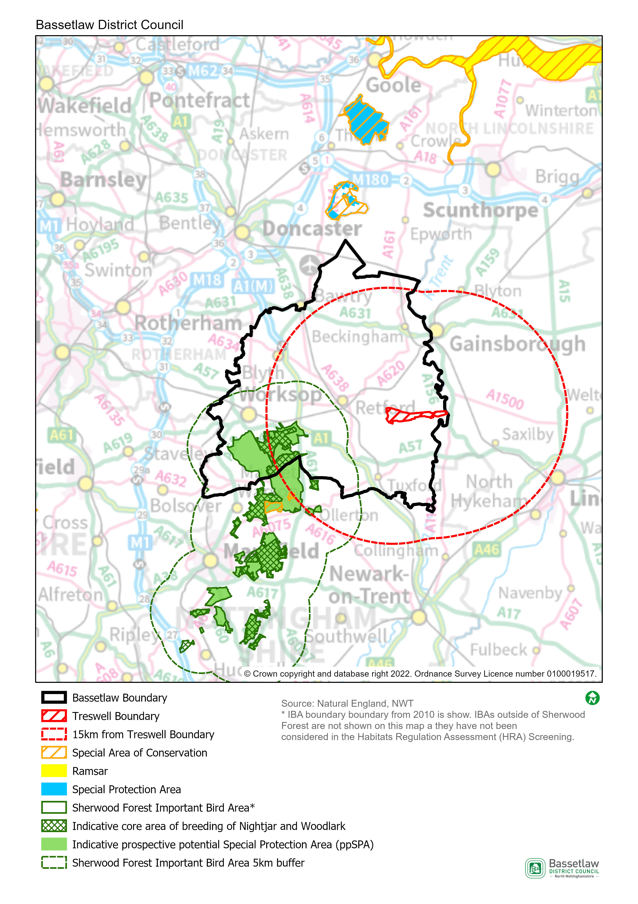

HRA Screening Matrix
The screening matrix below shows which types of impacts on European sites could potentially result from each of the policies and sites allocated in the Treswell and Cottam Neighbourhood Plan. Where a site is not expected to have a particular type of impact, the relevant cell is shaded green. Where a site could potentially have a certain type of impact, this is shown in orange. The final column sets out the screening conclusions.
Policy | Likely activities (operation) to result as a consequence of the proposal | Likely effects if proposal  implemented | European site(s) potentially affected | Could the proposal have likely significant effects on European sites?
Policy 1: Allocation of Site NP01 | Residential development.  Increase in vehicle traffic.  Increase in recreation pressure. | Physical loss and damage.  Air pollution.  Disturbance from recreation. | Birklands and Bilhaugh SAC  Sherwood Forest prospective potential Special Protection Area (ppSPA) | No significant effects anticipated.  The site where development is supported by the Policy is approximately 16.6km at the nearest from the Birklands and Bilhaugh SAC, and 12.6km at the nearest from the Sherwood Forest ppSPA. Physical loss and damage is, therefore, not possible.  It would not be expected for birds to be dependent on the habitat within the existing developed footprint of Treswell Village.  This Policy alone would not be expected to cause a significant increase in traffic and air pollution in the area.  With regard to pathways, it is considered that the nature and small scale of the development supported in this Policy, including the distance between the potential development site and the European sites, and intervening infrastructure, will not result in significant effects occurring.
Policy 2: Allocation of Site NP09 | Residential development.  Increase in vehicle traffic.  Increase in recreation pressure. | Physical loss and damage.  Air pollution.  Disturbance from recreation. | Birklands and Bilhaugh SAC  Sherwood Forest prospective potential Special Protection Area (ppSPA) | No significant effects anticipated.  The site where development is supported by the Policy is approximately 17.4km at the nearest from the Birklands and Bilhaugh SAC, and 13.8km at the nearest from the Sherwood Forest ppSPA. Physical loss and damage is, therefore, not possible.  It would not be expected for birds to be dependent on the habitat within the existing developed footprint of Treswell Village.  This Policy alone would not be expected to cause a significant increase in traffic and air pollution in the area.  With regard to pathways, it is considered that the nature and small scale of the development supported in this Policy, including the distance between the potential development site and the European sites, and intervening infrastructure, will not result in significant effects occurring.
Policy 3: Allocation of Site NP10 | Residential development.  Increase in vehicle traffic.  Increase in recreation pressure. | Physical loss and damage.  Air pollution.  Disturbance from recreation. | Birklands and Bilhaugh SAC  Sherwood Forest prospective potential Special Protection Area (ppSPA) | No significant effects anticipated.  The site where development is supported by the Policy is approximately 17.1km at the nearest from the Birklands and Bilhaugh SAC, and 13.5km at the nearest from the Sherwood Forest ppSPA. Physical loss and damage is, therefore, not possible.  It would not be expected for birds to be dependent on the habitat within the existing developed footprint of Treswell Village.  This Policy alone would not be expected to cause a significant increase in traffic and air pollution in the area.  With regard to pathways, it is considered that the nature and small scale of the development supported in this Policy, including the distance between the potential development site and the European sites, and intervening infrastructure, will not result in significant effects occurring.
Policy 4: Allocation of Site NP12 | Residential development.  Increase in vehicle traffic.  Increase in recreation pressure. | Physical loss and damage.  Air pollution.  Disturbance from recreation. | Birklands and Bilhaugh SAC  Sherwood Forest prospective potential Special Protection Area (ppSPA) | No significant effects anticipated.  The site where development is supported by the Policy is approximately 17.3km at the nearest from the Birklands and Bilhaugh SAC, and 13.6km at the nearest from the Sherwood Forest ppSPA. Physical loss and damage is, therefore, not possible.  It would not be expected for birds to be dependent on the habitat within the existing developed footprint of Treswell Village.  This Policy alone would not be expected to cause a significant increase in traffic and air pollution in the area.  With regard to pathways, it is considered that the nature and small scale of the development supported in this Policy, including the distance between the potential development site and the European sites, and intervening infrastructure, will not result in significant effects occurring.
Policy 5: Additional Residential Development | Residential development.  Increase in vehicle traffic.  Increase in recreation pressure. | Physical loss and damage.  Air pollution.  Disturbance from recreation. | Birklands and Bilhaugh SAC  Sherwood Forest prospective potential Special Protection Area (ppSPA) | No significant effects anticipated.  The areas where development is supported by the Policy (within the development boundary) are approximately 16.6km at the nearest from the Birklands and Bilhaugh SAC, and 12.6km at the nearest from the Sherwood Forest ppSPA. Physical loss and damage is, therefore, not possible.  It would not be expected for birds to be dependent on the habitat within the existing developed footprint of Treswell Village.  This Policy alone would not be expected to cause a significant increase in traffic and air pollution in the area.  With regard to pathways, it is considered that the nature and small scale of the development supported in this Policy, including the distance between the potential development sites and the European sites, and intervening infrastructure, will not result in significant effects occurring.
Policy 6: Design Principles | None. This policy sets out principles to influence the design and layout of residential developments - it will not itself result in new development. | n/a | n/a | No
Policy 7: Protecting Existing Community Facilities | Development of community facilities.  Increase in vehicular traffic. | Physical loss and damage.  Air pollution. | Birklands and Bilhaugh SAC  Sherwood Forest prospective potential Special Protection Area (ppSPA) | No significant effects anticipated.  The areas where development could be supported by the Policy (within or adjoining Treswell or Coottam villages) are 16.6km at the nearest from the Birklands and Bilhaugh SAC, and 12.6km at the nearest from the Sherwood Forest ppSPA. Physical loss and damage is, therefore, not possible.  It would not be expected for birds to be dependent on the habitat within the existing developed footprint of Treswell or Cottam.  This Policy alone would not be expected to cause a significant increase in traffic and air pollution in the area.  With regard to pathways, it is considered that the nature and small scale of the development supported in this Policy, including the distance between potential development sites and the European sites, and intervening infrastructure, will not result in significant effects occurring.
Policy 8: Local Green Space | None – this policy requires new development to protect Local Green Space, it will not itself result in development or increase traffic or visitor numbers. | n/a | n/a | No
Policy 9: Lee Beck Green Corridor | None – this policy provides to development proposals that enhance the setting and biodiversity of the Lee Beck Green Corridor. It will not itself result in development or increase traffic or visitor numbers. | n/a | n/a | No
Policy 10: Supporting Local Employment Opportunities | Economic development.  Increase in vehicular traffic. | Physical loss and damage.  Air pollution. | Birklands and Bilhaugh SAC  Sherwood Forest prospective potential Special Protection Area (ppSPA) | No significant effects anticipated.  The areas where development could be supported by the Policy are 14.8km at the nearest from the Birklands and Bilhaugh SAC, and 10.9km at the nearest from the Sherwood Forest ppSPA. Physical loss and damage is, therefore, not possible.  It would not be expected for birds to be dependent on the habitat within the Neighbourhood Area.  This Policy alone would not be expected to cause a significant increase in traffic and air pollution in the area.  With regard to pathways, it is considered that the nature and small scale of the development supported by this Policy, including the distance between potential development sites and the European sites, and intervening infrastructure, will not result in significant effects occurring.

In-combination effects
  - Regulation 105 of the Amended Habitats Regulations 2017 requires an Appropriate Assessment where “a land use plan is likely to have a significant effect on a European site (either alone or in combination with other plans or projects) and is not directly connected with or necessary to the management of the site”. Therefore, it is necessary to consider whether there may be significant effects from the Treswell and Cottam Neighbourhood Plan (Review) in combination with other plans or projects.
  - The first stage in identifying ‘in-combination’ effects involves identifying which other plans and projects in addition to the Treswell and Cottam Neighbourhood Plan (Review) may affect the European sites that were the focus of this assessment. There are a large number of potentially relevant plans and projects which could be considered, therefore, the review focused on planned spatial growth within Bassetlaw District, with the Habitats Regulations Assessment of the emerging Bassetlaw Local Plan (August 2021) the key source of reference.
  - In respect to the Sherwood Forest ppSPA, the HRA initially identified likely significant effects resulting from the development proposed in the Bassetlaw Local Plan. Through further investigation of the impact pathways and proposed mitigation, however, it was concluded that no adverse effects on the integrity of the ppSPA would occur. In respect to the Birklands and Bilhaugh SAC, the assessment identified potential effects as a result of increased recreational pressure. However, protections proposed in the Plan (then Policy ST40 – Biodiversity and Geodiversity), and an ongoing Recreational Impact Assessment, allowed adverse effects on the integrity of the SAC to be ruled-out.
  - The scale of development proposed by the Treswell and Cottam Neighbourhood Plan (Review) is in conformity with the Bassetlaw Local Plan and has been devised to meet the proposed minimum housing requirement figure for the Neighbourhood Area of 5 dwellings up to 2038, contributing to the Draft Local Plan’s housing growth projections for Bassetlaw as a whole. This scale of housing development, together with the area’s distance from the Birklands and Bilhaugh SAC and Sherwood Forest ppSPA, means that its ‘incombination’ effect is insignificant.

Impact Risk Zones for Sites of Special Scientific Interest (SSSI)
  - Sites of special scientific interest (SSSI) conserve and protect the best of our wildlife, geological and physiographical heritage for the benefit of present and future generations, under the Wildlife and Countryside Act 1981.
  - Impact Risk Zones are a GIS tool developed by Natural England to make a rapid initial assessment of the potential risks to SSSIs posed by development proposals. They define zones around each SSSI that reflect the particular sensitivities of the features for which it is notified. The zones indicate the types of development proposal that could potentially have adverse impacts, generally decreasing in sensitivity with distance from the site. The location of SSSI and their associated Impact Risk Zones can be observed and queried via Natural England’s MAGIC Map portal.
  - Review of the data clarifies that there is one SSSI located within the Plan area itself, but there are two in close proximity to the boundary, and their Impact Risk Zones cover the majority of the Plan area:
- Treswell Wood
  - The Plan area is also intersected by the Impact Risk Zones of a SSSI located 0.3 km to the north in the neighbouring parish of South Leverton:
- Ashton’s Meadow
  - The development supported by the policies in the Plan has been assessed to determine how it relates to the SSSI Impact Risk Zones noted above, and whether the nature of the development is likely to trigger any of the associated criteria, as provided by Natural England. The finding are detailed below.
Neighbourhood Plan Policy | Impact Risk Zone Criteria Triggered?
Policy 1: Allocation of Site NP01 | No. The impact risk threshold for rural residential development is 50 or more dwellings outside existing settlements. The Policy limits development of the site to a maximum of 2 dwellings.
Policy 2: Allocation of Site NP09 | No. The impact risk threshold for rural residential development is 50 or more dwellings outside existing settlements. The Policy limits development of the site to 1 dwelling.
Policy 3: Allocation of Site NP10 | No. The impact risk threshold for rural residential development is 50 or more dwellings outside existing settlements. The Policy limits development of the site to 1 dwelling.
Policy 4: Allocation of Site NP12 | No. The impact risk threshold for rural residential development is 50 or more dwellings outside existing settlements. The Policy limits development of the site to 1 dwelling.
Policy 5: Additional Residential Development | No. The impact risk threshold for rural residential development is 50 or more dwellings outside existing settlements. The Policy directs development to within the confines of the development boundary, and then as infill, with a default position of 1 or 2 dwellings per site.
Policy 6: Design Principles | No. The Policy does not, itself, support development.
Policy 7: Protecting Existing Community Facilities | No. Any potential development supported by the Policy would be within or directly adjoining Treswell or Cottam villages, where rural non-residential development is not a trigger.
Policy 8: Local Green Space | No. The Policy does not, itself, support development.
Policy 9: Lee Beck Green Corridor | No. The Policy does not support development over and above that supported by other policies.
Policy 10: Supporting Local Employment Opportunities | Unlikely. The Policy adds additional criteria that potential development has to meet over that already required by District and National policy – it does not, itself, support development.

  - As detailed above, although the majority of the area covered by the Plan is intersected by Impact Risk Zones, the type and scale of development supported through the Policies is unlikely to trigger the associated criteria.

Conclusions

Consultation
  - As required by the regulations, a draft version of this report was issued for the purposes of consultation with the statutory bodies, specifically the Environment Agency, Historic England, and Natural England. On conclusion of the five-week consultation (19 April to 24 May 2022), responses had been received from two of the three bodies. The responses are included in full at Appendix 1, and can be summarised as follows:
- Environment Agency: no response.
- Historic England: on the basis of the information provided in the draft report, it is considered that the preparation of a SEA is not likely to be required.
- Natural England: agrees with the conclusions, and does not have any other specific comments.
  - On the basis of the above, the initial conclusions are upheld, and no consequential amendments have been made to the report; the conclusions are detailed below.

SEA Screening
  - On the basis of the SEA Screening Assessment set out in this document, the conclusion is that the reviewed Treswell and Cottam Neighbourhood Plan will not have significant environmental effects in relation to any of the criteria set out in Schedule 1 of the SEA Regulations, and therefore does not need to be subject to a full SEA.

HRA Screening
  - The HRA Screening Assessment concludes that no significant effects are likely to occur with regards to the integrity of the Birklands and Bilhaugh SAC or the Sherwood Forest ppSPA as a consequence of the implementation of the Plan. As such the Plan does not require a full HRA to be undertaken.
  - The main reason for these conclusions is:
- The development that is supported in the Plan is deemed to be of a scale, nature, and location that will not result in any significant effects on the identified European sites.

Appendix 1: Consultation Responses

Environment Agency (two responses received)
(No response received)

Historic England
Received 25 April 2022.
Dear Mr Wilson
Thank you for your consultation of 19/04/22 for a draft SEA/ HRA Screening.
For the purposes of consultations on SEA Screening Opinions, Historic England confines its advice to the question, ?Is it likely to have a significant effect on the environment?? in respect of our area of concern, cultural heritage. Our comments are based on the information supplied with the screening request.

On the basis of the information supplied and in the context of the criteria set out in Schedule 1 of the Environmental Assessment Regulations [Annex II of ?SEA? Directive], Historic England is of the view that the preparation of a Strategic Environmental Assessment is not likely to be required.

The views of the other statutory consultation bodies should be taken into account before the overall decision on the need for a SEA is made. If a decision is made to undertake a SEA, please note that Historic England has published guidance on Sustainability Appraisal
/ Strategic Environmental Assessment and the Historic Environment that is relevant to both local and neighbourhood planning and available at:
<https://protect-eu.mimecast.com/s/DQe5CgL9NsAJvY8cNodWZ? domain=historicengland.org.uk>
Should it be concluded that, overall, a SEA will be required for the Plan, Historic England would be pleased to discuss the scope of the assessment in relation to the historic environment in due course.

I hope that this information is of use you have any queries,
please do not hesitate to contact me.

Natural England
Received 24 May 2022.
Dear Will Wilson
Treswell & Cottam Neighbourhood Plan (Review): Draft SEA / HRA Screening (Bassetlaw DC)
Thank you for your consultation on the above dated 19 April 2022
Natural England is a non-departmental public body. Our statutory purpose is to ensure that the natural environment is conserved, enhanced, and managed for the benefit of present and future generations, thereby contributing to sustainable development.
Natural England is a statutory consultee in neighbourhood planning and must be consulted on draft neighbourhood development plans by the Parish/Town Councils or Neighbourhood Forums where they consider our interests would be affected by the proposals made.
Strategic Environmental Assessment - Screening
Where Neighbourhood Plans could have significant environmental effects, they may require a Strategic Environmental Assessment (SEA) under the Environment Assessment of Plans and Programmes Regulations 2004 (as amended). Further guidance on deciding whether the proposals are likely to have significant environmental effects and the requirements for consulting Natural England on SEA are set out in the planning practice guidance.
Planning practice guidance also outlines that if an appropriate assessment is required for your neighbourhood plan this will also engage the need for a SEA. One of the basic conditions that will be tested by the independent examiner is whether the neighbourhood plan is compatible with European obligations, including those under the SEA Directive. Where a SEA is required it should be prepared in accordance with regulation 12 of the SEA Regulations

Habitats Regulations Assessment – screening and appropriate assessment requirements
Where a neighbourhood plan could potentially affect a ‘habitats site’, it will be necessary to screen the plan in relation to the Conservation of Habitats and Species Regulations (2017), as amended (the ‘Habitats Regulations’). Where likely significant effects are identified, it will be necessary to undertake an appropriate assessment of the neighbourhood plan and, if needed, identify and secure appropriate mitigation measures to ensure the plan does not result in an adverse effect on the integrity of the habitats site.
In accordance with Schedule 2 of The Neighbourhood Planning (General) Regulations 2012 (as amended), a neighbourhood plan cannot be made if it breaches the requirements of Chapter 8 of Part 6 of the Conservation of Habitats and Species Regulations 2017 (as amended).
A screening exercise should be undertaken if there is any doubt about the possible effects of the plan on the habitats site(s). This will be particularly important if a neighbourhood plan is to progress before a local plan and/or the neighbourhood plan proposes development which has not be assessed and/or included in the Habitats Regulations Assessment for the local plan. Where mitigation is necessary to ensure no effects then this will need to be properly assessed via an appropriate assessment.
Natural England agrees with your conclusions and does not have any other specific comments on this draft neighbourhood plan.
However, we refer you to the attached annex which covers the issues and opportunities that should be considered when preparing a Neighbourhood Plan.
For any further consultations on your plan, please contact: consultations@naturalengland.org.uk.

Appendix 2: Ecological attributes of the European sites

Birklands and Bilhaugh Special Area of Conservation (SAC)
Description
Covering an approximate area of 271.84 hectares, Birklands and Bilhaugh SAC is a landscape-remnant of the historic Sherwood Forest, which is of World renowned cultural significance due to the high concentration of ancient oak trees and associated folklore. The trees and open woodland- pasture habitat have been utilised over the centuries as a medieval Royal hunting forest, as a source of timber for the construction of cathedrals and English naval fleets, and more recently for public amenity, recreation and tourism. There is high public usage across the
SAC supported by a network of Public Rights of Way and permissive paths. Part of the SAC forms part of the Sherwood Forest National Nature Reserve.
The site lies on freely-draining, acidic, sandy soils and is notable for its rich invertebrate fauna, particularly spiders, and for a diverse fungal assemblage, including Grifoa suphurea and Fistulina hepatica. The oak population consists of approximately equal numbers of the pedunculate oak Quercus robur and the sessile oak Q. petraea covering a wide range of size and age, including an exceptional population of ancient standing oaks. Although birch (mainly Betula verrucosa) forms groves between the oaks the canopy is, over large areas, still rather open allowing a dense bracken field layer to develop. A wide variety of fungi are present. Within the woodland occur glades of acid grassland dominated by the tussock-forming wavy-hair grass Deschampsia flexuosa and which contain such characteristic herbs as heath bedstraw Galium saxatile and tormentil Potentilla erecta.
Area
270.5ha
Qualifying Features
H9190: Old acidophilous oak woods with Quercus robur on sandy plains
Site Status (an assessment by Natural England of the status of the SSSIs within the SAC):
- 96.87% in unfavourable (recovering) condition
- 3.13% in unfavourable (no change) condition
Special Area of Conservation objectives
Ensure that the integrity of the site is maintained or restored as appropriate, and ensure that the site contributes to achieving the Favourable Conservation Status of its Qualifying Features, by maintaining or restoring:
- The extent and distribution of qualifying natural habitats
- The structure and function (including typical species) of the qualifying natural habitats, and
- The supporting processes on which the qualifying natural habitat rely.
Site Improvement Plan: pressures, threats and related development
The main pressures and threats to this site include public access and disturbance in that the current visitor’s centre complex that is located within the SAC, is preventing the necessary restoration of the full extent of the oak woodland. The visitor centre complex needs to be physically removed and the area restored, but planning permission is proving problematic. Other issues include change in land management which has created a large age gap between the ancient trees, physical modification, impact of atmospheric nitrogen deposition, disease and invasive species.

Sherwood Forest prospective potential Special Protection Area (ppSPA)
Description
As the Sherwood Forest prospective potential SPA (ppSPA) is not currently designated as a European Site, there is no Standard Data form or SIP for it. However, the Sherwood Forest Important Bird Area is being used as a proxy for the purposes of this assessment, and the indicative core areas for breeding for nightjar and woodlark as identified by Natural England, are likely to be the most sensitive areas.
The Sherwood Forest IBA covers 7,320 ha and consists of several geographic sites stretching from south of Worksop to north of Nottingham. Once part of the 10,000 acre Royal Forest of Sherwood, the woodland is dominated by native oaks and other native trees such as silver birch, rowan, holly and hawthorn. It has been continuously forested since the end of the Ice Age.
Approximately 424.75ha of the Sherwood Forest ppSPA is also a designated National Nature Reserve (NNR). The reserve contains more than a thousand ancient oaks most of which are known to be more than 500 years old.
Sherwood Forest has the highest concentration of ancient trees in Europe and provides habitat for very rare invertebrates, particularly beetles, flies and spiders, many of which rely on the decaying and ageing timber of the veteran trees. Budby South Forest, in the northern half of the site, is dominated by link heather and supports a diverse range of insects and ground nesting birds such as woodlark, nightjar and tree pipit.
In 2004, it was estimated that there were approximately 63 male European Nightjar (females unknown) within in the IBA and approximately 25 breeding pairs of Woodlark.
Qualifying Features
The primary reasons for potential designation of this site are that the population of Caprimulgus europaeus; European nightjar represents 1.88% of the total UK breeding population and the population of Lullula arborea; Woodlark, is 2.51% of the total UK breeding population.
Site Status (an assessment by Natural England of the status of the SSSIs within the SAC):
The condition of the site was not assessed in the most recent IBA monitoring assessment. However, the IBA factsheet states that the mixed woodland habitat is in ‘very unfavourable’ condition, but the conditions of the nightjar and woodlark populations are favourable.
Prospective potential Special Protection Area objectives
As this area does not relate to an existing designated site, no conservation objectives have been established for it. However, it is anticipated that, were the site to be designated, any conservation objectives would reflect those for other SPAs, as follows:
- Ensure that the integrity of the site is maintained or restored as appropriate, and ensure that the site contributes to achieving the aims of the Wild Birds Directive, by maintaining or restoring:
  - The extent and distribution of the habitats of the qualifying features
  - The structure and function of the habitats of the qualifying features
  - The supporting processes on which the habitats of the qualifying features rely
  - The population of each of the qualifying features, and,
  - The distribution of the qualifying features within the site.
Site Improvement Plan: pressures, threats and related development
The main current threats to the site include logging and wood harvesting, climate change, changes in land use for energy production, housing and economic development, tourism and recreation and air pollution. War, civil unrest and military exercises are identified as a past threat, which is unlikely to return.
These threats have been rated low to very high, depending on the proportion of the area and/or population they are likely to affect and the severity of the threat. Recreational activities are identified as being the highest level of threat, followed by logging and wood harvesting and residential and commercial development. The IBA factsheet also identifies ‘other threat’ as being a high threat, but no details are given.

SEA Directive, Article 1
Planning Guidance - Paragraph: 079: Reference ID: 41-079-20140306

