Strategic Environmental Assessment & Habitat Regulations Assessment Screening Statement

Ranskill Neighbourhood Plan
4 May 2022

Table of Contents

1 Introduction 2
Strategic Environmental Assessment (SEA) 2
Habitat Regulations Assessment 3
Summary of Findings 3
The Ranskill Neighbourhood Plan 4
Vision 4
Community Objectives 5
Development Management Policies 6
Neighbourhood Plan Policy 6
2 SEA Screening – Assessment 6
SEA Assessment 7
3 HRA Screening – Assessment 11
HRA Screening Matrix 13
4 In-combination effects 19
5 Impact Risk Zones for Sites of Special Scientific Interest (SSSI) 19
Neighbourhood Plan Policy 20
6 Conclusions 21
Consultation 21
SEA Screening 21
HRA Screening 21
Appendix 1: Consultation Responses 22
Appendix 2: Ecological attributes of the European sites 24

Introduction
        - This document contains the Screening Statements for the Ranskill Neighbourhood Plan - (the Plan) - with regard to whether a Strategic Environmental Assessment (SEA) and / or Habitat Regulations Assessment (HRA) are required to be undertaken. The document also includes an assessment of the policies proposed in the Plan with regard to Impact Risk Zones for Sites of Special Scientific Interest (SSSI).
        - Regulation 15 of the 2012 Neighbourhood Planning (General) Regulations sets out the information that must accompany a Neighbourhood Plan when submitted to the local planning authority. In February 2015 amendments to the Neighbourhood Plan Regulations came into force; this is known as the Neighbourhood Planning (General) (Amendment) Regulations 2015. Regulation 2(4) of these amendments adds additions to the list of documents that a qualifying body must submit to a local planning authority with a Neighbourhood Plan. The additional document which must be submitted is either an environmental report prepared in accordance with the relevant regulations or, if the outcome concludes that an SEA or HRA is not necessary, a statement that sets out how environmental issues have been taken into account and considered during the preparation of the Neighbourhood Plan.
        - The National Planning Policy Framework (para 167) advises that assessments should be proportionate, and should not repeat policy assessment that has already taken place. In view of this, only a high level screening assessment of the Plan has been undertaken, and this assessment should be read in conjunction with the relevant reports produced for Bassetlaw District Councils Local Development Framework.
        - As the responsible authority under relevant regulations, Bassetlaw District Council has undertaken the Screening Assessment contained in this document, working with the Neighbourhood Plan Steering Group and their appointed consultant.

Strategic Environmental Assessment (SEA)
        - The requirement for a SEA to be undertaken on development plans and programmes that may have a significant environmental effect is outlined in European Union Directive 200142/EC. The Environmental Assessment of Plans and Programmes Regulations 2004 (the 2004 Regulations) state that this is determined by a screening process, utilising a specified set of criteria, outlined in Schedule 1 of the Regulations. The results of this process must be set-out in an SEA Screening Statement, which must be publicly available.
        - The objective of undertaking a SEA is “to provide for a high level of protection of the environment and to contribute to the integration of environmental considerations into the preparation and adoption of plans and programmes with a view to promoting sustainable development, by ensuring that, in accordance with this Directive, an environmental assessment is carried out of certain plans and programmes which are likely to have significant effects on the environment.”

Habitat Regulations Assessment
        - European protected sites (the ‘Natura 2000 Network’) are of exceptional importance for the conservation of important species and natural habitats within the European Union. The network of European protected sites comprises Special Protection Areas (SPAs) designated under the Birds Directive (79/409/EEC), Special Areas of Conservation (SACs) designated under the Habitats Directive (92/43/EEC) and Ramsar sites designated under the Ramsar Convention 1975. Government guidance advises that potential SPAs (pSPA), candidate SACs (cSAC) and potential Ramsar (pRamsar) sites are also included in HRA’s.
        - As a land use plan, an assessment of the Ranskill Neighbourhood Plan may be required under the Conservation of Habitats and Species (Amendment) Regulations 2012 (the Habitat Regulations) and Article 6(3) of the EU Habitats Directive in order to determine whether the Plan may result in significant effects on identified sites.
        - As with the SEA, a screening process is employed to establish whether any elements of the Draft Plan could have a significant effect on these sites. Regulation 32 of the Neighbourhood Planning (General) Regulations 2012 (as amended) further reemphasises the importance of carrying out this assessment by stating that one of the basic conditions that must be met before the Plan may be ‘made’ is that “the making of the neighbourhood plan is not likely to have a significant effect on a European site (as defined in the Conservation of Habitats and Species Regulations 2012) or a European offshore marine site (as defined in the Offshore Marine Conservation (Natural Habitats, &c.) Regulations 2007 (either alone or in combination with other plans or projects)”.

Summary of Findings
        - Following the undertaking of the Screening Assessments it is concluded that the Plan, in its current form, will not have any significant negative effects on the environment or any identified European sites. It is considered therefore that a full environmental assessment and habitat regulations assessment is not required.
        - This determination has been reached by assessing the contents of a draft version of the Submission Neighbourhood Plan (issued March 2022, but not yet in the public domain). The Plan has been assessed against criteria provided in Schedule 1 of the 2004 Regulations and with regard to Regulation 32 of the 2015 Neighbourhood Planning Regulations & the Habitat Regulations. The conclusions are detailed in full in Section 6 (p20) of this report.

The Ranskill Neighbourhood Plan

        - The Neighbourhood Plan is being developed by Ranskill Parish Council, the Qualifying Body for the Ranskill Neighbourhood Area in Bassetlaw District, Nottinghamshire, as depicted in Figure 1, below. Initial work was undertaken by the Ranskill Neighbourhood Plan Steering Group, but latterly responsibility has reverted to the Parish Council. The Plan has been formulated to consider the development needs of the Neighbourhood Area up to 2037.
Figure 1: Designated Neighbourhood Area
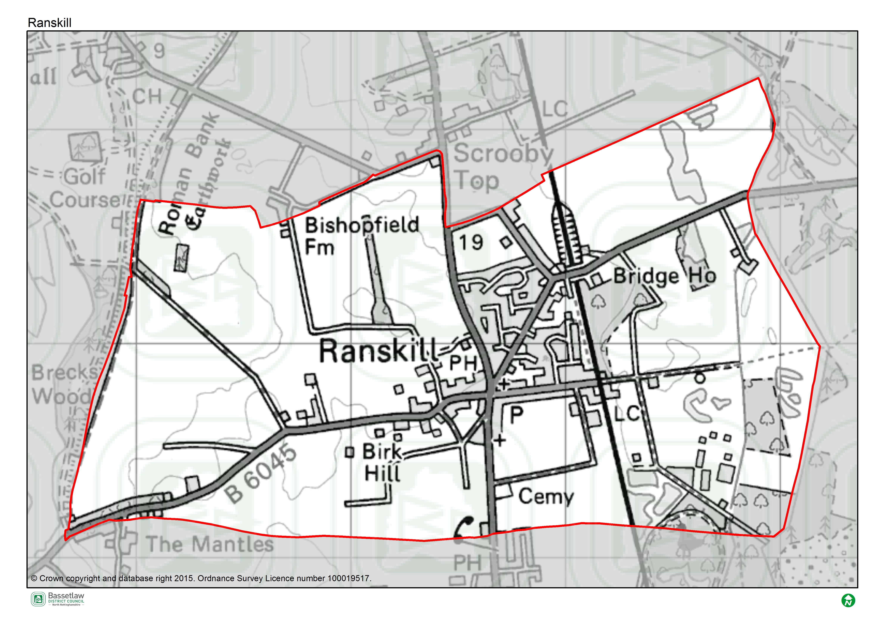 Plan Overview
        - As detailed below, the priorities of the Plan are encapsulated in the Vision and Community Objectives (see page 12 of the Plan), to be delivered through the application of seven Development Management Policies specific to the Neighbourhood Area.

Vision
In 2037 Ranskill will still be a small rural village. The built heritage will be protected with easy access to the countryside via a network of footpaths.
All development (which will include an additional employment site) will be designed to a high quality and carefully located, to minimise its impact on the surrounding landscape, and to be close to supporting infrastructure.
The sense of community spirit and cohesion will be fostered and strengthened, supported by the protection of existing community facilities.

Community Objectives
Community Objective 1: To ensure that future housing growth is limited and meets the needs of the local community (2/3 bed dwellings where possible) whilst minimizing the impact on the natural and built environment.
Community Objective 2: To ensure that all new development is limited and within or immediately adjacent to the Development Boundary, integrates easily with the existing settlement pattern and reinforces the existing rural character
Community Objective 3: To ensure development is designed to a high quality that reflects local character, topography, landscape sensitivity and views as detailed in in the Ranskill Design Guide 2020.
Community Objective 4: To maximise local employment opportunities by expanding the range of employment units in the Parish, to provide local employment and services for residents and visitors
Community Objective 5: To ensure that heritage of the Plan area is protected and, where possible, enhanced.
Community Objective 6: To encourage developers to consult with the community early in the planning application process (at pre-application stage) via mechanisms outlined in this Neighbourhood Plan

Development Management Policies

Neighbourhood Plan Policy | Intent
Policy 1: Sustainable Development, Infill and the Development Boundary | Identifies the development boundary for Ranskill and the criteria that development within the boundary should meet in order to be supported. This includes issues of number and scale of dwellings, character and design, green infrastructure, heritage and conservation, sustainable transport, and drainage. The policy also specifies that development outside of the development boundary will be limited to that necessary to support the rural economy, as per District and National policy.
Policy 2: Protecting the Natural Environment and Landscape Character | Seeks to ensure that development proposals respect landscape character features identified in the Plan and the supporting Design Code, specifically the identified significant green gaps, key views, and rural-urban interface. Provides support for the inclusion of Sustainable Drainage Systems where relevant, and seeks to ensure that development should achieve a biodiversity net gain in accordance with local and national policy.
Policy 3: Designation of Local Green Spaces | Proposes nine sites in the Neighbourhood Area as Local Green Spaces, with a view to protecting their value to the community and special characteristics.
Policy 4: Ensuring High Quality Design | Draws attention to the accompanying Design Code 2020, and details how it should be interpreted as part of development proposals, through reference to specific design-related variables.
Policy 5: A Mix of Housing Types | Seeks a mix of housing types and sizes that meets the needs of local people, in accordance with the most recent housing need assessment (HEDNA or equivalent – although a specific Housing Need Assessment does not accompany the Plan).
Policy 6: Maintaining Local Employment | Provides support for sustainable growth of businesses subject to being of a suitable scale, nature, design, and location.
Policy 7: Enhancing the Provision of Community Facilities | Provides support for new or improved community facilities, subject to appropriate design, location, and access.

SEA Screening – Assessment
        - The table below includes the assessment of the Ranskill Neighbourhood Plan including its Objectives and Development Management Policies against the criteria included in Schedule 1 of the 2004 Regulations. The Neighbourhood Plan is being assessed as a whole against the criteria listed below to allow for the consideration of its effects on the environment.

SEA Assessment

Criteria for determining the likely significance of effects (Annex II SEA Directive) | Significant effect likely? | Comment
1a The degree to which the plan or programme sets a framework for projects and other activities, either with regard to the location, nature, size and operating conditions or by allocating resources. | NO | The Ranskill Neighbourhood Plan (the Plan) sets-out a spatial vision for the designated Neighbourhood Plan area and provides a framework for development proposals. This framework will be delivered by the development management policies contained within the Plan. The framework will have some impacts on the environment, noticeably the support of development proposals. However it is deemed that these impacts will not be significant, due to their small-scale and localised nature.  The Plan is considered to be in general conformity with Bassetlaw District Council’s Core Strategy 2011. It is also considered to be in general conformity with the most recent version of the National Planning Policy Framework (NPPF).  In addition to the land use policies, four aspirational community projects are detailed in Appendix A of the Plan. These projects will be delivered in accordance with the policies in the Plan and those in the Bassetlaw Core Strategy, and it is deemed that they will not have any significant effects on the environment.
1b The degree to which the plan or programme influences other plans and programmes including those in a hierarchy. | NO | The Plan, where possible, will respond to rather than influence other plans and programmes. It is part of a hierarchy, but is at the lowest tier, sitting below the Bassetlaw Core Strategy DPD (District level) and National Planning Policy Framework (National level), and has thus been influenced by these higher-tier and pre-existing plans, rather than having an influence on them.  The Plan has been developed with a view towards the emerging Bassetlaw Local Plan but, as above, will remain at the lowest tier of the hierarchy.  The policies within a neighbourhood plan apply only within the designated Neighbourhood Area, and so the Plan will not have a direct impact on other plans in adjoining areas.
1c The relevance of the plan or programme for the integration of environmental considerations in particular with a view to promoting sustainable development. | NO | The Plan promotes sustainable development within the Neighbourhood Area through balancing environmental, social and economic objectives. The Vision & Objectives, in conjunction with Section 9 of the Plan (Sustainable Development and the Development Boundary), and the development management policies, work to ensure that all development proposals brought forward in the area will take this balance into account.  Specifically, the residential development supported by Policies 1 and 5, and the economic development supported in Policy 6, is viewed as key to ensuring the long-term sustainability of the area. This projected growth is balanced by the protection of key environmental and social / cultural assets, as supported by Policies 2, 3, and 7.  As a result, it is considered that the Plan effectively integrates and balances all potential environmental considerations, and that potential impacts are, therefore, not likely to be significant.
1d Environmental problems relevant to the plan or programme. | NO | The majority of effects the Plan will have on the environment will be positive. This is due mainly to Policies 2 and 3 that work to protect and enhance environmental assets and green infrastructure in the Plan area.  The proposed support for residential development within the development boundary (Policy 1) is likely to have some effects on the environment. However existing national and local planning policies, the site-specific criteria in the above proposed Policy, the Plan’s general support for sustainable development, and the planning application process, will collectively ensure that these effects are not significant.
1e The relevance of the plan or programme for the implementation of Community legislation on the environment (for example, plans and programmes linked to waste management or water protection). | NO | The Plan will be in compliance with the Bassetlaw Local Development Framework, which has taken into account the existing European and National legislative framework for environmental protection. The Plan will therefore have a positive effect on compliance with regards to relevant legislation and programmes. It is deemed that no proposals within the Plan will compromise this position.
2a The probability, duration, frequency and reversibility of the effects. | NO | It is deemed highly unlikely that there will be any irreversible damaging environmental impacts associated with the Plan. The policies within the Plan seek to ensure new development is sustainably built and promotes the enhancement and protection of environmental assets.  The timescales of the Plan is intended to be until 2037.  Should any unforeseen significant effects on the environment arise as a result of the Plan, the intention to monitor the Plan and to also review/update the Plan when required will allow these effects to be addressed (see Section 16: Monitoring and Review)
2b The cumulative nature of the effects. | NO | It is considered that the Policies contained in the Plan cumulatively will have minimal negative effects on the environment and will in fact have moderate to significant positive effects. It is considered that all effects will be at a local level.
2c The transboundary nature of the effects. | NO | Effects will be local, with no expected impacts on neighbouring areas.
2d The risks to human health or the environment (for example, due to accidents). | NO | No obvious risks have been identified as the overall aim of the Plan is to ensure the careful management of development and the continued sustainability of the Plan area.
2e The magnitude and spatial extent of the effects (geographical area and size of the population likely to be affected). | NO | The Plan relates to, and will have an influence on, a designated neighbourhood area of approximately 533 hectares, with a resident population of approximately 1500 people (Census 2011).  It is deemed the Plan as a whole will have a positive impact upon local residents through the protection and enhancement of local environmental assets, promotion of sustainable development, and through the delivery of identified community projects (see Appendix A).
2f The value and vulnerability of the area likely to be affected due to:  (i) special natural characteristics or cultural heritage;  (ii) exceeded environmental quality standards or limit values; or  (iii) intensive land-use. | NO | The Plan is deemed unlikely to have an adverse effect on the natural characteristics and cultural heritage of the neighbourhood area. Indeed, Policies 2, 3, and 4 of the Plan work to actively protect and enhance these, in addition to criteria within the other development management policies.  With respect to natural characteristics, there are five Local Wildlife Sites (LWS) within the Plan area. Mattersey Hill Marsh SSSI is immediately adjacent to the Plan boundary, as is Scrooby Top Quarry SSSI, and Mattersey Wood Ancient Woodland. The Idle Washlands SSSI is more distant, but has Impact Risk Zones that intersect the Plan area. It is considered that the development supported by the Plan will not result in significant effects on these assets. Furthermore, the Plan does not exceed environmental quality standards or limit values and does not provide specific policies in relation to intensive land uses.
2g The effects on areas or landscapes which have a recognised national, Community or international protection status. | NO | It is considered that the Plan will not adversely affect areas of landscape which have recognised community, national or international protection. Policy 2 specifically addresses the need to protect the local landscape character, including the identification of key views and significant green gaps.

HRA Screening – Assessment

        - For the HRA screening assessment, the designated neighbourhood area was assessed to identify if any Special Protection Areas (SPA), Special Areas of Conservation sites (SAC), or Ramsar sites were located within the boundary, as well as those considered as potential sites (pSPA, ppSPA, cSAC & pRamsar). The assessment also identified if any of these internationally important sites were located within a 15km radius from the Neighbourhood Plan area. The results of this exercise are detailed on the map included as Figure 4 on page 12. The Hatfield Moor SAC and Thorne and Hatfield Moors SPA are located approximately 14.9km to the north of the border of the Plan area. Descriptions of the ecological attributes of each of the sites are included as Appendix 2.
        - Although not formally a pSPA, Natural England has advised that there is a possibility of a Sherwood Forest pSPA being designated in the future, on reflection of populations of breeding nightjar and woodlark. In a note to Local Planning Authorities dated March 2014, Natural England advocates a precautionary approach to any plans or projects which could affect such a site. This approach should ideally cover the potential direct, indirect and cumulative impacts, which may include, but may not be limited to, the following;
- disturbance to breeding birds from people, their pets and traffic
- loss, fragmentation and/or damage to breeding and/or feeding habitat
- bird mortality arising from domestic pets and/or predatory mammals and birds
- bird mortality arising from road traffic and/or wind turbines

        - No formal assessments of the boundary of any future SPA have been made; therefore, it is not possible to definitively identify whether individual sites would fall inside or outside any possible future designated area. However, the Natural England note encloses a map which highlights the areas of greatest ornithological interest for breeding nightjar and woodlark. This has been included on Figure 4, and identifies that the ppSPA is approximately 9.2km south of the Plan area.
        - The Screening Assessment on page 12 has considered the main potential sources of effects on all of the identified European sites arising from the Plan, possible pathways to the sites, and the effects on possible sensitive receptors. The assessment considers the impacts of the Policies in the Plan directly on the identified sites, as these are land use Policies which mostly are expected to have some direct or indirect impact on the local environment.

Figure 4: Map of Special Protection Areas and Special Areas of Conservation in relation to the Ranskill Neighbourhood Area
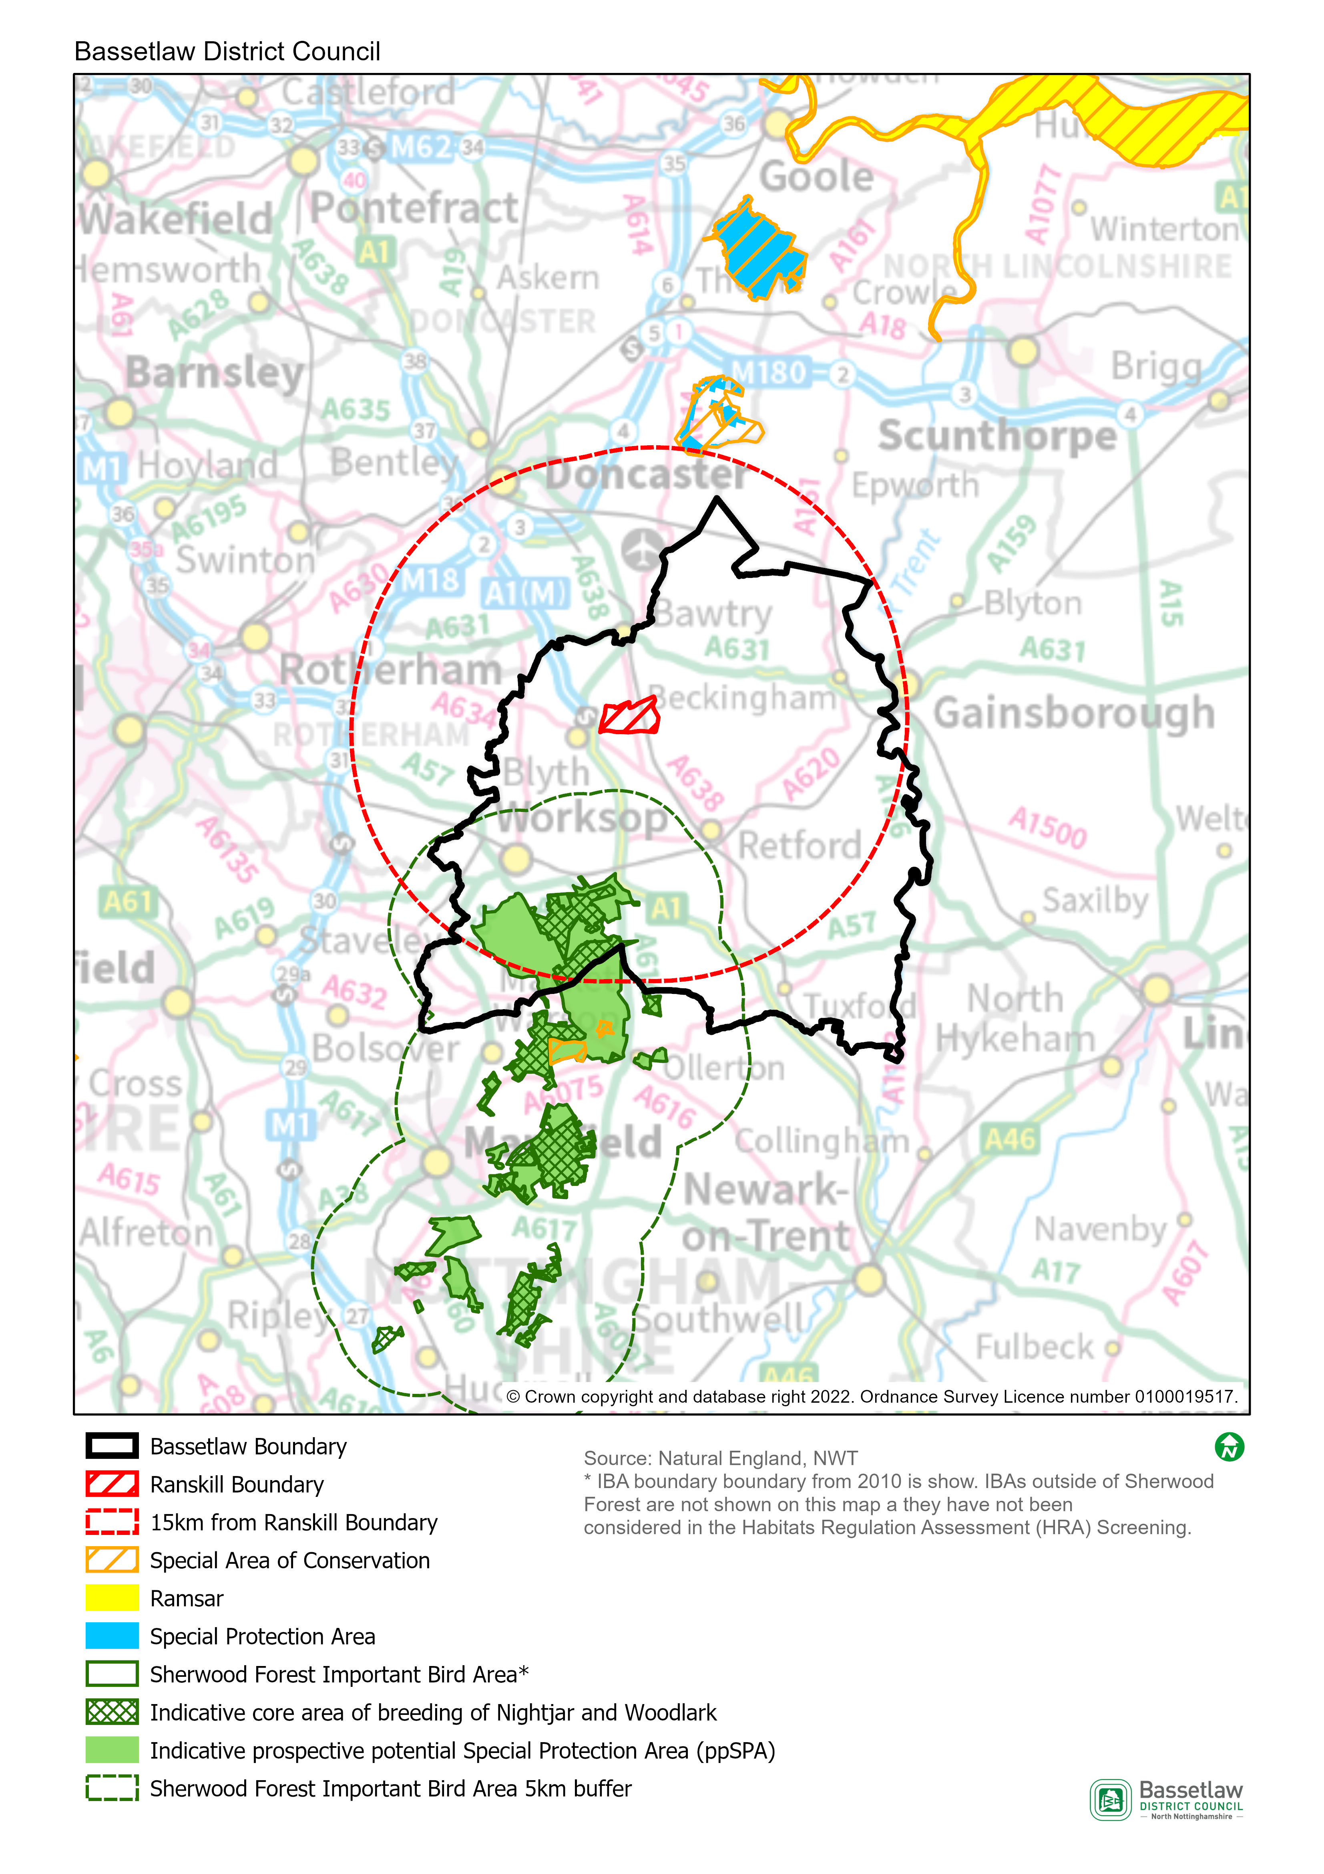

HRA Screening Matrix
The screening matrix below shows which types of impacts on European sites could potentially result from each of the policies and sites allocated in the Ranskill Neighbourhood Plan. Where a site is not expected to have a particular type of impact, the relevant cell is shaded green. Where a site could potentially have a certain type of impact, this is shown in orange. The final column sets out the screening conclusions.
Policy | Likely activities (operation) to result as a consequence of the proposal | Likely effects if proposal  implemented | European site(s) potentially affected | Could the proposal have likely significant effects on European sites?
Policy 1: Sustainable Development, Infill and Development Boundaries | Residential development.  Economic development.  Increase in vehicle traffic.  Increase in recreation pressure. | Physical loss and damage.  Air pollution.  Disturbance from recreation. | Hatfield Moor SAC  Thorne and Hatfield Moors SPA  Sherwood Forest prospective potential Special Protection Area (ppSPA) | No significant effects anticipated.  The areas where development is supported by the Policy (within the development boundary) are approximately 15.6km at the nearest from the Hatfield Moor SAC and Thorne and Hatfield Moor SPA, and 9.5km at the nearest from the Sherwood Forest ppSPA. Physical loss and damage is, therefore, not possible.  It would not be expected for birds to be dependent on the habitat within the existing developed footprint of Ranskill Village.  This Policy alone would not be expected to cause a significant increase in traffic and air pollution in the area.  With regard to pathways, it is considered that the nature and small scale of the development supported in this Policy, including the distance between the potential development sites and the European sites, and intervening infrastructure, will not result in significant effects occurring.
Policy 2: Protecting the Natural Environment and Landscape Character | None. This policy seeks to ensure the protection of landscape character, specifically key views, and significant green gaps - it will not itself result in new development. | n/a | n/a | No
Policy 3: Designation of Local Green Spaces | None – this policy requires new development to protect Local Green Space, it will not itself result in development or increase traffic or visitor numbers. | n/a | n/a | No
Policy 4: Ensuring High Quality Design | None. This policy sets out principles to influence the design and layout of residential developments - it will not itself result in new development. | n/a | n/a | No
Policy 5: A Mix of Housing Types | None – this policy aims to ensure that any residential development facilitated by other policies reflects the needs of potential occupants. It will not itself result in new development. | n/a | n/a | No
Policy 6: Maintaining Local Employment | Economic development.  Increase in vehicular traffic. | Physical loss and damage.  Air pollution. | Hatfield Moor SAC  Thorne and Hatfield Moors SPA  Sherwood Forest prospective potential Special Protection Area (ppSPA) | No significant effects anticipated.  The areas where development is supported by the Policy (within the development boundary) are approximately 15.6km at the nearest from the Hatfield Moor SAC and Thorne and Hatfield Moor SPA, and 9.5km at the nearest from the Sherwood Forest ppSPA. Physical loss and damage is, therefore, not possible.  It would not be expected for birds to be dependent on the habitat within the existing developed footprint of Ranskill Village.  This Policy alone would not be expected to cause a significant increase in traffic and air pollution in the area.  With regard to pathways, it is considered that the nature and small scale of the development supported in this Policy, including the distance between the potential development sites and the European sites, and intervening infrastructure, will not result in significant effects occurring.
Policy 7: Enhancing the Provision of Community Facilities | Development of community facilities.  Increase in vehicular traffic. | Physical loss and damage.  Air pollution. | Hatfield Moor SAC  Thorne and Hatfield Moors SPA  Sherwood Forest prospective potential Special Protection Area (ppSPA) | No significant effects anticipated.  The areas where development is supported by the Policy (adjacent to the settlement of Ranskill) are approximately 15.6km at the nearest from the Hatfield Moor SAC and Thorne and Hatfield Moor SPA, and 9.5km at the nearest from the Sherwood Forest ppSPA. Physical loss and damage is, therefore, not possible.  It would not be expected for birds to be dependent on the habitat within the existing developed footprint of Ranskill Village.  This Policy alone would not be expected to cause a significant increase in traffic and air pollution in the area.  With regard to pathways, it is considered that the nature and small scale of the development supported in this Policy, including the distance between potential development sites and the European sites, and intervening infrastructure, will not result in significant effects occurring.

In-combination effects
        - Regulation 105 of the Amended Habitats Regulations 2017 requires an Appropriate Assessment where “a land use plan is likely to have a significant effect on a European site (either alone or in combination with other plans or projects) and is not directly connected with or necessary to the management of the site”. Therefore, it is necessary to consider whether there may be significant effects from the Ranskill Neighbourhood Plan in combination with other plans or projects.
        - The first stage in identifying ‘in-combination’ effects involves identifying which other plans and projects in addition to the Ranskill Neighbourhood Plan may affect the European sites that were the focus of this assessment. There are a large number of potentially relevant plans and projects which could be considered, therefore, the review focused on planned spatial growth within Bassetlaw District.
        - The Habitats Regulations Assessment of the emerging Bassetlaw Local Plan (August 2021) concluded that the Local Plan does not result in likely significant effects upon Hatfield Moor SAC or Thorne and Hatfield Moors SPA, either alone or in combination. In respect to the Sherwood Forest ppSPA, the assessment initially identified likely significant effects resulting from the development proposed in the Bassetlaw Local Plan. Through further investigation of the impact pathways and proposed mitigation, however, it was concluded that no adverse effects on the integrity of the ppSPA would occur.
        - The scale of development proposed by the Ranskill Neighbourhood Plan is in conformity with the Bassetlaw Local Plan and has been devised to meet the proposed minimum housing requirement figure for Ranskill of 30 dwellings up to 2037, representing 0.2% of the Draft Local Plan’s housing growth projections for Bassetlaw. This scale of housing development, together with the area’s distance from the Sherwood Forest ppSPA, means that its ‘incombination’ effect is insignificant.

Impact Risk Zones for Sites of Special Scientific Interest (SSSI)
        - Sites of special scientific interest (SSSI) conserve and protect the best of our wildlife, geological and physiographical heritage for the benefit of present and future generations, under the Wildlife and Countryside Act 1981.
        - Impact Risk Zones are a GIS tool developed by Natural England to make a rapid initial assessment of the potential risks to SSSIs posed by development proposals. They define zones around each SSSI which reflect the particular sensitivities of the features for which it is notified and indicate the types of development proposal which could potentially have adverse impacts, generally decreasing in sensitivity with distance from the site. The location of SSSI and their associated Impact Risk Zones can be observed and queried via Natural England’s MAGIC Map portal.
        - Review of the data clarifies that there are no SSSIs located within the Plan area itself, but there are two in close proximity to the boundary, and their Impact Risk Zones cover the majority of the Plan area:
- Mattersey Hill Marsh
- Scrooby Top Quarry
        - Part of the Plan area is also intersected by the Impact Risk Zones of a more distant SSSI, located approximately 4.6km to the north:
- River Idle Washlands
        - The development supported by the policies in the Plan has been assessed to determine how it relates to the SSSI Impact Risk Zones noted above, and whether the nature of the development is likely to trigger any of the associated criteria, as provided by Natural England. The finding are detailed below.
Neighbourhood Plan Policy | Impact Risk Zone Criteria Triggered?
Policy 1: Sustainable Development, Infill and the Development Boundary | Unlikely. The impact risk threshold for rural residential development is 50 or more dwellings outside existing settlements. The Policy directs the majority of development to within the confines of the development boundary, and then as infill, with a default position of 1 or 2 dwellings per site.
Policy 2: Protecting the Natural Environment and Landscape Character | No. The Policy does not, itself, support development.
Policy 3: Designation of Local Green Spaces | No. The Policy does not, itself, support development.
Policy 4: Ensuring High Quality Design | No. The Policy does not, itself, support development.
Policy 5: A Mix of Housing Types | No. The Policy does not, itself, support development.
Policy 6: Maintaining Local Employment | Unlikely. The impact risk threshold for rural non-residential development is sites of more than 1ha outside of existing settlements. The Policy primarily supports development within the development boundary. Development outside the development boundary is not precluded, but must accord with extant District policies, thus limiting its scope.
Policy 7: Enhancing the Provision of Community Facilities | Unlikely. The impact risk threshold for rural non-residential development is sites of more than 1ha outside of existing settlements. The type of development supported by the Policy is unlikely to exceed the size threshold, and would most likely be within or adjoining the settlement, in accordance with the policy criteria, Policy 1, and extant District policies.

        - As detailed above, although the majority of the area covered by the Plan is intersected by Impact Risk Zones, the type and scale of development supported through the Policies is unlikely to trigger the associated criteria. Natural England is invited to comment on this position.

Conclusions

Consultation
        - As required by the regulations, a draft version of this report was issued for the purposes of consultation with the statutory bodies, specifically the Environment Agency, Historic England, and Natural England. On conclusion of the five-week consultation (22 March to 29 April 2022), responses had been received from two of the three bodies. The responses are included in full at Appendix 1, and can be summarised as follows:
- Environment Agency: do not disagree with the conclusion that the Ranskill Plan can be screened-out for SEA (and HRA, but recommend consulting Natural England in this regard).
- Historic England: no response received.
- Natural England: agrees with the conclusions that neither a SEA nor HRA is required, and does not have any other specific comments.
        - On the basis of the above, the initial conclusions are upheld, and no consequential amendments have been made to the report; the conclusions are detailed below.

SEA Screening
        - On the basis of the SEA Screening Assessment set out in this document, the conclusion is that the Ranskill Neighbourhood Plan will not have significant environmental effects in relation to any of the criteria set out in Schedule 1 of the SEA Regulations and, therefore, does not need to be subject to a full SEA.

HRA Screening
The HRA Screening Assessment concludes that no significant effects are likely to occur with regards to the integrity of the Hatfield Moor SAC, Thorne and Hatfield Moors SPA or the Sherwood Forest ppSPA as a consequence of the implementation of the Plan. As such, the Plan does not require a full HRA to be undertaken.

Appendix 1: Consultation Responses

Environment Agency
Received 28 April 2022.
Dear Will,
Thank you for your email and the attachments.
From the perspective of the Environment Agency’s remit we do not disagree with the conclusion that the Ranskill Plan can be screened out for SEA (and HRA – although the views of Natural England should be sought in this regard).

Environment Agency
Received 1 April 2022.
Dear Sir/Madam
Planning consultation: Ranskill Neighbourhood Plan - Draft SEA & HRA Screening Consultation
Thank you for your consultation on the above dated 22 March 2022.
Natural England is a non-departmental public body. Our statutory purpose is to ensure that the natural environment is conserved, enhanced, and managed for the benefit of present and future generations, thereby contributing to sustainable development.
Where Neighbourhood Plans could have significant environmental effects, they may require a Strategic Environmental Assessment (SEA) under the Environment Assessment of Plans and Programmes Regulations 2004 (as amended). Further guidance on deciding whether the proposals are likely to have significant environmental effects and the requirements for consulting Natural England on SEA are set out in the planning practice guidance.
Planning practice guidance also outlines that if an appropriate assessment is required for your neighbourhood plan this will also engage the need for a SEA. One of the basic conditions that will be tested by the independent examiner is whether the neighbourhood plan is compatible with European obligations, including those under the SEA Directive. Where a SEA is required it should be prepared in accordance with regulation 12 of the SEA Regulations.
Natural England welcomes the Screening Report which assesses the requirement for Strategic Environmental Assessment (SEA) and Habitats Regulations Assessment (HRA) for the Ranskill Neighbourhood Plan. We are pleased to see the consideration of Sherwood ppSPA, as well as the use of Impact Risk Zones within the report.
I can confirm that Natural England agrees with this report’s conclusion that it is not likely there will be significant environmental effects arising from the policies in the plan, which have not already been accounted for within the adopted local plan. Therefore, the Ranskill Neighbourhood Plan does not require a Strategic Environmental Assessment (SEA) to be undertaken.
Natural England also agrees that the Plan would be unlikely to result in any significant effect to European Sites, either alone or in combination, and therefore an appropriate assessment under the Habitats Regulations is not required.
Aside from this, Natural England have no specific comments at this stage. We would be happy to comment further should the need arise but if in the meantime you have any queries please do not hesitate to contact us. For any queries relating to the specific advice in this letter please contact me on 020 8720 4183. For any new consultations, or to provide further information on this consultation please send your correspondences to consultations@naturalengland.org.uk.

Appendix 2: Ecological attributes of the European sites

Hatfield Moor Special Area of Conservation (SAC)
Description
Hatfield Moors, which covers an area of 1363.55 hectares, is a remnant of an extensive lowland raised bog which once occupied the Humberhead levels. Hatfield is unique in having developed directly upon nutrient deficient gravels without an initial reed-swamp phase. Much of the bog has been cut for peat yet a restricted representative flora and fauna persists within a mosaic of mire and dry heath habitats beneath birch scrub. The mire communities are dominated by cottongrasses Eriophorum vaginatum and E. angustifolium, cross-leaved heath Erica tetralix and bogmosses Sphagnum spp., but include locally rare species such as cranberry Vaccinium oxycoccus, bog myrtle Myrica gale and bog rosemary Andromeda polifolia.
Area
1359.45ha
Qualifying Features
H7120: Degraded raised bogs still capable of natural regeneration
Site Status (an assessment by Natural England of the status of the SSSIs within the SAC):
- 92.23% in unfavourable (recovering) condition
- 6.50% in unfavourable (no change) condition
- 1.27% in favourable condition
Special Area of Conservation objectives
Ensure that the integrity of the site is maintained or restored as appropriate, and ensure that the site contributes to achieving the Favourable Conservation Status of its Qualifying Features, by maintaining or restoring:
- The extent and distribution of qualifying natural habitats
- The structure and function (including typical species) of the qualifying natural habitat, and
- The supporting processes on which the qualifying natural habitat rely.
Site Improvement Plan: pressures, threats and related development
The main pressures and threats to this site include drainage, inappropriate scrub control, impacts of atmospheric nitrogen deposition, public access/disturbance, peat extraction and invasive species. Additionally, planning permission is a problem in that wind farms have been erected or are planned in the wider area surrounding the SAC, yet investigation is needed to better understand the cumulative impact of existing and planned wind farm and other local developments on the nightjar population.
Thorne and Hatfield Moors Special Protection Area (SPA)
Description
Covering an approximate area of 2449.2 hectares, Thorne and Hatfield Moors SPA is an extensive lowland raised mire system adjacent to the Humber estuary on the north-east coast of England and is the largest remaining lowland peatland in England. Despite a long history of extensive peat extraction since the late nineteenth century, the site retains substantial areas of Sphagnum bog, which has been changed by succession to wet scrub woodland dominated by Birch Betula sp., sallows and Alder Alnus glutinosa. Where the peat surface has been removed, subsequent restoration of active bog has depended upon shallow flooding to allow Sphagnum and other bog plants to re-colonise. The mire communities are dominated by Hare’s-tail Eriophorum vaginatum and Common Cottongrass E. augustifolium, Cross-leaved Heath Erica tetralix, Soft-rush Juncus effuses and Sphagnum mosses, and include a variety of scarcer bog plants such as Bog-rosemary Andromeda polifolia and Cranberry Vaccinium oxycoccos. Drier health is dominated by Heather Calluna vulgaris, Bracken Pteridium aquilinum and Purple Moorgrass Molinia caerulea. Birch Betula sp. scrub, some of it dense, occurs throughout both moors. The diverse mosaic of habitats contribute greatly to the ornithological interest, which comprises breeding species, notably Caprimulgus europaeus.
Area
2449.2ha
Qualifying Features
A224: Caprimulgus europaeus; European nightjar (Breeding)
Site Status (an assessment by Natural England of the status of the SSSIs within the SAC):
- 92.23% in unfavourable (recovering) condition
- 6.50% in unfavourable (no change) condition
- 1.27% in favourable condition
Special Protection Area objectives
Ensure that the integrity of the site is maintained or restored as appropriate, and ensure that the site contributes to achieving the aims of the Wild Birds Directive, by maintaining or restoring:
- The extent and distribution of the habitats of the qualifying features
- The structure and function of the habitats of the qualifying features
- The supporting processes on which the habitats of the qualifying features rely
- The population of each of the qualifying features, and,
- The distribution of the qualifying features within the site.
Site Improvement Plan: pressures, threats and related development
The main pressures and threats to this site include drainage, inappropriate scrub control, impacts of atmospheric nitrogen deposition, public access/disturbance, peat extraction and invasive species. Additionally, planning permission is a problem in that wind farms have been erected or are planned in the wider area surrounding the SAC, yet investigation is needed to better understand the cumulative impact of existing and planned wind farm and other local developments on the nightjar population.

Sherwood Forest prospective potential Special Protection Area (ppSPA)
Description
As the Sherwood Forest prospective potential SPA (ppSPA) is not currently designated as a European Site, there is no Standard Data form or SIP for it. However, the Sherwood Forest Important Bird Area is being used as a proxy for the purposes of this assessment, and the indicative core areas for breeding for nightjar and woodlark as identified by Natural England, are likely to be the most sensitive areas.
The Sherwood Forest IBA covers 7,320 ha and consists of several geographic sites stretching from south of Worksop to north of Nottingham. Once part of the 10,000 acre Royal Forest of Sherwood, the woodland is dominated by native oaks and other native trees such as silver birch, rowan, holly and hawthorn. It has been continuously forested since the end of the Ice Age.
Approximately 424.75ha of the Sherwood Forest ppSPA is also a designated National Nature Reserve (NNR). The reserve contains more than a thousand ancient oaks most of which are known to be more than 500 years old.
Sherwood Forest has the highest concentration of ancient trees in Europe and provides habitat for very rare invertebrates, particularly beetles, flies and spiders, many of which rely on the decaying and ageing timber of the veteran trees. Budby South Forest, in the northern half of the site, is dominated by link heather and supports a diverse range of insects and ground nesting birds such as woodlark, nightjar and tree pipit.
In 2004, it was estimated that there were approximately 63 male European Nightjar (females unknown) within in the IBA and approximately 25 breeding pairs of Woodlark.
Qualifying Features
The primary reasons for potential designation of this site are that the population of Caprimulgus europaeus; European nightjar represents 1.88% of the total UK breeding population and the population of Lullula arborea; Woodlark, is 2.51% of the total UK breeding population.
Site Status (an assessment by Natural England of the status of the SSSIs within the SAC):
The condition of the site was not assessed in the most recent IBA monitoring assessment. However, the IBA factsheet states that the mixed woodland habitat is in ‘very unfavourable’ condition, but the conditions of the nightjar and woodlark populations are favourable.
Prospective potential Special Protection Area objectives
As this area does not relate to an existing designated site, no conservation objectives have been established for it. However, it is anticipated that, were the site to be designated, any conservation objectives would reflect those for other SPAs, as follows:
- Ensure that the integrity of the site is maintained or restored as appropriate, and ensure that the site contributes to achieving the aims of the Wild Birds Directive, by maintaining or restoring:
  - The extent and distribution of the habitats of the qualifying features
  - The structure and function of the habitats of the qualifying features
  - The supporting processes on which the habitats of the qualifying features rely
  - The population of each of the qualifying features, and,
  - The distribution of the qualifying features within the site.
Site Improvement Plan: pressures, threats and related development
The main current threats to the site include logging and wood harvesting, climate change, changes in land use for energy production, housing and economic development, tourism and recreation and air pollution. War, civil unrest and military exercises are identified as a past threat, which is unlikely to return.
These threats have been rated low to very high, depending on the proportion of the area and/or population they are likely to affect and the severity of the threat. Recreational activities are identified as being the highest level of threat, followed by logging and wood harvesting and residential and commercial development. The IBA factsheet also identifies ‘other threat’ as being a high threat, but no details are given.

SEA Directive, Article 1
Planning Guidance - Paragraph: 079: Reference ID: 41-079-20140306

