IN ACCORDANCE WITH THE NEIGHBOURHOOD PLANNING (GENERAL) REGULATIONS 2012 (AS AMENDED)
DESIGNATION OF A NEIGHBOURHOOD AREA
AND
DESIGNATION OF A NEIGHBOURHOOD FORUM

Bassetlaw District Council has, under Article 7 of the above regulations, APPROVED the following Neighbourhood Area, and identified it as a business area:
Retford Town Centre (as identified on the below map)
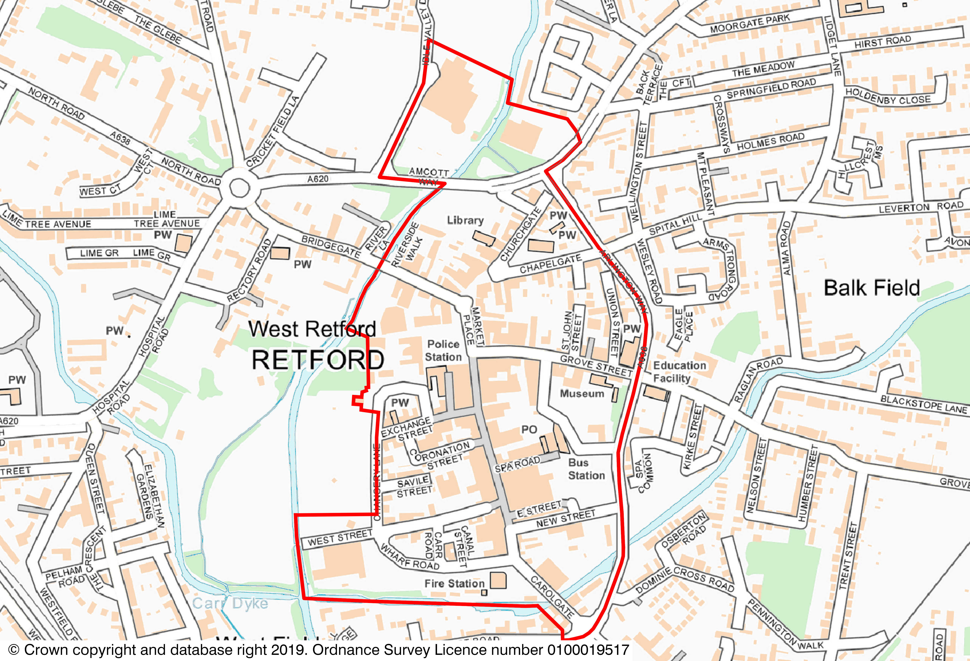
Bassetlaw District Council has also, under Article 10 of the above regulations, APPROVED the following Neighbourhood Forum to act as the qualifying body in relation to Retford Town Centre Neighbourhood Area:
Retford Town Centre Neighbourhood Planning Group
Chair: Rick Brand
Email: rickbrand@hotmail.com
All documentation, including the Constitution of Retford Town Centre Neighbourhood Planning Group, is available from the Bassetlaw District Council website.
Signed: David Armiger
Assistant Chief Executive - Housing, Regeneration & Neighbourhoods
4 March 2021

