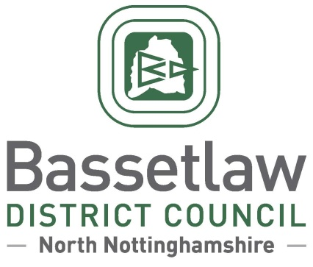

Lound Neighbourhood Development Plan – Draft Decision Statement

Summary
        - In accordance with Regulation 18 of the Neighbourhood Planning (General) Regulations 2012, Bassetlaw District Council has produced this ‘Decision Statement’ in relation to the Lound Neighbourhood Development Plan (the ‘Plan’).
        - Following an independent examination, Bassetlaw District Council confirms that the Plan will proceed to a neighbourhood planning referendum, following enactment of the modifications specified in the Examination Report.
        - The referendum is scheduled for Thursday 24 February 2022, based on the Lound Neighbourhood Area, as approved by Bassetlaw District Council on 30 June 2016.
        - This Decision Statement, along with the Independent Examiner’s report, can also be viewed on the Bassetlaw District Council website.

Background
        - On 9 May 2016, Lound Parish Council submitted an application to Bassetlaw District Council for the designation of Lound Parish as a Neighbourhood Area. On 30 June 2016, Bassetlaw District Council approved the Neighbourhood Area Designation following a statutory four-week consultation period (16 May – 13 June 2016).
        - The Pre-Submission Draft Lound Neighbourhood Plan was made available for consultation in accordance with Regulation 14 of the Neighbourhood Planning regulations from 1 August to 30 September 2020.
        - The Parish Council formally submitted the Neighbourhood Plan to the District Council on 26 March 2021. Bassetlaw District Council duly consulted the public and statutory bodies on the Plan for a 6-week period between 7 May and 18 June 2021, in accordance with Regulation 16 of the Neighbourhood Planning regulations.
        - An Independent Examiner was appointed to undertake the examination of the Submission version of the Neighbourhood Plan. The Examiner’s Report was sent to the District Council and Lound Parish Council on 25 August 2021.

Decisions and Reasons
        - The Head of Regeneration, in consultation with the Council’s Cabinet Member for Regeneration has determined that all the recommended modifications set out in the Examiner’s Report will be undertaken to ensure that the Plan meets the Basic Conditions.
        - The Examiner has concluded that, subject to the specified modifications being enacted, the Plan meets the Basic Conditions and other relevant legal requirements. The Council concurs with this view. Therefore, to meet the requirements of the Localism Act 2011, a referendum which poses the question “Do you want Bassetlaw District Council to use the Neighbourhood Plan for Lound to help it decide planning applications in the neighbourhood area?” will be held in the Lound Neighbourhood Area on 24 February 2022.

Beverley Alderton-Sambrook
Head of Regeneration, Bassetlaw District Council
10 December 2021

