IN ACCORDANCE WITH THE NEIGHBOURHOOD PLANNING (GENERAL) REGULATIONS 2012 (AS AMENDED)
MODIFICATION OF A DESIGNATED NEIGHBOURHOOD AREA

On 18 June 2021 Bassetlaw District Council received an application requesting a modification to the boundary of the existing Retford Town Centre Neighbourhood Area, so as to include the full extent of Bridgegate and its environs. Under Article 7 of the above regulations, the District Council has APPROVED the request and duly modified the boundary of the Neighbourhood Area, as detailed on the map below. The District Council has also confirmed that the expanded Neighbourhood Area will continue to be identified as a business area.

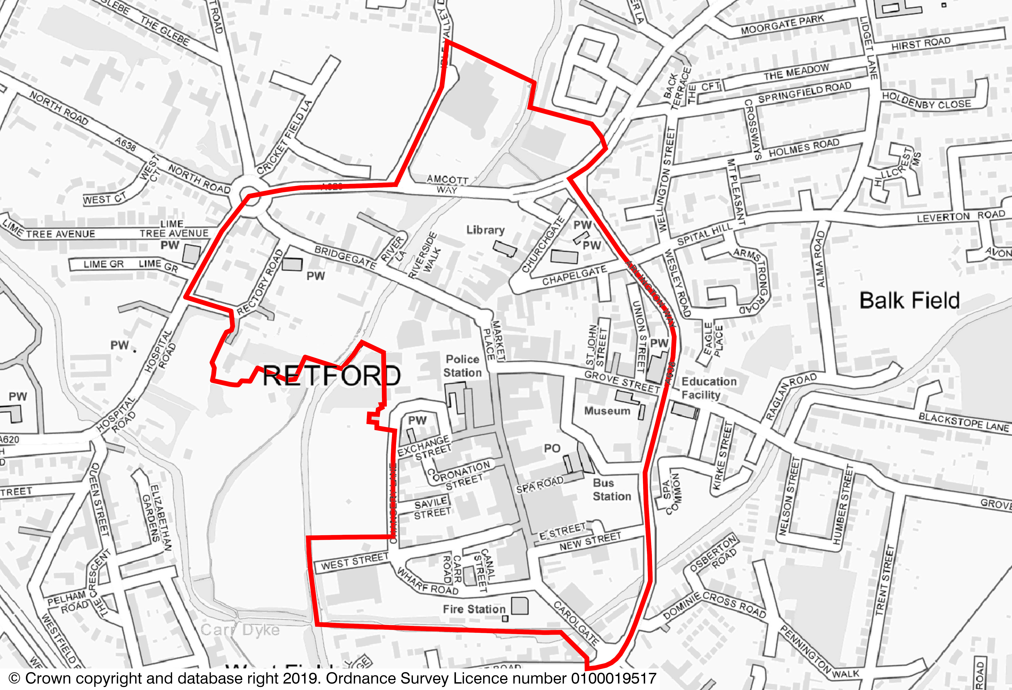

Retford Town Centre Neighbourhood Planning Group will continue to fulfil the role of Neighbourhood Forum (the Qualifying Body) for the Neighbourhood Area, leading the development of the associated Neighbourhood Plan.
All documentation relating to this decision is available from the Bassetlaw District Council website.
Signed: Beverley Alderton-Sambrook
Head of Regeneration
24 September 2021

