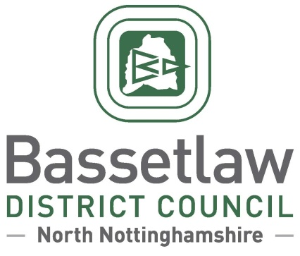

**Reviewed Treswell with Cottam Neighbourhood Plan: Decision Statement (Adoption)**

# Summary

* + - * 1. Following a positive referendum result on the 10 October 2024, Bassetlaw District Council is publicising its decision to ‘make’ the reviewed Treswell with Cottam Neighbourhood Plan part of the Bassetlaw Development Plan, in accordance with Regulation 19 of the Neighbourhood Planning (General) Regulations 2012.

# Background

* + - * 1. The Treswell with Cottam Neighbourhood Area was designated by Bassetlaw District Council on 18 December 2015. The original Treswell with Cottam Neighbourhood Plan was subsequently developed, and was adopted as part of the Development Plan by the District Council following a successful referendum on 21 February 2019.
        2. Work to review the original Neighbourhood Plan commenced in Spring 2019. The reviewed Neighbourhood Plan incorporates a range of modifications over the original Plan, summarised as follows (with policy numbers updated to reflect the now-adopted version of the Plan):
* Addition of policies 1 to 4, which each address a site-specific residential allocation in Treswell village.
* Addition of Policy 5, addressing additional residential development within the Treswell development boundary.

In addition to the above, consequential changes have also been made throughout the Plan for consistency, clarity, and to ensure that references to other documents and legislation are up-to-date, particularly the now-adopted Bassetlaw Local Plan.

* + - * 1. The reviewed Neighbourhood Plan was formally submitted to the District Council on 19 February 2024, followed by six weeks of consultation with the public and statutory bodies between 19 February and 2 April 2024.
        2. Bassetlaw District Council subsequently appointed an independent Examiner, Mr Andrew Ashcroft, to assess whether the reviewed Neighbourhood Plan met the basic conditions required by legislation, and whether the Plan should proceed to referendum.
        3. The Examiner’s Report, received on 31 May 2024, concluded that the Plan meets the Basic Conditions and that, subject to a number of specific modifications proposed in the report, the Plan should proceed to a public referendum. The Examiner’s Report, proposed modifications, and the intention to hold a referendum, were considered and approved by the District Council at a meeting held on 25 July 2024.

# Decision & Reasoning

* + - * 1. A public referendum was held in the Treswell with Cottam Neighbourhood Area, as proposed, on Thursday 10 October 2024.
        2. Paragraph 38A (4)(a) of the Planning and Compulsory Purchase Act 2004, as amended, requires that the District Council must make the Neighbourhood Plan if more than half of those voting have voted in favour of the plan. Bassetlaw District Council is not subject to this duty if the making of the plan would breach, or would otherwise be incompatible with, any EU obligation or any of the Convention rights (within the meaning of the Human Rights Act 1998).
        3. The referendum held on 10 October 2024 met the requirements of the Localism Act 2011 and posed the question: 'Do you want Bassetlaw District Council to use the Neighbourhood Plan for Treswell with Cottam to help it decide planning applications in the neighbourhood area?’.
        4. The count took place on the evening of the 10 October 2024 following the close of poll, and greater than 50% of those who voted were in favour of the plan being used to help decide planning applications in the plan area.
        5. The results of the referendum were:

Number cast in favour of a YES: 32 (68.09%)  
Number cast in favour of a NO: 15 (31.91%)

Turnout: 47 (17.74%)

* + - * 1. Bassetlaw District Council has assessed that the plan including its preparation does not breach, and would not otherwise be incompatible, with, any EU obligation or any of the Convention rights (within the meaning of the Human Rights Act 1998).
        2. In accordance with the Regulations and the Council’s procedure, the reviewed Treswell with Cottam Neighbourhood Plan is considered ‘made’ following the referendum held on 10 October 2024. Planning applications in the area must be considered against the Neighbourhood Plan, as well as existing planning policy, including the Bassetlaw Core Strategy and its successors, and the National Planning Policy Framework and Guidance.

**Neighbourhood Planning**

Bassetlaw District Council

14 October 2024

[neighbourhoodplanning@bassetlaw.gov.uk](mailto:neighbourhoodplanning@bassetlaw.gov.uk)

01909 533 495