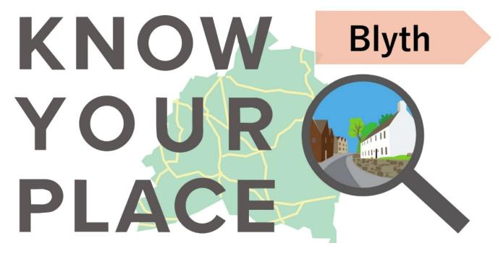

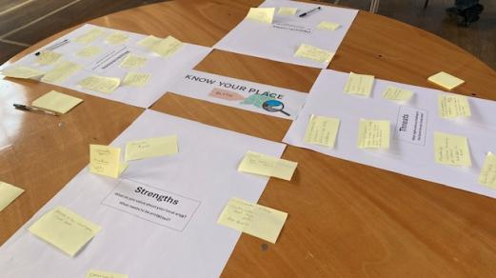

# Response data provided at the community event

# 2 - 8pm, 22nd May 2025



## Overview

This document details all of the comments provided during the community event (Know your Place), as originally written down. As per the event itself, the aim of this report is to assist the ongoing work to review the existing Blyth Neighbourhood Plan.

Comments on the various policies of the existing Neighbourhood Plan are detailed first, followed by the SWOT (Strengths, Weaknesses, Opportunities, and Threats) analysis completed for Blyth. This is followed by comments on the scoping maps, including Footpaths, Floodzones, Landscape Character Areas, and Heritage, all taken from the District Council’s mapping system.

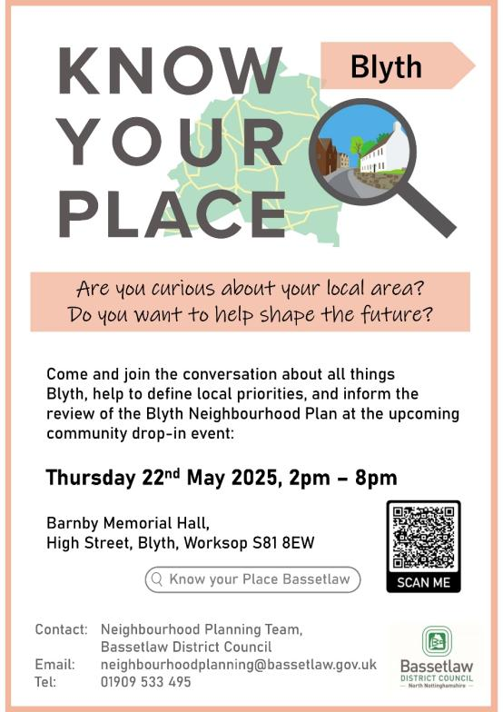

## What is Know your Place?

Know your Place is a new social learning tool developed by Bassetlaw District Council following its involvement in a government funded-pilot to explore new ways of supporting community-led planning. It aims to encourage curiosity and discussion around local issues, and to assist communities to identify and document local priorities. It is based on the premise that developing a better understanding of a place in the first instance will provide a firm foundation on which to consider if and how the themes raised could be responded to. This could, for example, include community projects, land use planning strategies, or further discussions or investigative work. Equally, better understanding of local issues may be a justifiable outcome in its own right.

## What happens next?

There are various ways that the response data included in this report might prove useful. What actually happens next is down to you – and we are keen to help to consider and facilitate this.

**Neighbourhood Planning, Bassetlaw District Council**

4 June 2025

1. [**Blyth Neighbourhood Plan 2018 – 2035 Final Version June 2020**](https://www.bassetlaw.gov.uk/planning-and-building-control/planning-policy/neighbourhood-plans/all-neighbourhood-plans/blyth-neighbourhood-plan/)

## Site Allocation Map/housing developments

* Land to be considered for residential properties in North Blyth (*pointing to land to the north of the junction of Blyth Road and Bawtry Road, North Blyth*). Properties suggested – high quality, up-market pensioners bungalows for people downsizing or moving into the area. Will not affect the core of Blyth.
* Land will current planning up for sale (*pointing to land to the east of the junction of Blyth Road and Bawtry Road, North Blyth*).
* North Blyth needs:
  + Mixed homes.
  + Play park.
  + Residents recreation green spaces.
* Co-ordinated Plan/development for North Blyth.
* Housing Plan – low cost, bungalows.
* Play area facilities.
* Land with outline permission up for sale (pointing to land to the south of the A1 Junction at Nornay).

## Policy 4: NP05: Land East of Bawtry Road (at Lynwood)

* *(No specific comments made)*

**Policy 5: BDC02: Land to the north of Retford Road**

* Built already! Large houses!!!

**Policy 6: BDC03: Land to the east of Spital Road**

* Affordable housing! Not just more big houses. Young families.
* This needs a follow-up to check with farmer if he still intends to sell for building land.

**Policy 9: Important Views**

* Church from Church Green.
* Village Green.
* Historic House.
* Alms Houses.
* Airmen’s Memorial.
* View:
  + Bridge walk,
  + river – Turnerwood path.
* Bridleway: Moor Farm Top view across to old beacon site.
* The Ridings.
* Grass field.
* Adjoining Land (farms), fallow or grazed by horses - wild flowers.

**Policy 10: Local Green Space**

* Maintain + improve greenspaces.
* Look to what can and in North Blyth.

1. **SWOT analysis**

## Strengths

* Community.
* Community – friendly, welcoming.
* Community with school, church.
* Friendliness.
* Safety.
* Church and pubs.
* Church + Almshouses.
* Conservation village.
* Café.
* Having a vibrant shop.
* Countryside – rural farm paths, river walks.
* Access to the countryside – Local walks.
* Availability of walks.
* Access to A1 for travel.

## Weaknesses

* Traffic.
* Speeding.
* Speed and volume of traffic through the village.
* SPEED of traffic through village.
* Traffic speed and volume.
* Potholes.
* Permanent speed cameras on all major roads into the village. There has been serious RTC’s in the past.
* Weight restrictions desperately required over all the ancient bridge structures.
* A57 should be the route in and out of Worksop.
* Stop HGV from using the village roads.
* Weight limit on the Bridges (Sheffield Road) (Nornay).
* There is no need to use the village roads with the junction A1 at Ranby.
* Sheffield Road: the road by Blyth Cricket Club is in a shocking state.
* The pavement from Red Hart to Park Lodge shocks.
* Lack of crossings.
* Footpath to Hodsock floods at River Ryton.
* Footpaths.
* Quality of footpaths and roads – lots of potholes/broken drains/broken tarmac.
* Roundabouts: regularly witness near-misses
* Limited community willingness to support the village.
* Lack of affordable houses.
* Can be difficult to find out about events in the village – esp. anything happening in the Village Hall.
* Amount of litter – dog poo, MacDonalds, and glass bottles etc.
* Too many commercial/industrial units to North Blyth. More residential properties needing to be built in infill sites.

## Opportunities

* Plan to the Future of Blyth:
  + Impact improvements
  + Community spaces
  + Groups maintained + supported
  + Cricket Club – bowling green, Memorial Hall.
* Need to do a: Design Code (look @ Misterton) and Housing Needs Assessment.
* Restoration of the Bowls Club.
* Improvements to the park: play equipment and planting of trees.
* Residential pensioner bungalows to be considered for planning in North Blyth (*pointing to land to the north of the junction of Blyth Road and Bawtry Road, North Blyth*).

## Threats

* Lack of community cohesiveness – willing to help make a difference.
* Flooding.
* Flooding – surface flooding from drains and from the river.
* Volume, type and speed of traffic through the village – more traffic – and more lorries – 30 mph limit is not often followed.
* Increase road traffic + impact and unsuitable roads.
* Increased volume and weight of traffic damaging roads, drains etc..
* Volume and speed of TRAFFIC through the village.
* Several threats to its cohesive structure of the village. Excessive and unwarranted housing would ruin the delicate balance of the village. Too busy, flood risks exploded, pollution, noise – no longer a village anyone works to live in!
* Lack of pedestrian crossing on Retford Road (near the school) – dangerous. Many cars don’t stop at the crossing on the High Street.

1. **Scoping Maps**

## Public Rights of Way

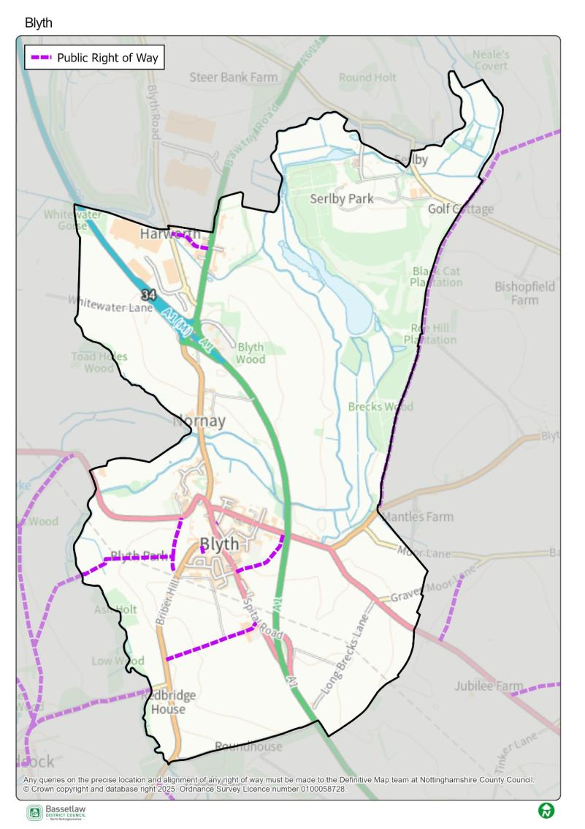

Footpath floods, just over river from footbridge

**Floodzone**

* Sheffield Road part Cherry Tree towards Oldcotes. Road floods – dangerous, will increase due in climate change.
* Footpath impassable due to flooding of River Ryton.
* Path to Hodsock over footbridge impassible most of the year due to flooding, and in dry months, difficult to walk due to uneven surface. Needs raised pathway.
* The flood risk areas must be protected at ALL times. We have a duty to the downstream villages.

**Landscape Character Area**

* Aim to maintain our existing woodland + green spaces. Health benefit – walking in lovely countryside.
* We must hang on to our green spaces come what may for the health and well-being of our current residents and future generations.

**Heritage**

* Road infrastructure – vibration in many houses. Need a detailed traffic impact assessment. Impact, noise, light, vibration, health (diesel/petrol).
* Maintain conservation village status – important to the village community – impacted by increased traffic impact, noise, health and living.



**Know your Place: what’s in a name?**

*The name ‘Know Your Place’ has an intentional dual meaning. On one hand it reflects the opportunity the initiative provides for all involved to learn more about the local area. This could be through viewing the information on display, through reading the contributions made by attendees, or through discussion both at and following community events. The name is also a conscious acknowledgement of the invaluable role communities have in shaping spatial knowledge and informing local priorities. Collectively, the initiative works on the basis that all parties have valuable knowledge and experience to share, but also the capacity to learn from the valuable knowledge and experience of other people.*

**Neighbourhood Planning**

Bassetlaw District Council

Queen’s Buildings,

Potter Street,

Worksop,

S80 2AH

Tel: 01909 533 495

Email:

[neighbourhoodplanning@bassetlaw.gov.uk](mailto:neighbourhoodplanning@bassetlaw.gov.uk)

Website: <https://www.bassetlaw.gov.uk/planning-and-building-control/planning-policy/neighbourhood-plans/know-your-place/>



**Know your Place website**